It is important to note that these codes are used to support a Matter Arising of Patoine et al. (2022) [1]. Land cover, ndvi, precipitation, air temperature, SOC, pH, clay percent, sand percent, soil nitrogen, and elevation data (0.5 ° resolution) are required before running all codes. Please contact Jinshi Jian [jinshi@vt.edu](mailto:jinshi@vt.edu) or Guillaume Patoine [guillaume.patoine@idiv.de](mailto:guillaume.patoine@idiv.de) for the data needed, and descriptions of the data please refer to Patoine et al. (2022) [1].

**Table 1. Description of R codes and data used.**

|  |  |  |  |
| --- | --- | --- | --- |
| Folder | File name | Description | Notes |
| code | functions.R | Function created and used | / |
| install_r_packages.R | Install necessary R packages | / |
| main_analysis_1_resample_and_plot_v2.R | Randomly take samples for Random Forest modeling | Changes required for scenario 1 and 3 |
| main_analysis_2_resample_and_RF_v2.R | Build Random Forest models based on randomly taken samples | Changes required for scenario 1 and 3 |
| main_analysis_3_resample_and_temporalTrend_v2.R | Predict global MBC between 1992-2013, and generate temporal trend | Changes required for scenario 1 and 3 |
| MBC_meta_analysis.Rmd | R markdown code for meta-analysis | / |
| MBC_MR.Rmd | R markdown code for plot | / |
| rawdata | glc_cmic_data.xlsx | MBC data from Patoine et al. (2022) | [1] |
| GSMBD20120601.xlsx | MBC data from Xu et al. (2013) | [2] |
| MBC_metadata.xlsx | MBC data from warming experiment compiled in this study | See Table 2 for details |
| LongTerm_BMC.xlsx | *In-situ* long-term soil microbial biomass carbon measurements | See Supplementary Table 1 in the manuscript for details |

**Table 2. Description of data for the meta-analysis.**

|  |  |  |
| --- | --- | --- |
| Sheet number | Sheet name | Description |
| 1 | Sheet1 | This is the main dataset which was used to support the meta-analysis of MBC response to warming |
| 2 | field_explaination | Description of all 67 columns in Sheet1 |
| 3 | UnitsConvertor | If MBC data in the paper were not reported in mmol/kg, convertor used to convert the MBC values to mmol/kg |
| 4 | refs | Details of references where MBC data were collected |
| 5 | ByStudy | Detailed data by study if calculation required |

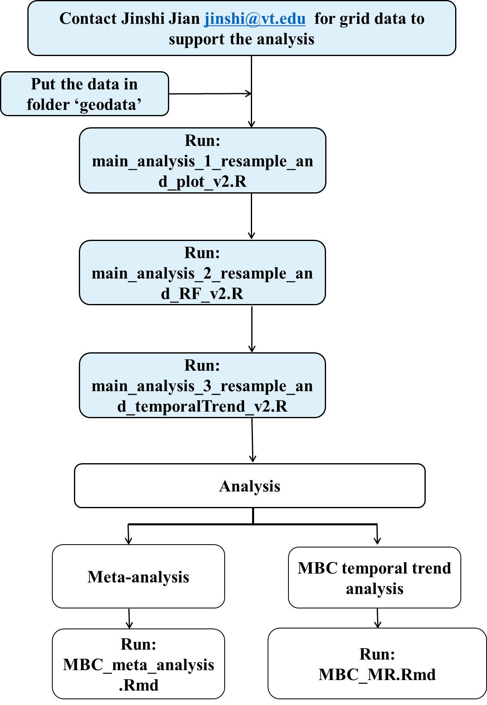

**Figure 1. Summary workflow for running through the code to reproduce the results of the analysis.**

[1] [Patoine, G. *et al.* Drivers and trends of global soil microbial carbon over two decades. *Nat. Commun.* **13**, 4195 (2022).](http://paperpile.com/b/49k4QB/sbFr)

[2] [Xu, X., Thornton, P. E. & Post, W. M. A global analysis of soil microbial biomass carbon, nitrogen and phosphorus in terrestrial ecosystems. *Glob. Ecol. Biogeogr.* **22**, 737–749 (2013).](http://paperpile.com/b/49k4QB/lJsC)