通过AppRegistry注册组件

AppRegistry.registerComponent('Test', () => Test);

内部会生成一个runnable对象，包含一个run函数，组件渲染时会调用该函数

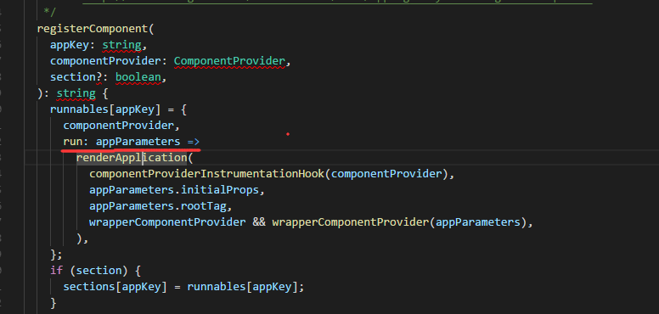

run函数调用react-native\Libraries\ReactNative\renderApplication.js的renderApplication

然后调用react-native\Libraries\Renderer\ReactNativeRenderer-dev.js中的ReactNative.render(renderable, rootTag)

ReactNative.render(renderable, rootTag)

getReactNativeHost().getReactInstanceManager()->createReactInstanceManager

mReactRootView.startReactApplication触发创建ReactApplicationContext，

**if** (!mReactInstanceManager.hasStartedCreatingInitialContext()) {  
 mReactInstanceManager.createReactContextInBackground();  
}

com.facebook.react.XReactInstanceManagerImpl#createReactContext

初始化js，注册module