Evolutionary Deep Nets with Adaptive Sparsity and Accuracy Improvement
Jinsong Wang and Kenneth A. Loparo
Case Western Reserve University
Cleveland, Ohio
{jxw741, kal4}@case.edu
Abstract—We study sparse evolutionary training for appliance-presence classification using synthetic UK-DALE mixtures. Two experimental objectives evaluate compression with approximately preserved binary accuracy and joint improvement in macro positive-class F1 and sparsity. A new CNN study trains 120 models over four targets and three seeds, with validation-only checkpoint, threshold and recipe selection. Compared with a 50-epoch fixed SET baseline, the selected warm-start compressed policy changes binary accuracy from 91.5325% to 91.5280%, so both round to 91.53%. Macro F1 increases from 92.4065% to 92.5896%, compact stored weights decrease by 17.36%, active first-layer connections decrease by 23.93%, and compact dense kernel MACs decrease by 8.17%. These two objectives analyze the same cohort rather than independent replications. Warm-start refinement requires 25 additional epochs after a 50-epoch source. Three seeds do not establish statistical superiority or accuracy equivalence, and source-window independence remains unverified. We retain the historical adaptive-sparsity pilot as context and provide three code workflows with native models, training curves, complete candidate results and provenance.
Index Terms—deep learning, energy disaggregation, non-intrusive load monitoring, adaptive sparsity.

I. Introduction
Non-intrusive load monitoring (NILM), also called energy disaggregation, estimates appliance use from a single building-level power sensor [1]. This study focuses on homes. NILM can reduce the need for separate appliance meters. Appliance information can support energy-saving advice, energy audits, and feedback for residents. It can also support building maintenance and energy services.
Zoha et al. [2] describe three main steps: data collection, feature extraction, and learning. Data collection records electrical signals such as power, current, and voltage. Feature extraction finds patterns linked to appliance use. Learning uses these patterns to identify appliances or estimate their power. Supervised methods need appliance measurements as training labels.
Appliances have different operating patterns. Some have two states, such as a lamp. Others have several states, such as a washing machine. These differences make it hard to use one model setup for every appliance. Low-rate readings capture many steady patterns, while short changes may need faster sampling [2]. Faster sampling also increases data and processing needs.
NILM methods include hidden Markov models, support vector machines, neural networks, and Bayesian methods [2]. Deep learning can learn useful features directly from power signals [1]. We study its prediction quality and the possible benefits of sparse connections. Larger networks have more capacity, but they also require more storage and computation.
We examine whether target-specific validation feedback and whole-neuron removal can reduce model size while retaining prediction quality. The research proceeds from the original Evolutionary Deep Nets baseline, through adaptive sparsity control, to warm-start pruning and distillation. These established components support an empirical study; we do not claim a new regularization principle or establish that their combination is novel.
The task is binary appliance-presence classification in one-hour synthetic windows, rather than time-resolved appliance-power estimation. We distinguish the historical ten-epoch DNN/CNN pilot, short software checks, and a completed 50-epoch CNN study with 25-epoch refinement extensions. The new study supplies the main predictive evidence. Its two experimental objectives share a common cohort, baseline and validation-selected compressed policy.

II. Background

A. Deep neural networks
A neural network contains connected units called neurons. Each neuron combines weighted inputs and applies an activation function. A multilayer perceptron passes its input through hidden layers to produce an output. We use DNN to refer to this feedforward model [4].
CNNs use filters to learn local power-signal patterns, while pooling reduces feature dimensions. RNNs represent sequence dependence [4]. The original study considered all three model families. The historical adaptive pilot compares DNN and CNN; the completed accuracy-improvement study focuses on CNN.

B. Sparse evolutionary training
SET replaces full connections with a sparse random network [3]. During training, it removes small positive and negative weights and adds new connections. This lets the network structure change while the usual connection budget stays fixed. Sparse connections may reduce the number of useful weights, but software must use that structure to gain speed.
RigL uses gradients to guide new connections [5]. Our gradient method follows this idea but is not a full RigL reproduction. Earlier work also studies structured sparse training and neuron removal [6]. These methods provide the basis for the added adaptive experiments.

C. Adaptive sparsity
Dynamic sparse reparameterization moves connections between layers while keeping a fixed total parameter budget [7]. PALS instead lets a network shrink, expand, or keep its size during training to balance loss and sparsity [8]. Adaptive sparsity loss also controls pruning under a user-defined budget [9]. Thus, changing sparsity during training is an established idea.
PALS is a close comparison for our budget controller. Structured RigL is relevant to our neuron removal and deployment cost [6]. Our pilot combines target-specific validation feedback, gradient growth, L21, and dense compaction for appliance classification. It does not reproduce PALS or Structured RigL, or establish that this combination is new.

D. Sparse regularization
L1 shrinks individual weights toward zero [10]. L21 shrinks groups of weights [11]. Here, each group contains a neuron’s incoming weights and bias. The added research combines these established methods with adaptive budgets. It tests their value without treating L1, L21, or gradient growth as new ideas.

III. Data
The original data procedure uses UK-DALE [12] and four appliance types: washing machine, dishwasher, refrigerator, and microwave. Each window has 600 samples at six-second intervals, covering one hour. Windows move forward by five minutes. A window is kept if its power is above zero for more than ten minutes. Selected appliance windows are added to form synthetic mixtures.
The supplied files contain 10,000 mixtures and four binary label columns, V1–V4. We reuse these files without regenerating mixtures. The original uploaded notebook pairs positional target slices with the intended order washing machine, dishwasher, refrigerator, and microwave. This evidence identifies intended plotting labels, but does not verify the CSV generation. We therefore retain T0–T3 as primary target identifiers and record the intended names as unverified metadata. The accompanying label schema checks column correspondence and can require source-backed verification before training.
We find 9,107 unique inputs and no conflicting labels among exact duplicates. Before deduplication, rows 0–1999 are test data, rows 2000–3599 are validation data, and the remaining rows are training data. Deduplication keeps test rows first, then validation rows, then training rows. The final split contains 5,770 training, 1,474 validation, and 1,863 test windows. A single mean and standard deviation computed from training inputs scale all three partitions. Table I reports positive-label counts and prevalence for this deduplicated dataset; these counts describe the full-data partitions used by the new CNN study.
Table I. Positive-label counts and prevalence by target. Appliance names indicate the unverified intended order.
Target / column | Intended appliance | Train  N = 5,770 | Validation  N = 1,474 | Test  N = 1,863
T0 / V1 | washing machine | 3,089 (53.54%) | 783 (53.12%) | 991 (53.19%)
T1 / V2 | dishwasher | 3,169 (54.92%) | 811 (55.02%) | 1,019 (54.70%)
T2 / V3 | refrigerator | 3,182 (55.15%) | 795 (53.93%) | 1,010 (54.21%)
T3 / V4 | microwave | 3,075 (53.29%) | 792 (53.73%) | 962 (51.64%)
Identical aggregate inputs cannot cross these splits. Different mixtures may nevertheless reuse appliance source windows, and one-hour windows advanced by five minutes can overlap substantially. Household and time independence remain unverified. The evaluation therefore concerns unique synthetic aggregate windows, not unseen households or measured whole-house demand. Deduplication also changes the evaluation distribution relative to the original duplicate-weighted mixture collection.

IV. Adaptive sparse networks

A. Models
Each appliance has its own binary classifier. The DNN uses dropout of 0.2, hidden layers of 100 and 20 neurons, and one sigmoid output. The CNN adds two convolution layers with 16 filters each. Their kernel sizes are 5 and 3, both with stride 2. Batch normalization and max pooling follow. Both models use ReLU hidden layers.
Sparsity affects only the first 100-neuron dense layer. Other layers stay dense. Sparse methods start with the same random mask for the same model and seed. If this layer has d inputs and n neurons, its initial connection count is round(pdn), where p = min(1, 20(d + n)/(dn)). Dense, L1, and L21 baselines start fully connected. RNNs are not part of this pilot.

B. L1 and L21
After each Adam update, L1 reduces each weight toward zero. Small weights become exactly zero. L21 does the same for a whole neuron group. The update rules are shown below. Here, η is 0.001, λ₁ is 0.0001, λ₂ is 0.001, and g is a neuron’s incoming weights plus bias.
$w ← sign(w) max(|w| − ηλ₁, 0). (1)$
$g ← max(1 − ηλ₂ / max(‖g‖₂, {10}^{−12}), 0) g. (2)$
L1 acts on the first hidden-layer weights; L21 also acts on their biases. The Euclidean shrinkage steps follow Adam updates and are then followed by mask enforcement. They are not an exact proximal update under Adam’s adaptive metric. The strengths shown above are pilot settings, not newly derived regularizers.

C. Adaptive connections
The per-target controller compares current validation binary cross-entropy (BCE) with the previous best BCE. A check is accepted when current BCE is no more than 1.01 times that previous best; the best value is then updated to the smaller value. Acceptance increments a good-check streak and resets the bad-check streak; rejection does the reverse. In the pilot, two consecutive accepted checks request a 10% budget reduction and two rejected checks request a 10% increase. Both streaks reset after an action. Requested budgets are rounded and clipped between 2% and 60% of all first-layer connections.
Checks update the best BCE and streaks during warmup and cooldown, although actions are suppressed. With zero-based epoch index e, warmup suppresses actions while e + 1 < 3, so the pilot’s third epoch is eligible. Cooldown suppresses an action while e minus the last action epoch is less than the configured cooldown; its default value is one. This defines the implementation boundary more precisely than “after three warmup epochs.” A clipped action may leave the integer budget unchanged.
Within each epoch, Adam updates and shrinkage use training minibatches. Validation then evaluates the current topology and records checkpoint candidates. Except on the final epoch, the controller chooses a requested connection budget, a training minibatch supplies gradient scores when needed, allowed neurons are selected, and rewiring is applied. SET removes 30% of the weights closest to zero separately among negative and nonnegative active weights, then removes additional weak connections if required by the requested budget. Fixed SET uses random regrowth; gradient variants rank candidate connections by absolute gradient. New weights receive random initialization. Removed or reinitialized connections have their corresponding Adam moments reset; surviving connections retain theirs. The revised implementation identifies optimizer slots by variable identity to avoid resetting unrelated variables with identical shapes. No controller or regrowth decision uses test labels.

D. Neuron removal
Structured methods select whole neurons using k = clip(round(0.9n√(B/B₀)), 8, n), where n is the original hidden width, B is the requested budget, and B₀ is the initial budget. Neurons are ranked by the product of their incoming weight-plus-bias norm and outgoing weight norm. Unselected incoming columns and biases are zeroed. A zeroed column can return when the allowed neuron count expands beyond the live columns and regrowth initializes new edges. Revival is not guaranteed at fixed k because zero ReLU neurons may have zero candidate gradients. If the selected columns cannot hold the requested connection budget, rewiring clips to their capacity and records the actual next budget.
Adaptive group SET combines budget control, gradient growth, neuron selection, and L21. Adaptive structured SET leaves out L21. Fixed group SET keeps a fixed connection budget. These comparisons help test which parts matter.
Compaction removes neurons whose effective incoming weights and bias are all zero, and removes their corresponding weights in the following layer. Retained unstructured zero weights still occupy dense storage and incur dense kernel MACs. The revised implementation exports native dense layers without mask operations, checks prediction agreement, saves the model, and verifies the reloaded model without custom objects. Section VI distinguishes these implementation checks from the predictive comparisons.

E. Controls at matching deployment budgets
The revised protocol adds three controls to distinguish the effects of adaptive training from those of reduced network width. For each backbone, target, and seed, the adaptive group SET checkpoint supplies a width selected using validation BCE alone. A smaller dense model and a static random sparse model are trained at that width. A magnitude-pruning control starts at the original dense width, removes neurons with the lowest incoming weight-plus-bias L2 norms halfway through training, and fine-tunes for the remaining epochs. Removed biases remain zero, and only post-pruning checkpoints are eligible. These controls retain the same feature extractor and second hidden layer.
The runner requires each exported control to match the reference’s dense kernel MAC count and stored weight bytes exactly. All methods receive the same training examples, epoch budget, validation threshold rule, and, in full mode, number of validation-only hyperparameter trials. Smaller controls cannot share identical full-width initial tensors; they share seeds and training-order rules. Matching exported bytes and MACs does not match training FLOPs, latency, or energy. The reference runs first to establish width, and the remaining methods use seeded shuffled execution order. The historical pilot did not include these three controls; their short validation runs do not replace a full comparison. The new accuracy study additionally trains dense widths 80 and 64 as fixed-width controls; these do not exactly match every target-specific selected policy width.

V Experimental design
The main study uses the deduplicated full-data split in Section III, targets T0–T3 and seeds 11, 23 and 37. All models share the CNN feature extractor, a second hidden layer of width 20, and a sigmoid output. The full-width baseline has 100 first-layer hidden neurons; reduced-width dense controls have 80 or 64. The flattened CNN representation has 1,184 features. We train 84 initial models, 24 warm-start refinements at widths 80 and 90, and 12 conservative refinements at width 96, giving 120 models. Policy rows reuse selected models and are not additional training runs.
Experiment 1 asks whether compression can retain approximately the same binary accuracy. Experiment 2 asks whether predictive quality, defined primarily as macro positive-class F1, and sparsity can both improve against the same fixed SET baseline. The two analyses share training runs and a final policy. “Same accuracy” means the observed values agree at the stated reporting precision; it is not a claim of exact equality, a prespecified noninferiority test or statistical equivalence. “Both improved” refers to F1 and sparsity; binary accuracy is reported separately.
For each seed, macro F1 is the unweighted average of positive-class F1 over four targets. Target F1 equals 2TP/(2TP + FP + FN), with zero returned for a zero denominator. We report mean and sample SD of the three seed-level macro scores. Binary accuracy is the fraction of correct target decisions, averaged over targets and seeds. Thresholds maximize validation positive-class F1 over 0.05–0.95 in steps of 0.01; ties within 10⁻¹² prefer the value closest to 0.5 and then the lower value. Predictions use probability ≥ threshold.
All initial models train for 50 epochs with batch size 128 and Adam learning rate following a cosine schedule from 0.001 to 0.00002. The full-width dense teacher and fixed SET establish separate sources. Dense widths 80 and 64 provide width controls. Gradual pruning and distillation train students from scratch: epochs 1–15 retain a dense hidden layer, epochs 16–35 apply a cubic monotone pruning schedule, and the last 15 epochs freeze topology. Final hidden width is 80 or 64 and final retained-layer edge density is 25%. Neuron scores multiply incoming weight-plus-bias norm by outgoing weight norm; within retained neurons, the smallest absolute weights are removed. No connections regrow in this pruning schedule. Distillation uses the dense teacher’s training probabilities with mixing coefficient 0.5, temperature 2, and temperature-squared Bernoulli KL scaling. The teacher adds 50 training epochs.
Warm-start refinement chooses the stronger source recipe by mean validation F1 across seeds for each target. Fixed SET is selected for all targets. Each refinement restores the corresponding native checkpoint and zero mask, then trains for 25 further epochs using cosine learning rate 0.0003 to 0.000006. Distillation from the frozen source uses coefficient 0.25 and temperature 2. A cubic schedule over the first 15 refinement epochs reduces width to 80, 90 or 96 and retained-layer edge density to at most 20%; the last ten epochs freeze topology. The total source-plus-refinement budget is 75 epochs. These comparisons do not control for the extra fine-tuning compute with an equally extended unpruned baseline.
Checkpoints maximize validation F1, with ties resolved by lower validation BCE and then earlier epoch. Pruned checkpoints become eligible only after reaching their final budget. An initial policy chooses among the three compressed students for each target by mean validation F1 across seeds. The extended policy also considers the three refinements, breaking recipe ties by smaller compact weight bytes and then method name. The extension was motivated by validation evidence; width 96 was added after validation sensitivity was observed for T2. Both policies were frozen before test arrays were loaded. The final policy selects width 80 refinement for T0–T2 and width 90 for T3. No test-driven recipe or threshold selection is used.
Deployment accounting sums kernels, biases and batch-normalization parameters and moving statistics. Weight bytes exclude optimizer state, activations, framework overhead and archive metadata; KiB = bytes/1024. Native dense export removes dead neurons and corresponding adjacent-layer weights. Remaining unstructured zeros still occupy dense arrays and incur dense kernel MACs. One multiplication with accumulation counts as one MAC, excluding bias, activation, pooling and normalization operations. These quantities do not establish measured speed or energy savings.

VI Results
The following comparisons use the newly trained fixed SET baseline. They must be distinguished from the historical ten-epoch pilot: its CNN fixed SET macro F1 was 89.49%, versus 89.17% for adaptive group SET, while stored weights decreased by 21.4%. That pilot demonstrated a compression trade-off rather than unchanged accuracy. Changing training length, scheduling and checkpoint selection prevents attributing the new-versus-historical score difference solely to the improved method.

A Experiment 1 Compression with approximately preserved accuracy
Table II. Compression and binary accuracy against the new fixed SET baseline. The final policy is chosen using validation F1, not test accuracy.
Method | Accuracy  (%) | Change  (pp) | Weights  (KiB) | Weight reduction  (%)
Fixed SET 100 | 91.5325 | +0.0000 | 474.55 | 0.00
Gradual pruning 80 | 90.2532 | -1.2793 | 380.41 | 19.84
Pruning + KD 80 | 90.4679 | -1.0646 | 380.41 | 19.84
Pruning + KD 64 | 90.1056 | -1.4269 | 305.10 | 35.71
Warm-start pruning 80 | 91.5012 | -0.0313 | 380.41 | 19.84
Warm-start pruning 90 | 91.4654 | -0.0671 | 427.48 | 9.92
Warm-start pruning 96 | 91.4609 | -0.0716 | 455.72 | 3.97
Selected compressed policy | 91.5280 | -0.0045 | 392.18 | 17.36

The final policy reduces stored weight arrays from 474.55 to 392.18 KiB, a 17.36% reduction. Binary accuracy changes from 91.5325% to 91.5280%, a decrease of 0.0045 percentage points. Both round to 91.53% at two decimal places. This supports an approximately accuracy-preserving compression observation on the evaluated split, with the exact small loss disclosed. It does not establish a noninferiority margin or statistical equivalence. More aggressive students trained from scratch reduce size further but have appreciable accuracy losses, so compression alone is insufficient.

B Experiment 2 Joint improvement in F1 and sparsity
Table III. All candidates and both validation-selected policies. F1 change uses the same new fixed SET baseline; training epochs include teacher or source training.
Method | Macro F1 (%)  mean ± SD | ΔF1  (pp) | Active first  layer edges | Dense MACs  (thousands) | Total train  epochs
Dense teacher 100 | 91.35 ± 0.48 | -1.06 | 118,400 | 257.92 | 50
Fixed SET 100 | 92.41 ± 0.38 | +0.00 | 25,680 | 257.92 | 50
Dense 80 | 91.33 ± 0.21 | -1.08 | 94,720 | 233.84 | 50
Dense 64 | 91.37 ± 0.36 | -1.03 | 75,776 | 214.58 | 50
Gradual pruning 80 | 91.58 ± 0.26 | -0.83 | 23,680 | 233.84 | 50
Pruning + KD 80 | 91.65 ± 0.24 | -0.75 | 23,680 | 233.84 | 100
Pruning + KD 64 | 91.53 ± 0.17 | -0.87 | 18,944 | 214.58 | 100
Warm-start pruning 90 | 92.53 ± 0.39 | +0.12 | 21,312 | 245.88 | 75
Warm-start pruning 80 | 92.56 ± 0.34 | +0.16 | 18,944 | 233.84 | 75
Warm-start pruning 96 | 92.56 ± 0.41 | +0.16 | 22,733 | 253.11 | 75
Selected pruned student | 91.54 ± 0.20 | -0.87 | 20,128 | 219.40 | 87.5
Selected compressed policy | 92.59 ± 0.36 | +0.18 | 19,536 | 236.85 | 75

The selected compressed policy reaches macro F1 of 92.5896% compared with 92.4065% for new fixed SET, an observed increase of 0.1831 percentage points. Active first-layer edges fall from 25,680 to 19,536 (23.93%), and compact dense MACs fall from 257,924 to 236,854 (8.17%). Mean retained width is 82.5. Counting removed neurons as zeros in the original 1,184 × 100 matrix, first-layer sparsity rises from 78.31% to 83.50%. Density within the retained columns is 20%; this denominator differs from original-matrix sparsity. Thus F1 and sparsity improve jointly in this observed comparison, while raw binary accuracy remains slightly lower.
Table IV. Target-level F1 means over three seeds. The T2 decrease is retained.
Target | Selected refinement | SET F1  (%) | Policy F1  (%) | Change  (pp)
T0 | Warm-start pruning 80 | 95.53 | 96.01 | +0.48
T1 | Warm-start pruning 80 | 97.20 | 97.38 | +0.18
T2 | Warm-start pruning 80 | 78.24 | 78.18 | -0.06
T3 | Warm-start pruning 90 | 98.65 | 98.79 | +0.13

The gain is not uniform: T0, T1 and T3 improve, while T2 decreases by 0.064 F1 percentage points. All three paired seed-level macro differences are positive, but the exact two-sided sign-flip p value is 0.25. Three seeds therefore do not establish statistical superiority. Seed variation is conditional on this dataset and does not quantify uncertainty over households. The complete candidate table retains weaker gradual-pruning and distillation results; warm-start refinement, rather than pruning from scratch, supplies the favorable observed trade-off.

C Training curves and software verification
Figures 1–3 show measured histories and the deployment trade-off. Curves use means over targets within each seed followed by means and sample SD across seeds. Training BCE includes dropout, whereas validation BCE is evaluated without dropout. Validation F1 curves select a threshold each epoch; held-out results use the saved selected checkpoint rather than necessarily the last epoch. The warm-start curve begins after the source checkpoint, so its horizontal axis must not be read as the full training budget.
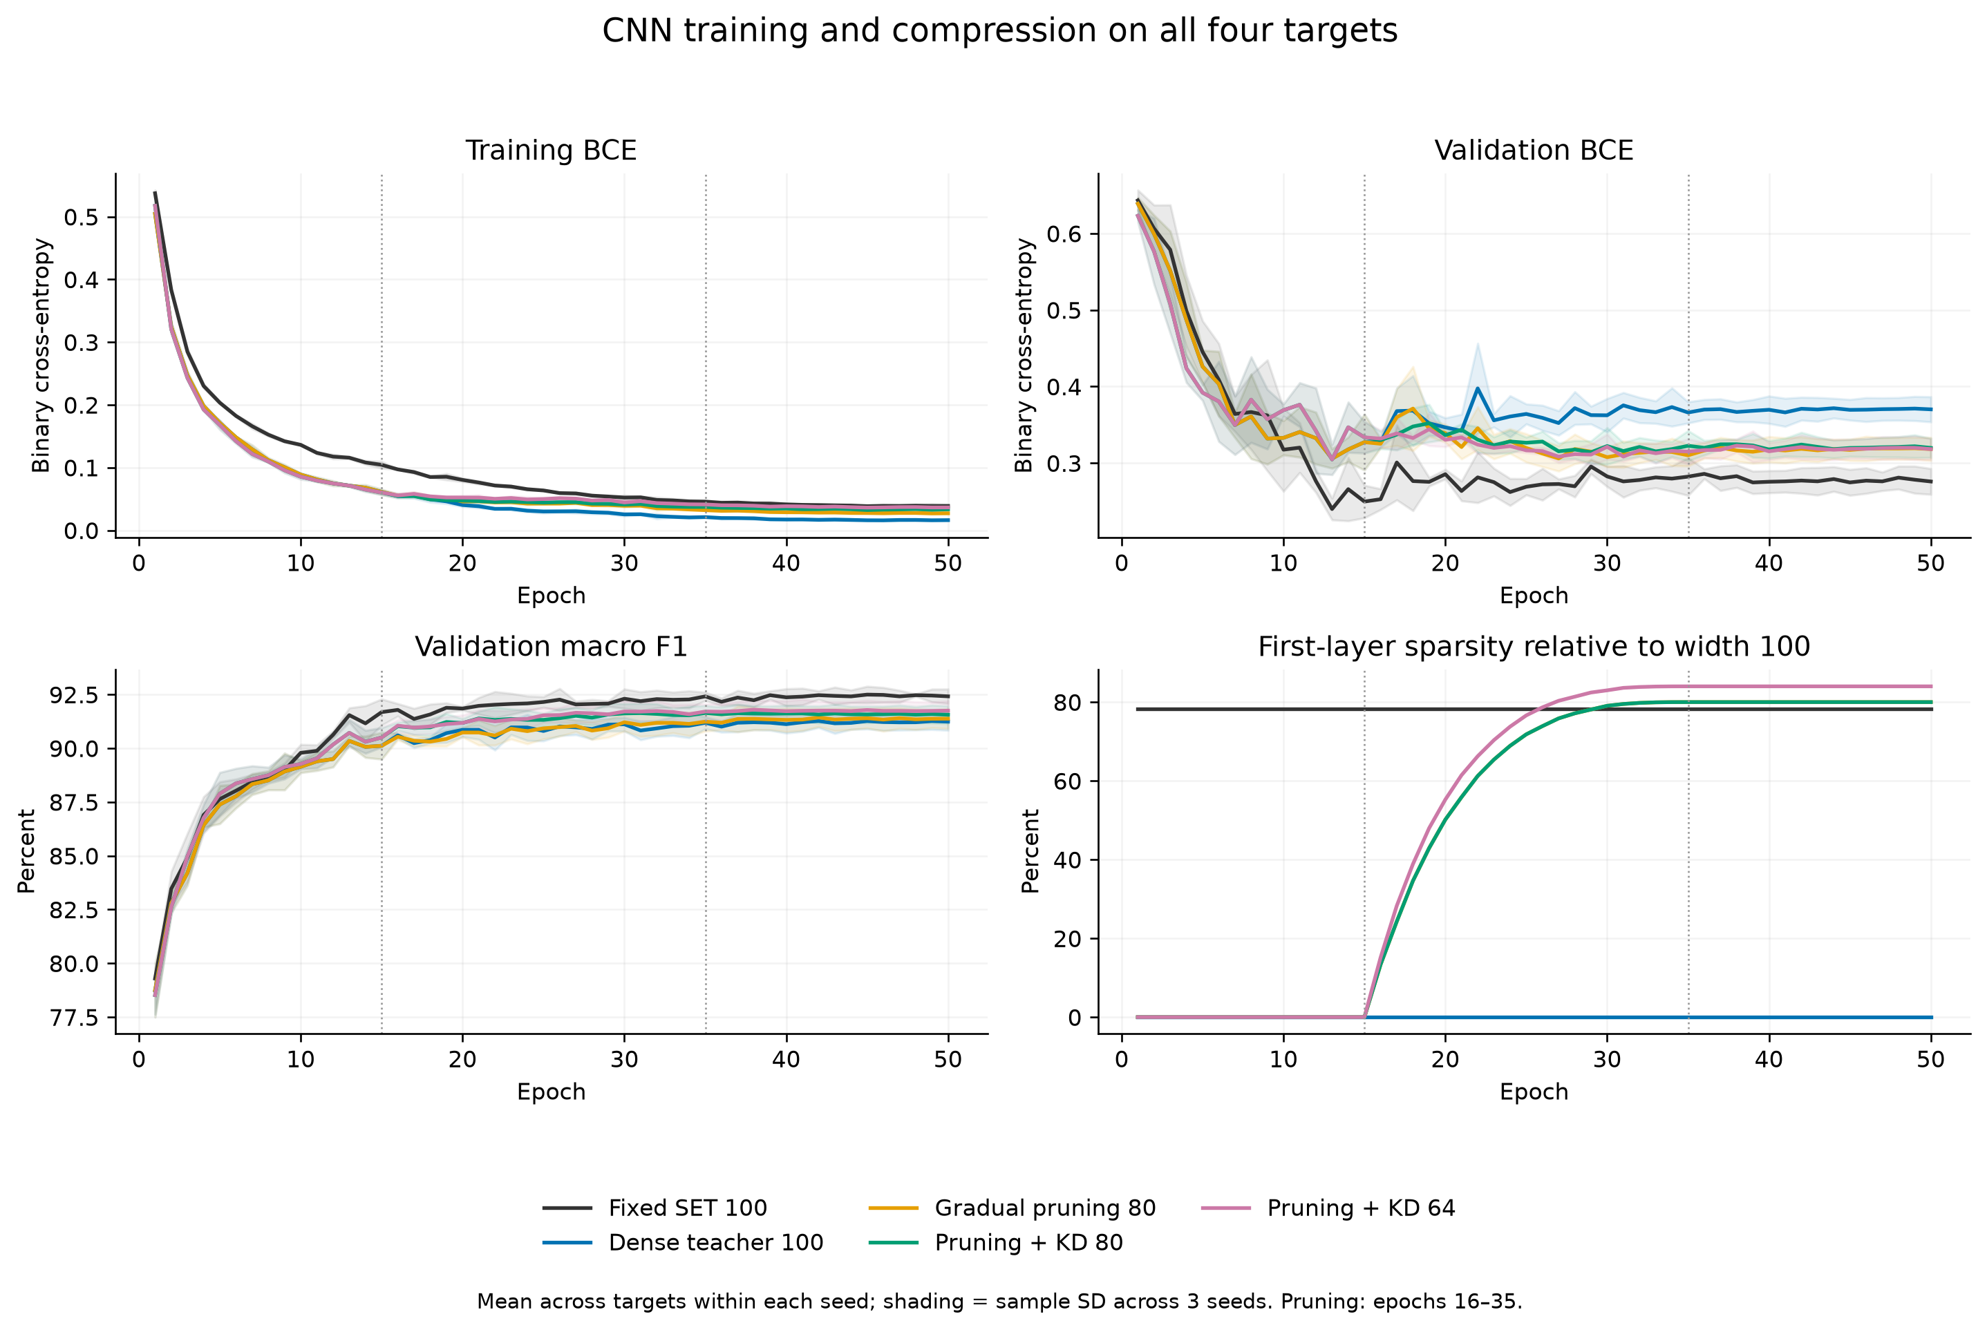
Figure 1. Measured 50-epoch training and validation trajectories, including first-layer sparsity. The dotted boundaries identify gradual pruning. These are validation rather than test learning curves.
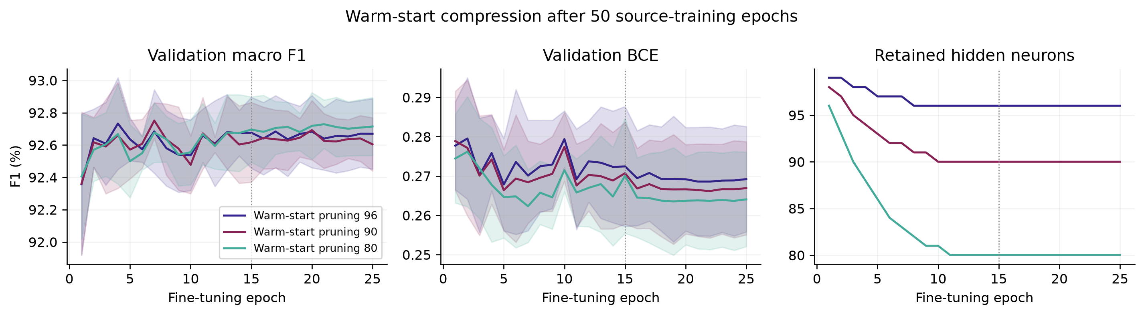
Figure 2. Measured 25-epoch warm-start refinement trajectories. Each run follows a separately trained 50-epoch source. Topology is frozen after refinement epoch 15.
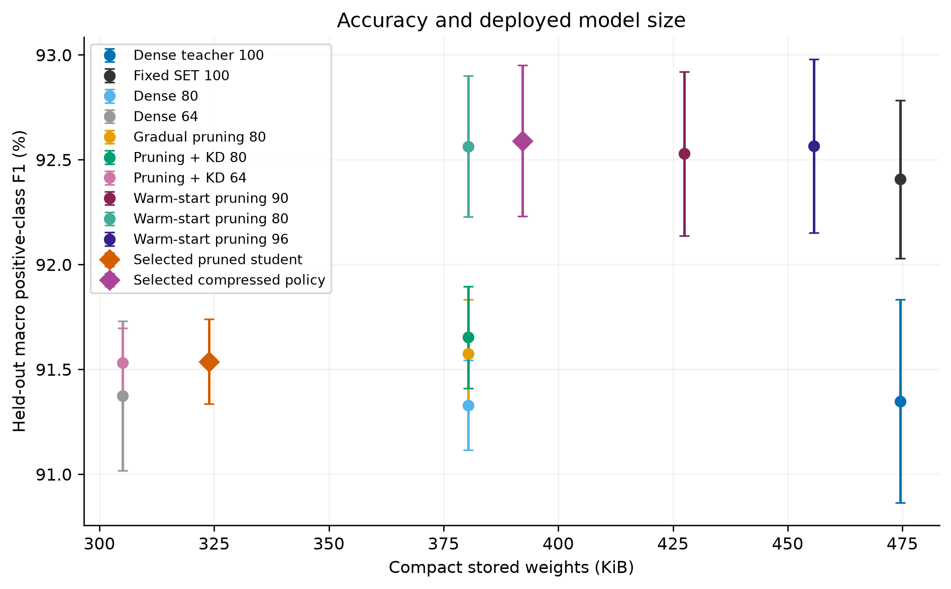
Figure 3. Held-out macro F1 and compact stored weights for the complete candidate suite. Error bars show seed SD; policy rows reuse validation-selected candidate models.
The implementation passes 28 automated regression tests. Earlier workflow checks also completed 120 three-epoch subset runs over two backbones, four targets, three seeds and five methods. Their 72 matched-control exports exactly matched the reference weight bytes and kernel MACs. The maximum observed probability difference after compaction was 1.79 × 10⁻⁷, no thresholded prediction changed, and native reload produced no measured probability difference on the check inputs. These short runs test implementation consistency and are separate from the 120 full-data CNN models in the present study. Saved full-data test predictions and metrics are retained for audit.

VII Limitations and next experiments
This study uses synthetic mixtures with exact-input deduplication but no verified independence of underlying appliance recordings, time blocks or households. Intended appliance labels are not verified against the generator; T0–T3 remain the primary identifiers. These results do not establish unseen-house NILM performance. Three training seeds and repeated validation adaptation provide limited uncertainty evidence; a ten-seed, independent-source study remains pending. The two experimental objectives share models and must not be counted as independent confirmations.
Warm-start refinement adds 25 epochs, and distillation adds source or teacher cost. The present comparisons therefore establish observed performance and deployment-size differences, not an equal-training-compute algorithmic advantage. A 75-epoch unpruned SET control with the same learning-rate continuation and validation exposure is needed to separate refinement from longer optimization. Further comparisons should match deployed widths and MACs, include PALS and structured sparse baselines [6]–[8], and reserve an independent final evaluation cohort. A prespecified accuracy tolerance and an adequately powered equivalence or noninferiority analysis are needed before asserting accuracy preservation statistically. Replicated device timing and power measurements are required for runtime or energy conclusions.

VIII Conclusion
On the supplied synthetic-window split, the validation-selected warm-start policy reduces compact weight arrays by 17.36% and active first-layer edges by 23.93%. Binary accuracy remains 91.53% at two-decimal reporting precision, with an exact observed change of −0.0045 percentage points. Macro positive-class F1 improves by 0.1831 percentage points against a newly trained 50-epoch fixed SET baseline. These observations address compression with approximately preserved accuracy and joint F1–sparsity improvement using the same cohort. Additional training cost, three-seed uncertainty and unverified source independence limit the conclusions; exact accuracy equivalence and broad predictive superiority remain unestablished.

IX Code and data availability
The public starting repository is https://github.com/jinsongwang/EvoNets. The revised code is organized into three folders: Evolutionary Deep Nets for the baseline; adaptive_sparsity for Adaptive Sparsity Research; and accuracy_improvement for Accuracy and Sparsity Improvement. The root contains shared data, dependencies and concise reproduction instructions. The adaptive training engine is stored once and imported by the accuracy workflow. The repository retains summary tables and selected training figures, while model binaries, per-run histories, prediction arrays, caches and validation logs are omitted to keep the file set small. The complete 120-model experiment archive is retained separately. Import-path packaging changes alter script hashes, so reproduction uses a fresh output directory; the saved summaries remain the measured results of the completed study.

References
[1] J. Kelly and W. Knottenbelt, “Neural NILM: Deep Neural Networks Applied to Energy Disaggregation,” Proceedings of ACM BuildSys, 2015.
[2] A. Zoha, A. Gluhak, M. A. Imran, and S. Rajasegarar, “Non-Intrusive Load Monitoring Approaches for Disaggregated Energy Sensing: A Survey,” Sensors, vol. 12, no. 12, pp. 16838–16866, 2012.
[3] D. C. Mocanu, E. Mocanu, P. Stone, P. H. Nguyen, M. Gibescu, and A. Liotta, “Scalable training of artificial neural networks with adaptive sparse connectivity inspired by network science,” Nature Communications, vol. 9, article 2383, 2018. https://doi.org/10.1038/s41467-018-04316-3
[4] I. Goodfellow, Y. Bengio, and A. Courville, Deep Learning. MIT Press, 2016.
[5] U. Evci, T. Gale, J. Menick, P. S. Castro, and E. Elsen, “Rigging the Lottery: Making All Tickets Winners,” Proceedings of ICML, PMLR, vol. 119, pp. 2943–2952, 2020. https://proceedings.mlr.press/v119/evci20a.html
[6] M. Lasby, A. Golubeva, U. Evci, M. Nica, and Y. Ioannou, “Dynamic Sparse Training with Structured Sparsity,” ICLR, 2024. https://proceedings.iclr.cc/paper_files/paper/2024/hash/8c5f30296296d2ae402ebbd09aaa9c12-Abstract-Conference.html
[7] H. Mostafa and X. Wang, “Parameter efficient training of deep convolutional neural networks by dynamic sparse reparameterization,” Proceedings of ICML, PMLR, vol. 97, pp. 4646–4655, 2019. https://proceedings.mlr.press/v97/mostafa19a.html
[8] Z. Atashgahi, M. Pechenizkiy, R. Veldhuis, and D. C. Mocanu, “Adaptive sparsity level during training for efficient time series forecasting with transformers,” arXiv:2305.18382, 2023, revised 2024. https://arxiv.org/abs/2305.18382
[9] G. Retsinas, A. Elafrou, G. Goumas, and P. Maragos, “Weight pruning via adaptive sparsity loss,” arXiv:2006.02768, 2020. https://arxiv.org/abs/2006.02768
[10] R. Tibshirani, “Regression Shrinkage and Selection via the Lasso,” Journal of the Royal Statistical Society Series B, vol. 58, no. 1, pp. 267–288, 1996. https://doi.org/10.1111/j.2517-6161.1996.tb02080.x
[11] M. Yuan and Y. Lin, “Model selection and estimation in regression with grouped variables,” Journal of the Royal Statistical Society Series B, vol. 68, no. 1, pp. 49–67, 2006. https://doi.org/10.1111/j.1467-9868.2005.00532.x
[12] J. Kelly and W. Knottenbelt, “The UK-DALE dataset, domestic appliance-level electricity demand and whole-house demand from five UK homes,” Scientific Data, vol. 2, article 150007, 2015. https://doi.org/10.1038/sdata.2015.7

