**Exercise**

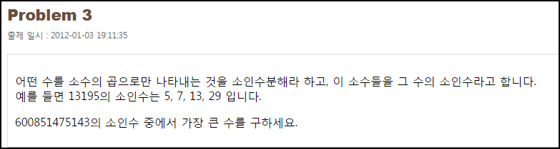

**Solution_code**

|  |  |  |
| --- | --- | --- |
| 1  2  3  4  5  6  7  8  9  10  11  12 | n = input("number : ")  cnt = 2    while cnt <= n :  if n%cnt ==0:  print '[+]',cnt  #print '[-]', n  n = n/cnt    #print cnt  cnt += 1 | [cs](http://colorscripter.com/info#e) |

**Result**

