## Econometrics HW 2

## Hayagreev Ramesh

N is the number of samples and n is the sample size. True value of β0 and β1 are 5 and 7 respectively. Mean of X and ε are 4 and 0 respectively. Variance-covariance matrix is [10 0; 0 4].

|  |  |  |  |  |  |  |
| --- | --- | --- | --- | --- | --- | --- |
|  | N=100,  n=100 | N=100,  n=1000 | N=1000,  n=100 | N=100,  n=100 | N=100,  n=100 | N=100,  n=100 |
| E[β̂̂0] | 5.014 | 4.9939 | 4.9971 | 5.01183 | 6.03265 | 4.62243 |
| E[β̂̂1] | 6.999 | 7.0005 | 7.0005 | 7.00028 | 6.99743 | 7.09113 |
| V[β̂̂0] | .1081 | .0104 | .1065 | .05808 | .10633 | .10394 |
| V[β̂̂1] | .00413 | .00039 | .0041 | .00104 | .00408 | .00402 |
| Cov[β̂̂0, β̂̂1] | -0.167 | -.0016 | -.01649 | -.00428 | -.01641 | -.01599 |

1. The first column (N=100,n=100) gives results

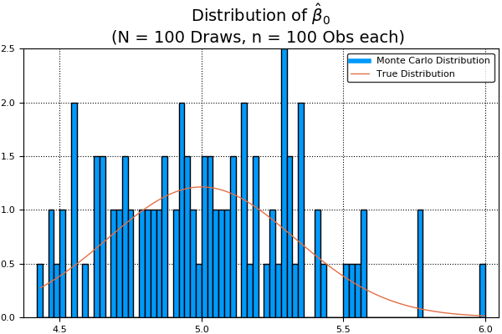

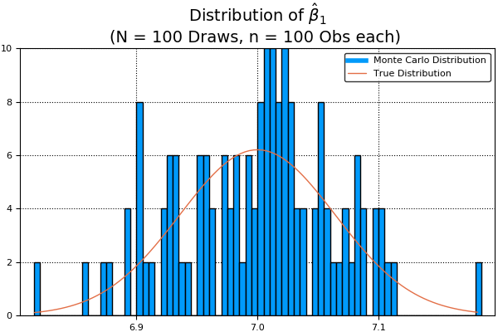

1. The second column (N=100, n=1000) shows results. Graphs are given below. As expected, the estimates for β0 and β1 are closer to the true values and the variance is about 10% of the variance in 1. This is expected since variance is inversely proportional to n.

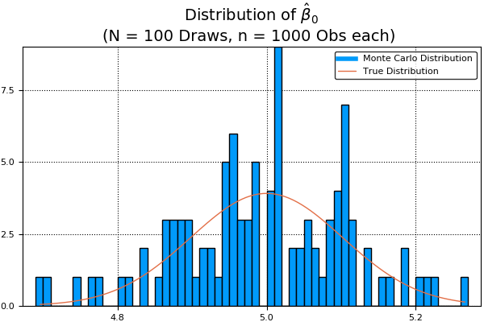

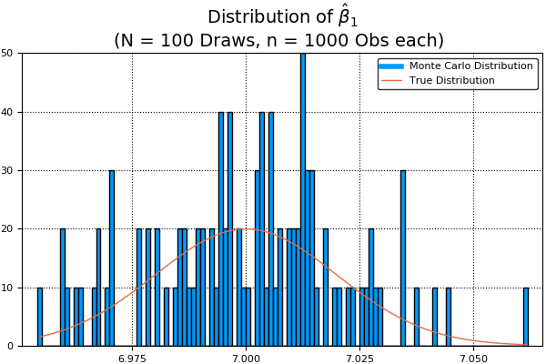

1. Results are shown in third column (N=1000, n=100). Graphs are given below. The estimates for β0 and β1 are closer to the true values as compared to part 1 but the variance is similar as in 1. This is expected as n is the same. Estimates are closer to the law of large numbers.

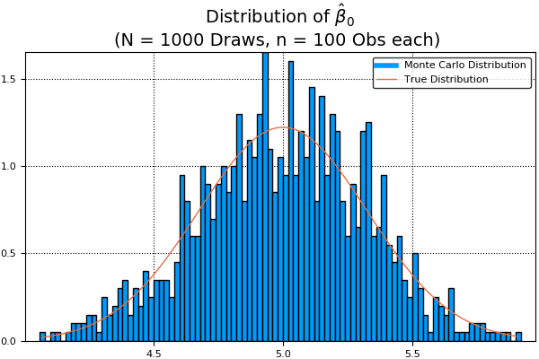

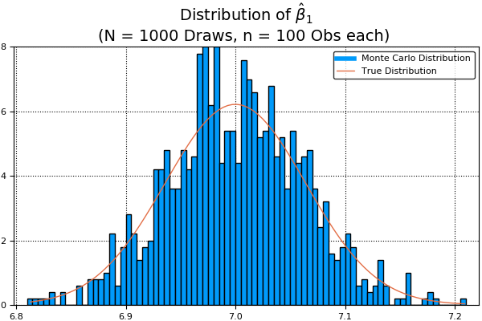

1. For this part, the mean of X has been kept the same whereas the variance-covariance matrix has been changed to [40 0; 0 4]. Results are in fourth column. Graphs are given below. The estimates for the coefficients are closer to the truth and variances are smaller than in part 1. This is expected as variance of X is higher in this case.

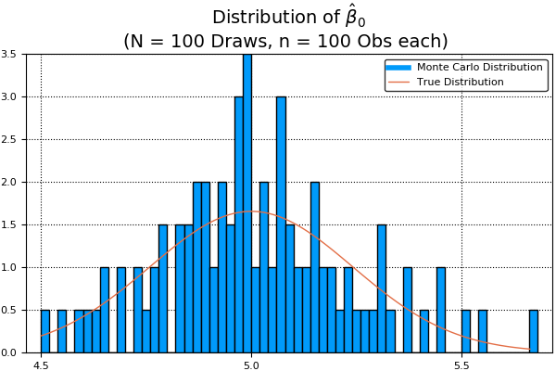

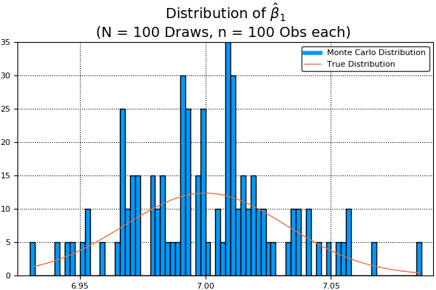

1. For this part, mean of ε was set to be 1 and rest remained same as part 1. Results are shown in column 5 and graphs are given below. The estimate for β0 is biased by the amount of the change in the mean of ε but the estimate for β1 remains close to the truth. Rest is similar to part 1.

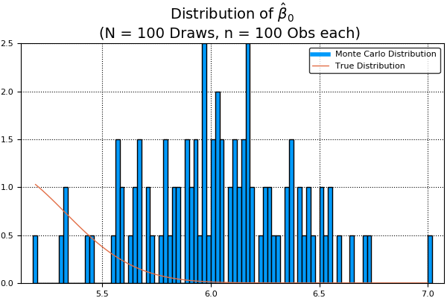

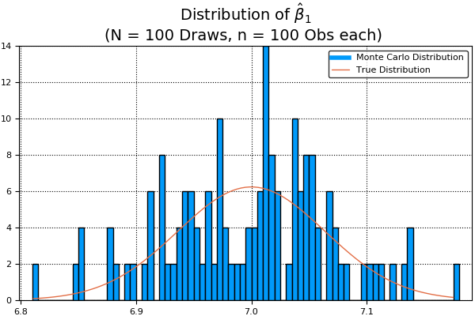

1. The variance-covariance matrix was changed to [10 1.5;1.5 4]. The rest remains the same as part 1. The results are in column 6 and the graphs are given below. In this case, both estimates are biased as the errors are correlated with the regressor.

