## Case 1: Xi is N(2,4), εi is N(0,Xi^2). β0=5, β1=7, N=100

## Distribution of coefficients for different sample sizes

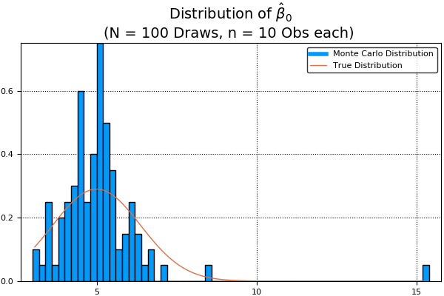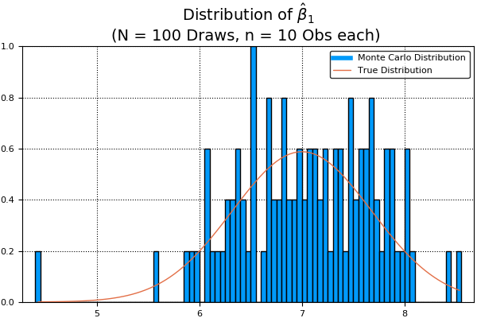

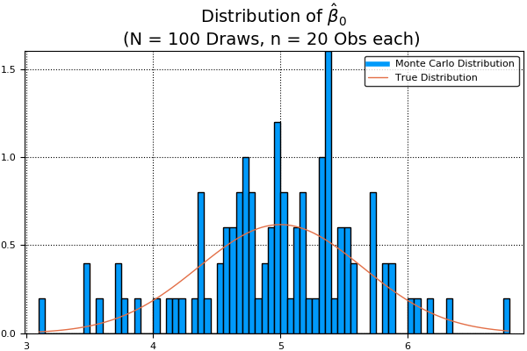 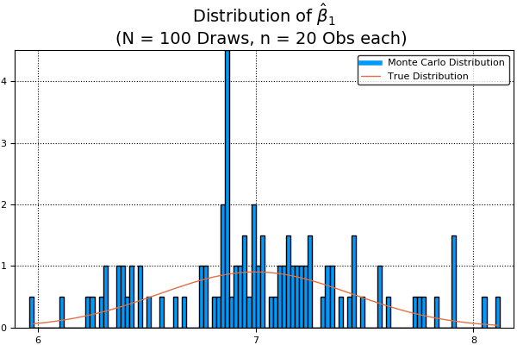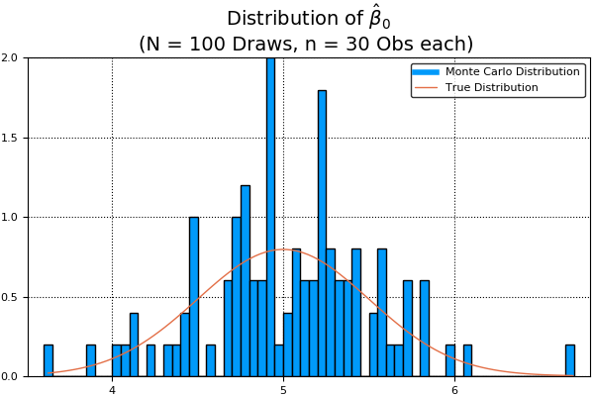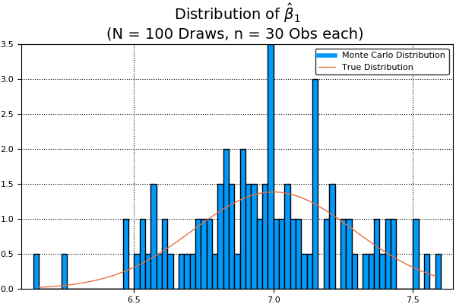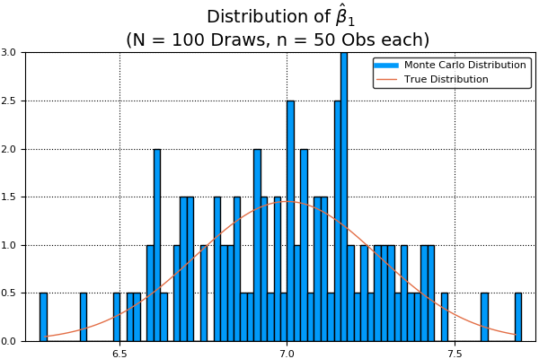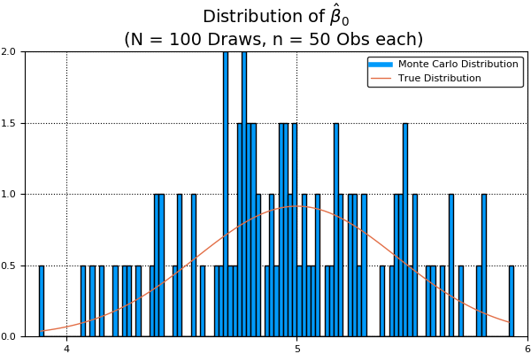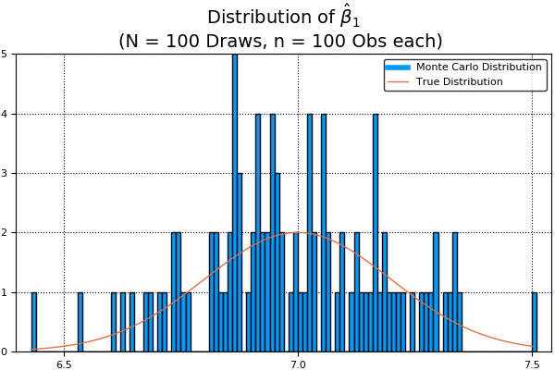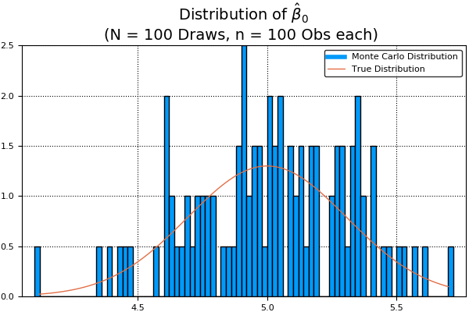

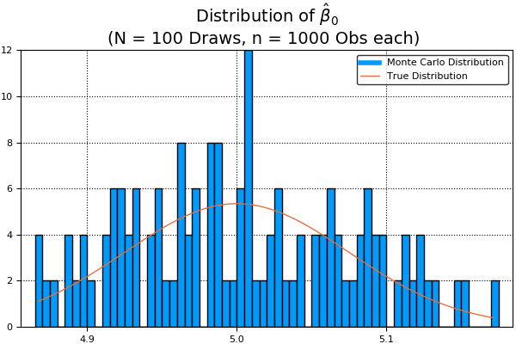

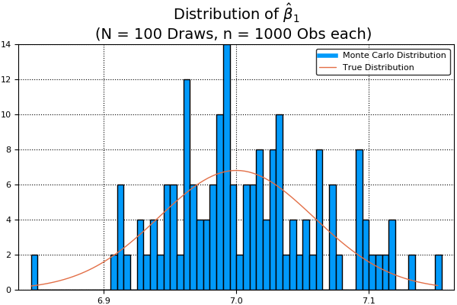

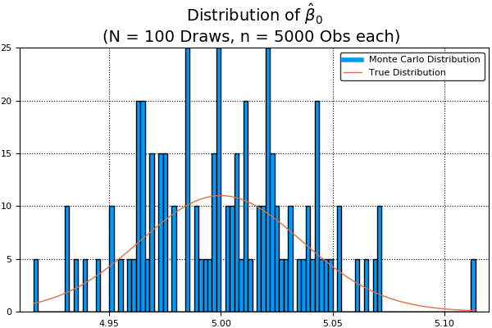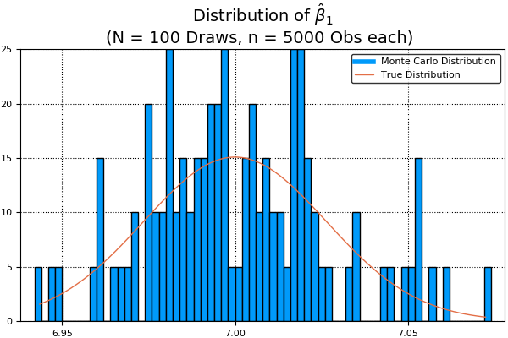

## Asymptotic distribution of coefficients

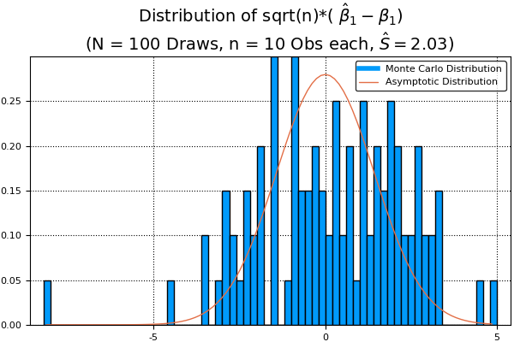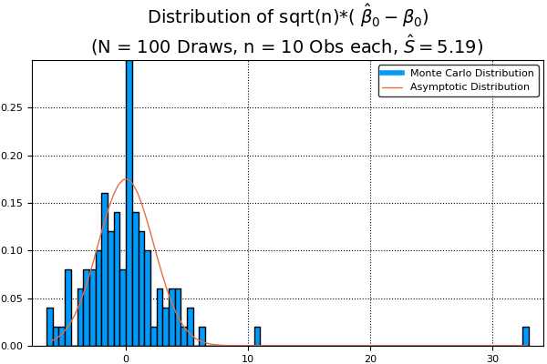

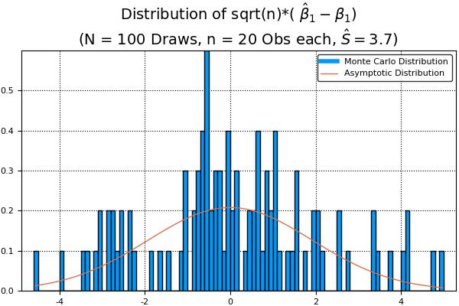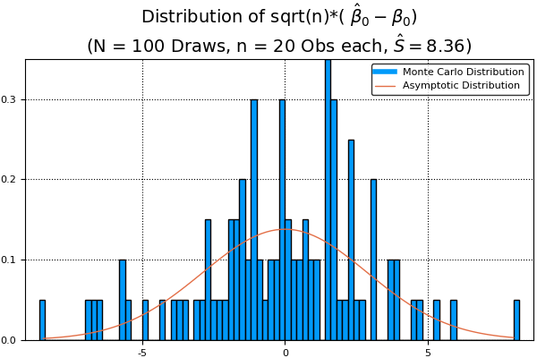

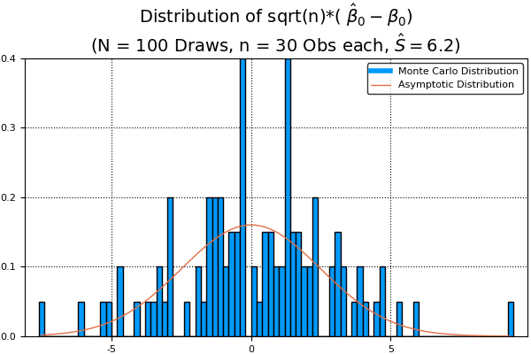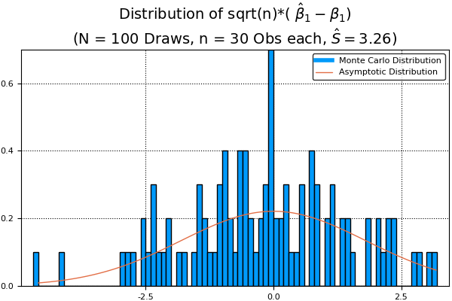

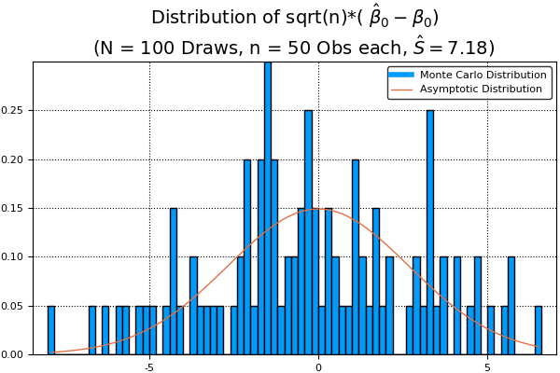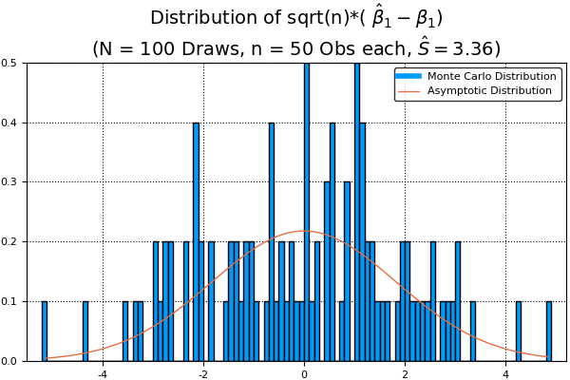

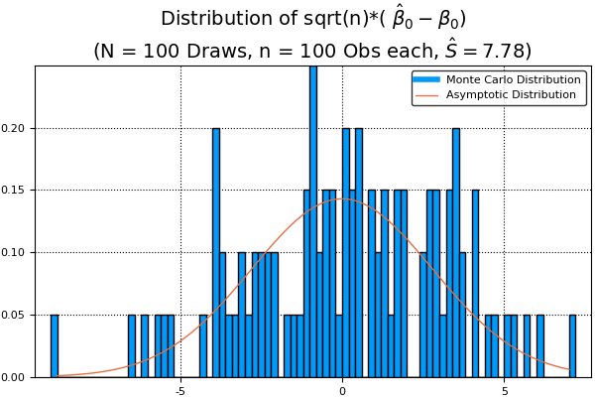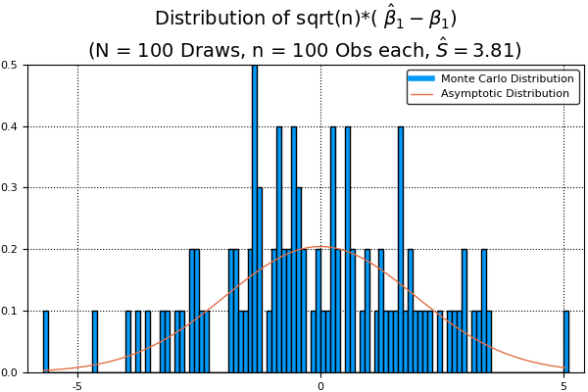

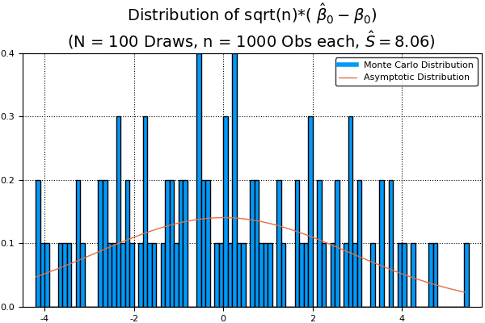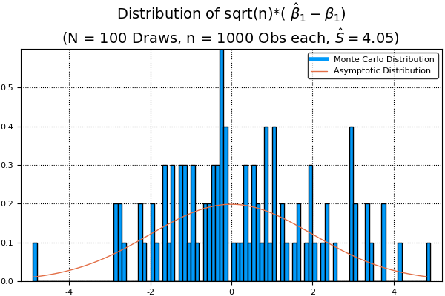

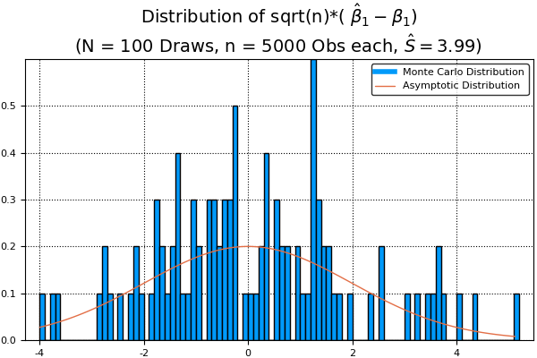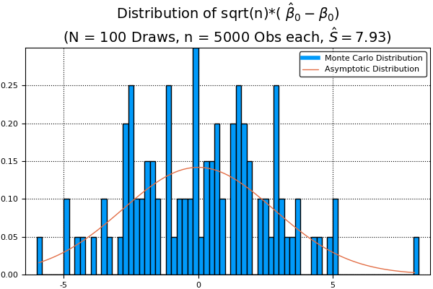

## Case 2:Xi is N(4,7), εi is N(0,Xi^2). β0=2, β1=11, N=100

## Distribution of coefficients for different sample sizes

## C:\Users\Viviktha\AppData\Local\Microsoft\Windows\INetCache\Content.Word\Plothw7_n10 _1.jpg.png

## C:\Users\Viviktha\AppData\Local\Microsoft\Windows\INetCache\Content.Word\Plothw7_n10 _2.jpg.png

## C:\Users\Viviktha\AppData\Local\Microsoft\Windows\INetCache\Content.Word\Plothw7_n20 _1.jpg.pngC:\Users\Viviktha\AppData\Local\Microsoft\Windows\INetCache\Content.Word\Plothw7_n20 _2.jpg.pngC:\Users\Viviktha\AppData\Local\Microsoft\Windows\INetCache\Content.Word\Plothw7_n30 _1.jpg.pngC:\Users\Viviktha\AppData\Local\Microsoft\Windows\INetCache\Content.Word\Plothw7_n30 _2.jpg.pngC:\Users\Viviktha\AppData\Local\Microsoft\Windows\INetCache\Content.Word\Plothw7_n50 _1.jpg.pngC:\Users\Viviktha\AppData\Local\Microsoft\Windows\INetCache\Content.Word\Plothw7_n50 _2.jpg.pngC:\Users\Viviktha\AppData\Local\Microsoft\Windows\INetCache\Content.Word\Plothw7_n100 _1.jpg.pngC:\Users\Viviktha\AppData\Local\Microsoft\Windows\INetCache\Content.Word\Plothw7_n100 _2.jpg.pngC:\Users\Viviktha\AppData\Local\Microsoft\Windows\INetCache\Content.Word\Plothw7_n1000 _1.jpg.pngC:\Users\Viviktha\AppData\Local\Microsoft\Windows\INetCache\Content.Word\Plothw7_n1000 _2.jpg.pngC:\Users\Viviktha\AppData\Local\Microsoft\Windows\INetCache\Content.Word\Plothw7_n5000 _1.jpg.pngC:\Users\Viviktha\AppData\Local\Microsoft\Windows\INetCache\Content.Word\Plothw7_n5000 _2.jpg.png

## Asymptotic distribution of coefficients

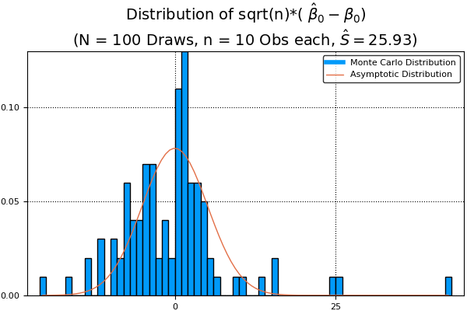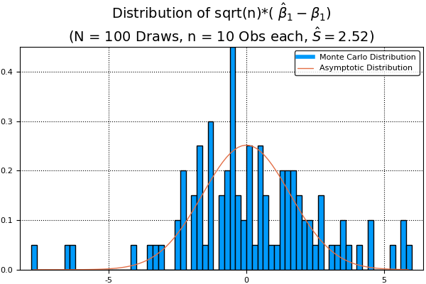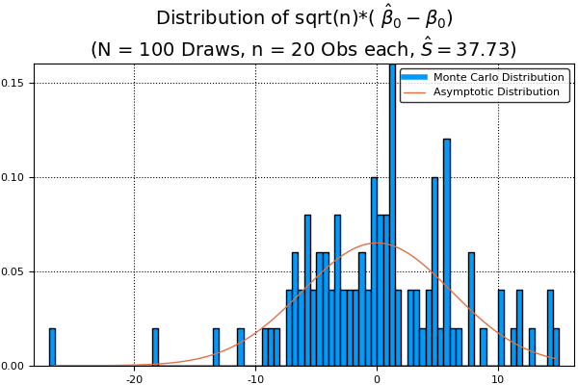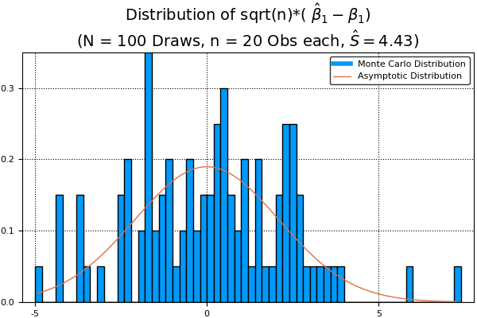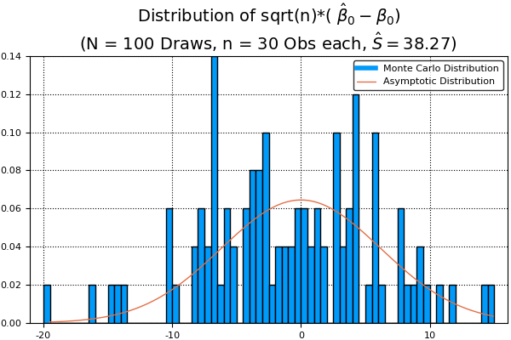

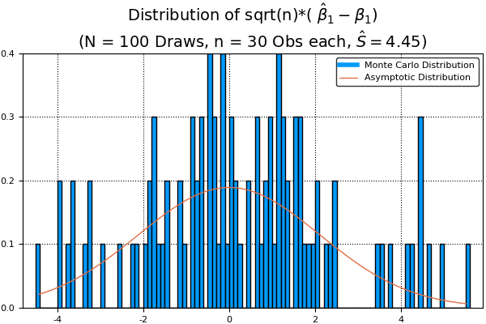

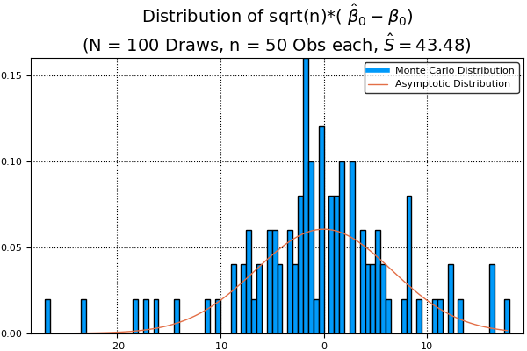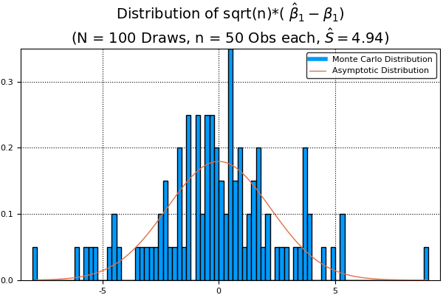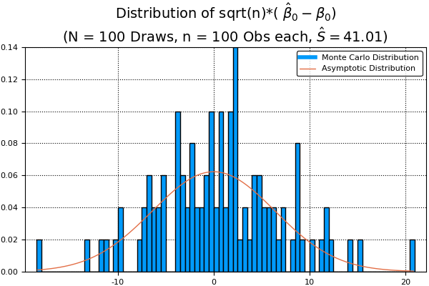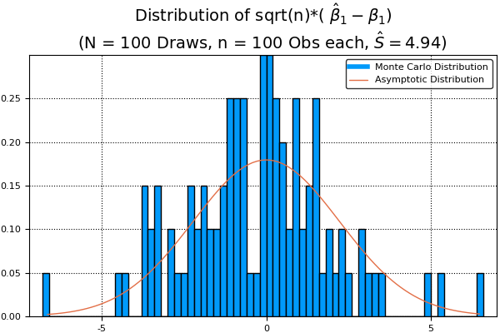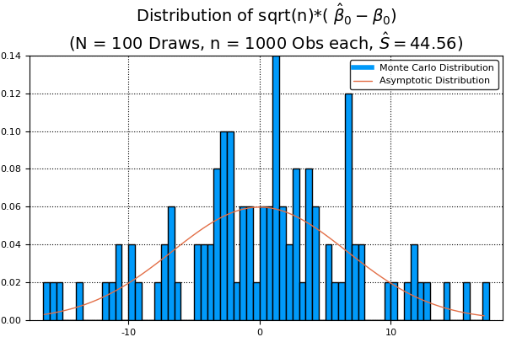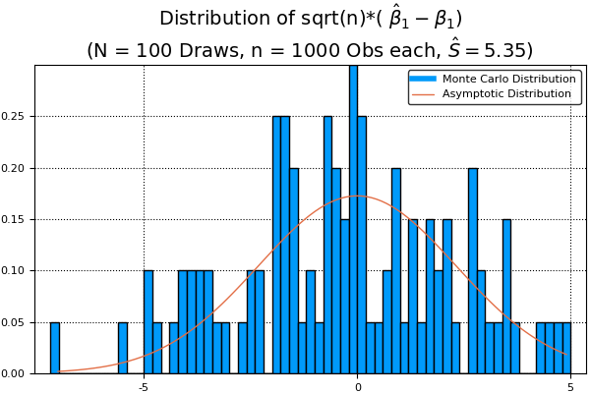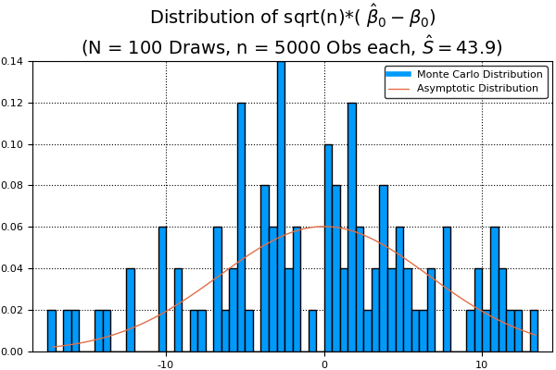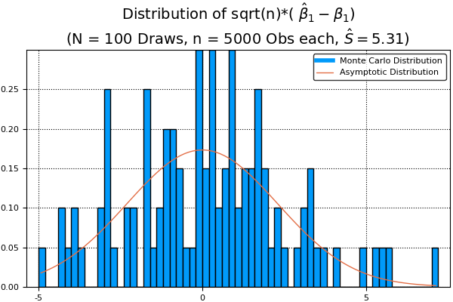

## Case 3: Xi is N(6,5), εi is N(0,Xi^2). β0=9, β1=3, N=100

## Distribution of coefficients for different sample sizes

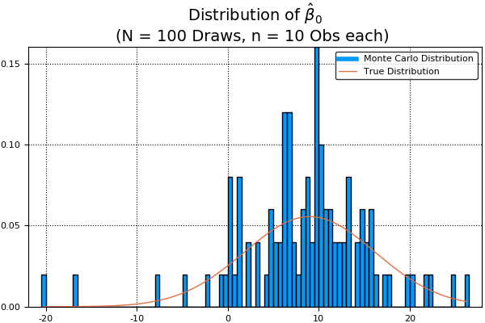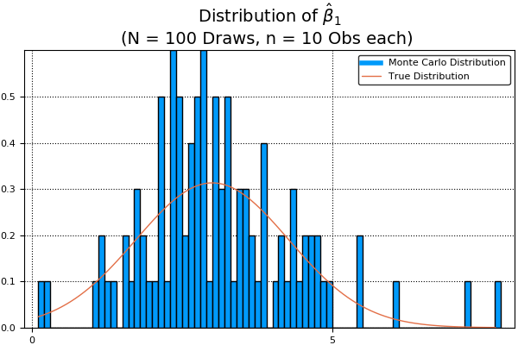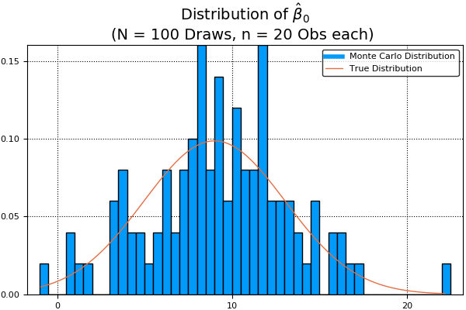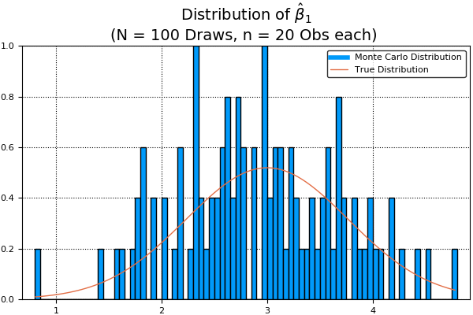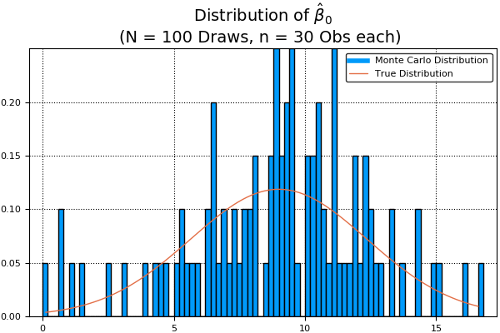

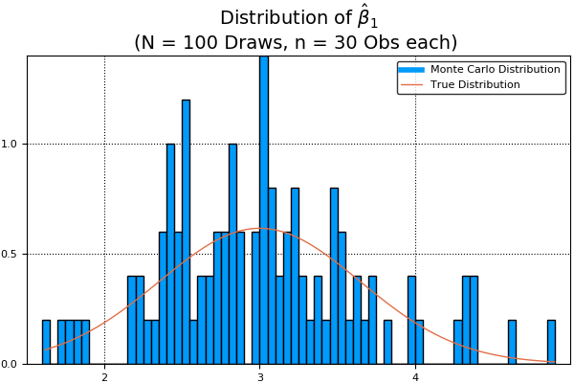

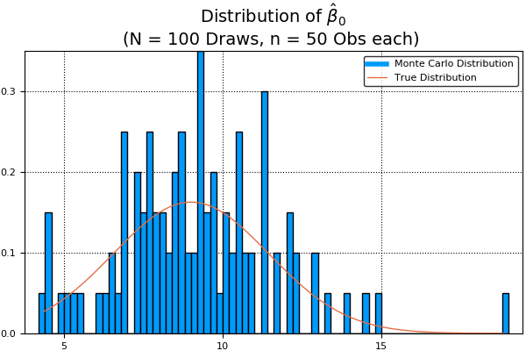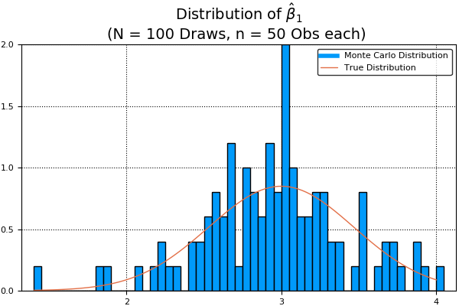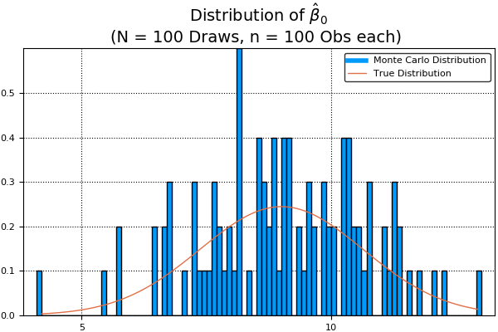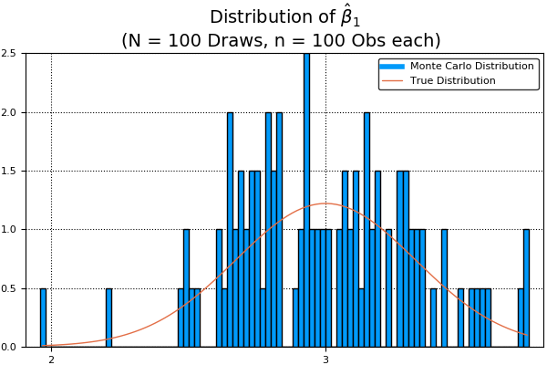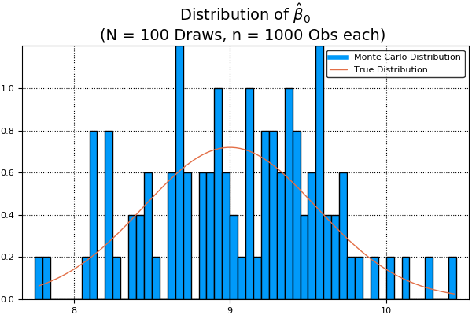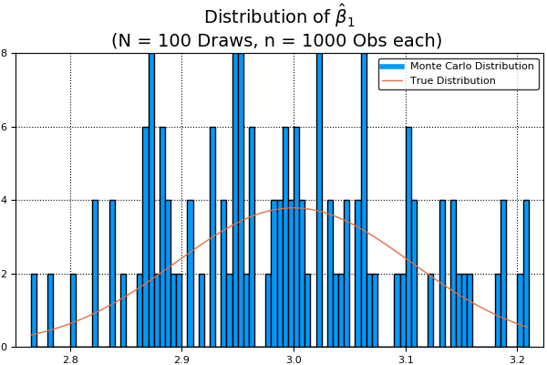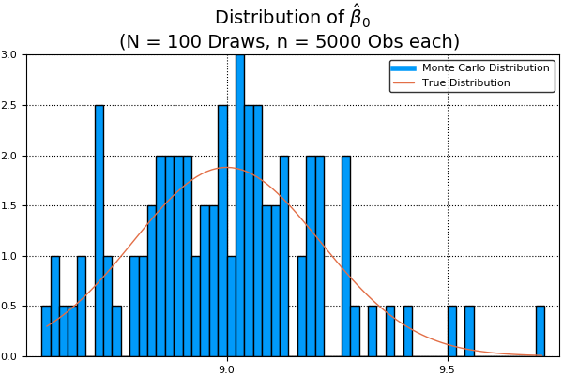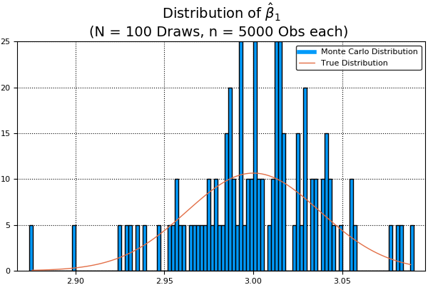

## Asymptotic distribution of coefficients

