REPORT ON

**E-STORE WEBSITE SYSTEM**

BY

**JINU JAIN**

**ABSTRACT**

E-Store is an e-commerce website which helps to choose a wide range of products through your desktop or smartphone rather than visiting the outlets. It is developed using word press which is an open source blogging platform and content management.

The basic e-commerce functionality in word press can be achieved through WooCommerce. WooCommerce is an open-source e-commerce plugin for WordPress. It is been developed to handle accurate stock and also to overcome a payment gateway problem. E-Store ensures that it accepts a review from our genuine buyers.

In today’s day to day life purchasing of products by visiting stores has become a tough job. As a standing in a queue for making the payment of the product has become difficult for customers. To overcome these difficulties, we are coming up with E-Store.

Word press power stats save the tracking information and analytics data in the backend. E-Store uses “Rank Math SEO” analysis to know the exact number of customers visiting our site track user engagement, it also shows us the product with high demand in that particular to understand the seasonal market demands for seasonal product supply.

**LIST OF FIGURES**

##### E-Commerce Workflow Diagram 14

##### Plugins for WooCommerce 21

##### WooCommerce Screen 22

##### System 27

##### Use Case 28

##### Actor 28

##### Communication Link 28

##### Use Case Diagram for Admin 29

##### Use Case Diagram for Customer 30

##### Activity Diagram for Admin and Customer 32

##### Sequence Diagram for Admin 35

##### Sequence Diagram for Customer 36

##### Entity Relationship Diagram 38

##### Site Map Diagram 40

##### Front Screen 41

##### Forms Screen 42

##### Analytics Screen 45

##### Elementor 46

##### WordPress Files Screen 47

##### Database Screen 48

##### Softaculous Screen 51

##### Installation 52

##### Elementor Editor 53

##### WordPress Dashboard 54

##### Hosting C-Panel 55

##### Infinity Free Main Home Screen 56

**LIST OF TABLES**

##### Login and Logout Test Case 50

##### Add Details on Cart 51

**TABLE OF CONTENTS**

[**CHAPTER 1: INTRODUCTION 1**](#_bookmark0)

### [COMPANY PROFILE 2](#_bookmark1)

### [EXISTING SYSTEM AND NEED FOR SYSTEM 4](#_bookmark2)

### [SCOPE OF WORK 5](#_bookmark3)

### [OPERATING ENVIRONMENT 6](#_bookmark4)

### [DETAIL DESCRIPTION OF TECHNOLOGY USED 7](#_bookmark5)

[**CHAPTER 2: PROPOSED SYSTEM 12**](#_bookmark6)

### [PROPOSED SYSTEM 13](#_bookmark7)

### [OBJECTIVES OF SYSTEM 14](#_bookmark8)

### [USER REQUIREMENTS 15](#_bookmark9)

### [SOFTWARE DEVELOPMENT MODEL (LIFECYCLE MODEL) 16](#_bookmark10)

[**CHAPTER 3: ANALYSIS & DESIGN 24**](#_bookmark11)

### [USE CASE DIAGRAMS 25](#_bookmark12)

### [ACTIVITY DIAGRAMS 28](#_bookmark13)

### [SEQUENCE DIAGRAMS 31](#_bookmark14)

### [ENTITY RELATIONSHIP DIAGRAM 34](#_bookmark15)

### [SITE MAP DIAGRAM 36](#_bookmark16)

### [USER INTERFACE DESIGN 38](#_bookmark17)

### [TEST PLANS AND TEST CASES 50](#_bookmark18)

**E-STORE WEBSITE SYSTEM**

# CHAPTER 1: INTRODUCTION

**EXISTING SYSTEM AND NEED FOR SYSTEM**

* + - In the Existing system, we are experiencing high crowd in the stores which make for us select the products.
    - Making the payments also takes a lot of time in some reputed stores.
    - This existing system of buying goods has several disadvantages.
    - It requires lots of time to travel to the particular shop to buy the goods.
    - It is having lots of manual work. Since everyone is leading busy life now a days, time means a lot to everyone.
    - Also there are expenses for travelling from house to shop.
    - It is less user-friendly.
    - In current system user must go to shop and order products.
    - It is difficult to identify the required product.
    - More over the shop from where we would like to buy something may not be open 24\*7\*365.
    - Hence we have to adjust our time with the shopkeeper’s time or vendor’s time.
    - In current e commerce system user have to go shop to view the description of the product.
    - It is unable to generate different kinds of report.
  1. **SCOPE OF WORK**
     + In scope of the work of the admin will maintain a wide range of products at affordable prices for customers and it makes easier for those who buy in the application.
     + If a customer leaves the product in the cart without buying and exits the application then the customer will get the mail after particular threshold time.
     + The customer can see a huge variety of products and compare them and choose their favorites that they wish to buy.
     + The proposed system helps in building a website to buy, sell products or goods online using internet connection.
     + The main advantage of e-commerce over traditional commerce is the user can browse online shops, compare prices and order merchandise sitting at home on their PC.
     + Enables consumers to shop or do other transactions 24 hours a day, all year round from almost any location.
     + It can be accessed over the Internet.
     + Purchasing of goods online, user can choose different products based on categories, online payments, delivery services and hence covering the disadvantages of the existing system and making the buying easier and helping the vendors to reach wider market.
     + It Provides consumers with more choices.
     + Customer can purchase Products Online.
  2. **OPERATING ENVIRONMENT**

### Hardware Requirements

* + - **Processor :** Intel Core 32 Bit
    - **Ram :** 512 MB RAM
    - **Hard Disk :** 1 GB Hard Disk

### Software Requirements

* + - **Operating System :** Windows 10
    - **Browser :** Google Chrome Version 84.0.4147.105
    - **Tools :** WordPress

PHP

Softaculous Tool

WooCommerce

MailChimp

Elementor

* 1. **DETAIL DESCRIPTION OF TECHNOLOGY USED**

### WORDPRESS -

* + - WordPress is an open source Content Management System (CMS), which allows the users to build dynamic websites and blogs.
    - Wordpress is the most popular blogging system on the web and allows updating, customizing and managing the website from its back-end CMS and components.
    - WordPress is highly customizable and has thousands of plugin pieces of software.
    - The Content Management System (CMS) is a software which stores all the data such as text, photos, music, documents, etc. and is made available on your website. It helps in editing, publishing and modifying the content of the website.
    - WordPress was initially released on 27th May, 2003 by Matt Mullenweg and Mike Little. WordPress was announced as open source in October 2009.
    - User Management: It allows managing the user information such as changing the role of the users to (subscriber, contributor, author, editor or administrator), create or delete the user, change the password and user information. The main role of the user manager is Authentication.
    - Media Management: It is the tool for managing the media files and folder, in which you can easily upload, organize and manage the media files on your website.
    - Theme System: It allows modifying the site view and functionality. It includes images, stylesheet, template files and custom pages.
    - Extend with Plugins: Several plugins are available which provides custom functions and features according to the users need.
    - Search Engine Optimization: It provides several search engine optimization (SEO) tools which makes on-site SEO simple.
    - Multilingual: It allows translating the entire content into the language preferred by the user.
    - Importers: It allows importing data in the form of posts. It imports custom files, comments, post pages and tags.
    - It is an open source platform and available for free.
    - CSS files can be modified according to the design as per users need.
    - There are many plugins and templates available for free. Users can customize the various plugins as per their need.
    - It is very easy to edit the content as it uses WYSIWYG editor (What You See Is What You Get is a user interface that allows the user to directly manipulate the layout of document without having a layout command).
    - Media files can be uploaded easily and quickly.
    - It offers several SEO tools which makes on-site SEO simple.
    - Customization is easy according to the user's needs.
    - It allows creating different roles for users for website such as admin, author, editor and contributor.
    - The WordPress Dashboard is a first screen which will be seen when you log into the administration area of your blog which will display the overview of the website.
    - It is a collection of gadgets that provide information and provide an overview of what's happening with your blog.
    - It can be customized according to needs by using some quick links such as writing quick draft, replying to latest comment, etc.
    - System Requirements for WordPress

• Database: MySQL 5.0+

• Web Server: o WAMP (Windows) o LAMP (Linux) o XAMP (Multi-platform) o MAMP (Macintosh)

• Operating System: Cross-platform

• Browser Support: IE (Internet Explorer 8+), Firefox, Google chrome, Safari, Opera

• PHP Compatibility: PHP 5.2+

### PHP -

* + - The PHP Hypertext Preprocessor (PHP) is a programming language that allows web developers to create dynamic content that interacts with databases.
    - PHP is basically used for developing web based software applications.
    - PHP started out as a small open source project that evolved as more and more people found out how useful it was Rasmus Lerdorf unleashed the first version of PHP way back in 1994.
    - PHP is a recursive acronym for "PHP: Hypertext Preprocessor".
    - PHP is a server side scripting language that is embedded in HTML. It is used to manage dynamic content, databases, session tracking, even build entire e-commerce sites.
    - It is integrated with a number of popular databases, including MySQL, PostgreSQL, Oracle, Sybase, Informix, and Microsoft SQL Server.
    - PHP is pleasingly zippy in its execution, especially when compiled as an Apache module on the Unix side. The MySQL server, once started, executes even very complex queries with huge result sets in record-setting time.
    - PHP supports a large number of major protocols such as POP3, IMAP, and LDAP. PHP4 added support for Java and distributed object architectures (COM and CORBA), making n-tier development a possibility for the first time.
    - PHP is forgiving: PHP language tries to be as forgiving as possible.
    - PHP Syntax is C-Like.
    - [PHP](http://php.net/) is an open-source, server-side scripting and programming language that’s primarily used for web development.
    - The bulk of the core WordPress software is written in PHP, which makes PHP a very important language for the WordPress community.
    - Some like to state that [PHP as a programming language is dead](https://kinsta.com/blog/is-php-dead/) but that’s not true.
    - There are different versions of [PHP](https://kinsta.com/blog/serverless-php/) that you can [install on your server](https://kinsta.com/knowledgebase/update-php-version-wordpress/), with the newer PHP 7.3 and 7.4 [offering significant performance improvements](https://kinsta.com/blog/php-benchmarks/).
    - Those performance improvements, plus improved security, are why Kinsta always offers [the most recent versions of PHP](https://kinsta.com/blog/php-7-4/).

### SOFTACULOUS TOOL -

* + - Softaculous works on many Web Hosting Control Panels i.e. cPanel, DirectAdmin, Plesk, H-Sphere, ISP System, Interworx, CentOS WebPanel and Hosting Controller.
    - Unlike other auto installers Softaculous is much faster, well designed and it installs all scripts in just ONE STEP.
    - Softaculous includes 300+ apps and 1100+ PHP classes.
    - The apps are updated on daily basis to make sure you get the update and secure version of apps.
    - One can browse through the Ratings, Reviews and Demos of the scripts to decide which application suits your needs best. Migration from any other installer is like a breeze.
    - Not only Softaculous installs a script, it also maintains the whloe cycle of your installations like backups, upgrades, etc.
    - It’s very easy to integrate.
    - Softaculous is a commercial script library that automates the installation of commercial and open source web applications to a website.
    - Softaculous scripts are executed from the administration area of a website control panel, typically via an interface tool such as cPanel, Plesk, H-Sphere, DirectAdmin and InterWorx.
    - Softaculous applications typically create tables in a [database](https://en.wikipedia.org/wiki/Database), install [software](https://en.wikipedia.org/wiki/Computer_software), adjust [permissions](https://en.wikipedia.org/wiki/File_system_permissions), and modify web server configuration files.
    - Softaculous targets [open-source software](https://en.wikipedia.org/wiki/Open-source_software) and is available in Free and Premium license versions.
    - Softaculous is an Instant/Auto Installer.
    - Softaculous helps users to install free/open source software in minutes.
    - A user can install a software, available in Softaculous, without having to download/upload any files, change any files.
    - In short, Softaculous just helps you to install software really FAST.
    - In cPanel you have two options to install applications with just a few clicks:
* Using the Apps Installer group and scroll the list until you find the application one wants to install.
* Access the Softaculous Apps Installer menu in cPanel and load the Softaculous interface.

### WOOCOMMERCE -

* + - WooCommerce is a flexible, open-source ecommerce solution built on WordPress.
    - Whether you’re launching a business, taking an existing brick and mortar store online, or designing sites for clients you can get started quickly and build exactly the store you want.
    - Activate the free WooCommerce plugin on a new or existing WordPress site, follow the optional guided tour, and set up a new store in minutes with:
* Product, Cart, and Checkout pages
* Secure payments by credit card and alternatives
* Configurable shipping options, including flat rates and [label printing](https://woocommerce.com/products/shipping/?utm_source=wp%20org%20repo%20listing&utm_content=3.6)
* Integrate content and commerce across your site via modular blocks
* [Automated tax calculations](https://woocommerce.com/products/tax/?utm_source=wp%20org%20repo%20listing&utm_content=3.6)
* [Google Analytics](https://woocommerce.com/products/woocommerce-google-analytics/?utm_source=wp%20org%20repo%20listing&utm_content=3.6), [MailChimp](https://woocommerce.com/products/mailchimp-for-woocommerce/?utm_source=wp%20org%20repo%20listing&utm_content=3.6), and [Facebook](https://woocommerce.com/products/facebook/?utm_source=wp%20org%20repo%20listing&utm_content=3.6) integration
* [Central store dashboard](https://woocommerce.com/posts/woocommerce-admin-a-new-central-dashboard-for-woocommerce/?utm_source=wp%20org%20repo%20listing&utm_content=3.6) with key metrics, and more.

Beyond the basics, WooCommerce is fully customizable and extendable:

* Choose a design to suit your brand and industry.
* Enhance your store with free and paid extensions: add features and integrate with local and global ecommerce web services.
* Inspect and modify any aspect of the core plugin code.
* Leverage hooks and filters to modify functions.
* Build on top of the REST API and webhooks.
  + - Open-source freedoms mean full ownership of content and data forever – plus the expertise of a friendly [global community](https://woocommerce.com/meetups/?utm_source=wp%20org%20repo%20listing&utm_content=3.6).
    - WooCommerce is built to allow store managers to run an ecommerce site themselves, no web developer needed. There is also a free WooCommerce [mobile app](https://woocommerce.com/mobile/?utm_source=wp%20org%20repo%20listing&utm_content=3.6) (Android and iOS) for store management on the go.
    - WooCommerce is developed and supported by Automatic, the creators of Jetpack and WordPress.com, along with independent contributors. The [official extension marketplace](https://woocommerce.com/product-category/woocommerce-extensions/?utm_source=wp%20org%20repo%20listing&utm_content=3.6) is on WooCommerce.com.
    - With WooCommerce, you can sell both physical and digital goods in all shapes and sizes, offer product variations, complex configurations, and instant downloads to shoppers; and even sell affiliate goods from online marketplaces.
    - And those are just the out-of-the-box options. With paid extensions, you can extend your WooCommerce store to take bookings, offer memberships, set up recurring payments by subscription, create dynamic pricing rules, and much more.
    - Shipping with WooCommerce is highly configurable. Adjust the built-in settings to offer free shipping or flat rate shipping, limit your shipments to specific countries by setting up shipping zones, or open your store up to the world.
    - Official extensions connect you with hundreds of local and international carriers – including [Royal Mail](https://woocommerce.com/products/royal-mail/?utm_source=wp%20org%20repo%20listing&utm_content=3.6), [FedEx](https://woocommerce.com/products/fedex-shipping-module/?utm_source=wp%20org%20repo%20listing&utm_content=3.6), and [Australia Post](https://woocommerce.com/products/australia-post-shipping-method/?utm_source=wp%20org%20repo%20listing&utm_content=3.6) – and let you integrate with [inventory management and fulfilment providers](https://woocommerce.com/product-category/woocommerce-extensions/shipping-methods/inventory-fulfillment/?utm_source=wp%20org%20repo%20listing&utm_content=3.6).
    - There are also extensions available to add [delivery and shipping options](https://woocommerce.com/product-category/woocommerce-extensions/shipping-methods/delivery-shipping-options/?utm_source=wp%20org%20repo%20listing&utm_content=3.6) and support strategies like buy-one-get-one free, free gifts, and add-ons. [WooCommerce Shipping](https://woocommerce.com/products/shipping/?utm_source=wp%20org%20repo%20listing&utm_content=3.6) supports real-time calculations and printing labels at home.
    - WooCommerce was originally created with developers in mind. Built with a REST API, it integrates with virtually any service. Store data can be accessed anywhere, anytime, 100% securely.
    - WooCommerce allows developers to easily create, modify, and scale a store that meets client’s specifications, and to make enhancements either with extensions or with customs solution.
    - No matter the size of the store you want to build, WooCommerce has a robust framework that supports stores from basic to enterprise – with content and commerce in a single, central location.
    - WooCommerce is audited by a dedicated team of developers who work across time zones to identify and patch any and all discovered bugs.
    - There is comprehensive, easily-accessible documentation that is updated with each release.

### MAILCHIMP –

* + - Mailchimp is a newsletter service that allows you to send out email campaigns to a list of email subscribers.
    - It is free for lists up to 2000 subscribers, which is why it is the newsletter-service of choice for thousands of businesses.
    - This plugin helps you grow your Mailchimp lists and write better newsletters through various methods. You can create good looking opt-in forms or integrate with any existing form on your site, like your comment, contact or checkout form.
    - Some features of Mailchimp are:
* Connect with your Mailchimp account in seconds.
* Sign-up forms which are good looking, user-friendly and mobile optimized. You have complete control over the form fields and can send anything you like to Mailchimp.
* Seamless integration with the following plugins:
* Default WordPress Comment Form
* Default WordPress Registration Form
* Contact Form 7
* WooCommerce
* Gravity Forms
* Ninja Forms 3
* WPForms
* BuddyPress
* MemberPress
* Events Manager
* Easy Digital Downloads
* Give
* UltimateMember

### ELEMENTOR –

* + - [Elementor](https://doyouevenblog.com/elementor/) is a WordPress plugin that helps you build and design different parts of your site.
    - It is a page builder, but you can also use Elementor to style custom-format blog posts, style your own headers and footers, as well create various “widgets” you can use just about anywhere on your site!
    - Elementor takes home my “best WordPress plugin currently made” for a few reasons:
* The page-builder easily rivals that of Leadpages, Instapage, and any other expensive landing page software.
* Elementor can replace many other plugins, such as any tool you use for either popups or opt-in boxes!
* They integrate well with email service providers (Mailchimp, ConvertKit, Drip, etc.)
* Their team is constantly pushing out new features that blow my mind–especially for the price.
  + - Basically, the content throughout a WordPress website is built up **using pages and posts.** In order to make your site as user-friendly as possible, it is essential that a balanced combination of posts and pages is utilized to curate your content fully.
    - **Pages** are a great way to add **timeless, static content**that doesn’t need a publishing date, such as the **“Home,” “About,” and “Contact Us”**pieces of a site.
    - On the other hand, **posts**provide the opportunity to create **dynamic content that carries a publishing date** and can be updated on the fly.
    - Overall, the key to excellent website content is the careful curation of posts and pages, which together can provide highly engaging experiences for visitors to your site.

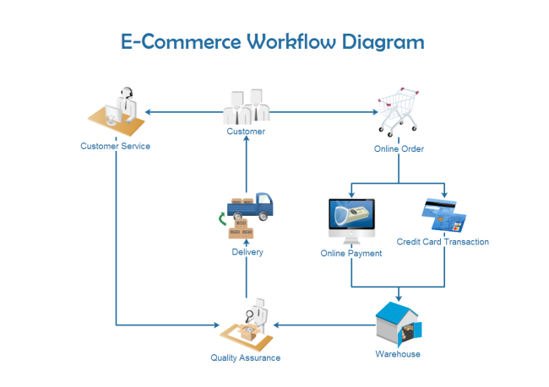

Figure 1: E-Commerce Workflow Diagram

**CHAPTER 2: PROPOSED SYSTEM**

* 1. **PROPOSED SYSTEM**
     + The proposed system helps in building a website to buy, sell products or goods online using internet connection.
     + Enables consumers to shop or do other transactions 24 hours a day, all year round from almost any location.
     + It can be accessed over the Internet.
     + In Proposed System the admin will maintain a wide range of products at affordable prices for customers and it makes easier for those who buy in the application.
     + If a customer leaves the product in the cart without buying and exits the application then the customer will get the mail after particular threshold time.
     + Purchasing of goods online, user can choose different products based on categories, online payments, delivery services and hence covering the disadvantages of the existing system and making the buying easier and helping the vendors to reach wider market.
     + It Provides consumers with more choices.
     + Customer can purchase Products Online.
  2. **OBJECTIVES OF SYSTEM**
     + Online Shopping System helps in buying of goods, products and services online by choosing the listed products from website (E-Commerce site).
     + Ecommerce (Electronic Commerce) is process of doing business through computer networks. The primary goal of an e-commerce site is to sell goods and services online.
     + The Shopping cart is mainly useful for who haven’t time to go to shopping. Shopping cart is a very important feature used in e-commerce to assist people making purchases online.
     + The sale and purchase transaction is completed electronically and interactively in real-time.
     + User can login into ecommerce website, once he logged in then automatically one shopping cart will be created, once user select an item it will add to cart.
     + In case user thinks the selected item is not useful for him, then he can delete that item form the cart.
     + Online shopping is a form of electronic shopping store where the buyer is directly online to the seller’s computer usually via the internet.
     + A person sitting on his chair in front of a computer can access all the facilities of the Internet to buy or sell the products.
  3. **USER REQUIREMENTS**
     + Users should be able to use the system from Internet browser.
     + Visitors new to the site should be able to register by themselves.
     + Users will be differentiated by unique user identifiers.
     + The system should be fast.
     + Redundancy of data must be avoided.
     + Efficiency in data retrieval and management.
     + The online transactions should be done smoothly.
     + Maintaining security of data.
     + User should be able to add products to cart.
     + User should be able to edit their details.
     + Visitors should be able to modify the quantities of items in and/or delete items from their shopping carts before checkout.
     + Large numbers of users should be able to use the simultaneously.
     + The performance of the application should not degrade with an increase in the number of goods or services offered.
     + The users overall experience should be smooth.
  4. **SOFTWARE DEVELOPMENT MODEL (LIFECYCLE MODEL)**

### WORDPRESS METHODOLOGY -

* + - WordPress is a free-and-open-source content management system that is developed by both a core group of lead developers, and a community composed entirely of volunteers.
    - About [one quarter of all the websites on the Internet](http://venturebeat.com/2015/11/08/wordpress-now-powers-25-of-the-web/) have WordPress as their content management system, and for good reason—it combines ease of use that allows it to be applied to even the most basic websites, and plugin-based modularity that allows its functionality to be extended to meet virtually any needs.
    - Its open-source, community-managed nature also ensures that WordPress is constantly up-to-date with security patches and new features.
    - WordPress is particularly useful when building an ecommerce website, because there are plenty of premade themes suited to an online storefront.
    - It also features plugins that add complete ecommerce functionality to a site, from product display to shopping cart and checkout.
    - WordPress is that it’s a flexible platform that offers you complete control over what your website does and how it appears.
    - On top of your storefront, you can also include a blog, a forum, and any other pages you need.

### Steps involved in the process are:

* 1. Choose your domain name and hosting provider.
* The first step in WordPress ecommerce setup starts with your domain name. This will become the address of your future website.
* A domain name is what you enter into the address bar of your browser to access a website.
* While WordPress itself is free, the domain name is provided by FreeHost and the hosting was provided by InfinityFree software.
* The cost is well worth it, as having your own domain name (i.e. yourbusinessname.com) is far more professional-looking than having your name on someone else’s domain (i.e. yourbusinessname.otherdomain.com).
* There must also be a hosting provider, a service that will host your website on the Internet. By having a dedicated hosting provider, you're assured that your website will load quickly and not suffer from extended periods of downtime.
* There is an option of a shared or dedicated host. With a shared host, your website is on the same server as several other websites, which is cheaper, but often provides you with less control over your website as well as potentially smaller storage and bandwidth availability.
* Meanwhile, a dedicated host is more expensive, but gives your website a whole server exclusively for your use, and gives you a wide degree of control, storage, and bandwidth.

#### One-click install

* In the one-click install, you register your domain name and get your WordPress site hosted from the same provider. Wordpress recommends your host supports PHP 7, MySQL v5.6+ or MariaDB v10.0+, and HTTPS.
* One can also use hosting providers trusted by WordPress, which will make installation easier and ensure that your chosen host is supported. WordPress itself recommends [Pressable](https://wordpress.com/start/design-type-with-store), [BlueHost](https://www.bluehost.com/wordpress-hosting" \t "_blank), [Dreamhost](https://www.dreamhost.com/wordpress-hosting/" \t "_blank), [Flywheel](https://getflywheel.com/), and [SiteGround](https://www.siteground.com/wordpress-hosting.htm" \t "_blank).

#### Manual install

* With the manual option, you set up a server manually, then install the WordPress platform on your server, and configure it.
* You’ll need to have an FTP client, a database setup through cPanel or phpMyAdmin, and access to your web server.
* As such, this option is recommended only for advanced users.
* WordPress has [extensive documentation that can walk you through the process.](https://codex.wordpress.org/Installing_WordPress#Step_2:_Create_the_Database_and_a_User)

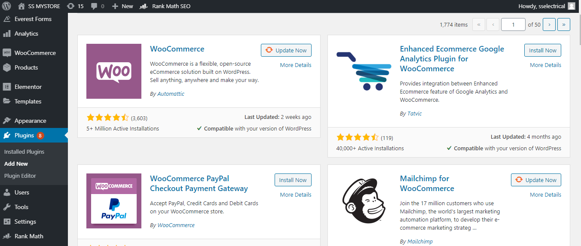

Figure 2: Plugins for WooCommerce

* WordPress ecommerce website from a standard WordPress website will be the means by which you sell products directly from your site.
* There are no native WordPress ecommerce features, so to add this functionality to your website, you’ll need to install an ecommerce plugin.

### WooCommerce

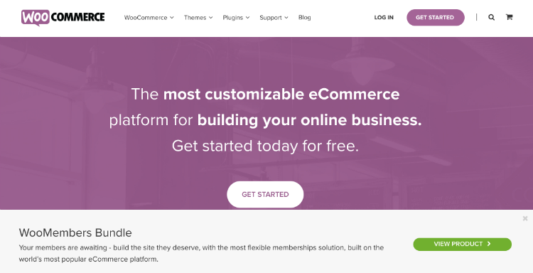

Figure 3: WooCommerce Screen

* Once a mere ecommerce plugin, [WooCommerce](https://woocommerce.com/) has now morphed into a whole platform with its own plugin system since [it was acquired by Automatic two years ago](https://ma.tt/2015/05/woomattic/).
* It's a highly customizable platform that gives you total control over your online store. [About 30% of all online stores use WooCommerce as their platform](https://wordpress.org/plugins/woocommerce/); some local stores that use it are [Beauty Choice](http://beautychoice.com.sg/) and [Green Point Flowers](http://greenpointflowers.com.sg/).
* WooCommerce features a complete ecommerce backend that helps you build and organize product pages, and provides a shopping cart and checkout process.
* It’s free to use, but you can extend its functionality even further with various [paid and free extensions](https://woocommerce.com/product-category/woocommerce-extensions/).
* Extensions can do anything from serving [AI-driven recommendations](https://woocommerce.com/products/recommendation-engine/) to customers on product landing pages, to providing the option for scheduled [group and daily deals](https://codecanyon.net/item/woocommerce-group-daily-deals/9910045) that trigger when a predefined number of people purchase an item.

## Install your ecommerce plugin.

* Once you’ve chosen an ecommerce plugin for your WordPress site, it’s time to install it through your WordPress backend. For convenience’s sake, the following steps assume that you chose the WooCommerce platform:
  + Log in to your WordPress dashboard.
  + On the sidebar, go to the Plugins section and click “Add New”.
  + In the search bar, type “WooCommerce” and hit Enter. Click “Install Now” on WooCommerce by WooThemes.
* If you’re still at the stage where you’re looking for a hosting provider. [Bluehost offers an all-in-one solution](https://www.bluehost.com/wordpress-woocommerce) for WordPress ecommerce setup, which includes a domain name, WordPress with WooCommerce pre-installed, and SSL certification to keep your online store secure.

## Set up the product pages.

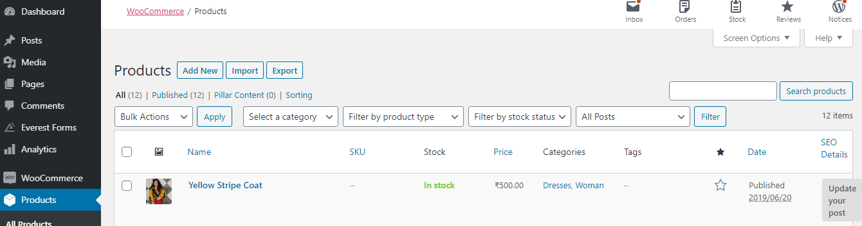

Figure 4: Product Pages

* Every product you add must have the following features:
  + Product name
  + Price
  + Image
  + Brief description
* Begin by entering your WordPress admin panel, then select “Products” on the sidebar and select “Add Product”. WooCommerce allows you to add both physical and virtual products to your store.

### Adding physical products

* Insert the product name where a post title would normally be, and add a description where post content would be. Then, on the right sidebar, add a product image for your product (analogous to a featured image), and then optionally insert more images in the product gallery.
* Next, in the Product Data section, add more details about your product. The first thing to pay attention to is the Product Type drop-down box. The applicable product types for physical products are the following:
  + Simple: A simple product with no SKU options
  + Grouped: Multiple related products, which consist of several related “child” products, each of which is a Simple product
  + Variable: A product with different SKUs, for example, shirts or shoes that have different size options
  + External/Affiliate: Items sold outside of your store
* For now, let’s go with a Simple product.
* You’ll also see “Virtual” and “Downloadable” checkboxes next to the Product Type. Leave these unchecked for physical products.

## Payment and Checkout

* WooCommerce supports a wide variety of other gateways, and adding them is as easy as a trip to the [Payment Gateways section](https://woocommerce.com/product-category/woocommerce-extensions/payment-gateways/) of the WooCommerce Extensions store, from which you can add the gateway of your choice with a single click. Payment gateways come in both free and paid forms.
* To make use of most features of payment gateways, [you’ll need to have an SSL certificate](https://www.constructdigital.com/blog/develop-ecommerce-website-in-singapore-part-2#security). This ensures that all transactions, and thus exchanges of financial information, between you and your customer are safe from the prying eyes of hackers. Getting an SSL certificate can usually be achieved through your hosting provider for a fee.
  + - **The Modules used in the project are:**
  + Admin
  + Customer

**Admin:**

* Admin will login into the application with the default username and password.
* Admin can add and edit the products and product details. He can also view the orders placed by customers and reviews by customers.
* Admin can also view the abandoned cart products and featured products. Admin can also view the payments.

**Customer:**

* The customer can view the application by registering or without registering as a guest user. But the guest user has limited functionalities compared to the registered user.
* Registered customer must log in with the username and password after logging in he can select the products and add them to the cart.
* After the product is selected customer needs to provide some additional details like shipping address after that the payment will be initiated by the customer, after successful payment the customers will get 3 emails listed as Order copy, Delivery Details Copy and Thanks Copy.

**CHAPTER 3: ANALYSIS & DESIGN**

* 1. **USE CASE DIAGRAMS**
     + Use case diagrams are a set of use cases, actors, and their relationships. They represent the use case view of a system.
     + A use case represents a particular functionality of a system.
     + Hence, use case diagram is used to describe the relationships among the functionalities and their internal/external controllers. These controllers are known as actors.
     + Use case diagrams are valuable for visualizing the functional requirements of a system that will translate into design choices and development priorities.
     + They also help identify any internal or external factors that may influence the system and should be taken into consideration.
     + They provide a good high level analysis from outside the system.
     + Use case diagrams specify how the system interacts with actors without worrying about the details of how that functionality is implemented. Symbols used in Use Case diagram.
     + The Notations and symbols are as follows:
       - System
         * Draw your system's boundaries using a rectangle that contains use cases.
         * Place actors outside the system's boundaries.



Figure 5: System

* + - * Use Case
        + Use Cases using ovals.
        + Label the ovals with verbs that represent the system's functions.

Description: Use Case Diagram Notation - Use Case

Figure 6: Use Case

* + - * Actors
        + Actors are the user of a system.
        + When one system is the actor of another system, label the actor system with the actor stereotype.

Description: Use Case Diagram Notation - Actor

Figure 7: Actor

* + - * Communication Link
        + The participation of an actor in a use case is shown by connecting an actor to a use case by a solid link.
        + Actors may be connected to use cases by associations, indicating that the actor and the use case communicate with one another using messages.

Figure 8: Communication Link

* + - * Relationships
        + Illustrate relationships between an actor and a use case with a simple line.
        + For relationships among use cases, use arrows labelled either "uses" or "extends".
        + A "uses" relationship indicates that one use case is needed by another in order to perform a task.
        + An "extends" relationship indicates alternative options under a certain use case.



Figure 9: Relationship

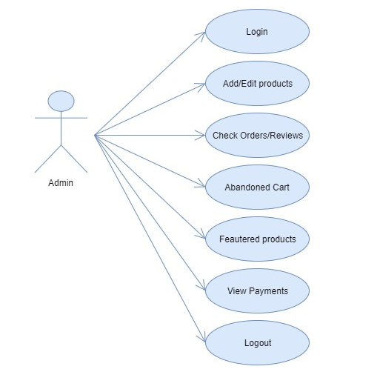

Figure 10: Use Case Diagram for Admin

# https://secureservercdn.net/160.153.137.210/11v.681.myftpupload.com/wp-content/uploads/2018/10/E-Kart-Website-Use-Case-Diagram-for-Customer.png

Figure 11: Use case Diagram for Customer

* 1. **ACTIVITY DIAGRAMS**
     + Activity diagram is another important diagram in UML to describe the dynamic aspects of the system.
     + Activity diagram is basically a flowchart to represent the flow from one activity to another activity.
     + The activity can be described as an operation of the system.
     + The control flow is drawn from one operation to another.
     + This flow can be sequential, branched, or concurrent.
     + Activity diagrams deal with all type of flow control by using different elements such as fork, join, etc.
     + The basic purpose of activity diagrams is similar to other four diagrams.
     + It captures the dynamic behavior of the system.
     + Other four diagrams are used to show the message flow from one object to another but activity diagram is used to show message flow from one activity to another.
     + Activity is a particular operation of the system.
     + Activity diagrams are not only used for visualizing the dynamic nature of a system, but they are also used to construct the executable system by using forward and reverse engineering techniques.
     + The only missing thing in the activity diagram is the message part.
     + It does not show any message flow from one activity to another.
     + Activity diagram is sometimes considered as the flowchart.
     + Although the diagrams look like a flowchart, they are not.
     + It shows different flows such as parallel, branched, concurrent, and single.
     + The purpose of an activity diagram can be described as −
       - Draw the activity flow of a system.
       - Describe the sequence from one activity to another.
       - Describe the parallel, branched and concurrent flow of the system.

ACTIVITY DIAGRAM ADMIN AND CUSTOMER

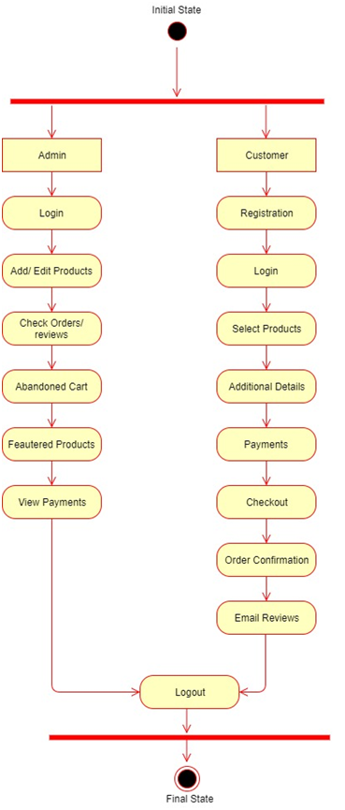

Figure 12: Admin and Customer Activity Diagram

* 1. **SEQUENCE DIAGRAMS**
     + A sequence diagram shows object interactions arranged in time sequence.
     + It depicts the objects and classes involved in the scenario and the sequence of messages exchanged between the objects needed to carry out the functionality of the scenario.
     + Sequence diagrams are typically associated with use case realizations in the Logical View of the system under development.
     + Sequence diagrams are sometimes called event diagrams or event scenarios.
     + A sequence diagram shows, as parallel vertical lines (lifelines), different processes or objects that live simultaneously, and, as horizontal arrows, the messages exchanged between them, in the order in which they occur.
     + This allows the specification of simple runtime scenarios in a graphical manner.
     + If the lifeline is that of an object, it demonstrates a role. Leaving the instance name blank can represent anonymous and unnamed instances.
     + Messages, written with horizontal arrows with the message name written above them, display interaction.
     + Solid arrow heads represent synchronous calls, open arrow heads represent asynchronous messages, and dashed lines represent reply messages.
     + If a caller sends a synchronous message, it must wait until the message is done, such as invoking a subroutine.
     + If a caller sends an asynchronous message, it can continue processing and doesn’t have to wait for a response.
     + Asynchronous calls are present in multithreaded applications, event-driven applications and in message-oriented middleware.
     + Activation boxes, or method-call boxes, are opaque rectangles drawn on top of lifelines to represent that processes are being performed in response to the message (Execution Specifications in UML).
     + Objects calling methods on themselves use messages and add new activation boxes on top of any others to indicate a further level of processing.
     + If an object is destroyed (removed from memory), an X is drawn on bottom of the lifeline, and the dashed line ceases to be drawn below it.
     + It should be the result of a message, either from the object itself, or another.
     + A message sent from outside the diagram can be represented by a message originating from a filled-in circle (found message in UML) or from a border of the sequence diagram (gate in UML).
     + UML has introduced significant improvements to the capabilities of sequence diagrams.
     + Most of these improvements are based on the idea of interaction fragments which represent smaller pieces of an enclosing interaction.
     + Multiple interaction fragments are combined to create a variety of combined fragments, which are then used to model interactions that include parallelism, conditional branches, and optional interactions.

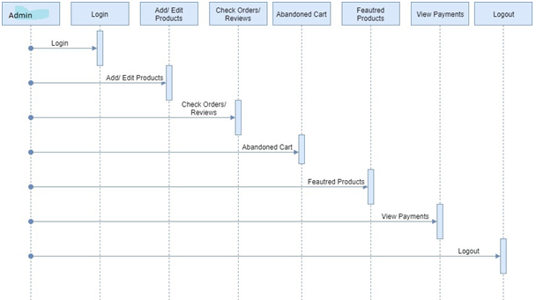

Figure 13: Sequence Diagram for Admin

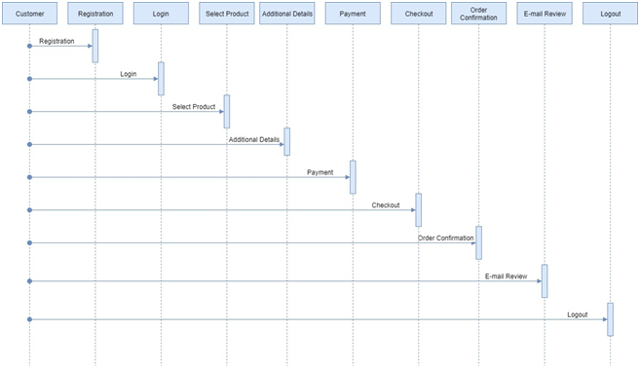

Figure 14: Sequence Diagram for Customer

* 1. **ENTITY RELATIONSHIP DIAGRAM**
     + An entity–relationship model (or ER model) describes interrelated things of interest in a specific domain of knowledge.
     + A basic ER model is composed of entity types (which classify the things of interest) and specifies relationships that can exist between entities (instances of those entity types).
     + In software engineering, an ER model is commonly formed to represent things a business needs to remember in order to perform business processes.
     + Consequently, the ER model becomes an abstract data model that defines a data or information structure which can be implemented in a database, typically a relational database.
     + Entity–relationship modelling was developed for database design by Peter Chen and published in a 1976 paper. However, variants of the idea existed previously.
     + Some ER models show super and subtype entities connected by generalization- specialization relationships, and an ER model can be used also in the specification of domain-specific ontologies.

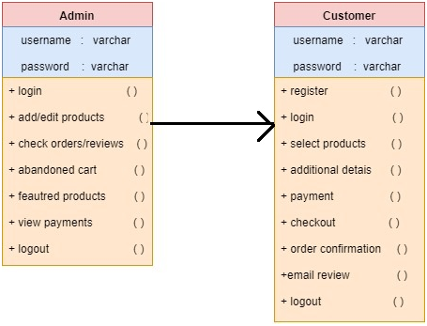

Figure 15: Entity Relationship Diagram

* 1. **SITE MAP DIAGRAM**
     + A site map (or sitemap) is lists of pages of a web site.
     + There are three primary kinds of site map:
       - Site maps used during the planning of a Web site by its designers.
       - Human-visible listings, typically hierarchical, of the pages on a site.
       - Structured listings intended for web crawlers such as search engines.
     + Sitemaps may be addressed to users or to software.
     + Many sites have user-visible sitemaps which present a systematic view, typically hierarchical, of the site.
     + These are intended to help visitors find specific pages, and can also be used by crawlers.
     + Alphabetically organized site maps, sometimes called site indexes, are a different approach.
     + For use by search engines and other crawlers, there is a structured format, the XML Sitemap, which lists the pages in a site, their relative importance, and how often they are updated.
     + This is pointed to from the robots.txt file and is typically called sitemap.xml.
     + The structured format is particularly important for web sites which include pages that are not accessible through links from other pages, but only through the site's search tools or by dynamic construction of URLs in JavaScript or Adobe Flash.
     + They also act as a navigation aid by providing an overview of a site's content at a single glance.

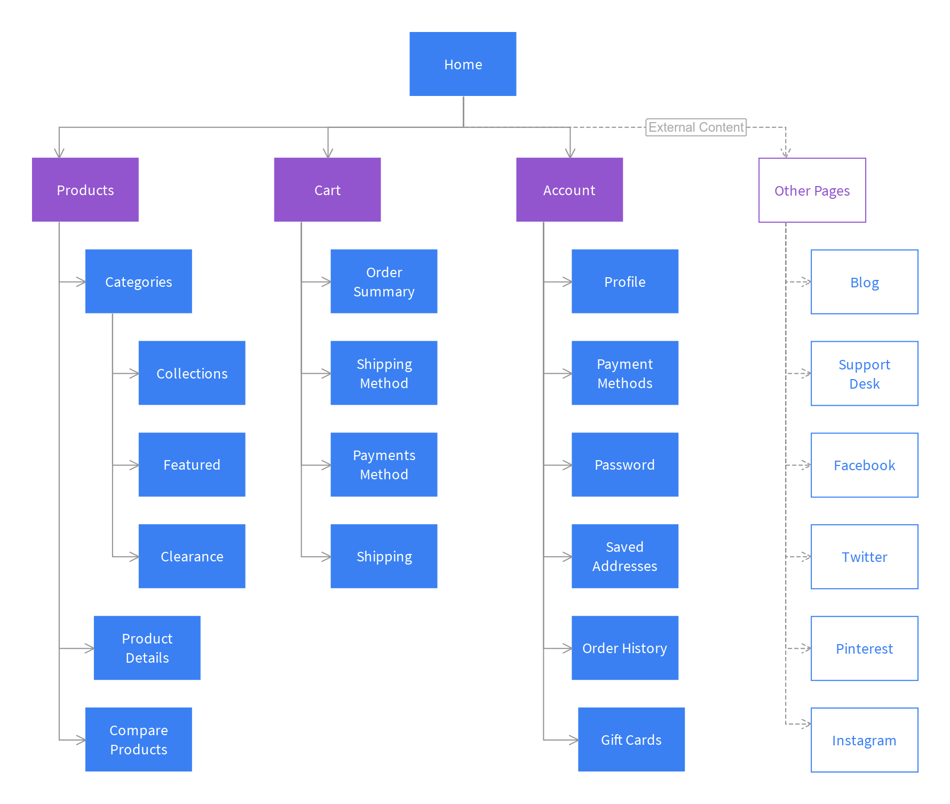

Figure 16: Site Map Diagram

* 1. **USER INTERFACE DESIGN**

FRONT SCREEN

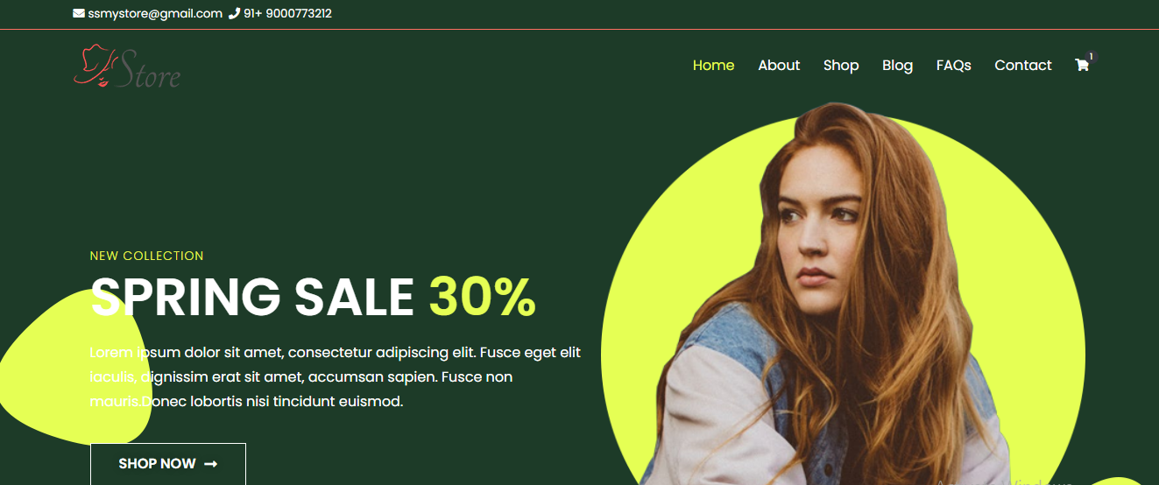



Figure 17: Front Screen

FORMS SCREEN

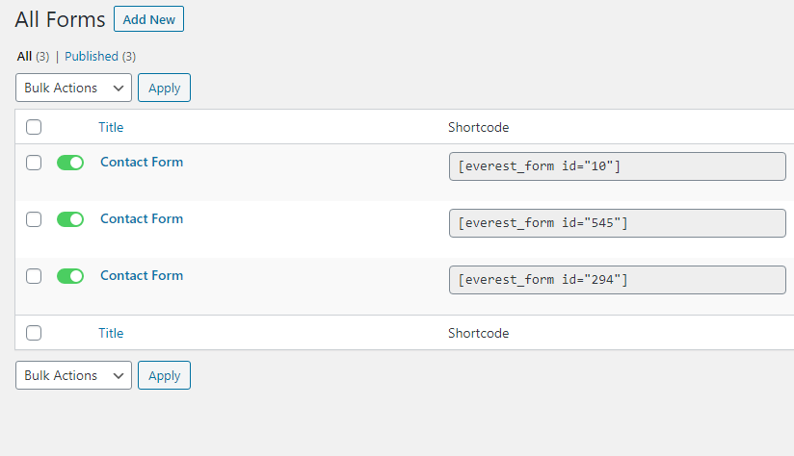

Figure 18: Forms Screen

ANALYTICS SCREEN (Rank Math SEO)

* Rank Math is designed to present the right information to you at the right time.
* The simple, but powerful user-interface highlights important information about your posts alongside the post itself.
* Using this information, you can improve your post's SEO instantaneously.
* Rank Math SEO has Clean, & Simple User Interface.
* **Rank Math practically configures itself. Rank Math features a step-by-step installation and configuration wizard that sets up SEO for WordPress perfectly**.
* Upon installation, Rank Math verifies your site’s settings and recommends the ideal settings for best performance. The step-by-step wizard then sets up your site’s SEO, social profiles, webmaster profiles and other SEO settings.

### Clean, & Simple User Interface

* Get more done in less time with intuitive UI elements
* **Rank Math is designed to present the right information to you at the right time**.
* The simple, but powerful user-interface highlights important information about your posts alongside the post itself. Using this information, you can improve your post’s SEO instantaneously.
* **Rank Math also features advanced snippet previews**.
* One can preview how your post will appear in the SERPs, preview rich snippets, and even preview how your post will look when shared on social media.

### Google Webmaster Central Integration

* Helps you track keyword rankings and Search Engine Errors
* Rank Math presents valuable information from Google Search Console right inside your WordPress admin dashboard.
* **One can see the keywords which you rank for, your sitemap status, and indexing issues**.
* This information is invaluable in maintaining a high-performance website.

### Google Crawl Errors

* Check where Google is facing problems crawling your website
* 404 errors ruin a visitor’s experience. Rank Math’s advanced 404 error monitor finds and lists all pages that throw 404 errors.
* The detailed analytics for both desktop and mobile help you **identify and fix potential 404 errors.**

### Contextual Help (tooltips, notices, help tabs, etc.)

* Makes every option and setting easy-to-understand
* Rank Math has a lot of features. To help understand each feature better, **Rank Math offers helpful and informative tooltips with each section**. These tooltips describe each setting, what it’s used for, and how it should be configured.
* Tooltips also link to related settings when needed. This makes setting up your WordPress site's SEO a breeze.

### Automated Image SEO

* Helps improve your image rankings even further
* Image SEO is a powerful but often overlooked technique to generate traffic.
* **Rank Math puts image SEO on autopilot by automatically adding ALT and Title attributes to all your images**. Rank Math doesn’t even change your posts to achieve this.
* The tags are added on the fly when the post is viewed by the user.

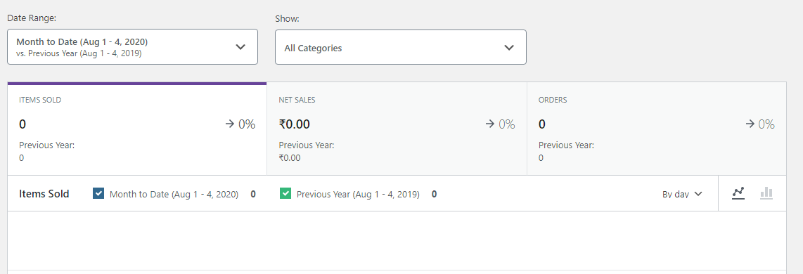

Figure 19: Analytics Screen

ELEMENTOR

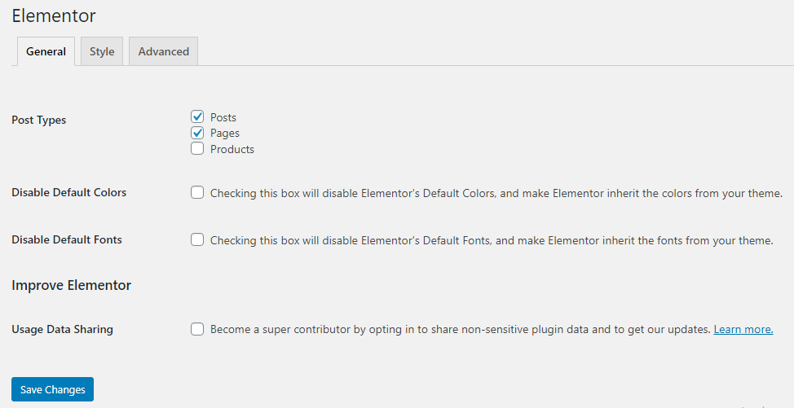

Figure 20: Elementor

WordPress Files Screen

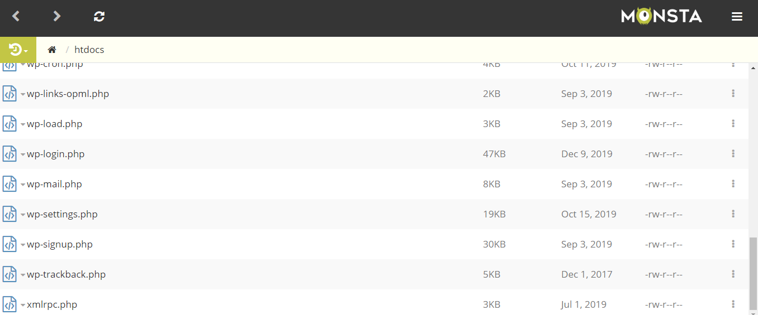

Figure 21: WordPress Files Screen

Database Screen

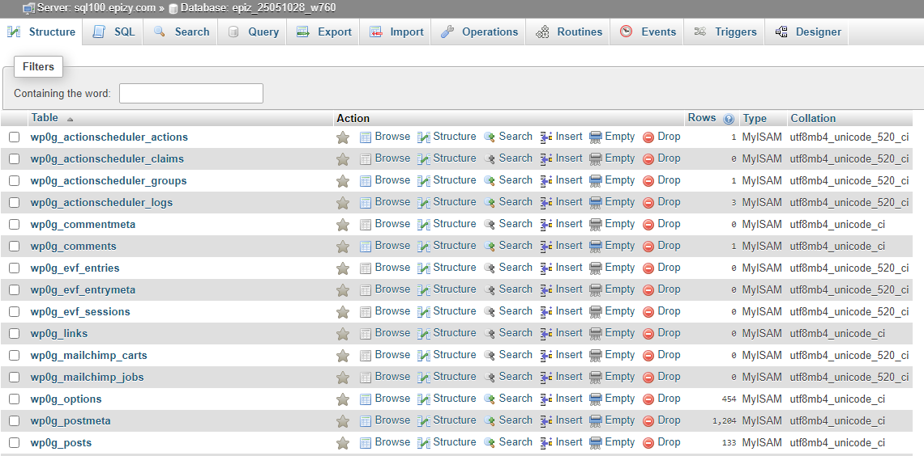

Figure 22: Database Screen

* 1. **TEST PLANS AND TEST CASES**
     + A test plan is a document detailing the objectives, target market, internal beta team, and processes for a specific beta test for a software or hardware product.
     + The plan typically contains a detailed understanding of the eventual workflow.
     + A test plan documents the strategy that will be used to verify and ensure that a product or system meets its design specifications and other requirements.
     + A test plan is usually prepared by or with significant input from test engineers.
     + The input for the test plan is:
       - Project Plan
       - Requirement Document
       - System Design Document
     + The requirement documents and the design document are the basic documents used for selecting the test unit and the deciding the approaches to be used during testing.
     + A test plan should contain following:

1. Test Unit Specification
2. Features to be tested
3. Approach for testing

### Test Case 1: Logging into the system/Logging out of the system:

|  |  |
| --- | --- |
| **Input** | 1. Enter User name and password. 2. Enter the invalid user name and password 3. Click on the ‘logout’ Button. |
| **Result** | 1. Login successful with User name and Password. 2. Error message ‘Invalid User name and password’ displayed. 3. Successful logout of the system. |
| **Condition** | You should have registered with valid User  name and password to logon to the system. |

Table 1: Login and Logout Test Case

### Test Case 2: Add Details on Cart:

|  |  |
| --- | --- |
| **Input** | 1. Click on ‘Add to Cart’ button. 2. Fill in the details. 3. Click on ‘Submit’ button. |
| **Result** | 1. It has displayed the Shipping Details. 2. Validations will be performed. 3. Successfully added the details. |
| **Condition** | Customers can only add the details. |

Table 4: Add Details on Cart

# CHAPTER 4: SCREEN SHOTS

## SCREEN SHOTS

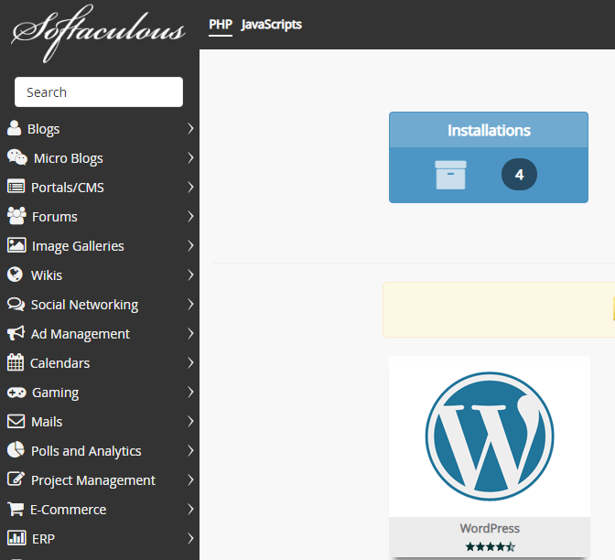

Figure 23: Softaculous Screen

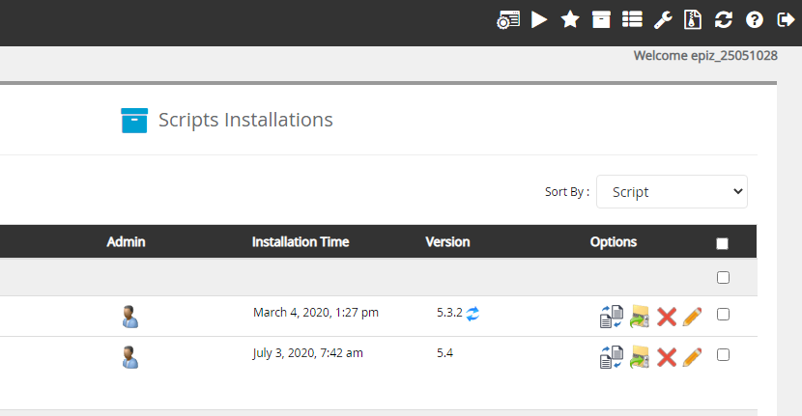

Figure 24: Installation Screen

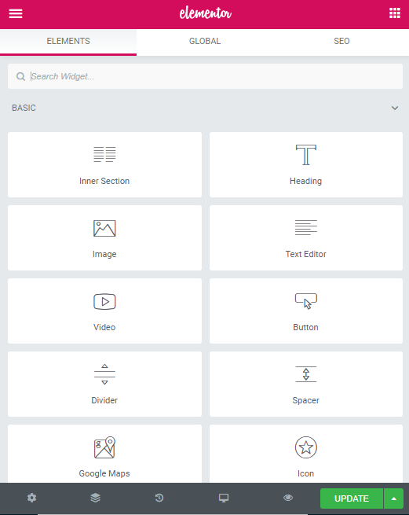

Figure 25: Elementor Editor

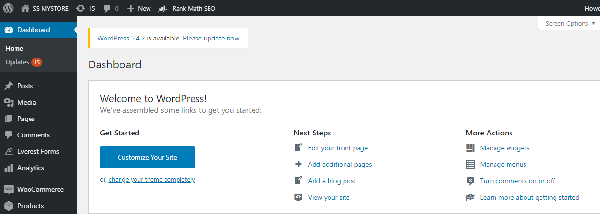

Fig 26: WordPress Dashboard

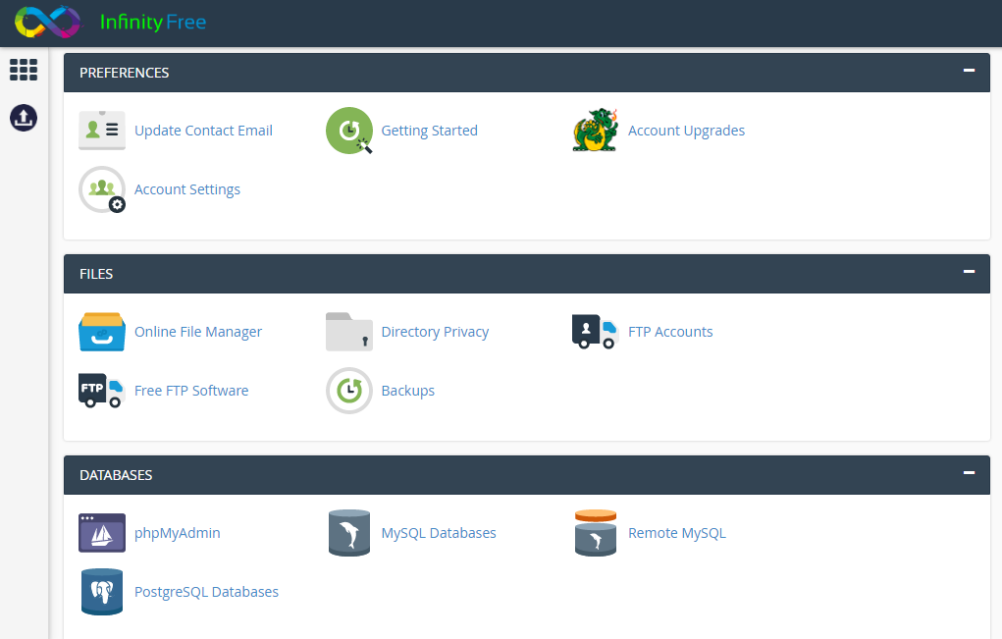

Figure 27: Hosting C-Panel

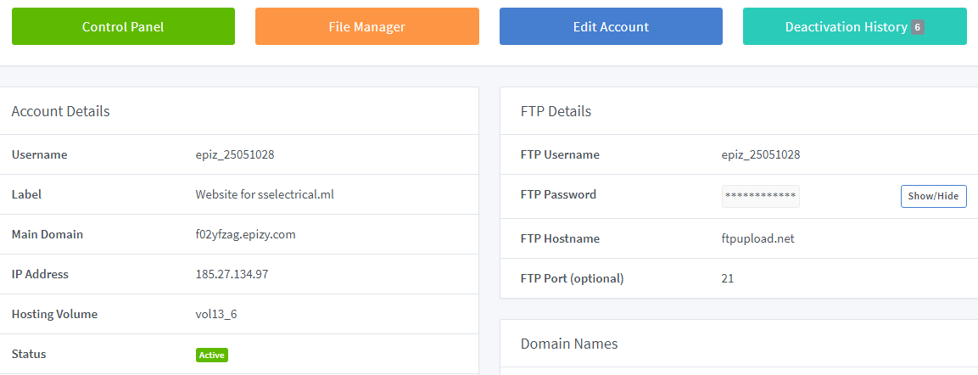

Figure 28: InfinityFree Main Page

**DRAWBACKS AND LIMITATIONS**

* + - Security. The biggest drawback of e-commerce is the issue of security.
    - Lack of privacy. Many websites do not have high encryption for secure online transaction or to protect online identity. ...
    - Tax issue can be a major concern for people.
    - People fear to operate in a paperless and faceless electronic world. Some of the business organizations do not have physical existence.
    - Product suitability can be a concern because people have to rely on electronic images.
    - Cultural obstacles differences in culture create obstacles to both the business and the consumers.

**PROPOSED ENHANCEMENTS**

* + - The proposed system helps in building a website to buy, sell products or goods online using internet connection with high security
    - Make Search Easy and Reliable
    - Build security verification programs like the one from VeriSign which is now powered by Symantec.
    - The Power of Images in ecommerce websites that allows people to zoom in photos using a small quadrant providing a calculator at the right side of the page where they can calculate the final price before adding products to their carts.
    - Streamlined can be done while checking out the products.
    - An instant chat option to your site and have a sales rep get in touch with the visitor as soon as they arrive on your site.

**CONCLUSION**

* + - E-Commerce is not just about conducting business transactions via the Internet. Its impact will be far-reaching, and more prominent then we know currently.
    - Since more businesses are being held online resulting in high economy development and emergence of a more innovative and advanced technology.
    - E-commerce is continuously progressing and is becoming more and more important to businesses as technology continues to advance and is something that should be taken advantage of and implemented.
    - From the inception of the Internet and e-commerce, the possibilities have become endless for both businesses and consumers. Creating more opportunities for profit and advancements for businesses, while creating more options for consumers.
    - However, just like anything else, e-commerce has its disadvantages including consumer uncertainties, but nothing that cannot be resolved or avoided by good decision-making and business practices.
    - There are several factors and variables that need to be considered and decided upon when starting an e-commerce business. Some of these include: types of e-commerce, marketing strategies, and countless more. If the correct methods and practices are followed, a business will prosper in an e-commerce setting with much success and profitability.

**BIBLIOGRAPHY**

<https://protrex.in/>

<https://www.guru99.com/>

<https://www.wikipedia.org/>

<https://app.infinityfree.net/accounts>

<https://www.google.com/>

<https://www.freenom.com/>

<https://www.freenom.com/>en/index.html?lang=en