
September 18, 2026

CIS 285 – Software Engineering Tools
Project Report by Jinuka Gunasekara
Simple Software Development
Project Plan
- Project Schedule
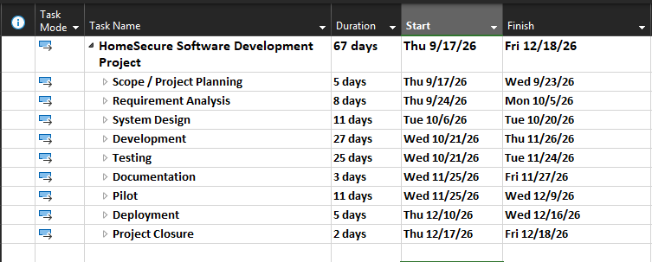
The above chart is the main scheduling view used for the HomeSecure project. It shows each task, its duration, start and finish dates, and the timeline.
The project begins on September 17, 2026, and finishes on December 18, 2026.
Task Purpose:
Task | Purpose
Scope / Project Planning | Defines the project scope, stakeholders, and initial project resources.
Requirement Analysis | Identifies functional, security, device, web/mobile, and third-party integration requirements.
System Design | Creates the architecture, database, APIs, interfaces, and security design.
Development | Builds the backend, web application, mobile application, smart-device integrations, and automation features.
Testing | Covers unit, integration, application, device, security, performance, notification, acceptance, and regression testing.
Documentation | Produces technical, user, installation, and security documentation.
Pilot | Deploys the system to pilot users, gathers feedback, and resolves pilot issues.
Deployment | Deploys the production environment, backend/cloud services, web application, and mobile applications.
Project Closure | Performs the final review, records lessons learned, and closes the project.

2. Resource Sheet
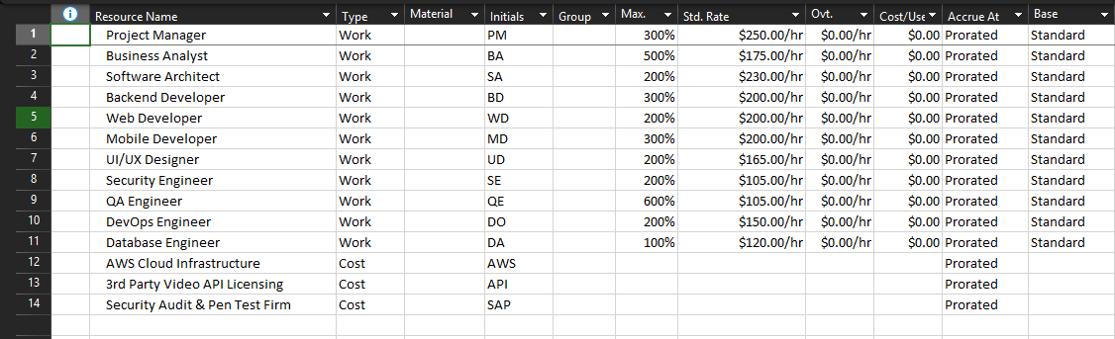
The Resource Sheet identifies the people and external cost resources used by the project. Work resources include the Project Manager, Business Analyst, Software Architect, developers, UI/UX Designer, Security Engineer, QA Engineer, DevOps Engineer, and Database Engineer. Max Units were set to represent the number of people available for roles that require multiple team members. This view is useful for checking availability, hourly rates, and resource overallocations.
The project also uses cost resources for AWS Cloud Infrastructure, third-party video API licensing, and an external security audit and penetration-testing firm. These costs are assigned to the related project tasks rather than entered as hourly rates.
3. Task Usage View
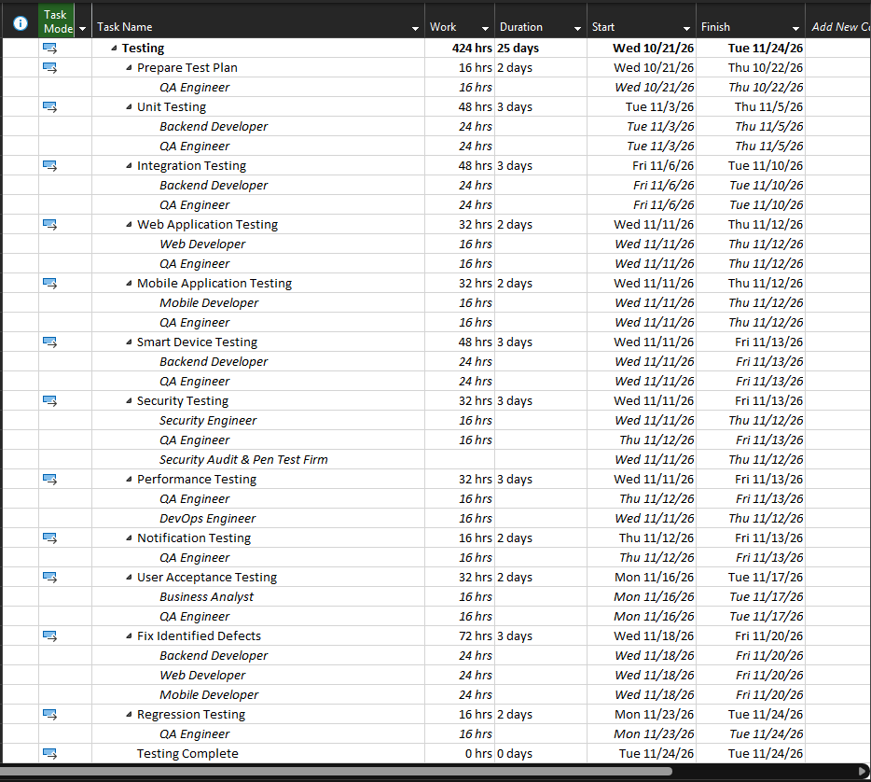
The Task Usage view shows how resources are assigned to individual tasks and how work is distributed over time. For HomeSecure, the Security Testing task is a useful example because it involves QA and security resources as well as the external security audit cost. This view helps the project manager understand who is working on a task and identify workload or allocation problems.
4. Calendar View
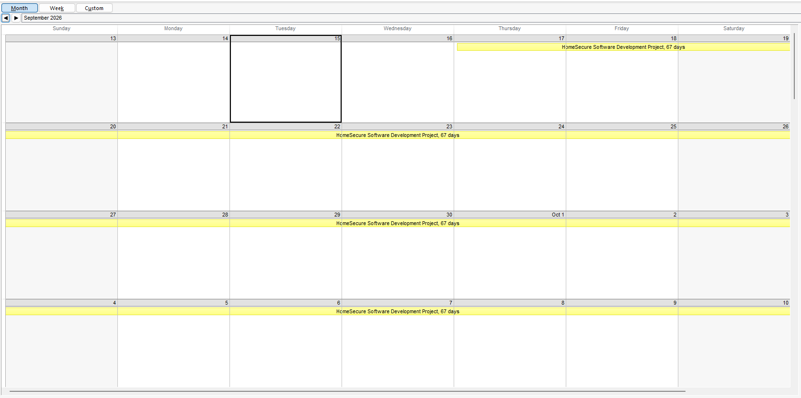
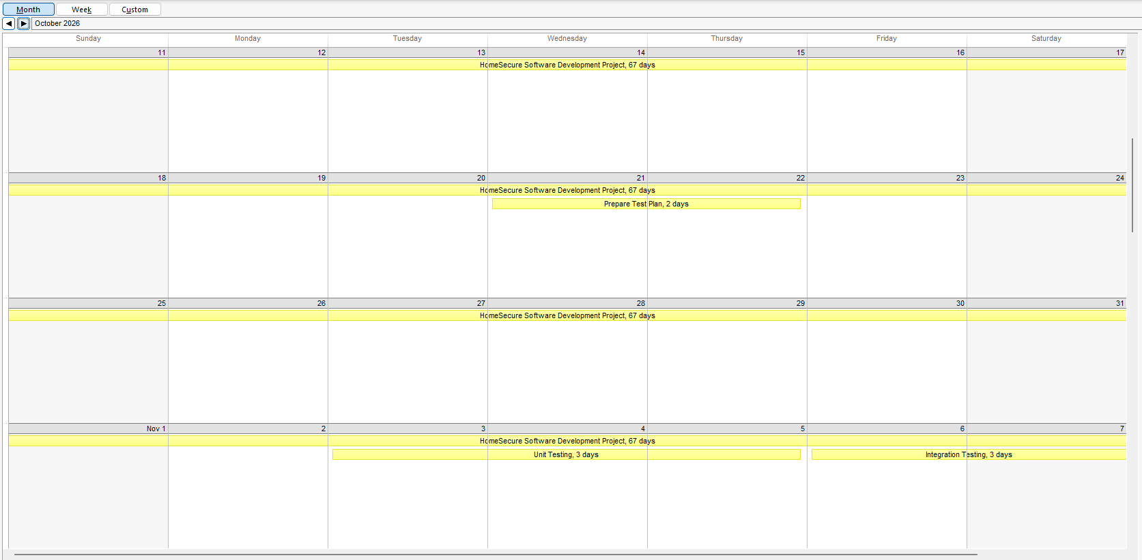
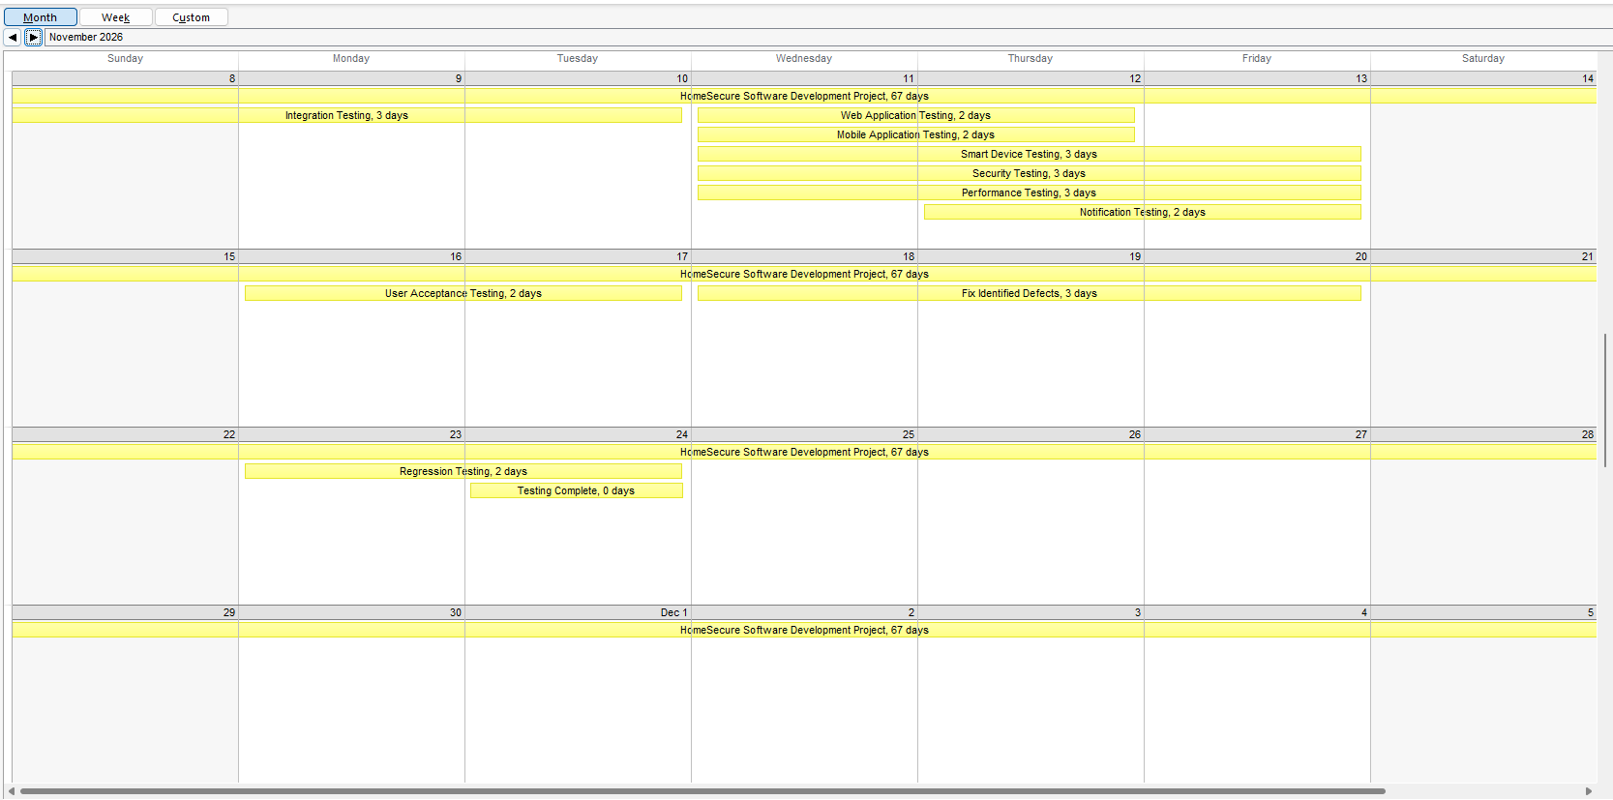
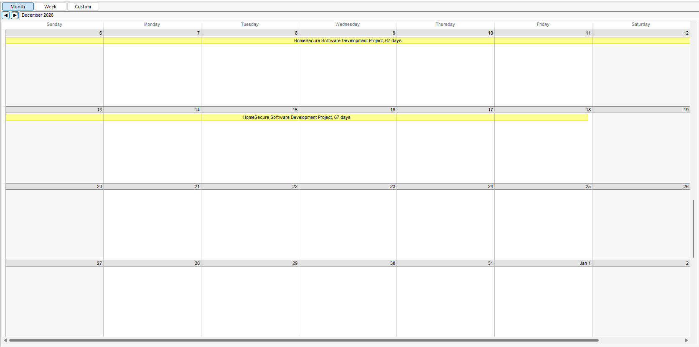
The Calendar view presents project activities according to their scheduled dates. It provides a simple month-by-month view of when work takes place and makes it easier to see how the project progresses from planning in September through development, testing, pilot work, deployment, and completion in December.

5. Network Diagram and Critical Path
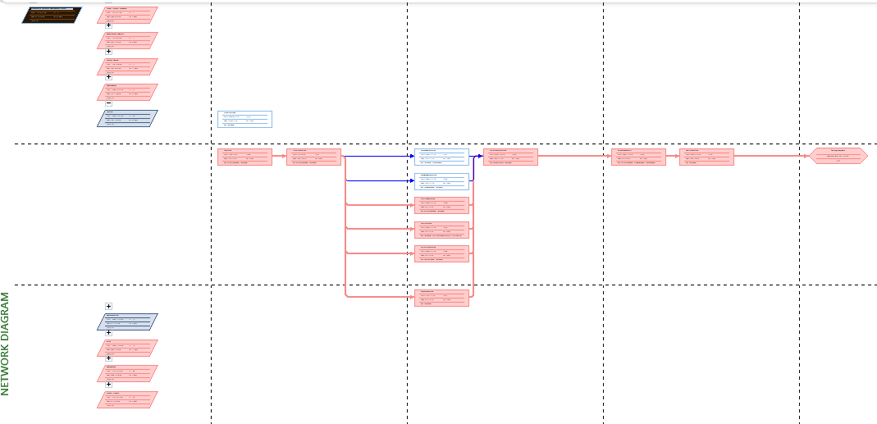
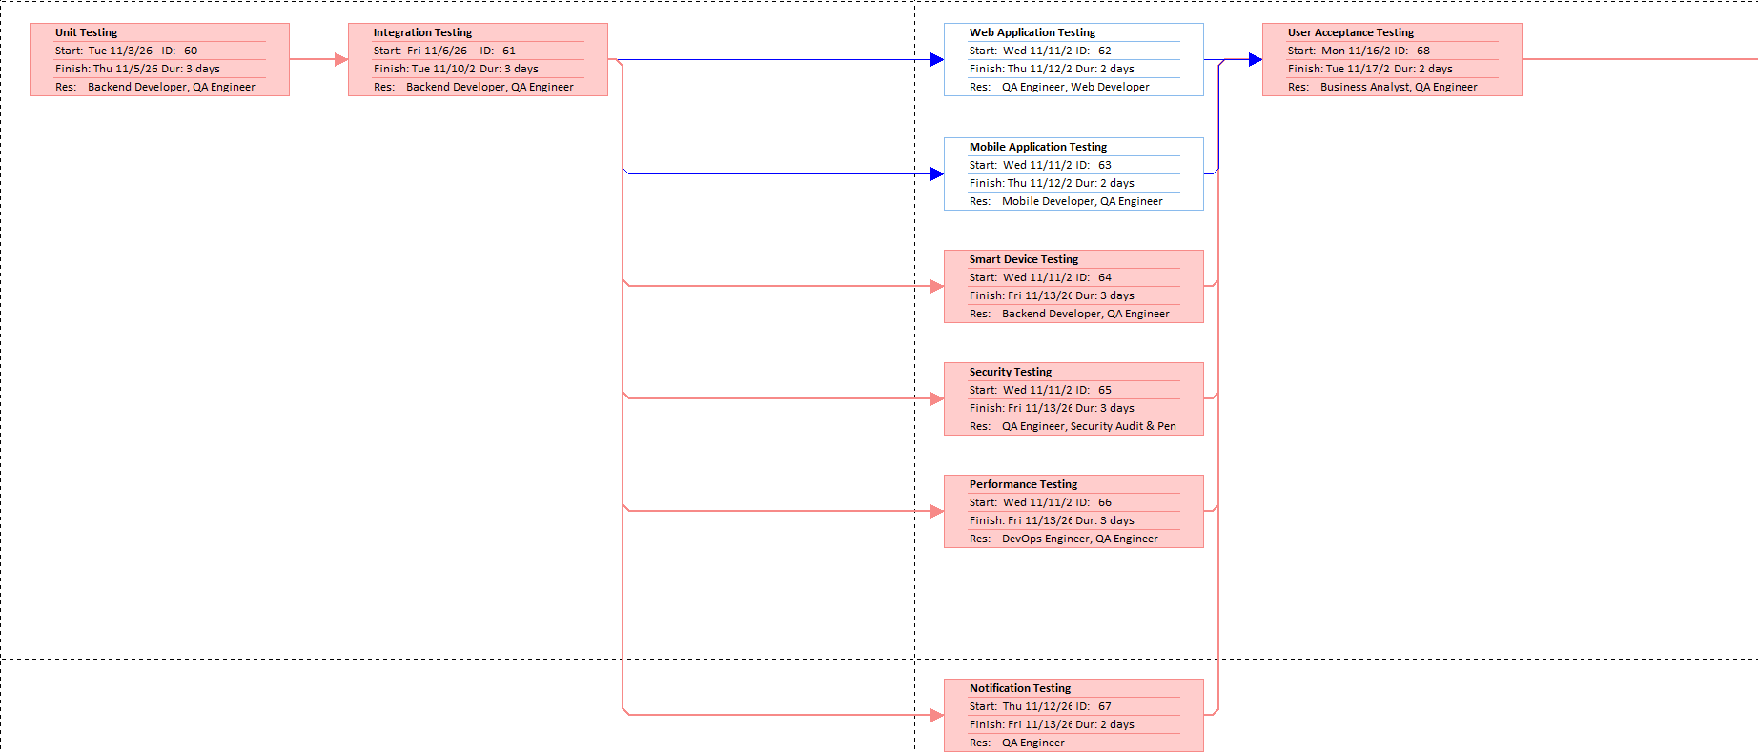
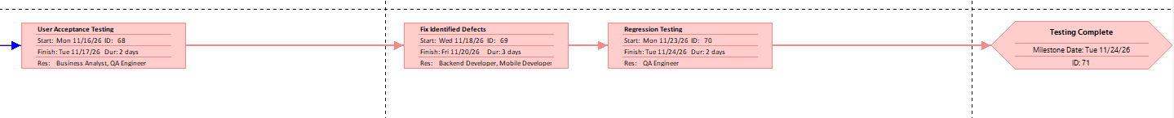
The Network Diagram displays the logical relationships between project activities. Each task is represented as a node, while connecting lines show predecessor and successor relationships. This view is useful for checking whether the project workflow is logically connected from planning through completion.
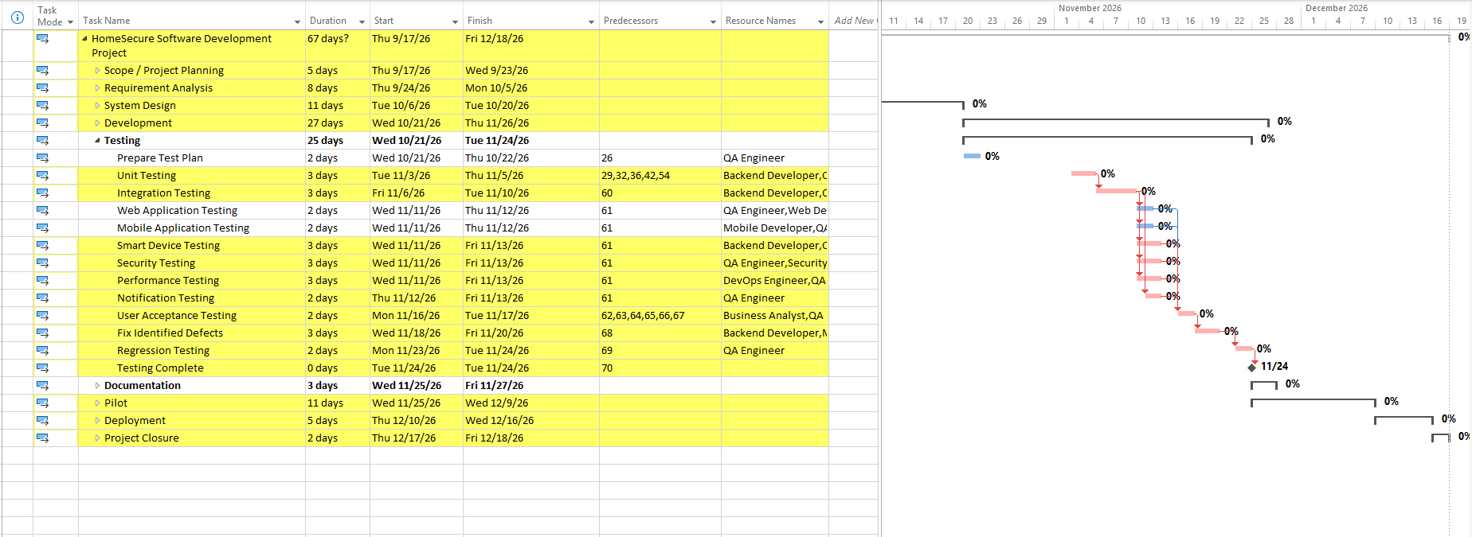
The critical path is the sequence of scheduled tasks that determines the project finish date. Critical tasks have little or no scheduling flexibility; therefore, a delay in one of these tasks can delay the final completion date. For this report, the exact critical tasks should be identified from Microsoft Project's Critical Tasks display because Microsoft Project calculates the critical path from the final task durations and dependencies.
6. Project Budget and Cost
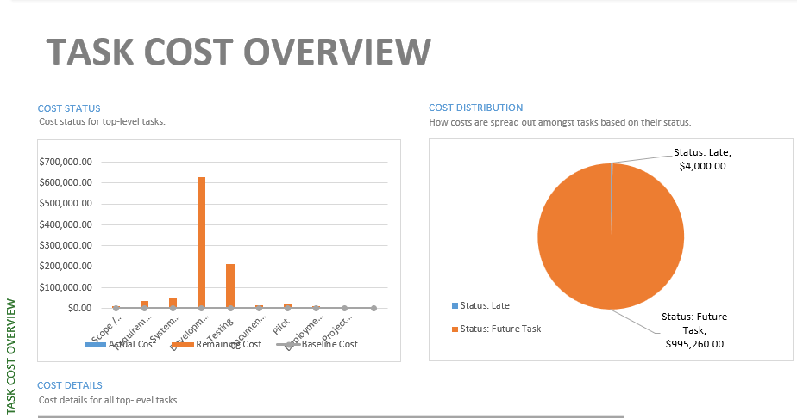
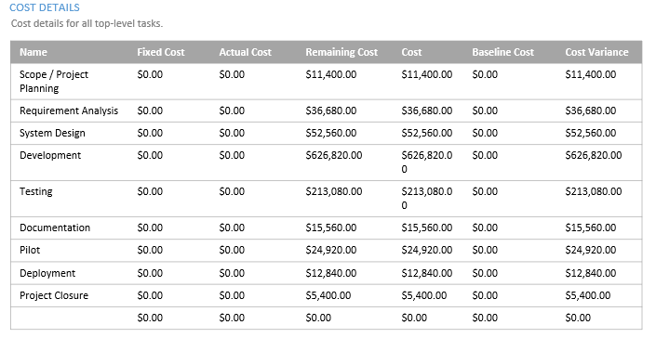
The assignment provides a total project budget of $1,000,000. Microsoft Project calculates labor cost from resource assignments, work, and hourly rates. Additional project expenses were represented with cost resources for cloud infrastructure, video API licensing, and external security testing. The completed Microsoft Project plan has a planned cost of approximately $999,260, keeping the project within the $1,000,000 budget.
7. Project Reports
7.1 Project Overview:
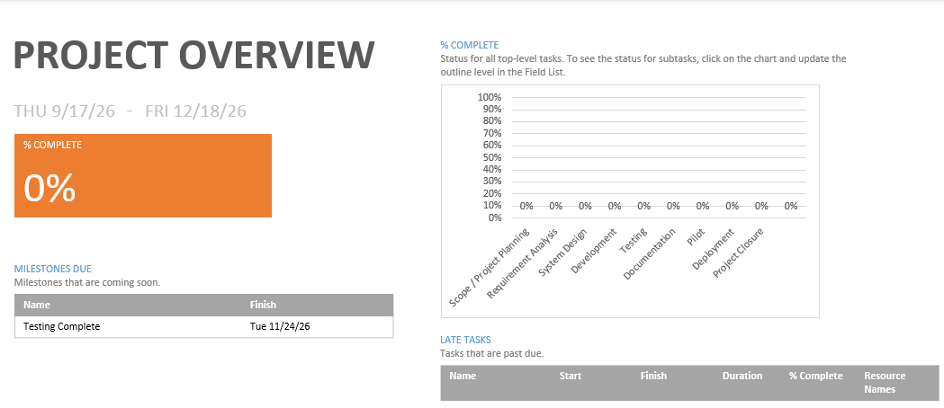
The Project Overview report summarizes the overall condition and progress of the project. It provides a high-level view of important schedule information and is useful for communicating project status.
7.2 Resource Overview:
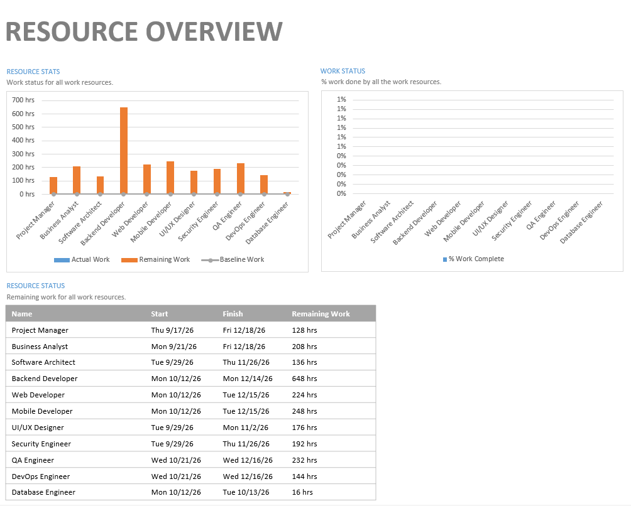
The Resource Overview report summarizes how project resources are being used. It helps identify the amount of work assigned to the project team and supports resource-management decisions.

7.3 Critical Tasks Overview:
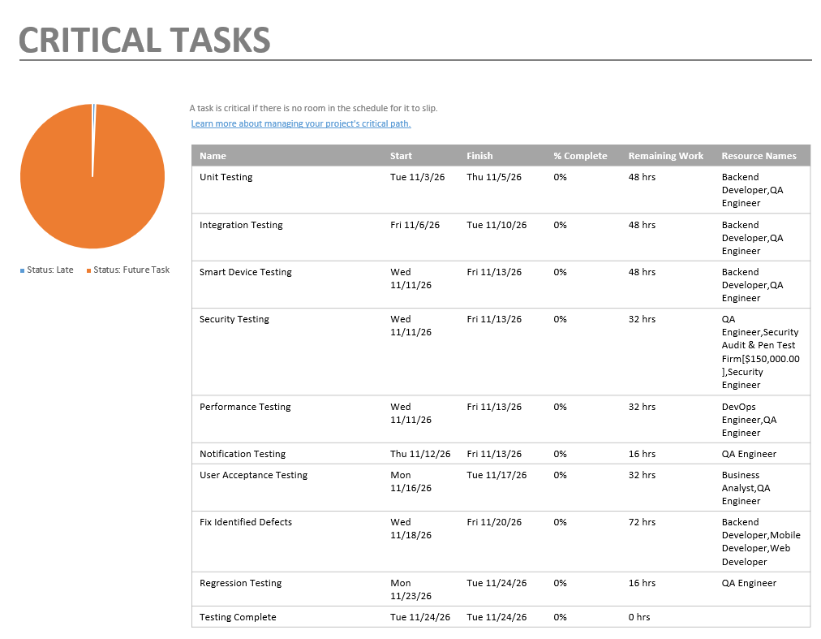
The Critical Tasks report focuses on activities that directly influence the project completion date. It helps the project manager identify tasks that require close schedule monitoring.

7.4 Work Overview:
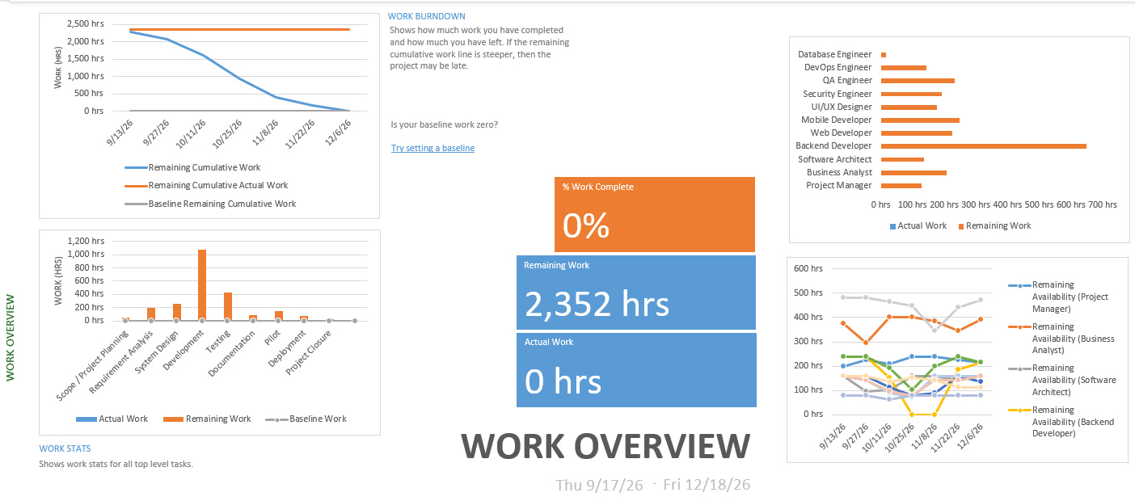
The Work Overview report summarizes the amount of work planned for the HomeSecure project and shows how that work is distributed among project resources. It is useful for reviewing overall workload, comparing resource assignments, and identifying how team effort is being used throughout the project

