Spring Roo – A Quick App Development

# Introduction

Spring Roo is a framework of Spring framework that enables quick app development.

There are 2 modes the application may be developed

* Auto generate from database structure
* Generate from spring roo cli

# Requirements

JDK 1.7 minimum

Oracle database

Maven

Following sections perform the steps to develop the application using Oracle as the database

# Auto Generate from database structure

This needs older version of spring roo – v 1.3

1. Download the spring roo v1.3 and add the roo.sh / roo.bat to the path

<http://spring-roo-repository.springsource.org/>

1. Determine the version of the Oracle database to determine the version of the ojdbc driver you need.
2. Oracle integration is not out of the box. It needs the osgi ojdbc jar to be installed. Following links have helped to use roo to osgify the ojdbc jar. Add this osgi jar to the bundle.

<http://rns-techtock.blogspot.com/2012/08/oracle-database-reverse-engineering.html>

<https://kerrywilson.dev/post/2012/01-29-spring-roo-reverse-engineer/>

<https://nidget.wordpress.com/2011/07/21/how-to-osgify-an-oracle-jdbc-driver-with-spring-roo/>

1. Create a new directory for your project and cd into it
2. Go to the spring roo cli using roo.sh / roo.bat
3. Create a project in roo

roo> project --topLevelPackage com.jin.rooapp13

Created ROOT/pom.xml

Created SRC_MAIN_RESOURCES

Created SRC_MAIN_RESOURCES/log4j.properties

Created SPRING_CONFIG_ROOT

Created SPRING_CONFIG_ROOT/applicationContext.xml

1. Ensure that the ojdbc bundle is active and available

roo> osgi ps

START LEVEL 99

ID|State |Level|Name

0|Active | 0|System Bundle (4.4.1)

1|Active | 1|file:/Users/deeptivijay/Documents/_MyLearning_/springroo/spring-roo-1.3.2.RELEASE/bundle/ST4-4.0.8.jar (0.0.0)

2|Active | 1|file:/Users/deeptivijay/Documents/_MyLearning_/springroo/spring-roo-1.3.2.RELEASE/bundle/animal-sniffer-annotations-1.9.jar (0.0.0)

3|Active | 1|antlr-java-parser (1.0.15)

4|Active | 1|file:/Users/deeptivijay/Documents/_MyLearning_/springroo/spring-roo-1.3.2.RELEASE/bundle/antlr-runtime-3.5.2.jar (0.0.0)

…

85|Active | 1|Spring User Agent Analysis - Client (1.0.2.RELEASE)

116|Active | 1|com-oracle-convert-osgi (12.1.0.2_0001)

roo>

1. Create the JPA layer for Oracle using hibernate

roo> jpa setup --database ORACLE --provider HIBERNATE

Created SPRING_CONFIG_ROOT/database.properties

The ORACLE JDBC driver is not available in public Maven repositories. Please adjust the pom.xml dependency to suit your needs

Updated SPRING_CONFIG_ROOT/applicationContext.xml

Created SRC_MAIN_RESOURCES/META-INF/persistence.xml

Updated ROOT/pom.xml [added dependencies com.oracle:ojdbc14:10.2.0.5, org.hibernate:hibernate-core:4.3.6.Final, org.hibernate:hibernate-entitymanager:4.3.6.Final, org.hibernate.javax.persistence:hibernate-jpa-2.1-api:1.0.0.Final, commons-collections:commons-collections:3.2.1, org.hibernate:hibernate-validator:4.3.2.Final, javax.validation:validation-api:1.0.0.GA, javax.transaction:jta:1.1, org.springframework:spring-jdbc:${spring.version}, org.springframework:spring-orm:${spring.version}, commons-pool:commons-pool:1.5.6, commons-dbcp:commons-dbcp:1.4]

roo>

1. Edit the pom.xml for the correct ojdbc jar
2. Edit the database.properties with correct database credentials
3. Run the following command to verify the xml generated by connecting to the database

roo> database introspect --schema foodie

1. Run the following command to generate the database

roo> database reverse engineer --schema foodie

1. Configure the application with a web presentation layer

roo> web mvc setup

1. Generate the controllers for all the entities created

roo> web mvc all --package ~.web

The previous command implements the controllers and view artifacts for all the data access operations (i.e. create, show, list, update and delete), and for all the entities in the persistence layer.

1. Run the application

roo> perform command --mavenCommand tomcat7:run

OR

$ mvn tomcat7:run

# Application view

<http://localhost:8080/rooapp13/>

## Homepage

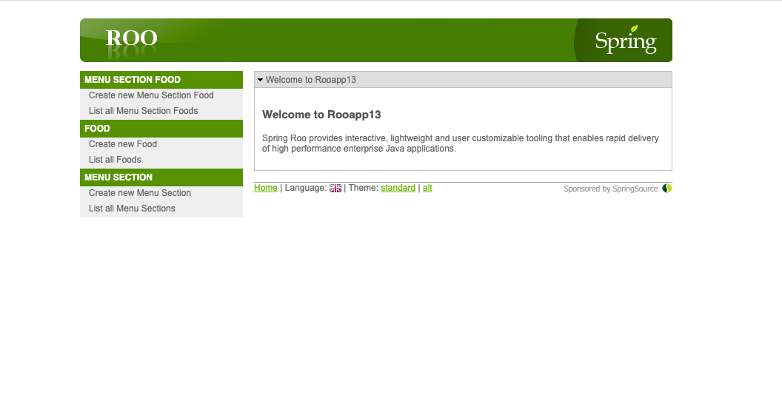

## Create Food

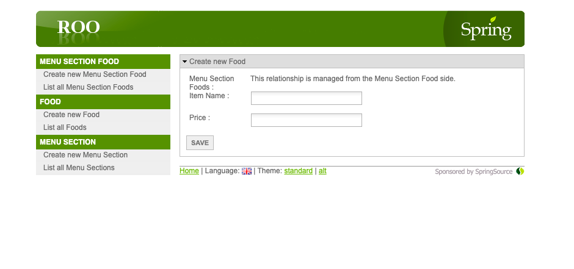

## List Food

