Surface Wave Measurement Based on Cross-correlation
Ge Jin and James Gaherty

1.0 Introduction
Seismic surface waves represent one of the primary means for scientists to probe the structure of Earth’s crust and upper mantle. Surface waves provide direct constraints on both absolute velocity and relative velocity variations, and analysis of waves with different periods provides sensitivity to different depths. These velocity variations in turn provide some of the best available constraints on a variety of geodynamic parameters, including absolute and relative variations in temperature (ref), crust and mantle composition, the presence or absence of fluid (melt) phases, and the distribution and orientation of flow-induced mineral fabric. In many cases, however, resolution of these properties is limited by uncertainties in observed surface-wave velocities due to complexity in the seismic wavefield. Because they sample the highly heterogeneous outer shell of the Earth, surface waves often contain waveform complexity caused by focusing and defocusing (often termed scattering or multipathing) that makes measurement of wave velocity uncertain (Figure 1). (Figure 1 is a set of observed seismograms across USArray, showing substantial scattering for some waveforms)
In recent years, a number of investigators have developed data analysis schemes designed to more robustly estimate surface-wave velocities in the presence of multipathing (Friedrich and Wielandt, 1995; Forsyth and Li, 2005; Yang and Forsyth, 2005; Lin et al., 2009; Lin and Ritzwoller, 2011; Yang et al., 2011). These techniques exploit arrays of seismic stations to better quantify the detailed character of the surface wavefield, specifically by combining measurements of both phase and amplitude between stations. These observations can be modeled in the context of wavefield character, for example local plane-wave propagation direction (e.g. Forsyth and Li, 2005) or apparent velocities (Lin et al., 2009), as well as the structural phase and/or group velocity or delay times associated with the underlying media. The techniques are particularly useful for estimating structural velocities in localized regions spanning a receiver array, as opposed to along the entire path from the source to the receiver employed in global (e.g. Levshin et al., 1992; Li and Romanowicz, 1995; Ekström et al., 1997) and some regional (e.g. Chen et al., 200x; Tape et al., 2010) analyses. The estimates of structural phase or group velocities across the array can then be inverted for models of seismic velocity through the crust and mantle beneath the array, with greater confidence and and accuracy than when using phase information alone (e.g. Yang et al., 2011; Rau and Forsyth, 200x; Lin et al., 2011).
We have developed a new algorithm to accurately estimate structural phase velocities from broadband recordings of surface waves propagating across an array of receivers. The analysis is based on the notion that waveform cross-correlation provides a highly precise and robust quantification of relative phase and amplitude between two observed waveforms, if the waveforms are similar in character. This notion is routinely exploited in body-wave analyses for structure (e.g. van Decar and Crosson, 199x) and source (e.g. Schaff and Beroza, 200x) characteristics, but it is not widely utilized in surface-wave analysis. Our approach builds upon the Generalized Seismological Data Functional (GSDF) analysis of Gee and Jordan (1991), which utilizes cross-correlation between observed and synthetic seismograms to quantify phase and amplitude behavior of any general seismic waveform, including surface waves (Gaherty and Jordan, 1995; Gaherty et al., 1996; Gaherty, 2004; Chen et al., 200x, 200x). By applying this quantification to cross-correlation functions between surface waves observed at two nearby stations, we generate highly robust and precise estimates of relative phase between the stations, due to the similar nature of the recorded waveforms. The procedure is applicable to arrays across a variety of scales, from the continental scale of EarthScope’s USArray Transportable Array (TA), to the few 100’s km spanned by a typical PASSCAL experiment, to 100’s of meters in industry experiments, and is amenable to automated analyses with minimal analyst interaction. The resulting delay times and associated amplitudes can be modeled in the context of both wave-propagation and structural velocities. Here we outline the analysis, and demonstrate it’s application to the TA.

2.0 Methodology
2.1 Inter-station phase delays
The methodology is based on the GSDF work flow presented by , and subsequently utilized for regional upper-mantle and crustal modeling [e.g. Gaherty and Jordan, 1995; Gaherty et al, 1996; Gaherty, 2001, 2004; Chen et al., 200x; Gaherty and Dunn, 2007]. In those analyses, the starting point consists of an observed broadband seismogram containing all seismic phases of interest, and a complete synthetic seismogram relative to which the phase delays and amplitude anomalies can be measured. Here, we substitute a seismogram from a nearby station for the synthetic waveform, and measure phase and amplitude differences between phases of interest recorded at the two stations. Waveforms from these two stations are presented as ,𝑆-1.(𝑡) and ,𝑆-2.(𝑡) here (Figure 2). Because this is the first application of GSDF to an interstation analysis, we summarize the steps in some detail. Gee and Jordan (1992) provides a full theoretical presentation of GSDF. (Figure 2 is 3 seismograms, the two original ones, and then one windowed)
The first step is to isolate the signal that we are interested in time domain. In the USArray application, we applied a window ,𝑊-𝑆. on ,𝑆-2.(𝑡) that includes the primary surface wave (Rayleigh on vertical-component record, and Love on the transverse component) and most of its coda. Including the coda is useful, in that it is often highly correlated at stations within 1-2 wavelengths, as shown in Figure 2. We then calculate the cross-correlation function Ct (cross-correlagram) between ,𝑆-1. and ,,𝑊-𝑆.𝑆-2, defined as:
𝐶,𝑡.=,𝑆-1.⋆,𝑊-𝑆.,𝑆-2.
(Figure 3, which shows broadband crosscorrelation and windowed correlation together, then narrow band cc with Gaussian fits, then dtp as a function of frequency). 𝐶,𝑡. contains the delay or lag information of all coherent signals within the window that we applied on ,𝑆-2, with the peak corresponding roughly to a wide-band group delay between the two stations, with a center frequency defined by the dominant energy in the data, typically around 30 mHz for teleseismic Rayleigh waves. We further isolate the dominant energy in the cross-correlation function in the time domain by applying a Hanning window around the peak of the cross-correlation function, producing WCt. The window function we applied here has a length of 200s.
We then isolate the signals of interest in the frequency domain by convolving a sequence of n Gaussian, narrow-band filters to WCt, forming a set of filtered correlagrams 𝐹-𝑖.(,𝜔-𝑖.)∗,𝑊-𝐶.𝐶(𝑡), where Fi(ωi) corresponds to each filter at center frequency ωi (Figure 3). These filtered correlagrams provide the frequency-dependent group and phase delays between the two stations, as well as the relative amplitude behavior. These frequency-dependent delays characterize the relative dispersion that has occurred between the two stations, and they provide the fundamental data for determining the phase velocity characteristics of the wavefield and the structure being sampled. In the application that presenting here, we are interested in characterizing the phase-velocity of fundamental-mode surface waves in the 5-200 mHz band, and so we apply a sequence of xxx narrow-band, zero-phase Butterworth filters (are butterworth filters really good approximations for Gaussian filters?) with the corner frequencies 10% lower and higher than the center frequency.
The narrow-band filtered cross-correlation function can be well approximated by a five-parameter wavelet which is the product of a Gaussian envelope and a cosine function:
,𝐹-𝑖.∗,𝑊-𝐶.𝐶(𝑡)≈𝐴𝐺𝑎,𝜎,𝑡−,𝑡-𝑔...,cos-,𝜔,𝑡−,𝑡-𝑝....
(Gee and Jordan, 1992). In this equation, ,𝑡-𝑔. and ,𝑡-𝑝. represent the frequency-dependent group and phase delays between the two stations, respectively, Ga is the Gaussian function, A is a positive scale factor, 𝜎 is half-bandwidth and 𝜔 is the center frequency of the narrow-band waveform.
The raw phase and group delays can then be corrected for bias introduced by the time-domain windowing steps. As pointed out by Gee and Jordan , windowing of the wide-band cross-correlation function around it’s peak introduces a bias in the frequency-dependent phase delays that can be estimated as
𝛿,𝑡-𝑒𝑟𝑟.=,1−𝜉.,,,𝜔-𝑓.−,𝜔-𝑐.-,𝜔-𝑓...,,𝑡-𝑐.−𝛿,𝜏-𝑔.(,𝜔-𝑓.).
where 𝜉 is a time location parameter usually close to 1, ,𝜔-𝑓. is the frequency being measured, ,𝜔-𝑐. is the wide-band center frequency, ,𝑡-𝑐. is center of the window function ,𝑊-𝐶.,𝑡., and 𝛿,𝜏-𝑔.(,𝜔-𝑓.) is the group delay of frequency ,𝜔-𝑓.. This bias can be significant for those frequencies that are much lower than the center frequency, but can be minimized by iterating on the windowing and fitting process. For frequencies that are ..... (how do you choose when to iterate? —it would make sense to choose a criteria something like 2 x the bandwith of the broadband cross correlation function, σc – however, state it clearly here)... we utilize the initial estimate of dtg to re-center the window function prior to narrow-band filtering these frequencies. This significantly reduces the difference between ,𝑡-𝑐. and 𝛿,𝜏-𝑔.(,𝜔-𝑓.), thereby minimizing the bias correction.
The raw phase delays are then checked and corrected for cycle-skipping. This is particular important for the higher-frequency observations, and/or for station pairs with relatively large source-receiver separation, for which the phase delay between the two stations may approach or exceed the period of the observation, and the choice of cycle can be ambiguous. We utilize a variety of information on choosing the correct phase, including the predicted phase velocity from typical crust and upper mantle models at the dominant period of the measurement (typical 30-40 s), requiring the resulting dispersion curve to be smooth, and checking the apparent phase between nearby station pairs for consistency. In most cases, this combination of information allows for unambiguous selection of the correct phase delay.
The window function ,𝑊-𝑆. may also introduce bias in the measurement, simply by altering the input seismograms at the edges of the window. To account for this, we calculate the cross-correlation between ,𝑆-2. and the isolation filter ,,𝑊-𝑆.𝑆-2.,
,𝐶.,𝑡.=,𝑆-2.⋆,𝑊-𝑆.,𝑆-2. (missing a squiggle or something)
We then repeat the same windowing and narrow-band filtering process that was applied to Ct, producing a set of frequency dependent measurements dtp and dtg (both with squiggles or whatever notation). Since S2 and WSS2 are similar within the window of interest, 𝐶.,𝑡. is similar to the auto-correlation function of WSS2 with the group delay and phase delay close to zero. Any non-zero phase change measured in ,𝐶.,𝑡. corresponds to a delay associated with the windowing process, and by assuming that this windowing delay will be similar for the cross correlation Ct, we calculate a final set of bias-corrected delay times (Figure 3):
(Put equations for δτp and δτg here – the delta taus. They are never written very clearly in Gee and Jordan, and people found it confusing)
We perform this analysis between a given station and several nearby stations – generally those within xxxx. Figure 4 displays the raw phase delays for a representative event recorded across the transportable array. These observed variations are driven primarily by structural variations beneath the array, and they form the basis for inverting for phase-velocity variations across the array. (I’d like to see two panels for figure 4. One would plot dtp as a function of interstation distance for an entire set of measurements for one event, ideally the event used for Figures 1, 2, and 3. Maybe pick one frequency, or plot a couple of frequencies with different colors and symbols. The second would be a relative dispersion curve for each station pair – dtp normalized by distance as a function of frequency – this will be lots and lots of lines, but should form a cloud. Be interesting to see what they look like. Another possibility is to display the individual delay times normalized by distance as color-coded dots on a map, plotted at the path midpoint. That would be more work, but would be interesting for evaluating basic structure of the data).

2.2 Wavefield Amplitudes
The associated amplitude of the surface wavefield is estimated using amplitude measurements performed on single station waveforms. We apply the five-parameter wavelet fitting to windowed and narrow-band filtered auto-correlation function ,𝐶.,𝑡., which is defined as the cross-correlation between the isolation filter and the original waveform to generate the isolation filter. The scale factor 𝐴 of the wavelet is a good approximation of the power spectrum density function at center frequency of the narrow-band filter.

2.3 Derivation of apparent phase velocity
For each earthquake and at each frequency, the apparent phase velocity of the wavefield across the array 𝑐′(,𝑟.) is defined by the Eikonal equation
,1-𝑐′(,𝑟.).=,∇τ,,𝑟...
where τ,,𝑟.. is the phase travel time. Also called the dynamic phase velocity, 𝑐′(,𝑟.) is the reciprocal of travel time surface gradient, which is close to the structural phase velocity, but will likely be distorted by propagation effects such as multi-pathing, back-scattering, and focusing of the wavefront [e.g. . The collection of inter-station phase delays provides a large and well-distributed dataset for estimating the phase gradient ∇τ,,𝑟.. via tomographic inversion. The phase difference between two nearby stations δτp. can be described as:
, δτp .=,--,𝑆.,,𝑟..∙𝑑,𝑟..
where ,𝑆.,,𝑟..=∇τ,,𝑟.. is the slowness vector and dr is the great-circle path connecting the two stations. We invert for the two Cartesian components of the slowness distribution (Sx and Sy) as a function of position across the array. ,𝑆-𝑥. and ,𝑆-𝑦. can be either positive or negative depending on the direction of wave propagation. The inversion is stabilized using a smoothness constraint that minimizes the second gradient of ,𝑆-𝑥. and ,𝑆-𝑦.. The error function being minimized can be presented as:
𝐸𝑟𝑟=,--𝛿,𝑡-𝑖..+𝑎,,--,𝛻-2.,𝑆-𝑥.(,𝑟.).+,--,𝛻-2.,𝑆-𝑦.(,𝑟.)..
where 𝛿,𝑡-𝑖. is the difference between observed and predicted phase delay between the ,𝑖-𝑡ℎ. station pair, and 𝑎 is the parameter controlling the smoothness. Figure 5 presents the apparent (Eikonal) phase velocities determined from the dtp data presented in Figure 4.

2.4 Derivation of structural phase velocity
The bias between apparent phase velocity and structure phase velocity can be corrected by adding amplitude measurements into the inversion, using an approximation to the Helmholtz equation [ Wielandt, 1993; Lin and Ritzwoller, 2011]:
,1-𝑐(,𝑟.).=,∇τ,,𝑟...−,,𝛻-2.𝐴,,𝑟.. -𝐴,,𝑟..,𝜔-2...
Here 𝑐(,𝑟.) is the structural phase velocity and 𝐴,,𝑟.. is the amplitude. The amplitude Laplacian term corrects for the influence of non-plane wave propagation on the apparent phase velocities, allowing for the recovery of the true structural phase velocity. Lin and Ritzwoller [2011] apply this formulation to USArray TA data to explore the seismic structure of the western US.
The input apparent phase velocity is derived as in 2.3. For the amplitude term, we follow Lin and Ritzwoller by fitting a smooth amplitude surface 𝐴(,𝑟.) to the single-station amplitude estimates from 2.2. However, since the correction term depends on the Laplacian of the amplitude, we add a constraint ensure smoothness of this term. The error function for the surface fitting is
𝐸𝑟𝑟=,--,𝐴,,𝑟..−,𝐴-0.(,𝑟.)..+𝑎,--,𝛻-2.𝐴(,𝑟.).+𝑏,--,𝛻-4.𝐴(,𝑟.).
where Ar is the observed station amplitude at position r, ,𝐴-0(.,,𝑟).. is the linearly interpolated amplitude surface estimated at r , 𝑎 and 𝑏 control the smoothing weight for the surface and the Laplacian term of the surface. In practice, calculating the second gradients of amplitude required for this error minimization is sometimes problematic, as the individual amplitude measurements can be highly variable due to local site conditions and erroneous instrument responses. We utilize a finite difference calculation to estimate these second derivatives numerically, which produces a subtle degree of smoothness into the inferred amplitude field.
[I don’t fully understand this paragraph. The last two sentances above are my attempt to rewrite, but I’m not sure I correctly express it. Lets discuss]. Although we already consider the smoothness of the Laplacian term when fitting the amplitude surface, after the correction term is calculated, one further step of smoothing is still usually needed. This is because the amplitude measurement is usually less stable than the phase measurement, and to get the correction term, the second gradient of amplitude term has to be calculated using finite difference method. This will introduce some high frequency noise into the result as well.
In the following section, we present the full application of this analysis to data from USArray’s Transportable Array (TA). The analysis up through the calculation of structural phase velocity is done for individual events, and a range of frequencies. For a fixed array geometry, the resulting phase-velocity maps from individual events are averaged (stacked) to produce phase velocity maps that can be used in a structural inversion for shear velocity. In the case of a rolling array such as the TA, stacking and averaging over multiple events produces a single comprehensive phase velocity map that spans the history of the array deployment.

Done thru here – next is a section that presents application to USArray. First show some panels with the key fields (eikonal, amplitude, propgation direction, and structural cv) for two individual events from different directions. Then show averages over a single small region of USArray deployment (i.e. stack over several events in a 1.5 year period). The show the result for the entire continent to date.

Data Processing
We applied our method on the data of USarray from 2006 to 2011. ?? global events over magnitude 6 and shallower than 100km are selected to inverse the dynamics and structure phase velocity maps. Software SOD is used to download boardband seismic waveforms and remove the instrument response, and SAC is used to applied the filter and cross-correlation operation.

Auto selection of good measurement
When building this program, we try to reduce the human inter-action in the problem and hence decrease the subjectivity in the measurement as much as possible. Signal to noise ratio (SNR) and coherence of the waveforms are the two most important standards we used to exclude automatically the measurement with low quality. In this study, SNR is defined the ratio between the average amplitude of the signal inside the interested window to that outside the interested window. SNR of original seismograms and cross-correlation waveforms are calculated separately since different window functions are used.
Coherence can be calculated by comparing the amplitude of cross-correlation and two auto-correlation functions. Since we have already use five-parameter wavelet to estimate all these functions, it is convenient to use the fitting results. Coherence of a certain frequency band can be written as:
,𝛾-2.=,,𝐴-12-2.-,𝐴-11.,𝐴-22..
where ,𝐴-12. is the amplitude of narrow-band cross-correlation wavelet while ,𝐴-11. and ,𝐴-22. are the amplitude of the narrow-band auto-correlation wavelet of the two stations, prospectively. In this study, we exclude all the measurement with the coherence lower than 0.5.

Auto-Fitting the magnitude of amplitude correction term
Since the correction term has been strongly smoothed, the amplitude of this term is smaller than it should be. As a result, it cannot fully remove the bias introduced by multi-path interference and other propagation effects. However, it is well known that structure phase velocity can be well recovered by averaging the measurement of many events with good azimuthal coverage . As a result, we can rescale the amplitude correction term for each event to make the structure phase velocity map of single event close to the averaged dynamic phase velocity map of many events. Although this procedure doesn’t improve the isotropic phase velocity map a lot, it does improve the accuracy of azimuthal anisotropy measurement.

Discussion

Improvement compare to FTAN method
As one of the most popular methods for surface wave measurement, FTAN method has been successfully applied in many studies . In this method, a continuous group delay dispersion curve is first detected through different frequency bands by tracking the maximum amplitude of the envelope function, and then the phase and amplitude on this curve is measured. Finally, phase delay from the source to the station is then calculated by assuming a reference model.
The main difference between our method and FTAN method is that instead of only focusing on a small window around the peak energy, our method takes all the coherent propagating energy into the consideration. As a result, random noise can be further depressed to make the measurement more precise.
We built up a simple synthetic test to explore the robustness of these two methods. We simulate a narrow band surface wave by a Gaussian enveloped cosine function propagating with group velocity (the velocity of Gaussian envelop) 3.7km/s and phase velocity (phase velocity of the cosine function) 4.0km/s. 10% random noise is added into the waveform, and then the phase difference between 200 station pairs 50km apart are measured at 0.03Hz by both methods. The result of this synthetic test is shown in Figure 2. It shows that under the same noise level, the error produced by our method is about half of that produced by FTAN method.
Another difference is that instead of measuring the phase delay from the source to the station, we measure the phase difference between the nearby stations. And since the stations are close to each other, usually within several wavelengths even for the highest frequency, there’re no need to concern about cycle skipping problem.

Helmholtz Tomography
One of the main purposes of this paper is to provide alternative ways to perform Helmholtz tomography developed by Lin and Ritzwoller . There’re several improvements that we try to make.
First, when calculating the dynamic phase velocity map, which is the gradient of the phase arrival time, we inverse for the slowness directly instead of fitting the travel-time surface then make the gradient. Fitting the travel-time surface by minimizing the second derivative of the surface leads to minimizing the first derivative of the dynamic phase velocity, which has no control on the roughness of the phase velocity map. In our case, by separately inverse for two slowness components ,𝑆-𝑥. and ,𝑆-𝑦., and minimizing their second derivative, we ensure the smoothness not only of the phase gradient, but also of the incident angle or propagation direction, which is an important information to explore azimuthal anisotropy.
The amplitude correction term, on the other hand, is more challenging to estimate, because it requires both amplitude distribution and the Laplacian term of it. Theoretically, at least three data points are needed to calculate the gradient of surface, while Laplacian term requires at least six data points. As a result, by nature the resolution of the amplitude correction term is only half as fine as the resolution of phase gradient. This difference can be even more significant if we compare the precision of amplitude measurement and phase measurement.
Extra efforts have to be made to stabilize the Laplacian term. Lin and Ritzwoller fit the minimizing curvature amplitude surface twice iteratively while we prefer adding the fourth derivative into the smoothing kernel and applying a further smoothing operator on the Laplacian term alone. This two method is not mathematically equivalent but both targeting at producing smooth correction term. However, one of the inevitable consequences of these smoothing operations is the underestimation of the correction term. As a result, we try to reduce this bias by increasing the amplitude of this correction term by minimizing the difference between the individual event phase velocity map and the multi-event averaged dynamic phase velocity map.

From intro:
Methods in the other group try to use take amplitude measurement to correct the interference effect. Friederich and Wielandt developed a method simultaneously inverse the incoming wavefield and phase velocity inside the array, and the incoming wavefield is presented by 44 parameters at each frequency. Forsyth and Li simplified the incoming wavefield as the interference between two plane waves, which reduced the number of parameters to 4. The two plane wave assumption only is only valid in small area, for regional study like western US, the interested area has to be divided into several pieces and the smoothing between the pieces has to be taken good care of .
Lin and Ritzwoller proposed a new method based on Helmholtz equation, which use amplitude term to build up relation between dynamic phase velocity (phase only measurement) and structure phase velocity, and succeeded applying it on USarray data to explore the upper mantle structure of western US. Even though Helmholtz equation is only satisfied in a laterally homogeneous medium for single mode seismic surface waves, it has been proved to be able to efficiently recover the structure phase velocity from the wavefield in a slightly or smoothly inhomogeneous material .

Conclusion
- We have developed a new method to measure the phase and amplitude of surface wave more precisely and automatically.
- Based on the phase difference measurement, we provide an alternative way to realize Helmholtz tomography, which corrects the multi-pathing effect of surface wave.
- We applied our method on USarray data and provide Rayleigh wave phase velocity tomography of western and central US.

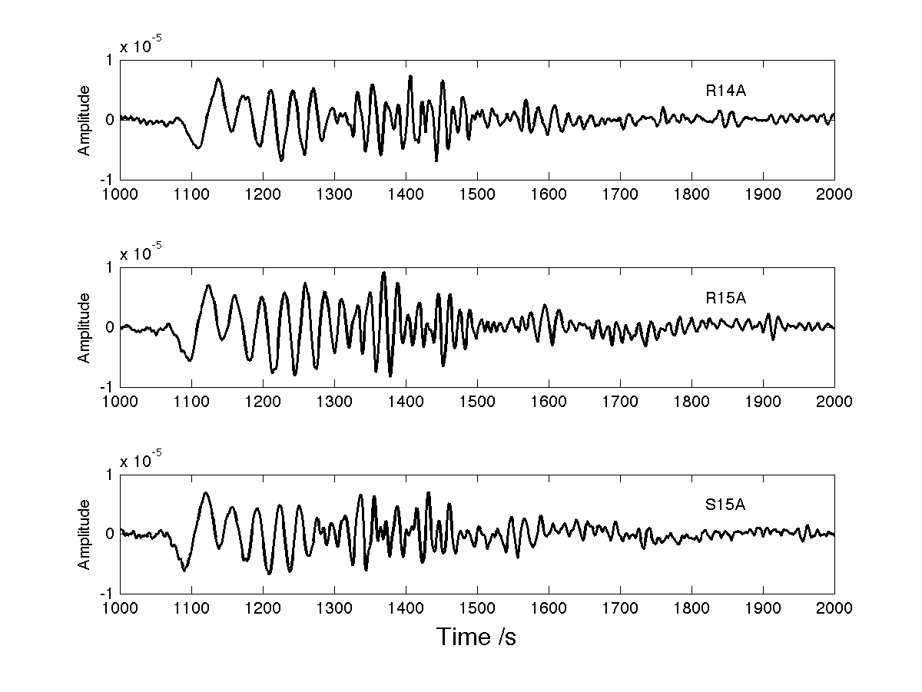
Figure 1: Waveform of three nearby stations of the event 200806171742. The distance between the stations is less than 100km.

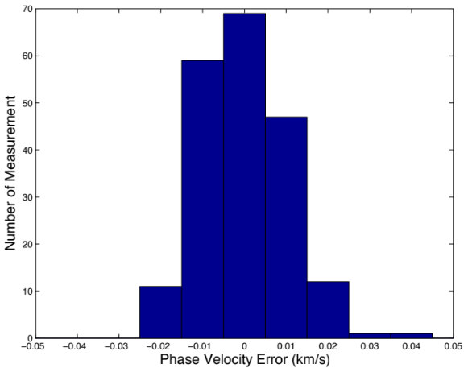 | 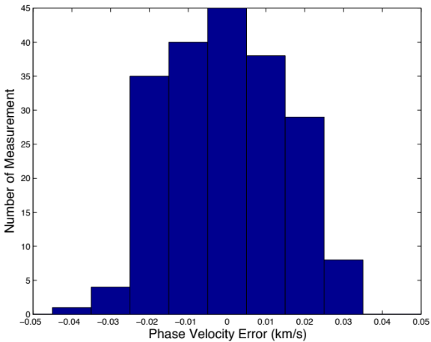
Figure 2: Comparison between our method and FTAN method in a simple synthetic test. Left subfigure shows the error histogram of our method for 200 individual measurements with 20% noise, and right subfigure shows the FTAN measurement error on the same data.

Reference:

Bodin, T., and V. Maupin (2008), Resolution potential of surface wave phase velocity measurements at small arrays, Geophysical Journal International, 172(2), 698-706.
Capon, J. (1970), Analysis of Rayleigh-wave multipath propagation at LASA, Bulletin of the Seismological Society of America, 60(5), 1701-1731.
Ekström, G., J. Tromp, and E. Larson (1997), Measurements and global models of surface wave propagation, Journal of Geophysical Research, 102(B4), 8137-8157.
Forsyth, D. W., and A. Li (2005), Array Analysis of Two-Dimensional Variations in Surface Wave Phase Velocity and Azimuthal Anisotropy in the Presence of Multipathing Interference, Seismic Earth: array analysis of broadband seismograms(157), 81.
Foster, A., G. Ekstrom, and V. Hjorleifsdottir (2010), Surface wave propagation across the USArray, paper presented at AGU Fall Meeting.
Friederich, W., and E. Wielandt (1995), Interpretation of seismic surface waves in regional networks: joint estimation of wavefield geometry and local phase velocity. Method and numerical tests, Geophysical Journal International, 120(3), 731-744.
Gee, L., and T. Jordan (1992), Generalized seismological data functionals, Geophysical Journal International, 111(2), 363-390.
Goldstein, P., D. Dodge, M. Firpo, and L. Minner (2003), SAC2000: Signal processing and analysis tools for seismologists and engineers, International Geophysics, 81, 1613-1614.
Kulesh, M., M. Diallo, and M. Holschneider (2005), Wavelet analysis of ellipticity, dispersion, and dissipation properties of Rayleigh waves, Acoustical Physics, 51(4), 425-434.
Levshin, A., and M. Ritzwoller (2001), Automated detection, extraction, and measurement of regional surface waves, Pure and Applied Geophysics, 158(8), 1531-1545.
Levshin, A., L. Ratnikova, and J. Berger (1992), Peculiarities of surface-wave propagation across central Eurasia, Bulletin of the Seismological Society of America, 82(6), 2464-2493.
Li, X. D., and B. Romanowicz (1995), Comparison of global waveform inversions with and without considering cross-branch modal coupling, Geophysical Journal International, 121(3), 695-709.
Lin, F. C., and M. H. Ritzwoller (2011), Helmholtz surface wave tomography for isotropic and azimuthally anisotropic structure, Geophysical Journal International.
Lin, F. C., M. H. Ritzwoller, and R. Snieder (2009), Eikonal tomography: surface wave tomography by phase front tracking across a regional broad band seismic array, Geophysical Journal International, 177(3), 1091-1110.
Maeda, T., K. Obara, T. Furumura, and T. Saito (2011), Interference of long-period seismic wavefield observed by the dense Hi-net array in Japan, Journal of Geophysical Research, 116(B10), B10303.
Maggi, A., C. Tape, M. Chen, D. Chao, and J. Tromp (2009), An automated time‚Äêwindow selection algorithm for seismic tomography, Geophysical Journal International, 178(1), 257-281.
Nettles, M., and A. M. Dziewoñski (2011), Effect of Higher-Mode Interference on Measurements and Models of Fundamental-Mode Surface-Wave Dispersion, Bulletin of the Seismological Society of America, 101(5), 2270-2280.
Owens, T. J., H. P. Crotwell, C. Groves, and P. Oliver-Paul (2004), SOD: standing order for data, Seismological Research Letters, 75(4), 515-520.
Pedersen, H. A., O. Coutant, A. Deschamps, M. Soulage, and N. Cotte (2003), Measuring surface wave phase velocities beneath small broad‚Äêband arrays: tests of an improved algorithm and application to the French Alps, Geophysical Journal International, 154(3), 903-912.
Snieder, R., and G. Nolet (1987), Linearized scattering of surface waves on a spherical Earth, J. geophys, 61, 55-63.
Tape, C., Q. Liu, A. Maggi, and J. Tromp (2010), Seismic tomography of the southern California crust based on spectral-element and adjoint methods, Geophysical Journal International, 180(1), 433-462.
Wielandt, E. (1993), Propagation and Structural Interpretation of Non-Plane Waves, Geophysical Journal International, 113(1), 45-53.
Yang, Y., and D. W. Forsyth (2006), Regional tomographic inversion of the amplitude and phase of Rayleigh waves with 2-D sensitivity kernels, Geophysical Journal International, 166(3), 1148-1160.
Yang, Y., W. Shen, and M. H. Ritzwoller (2011), Surface wave tomography on a large-scale seismic array combining ambient noise and teleseismic earthquake data, Earthquake Science, 24(1), 55-64.

