# 3.1 PCA

**I want this in Bold**

|  |  |  |
| --- | --- | --- |
| PC | Variance explained | Culmulative Proportion |
| 1 | 5.0312012 | 0.7187430 |
| 2 | 1.1975728 | 0.8898249 |
| 3 | 0.6780034 | 0.9866825 |
| 4 | 0.0683645 | 0.9964488 |
| 5 | 0.0187136 | 0.9991222 |
| 6 | 0.0053320 | 0.9998839 |
| 7 | 0.0008124 | 1.0000000 |

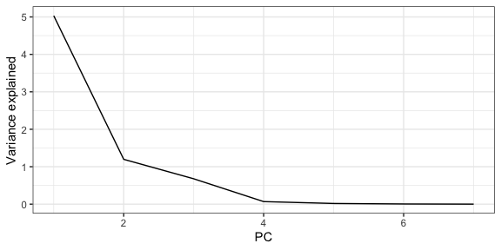

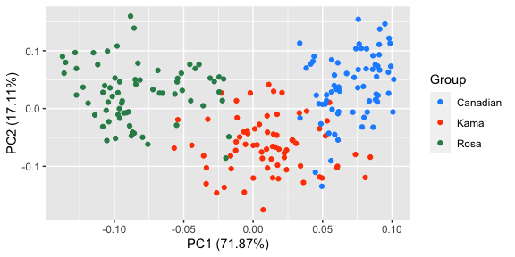

By examining the first 2 eigenvectors, we can see that pc1 is a general measure of the area, perimeter, kernel length, width and groove length. whereas the main contribution to pc2 is by the asymmetry coefficient and to a lesser extent, kernel length and groove length.

Table 3.2

|  |  |  |  |
| --- | --- | --- | --- |
| Variable | Eigenvector 1 | Eigenvector 2 | Eigenvector 3 |
| area | -0.4444735 | 0.0265636 | -0.0258709 |
| perimeter | -0.4415715 | 0.0840028 | 0.0598391 |
| compact | -0.2770174 | -0.5291513 | -0.6296918 |
| length_k | -0.4235633 | 0.2059752 | 0.2118797 |
| width_k | -0.4328187 | -0.1166896 | -0.2164834 |
| asym | 0.1186925 | 0.7168820 | -0.6795058 |
| length_k_g | -0.3871608 | 0.3771933 | 0.2138972 |

# 3.2 Factor analysis

Table 3.3

|  |  |  |  |
| --- | --- | --- | --- |
|  | Factor 1 | Factor 2 | Factor 3 |
| Variance explained | 5.031201 | 1.1975728 | 0.6780034 |
| Culmulative proportion of total variance | 0.718743 | 0.8898249 | 0.9866825 |

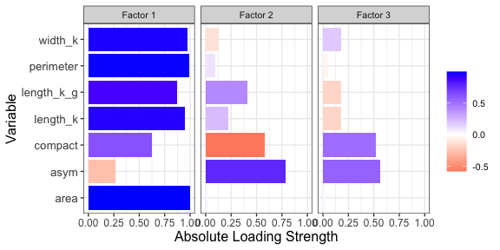

Table 3.4

|  |  |  |  |
| --- | --- | --- | --- |
|  | Factor 1 | Factor 2 | Factor 3 |
| Variance explained | 4.1861181 | 1.0524208 | 1.6682386 |
| Culmulative proportion of total variance | 0.5980169 | 0.7483627 | 0.9866825 |

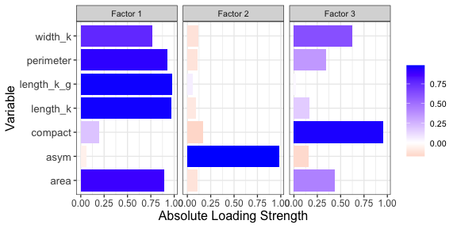

Table 3.5

|  |  |  |  |  |  |  |
| --- | --- | --- | --- | --- | --- | --- |
|  | Df | Wilks | approx F | num Df | den Df | Pr(>F) |
| factor(group) | 2 | 0.1316657 | 180.8578 | 4 | 412 | 0 |
| Residuals | 207 | NA | NA | NA | NA | NA |