**Hartig(2009)**

endo-siRNAs points to one mechanism by which transposons can be silenced in the somatic cells of Drosophila. Prevents the proliferation of transposable elements.

we show that biogenesis of endo-siRNAs depends on a new isoform of the dsRNA-binding domain protein Loquacious (also known as R3D1).

Endo-siRNA lacks sequences that cross exon-exon junctions, This is consistent with a lack of endo-siRNAs that cross the exon–exon junction and, consequently, the idea that antisense transcription is providing the second strand to form the duplex precursor for endo-siRNAs.

*No siRNA crosses exon junctions, keep this in mind. Confusing, but keep in mind.

Note, p9, fig6 provides a very good digramatic representationn of the PD pathway.

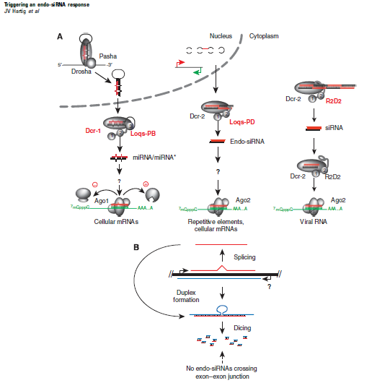

*Note how in this diagram the siRNA precursor is a duplex formed from 2 sense/antisense transcripts. Whereas it seems that for the hpRNA biogenesis pathway, its formed from inverted repeats within a single strand.

Actually wait, refer to the review for a better photoS

**Zhou(2009)**

Endo-siRNAs are predominantly 21 nt in length and are derived either from long endogenous transcripts capable of forming extensive fold-back structures, or are processed from double-stranded regions formed by intermolecular hybridization of convergently transcribed mRNAs

**Key findings**:

Depletion of all Loqs isoforms in cultured cells affects the biogenesis of both miRNAs and endo-siRNAs, whereas cells singly depleted of Loqs-PB or Loqs-PD show an impact only on the miRNA or on the endo-siRNA pathway.

While the re-expression of Loqs-PD restored endo-siRNA levels in cultured cells that had been depleted of all Loqs isoforms, Loqs-PD was incapable of rescuing miRNA processing defects.

Note this probing for a handful of siRNA/ miRNA targets in order to establish Loqs-PD role in siRNA biogenesis.

Also note how previous bioinformatics attempts used libraries constructed from KO,dicer,cells response to transfection/foreign RNA, but NOT from rescue attempts. For example, Endo-siRNAs mapping to overlapping transcripts (exonic antisense) were strongly reduced in dcr-2 and LOQS KO.

Knockdown of dcr-2 caused a reduction of endosiRNA sequences for the majority of transposable elements.