Snakemake:

1. Define rules in snake make files

We have your input, output and also must define your target files. This tells snakemake which files it targets to generate

Note the usage of wildcards and the subsequent calling of targets .

Note later also defining a list of samples (sample=SAMPLE) for the various targets called.

**Using expand**:

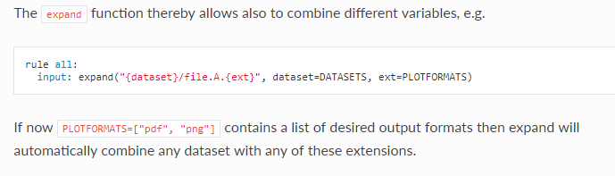

The example below then uses strings to further select 2 types of input

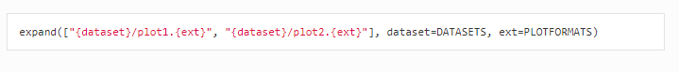This then gives:

["ds1/plot1.pdf", "ds1/plot2.pdf", "ds2/plot1.pdf", "ds2/plot2.pdf", "ds1/plot1.png", "ds1/plot2.png", "ds2/plot1.png", "ds2/plot2.png"]

Now compare that to:

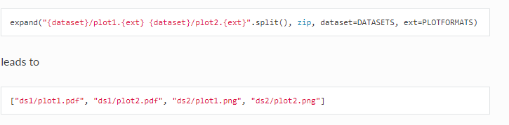

**Embedding other scripts in snakemake:**

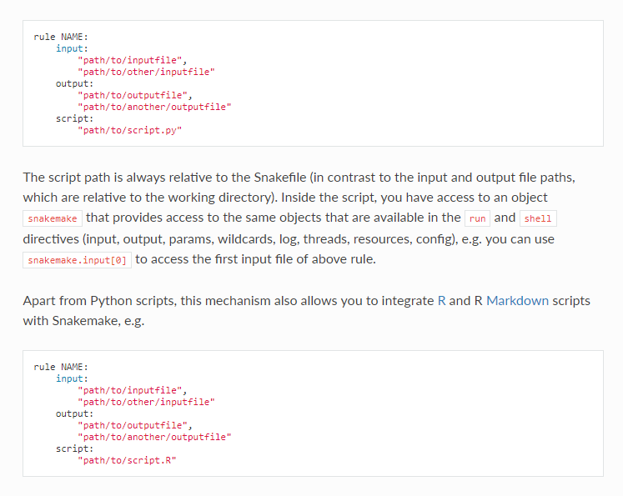

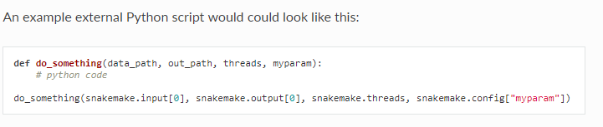

Okay, this explanation is clearly insufficient for more complicated situations.

**Functions as input files**:

