1. Okamura et al. (2008) The Drosophila hairpin RNA pathway generates endogenous short interfering RNAs. **(HPRNA)**
2. Okamura et al. (2008) .Two distinct mechanisms generate endogenous siRNAs from bidirectional transcription in Drosophila melanogaster
3. Czech et al. (2008) An endogenous small interfering RNA pathway in Drosophila.
4. Kawamura et al. (2008) Drosophila endogenous small RNAs bind to Argonaute 2 in somatic cells.
5. Ghildiyal et al. (2008) Endogenous siRNAs derived from transposons and mRNAs in Drosophila somatic cells

1.

**Methods to identify hpRNA**

EINVERTED4 to identify candidate genomic hairpins contained within 10-kb

windows that satisfied a cutoff score ≥80 and had ≥70% pairing within the duplex region

These criteria eliminated all but one of the annotated *Drosophila* miRNAs (*mir-997)*. Filtered candidates again,

Only keeping those with hits in 3 different datasets? Removed reads with overlap with TE.

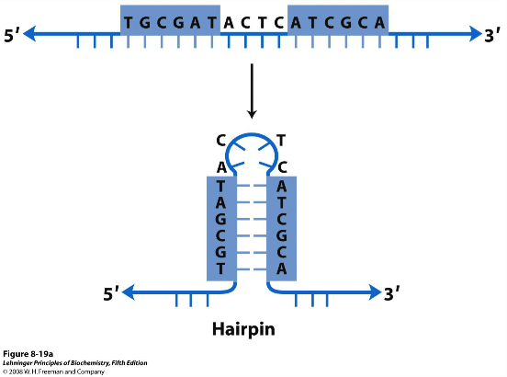

Still, we chose to introduce an ‘hp’ prefix to these six loci to distinguish the small-RNA-generating hairpins

(‘hpRNAs’) from the potential protein-encoding segments of these transcripts.

Consistent with their apparent derivation from phased cleavage of long inverted repeats, their processing was unaffected by Dcr-1 depletion, but was strongly dependent on Dcr-2. In addition, ~21-nucleotide hpRNA

products were markedly reduced when AGO2 was depleted. There was also Dcr-2/AGO2 dependent accumulation of ~21-nucleotide (siRNA) and ~42-nucleotide (terminal loop) hp- CG4068D isoforms.

**Identifying Target 1**

However, hp-CG4068B, the most abundant siRNA product of hp-CG4068, contains 20 nucleotides of antisense complementarity (including three G•U pairs) to the coding region of mus308 (Fig. 3f). Consistent with this, we observed that *mus308* levels were increased ~2–3-fold in cells depleted of Dcr-2 or AGO2.

**Identifying Target 2**

Targets of hp-CG18854, CG18854 exhibits significant homology to the chromodomain gene CG8289, and some

of the abundant hp-CG18854-derived siRNAs exhibited extensive antisense complementarity to CG8289.

hp-CG18854 specifically repressed the accumulation of CG8289:GFP.

This paper provides a good diagram of what the hp-siRNA actually looks like.

**Adaptive Regulation of Testis Gene Expression and Control of Male Fertility by the Drosophila Hairpin RNA Pathway(2015)**

Explaning the additional CR46340 in DM6, gff.

We were interested to compare hpRNAs with “long” miRNA loci, since the longest annotated miRNAs (mir-989, mir-959, and mir-997) and the shortest hpRNAs (e.g., hpRNA1) exhibit similar hairpin duplexes of 60–80 bp.

Curiously, miR-997 behaved like an hpRNA, since it was strongly dependent on both Dcr-2 and Loqs-PD ([Figure 1](http://www.sciencedirect.com/science/article/pii/S1097276514009204#fig1)D).

34,000 miR-997 reads revealed two mir-997 progenitor hairpins in the Drosophilagenome. Both exhibit hairpin structures to which some mature reads map uniquely, indicating their independent transcription and processing ( [Figure S1](http://www.sciencedirect.com/science/article/pii/S1097276514009204#app2)A). These observations support their reclassification as hpRNAs (hp-mir-997-1 and hp-mir-997-2).

Targets of hpRNA?

we sought to broaden the evidence that hpRNAs might regulate specific targets.

Searches for potential targets of hp-mir-997, “pncr009”, found them .

**02 okamura- cisnat**

About 1,000 *Drosophila* loci are arranged as *cis*-NAT pairs -> this is from a paper.

(**Genome-wide in silico identification and analysis of cis natural antisense transcripts ( cis -NATs) in ten species**)

In opposite directions at the same genomic locus with ≥20 nt overlap in exonic regions,

We combined the classification schemas by Lehner ( 9 ) and Munroe ( 30 ) into a new one that divided SA gene pairs into six categories ( Figure 1 ): ‘Convergent (tail–tail)’—SA gene pairs overlapping by their last exon, ‘Divergent (head–head)’—SA gene pairs overlapping by their first exon, ‘Complete (full overlap)’—one gene sequence completely covered by an exon of the other, ‘Contained’—one gene sequence completely covered by the intron and exon of the other, ‘Intronic’—one gene starting within an intron of the other and transcribing beyond the start of the other, and ‘Others’—all other SA pairs. Each SA pair is classified into one and only one class; when there is ambiguity the class with the more stringent definition is chosen, in the order of, from most stringent to least, ‘Complete’, ‘Contained’, ‘Intronic’, ‘Divergent (head–head)’, ‘Convergent (tail–tail)’ and ‘Others’.

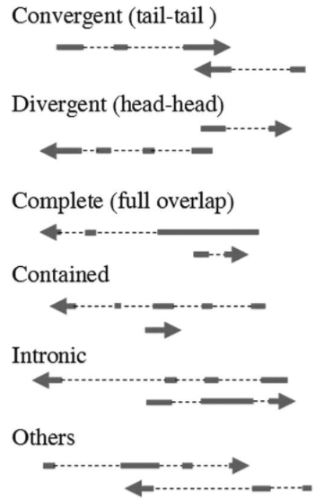

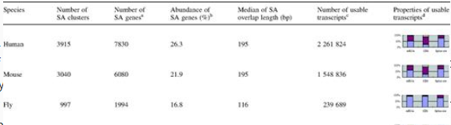

Then apparently using the findings from this paper, they found that two major classes of cis-NAT mRNA pairs in D. melanogaster are divergently transcribed loci that overlap on their initiating 5′ exons (100 loci) and convergently transcribed loci that overlap on their terminal 3′ exons (793 loci).

They then took their siRNA dataset and examined the reads that were mapped to these cisnats.

First, there were extremely few small RNAs emanating from either strand of 5′ cis-NAT overlap regions, In contrast, the overlap regions of 3′ cis-NAT pairs generated RNAs with a strong 21-nt bias (Fig. 1h), similar to other known Dcr-2 products.

These RNAs came from the top and bottom strands in approximately equal numbers, that 3′ cis-NATs are a substantial source of endogenous siRNAs.

How did they then filter for cis-nat RNAs:

1. First, we selected cis-NAT overlap regions that produce a preponderance (> 67%) of

21-nt RNAs relative to all other sizes

2. Second, we asked that there be at least 11 independent 21-nt reads generated

by a given overlap.

3. These criteria resulted in a set of 117 cis-NATs, with 40 pairs producing ≥40 siRNA reads

Okay so we got the feature annotation for all the cistnats now, great. Now what?

Can we do a lift over to DM6? I hope so.

**03_Czech**

Immunoprecipitated AGO2-associated RNAs

differed in their mobility from those bound to AGO1. Separated reads into 2 types, non-miRNA and miRNA. non-miRNAs lying at 21 nucleotides and miRNAs exhibiting a broader peak from 21 to 23 nucleotides.

The remaining small RNAs in AGO2 complexes formed a complex mixture of

endogenous siRNAs (endo-siRNAs; Fig. 1c). Among these, transposons and satellite repeats

With a set of putative siRNAs at hand, we computationally extracted genomic

sites, which give rise to multiple uniquely mapping RNAs that do not fall into heterochromatic regions. Which was further separated into 2 categories, structured loci and convergently transcribed loci.

1. Able to form DS structures naturally
2. Basically cis-nats

Okay so we have 2 tables of siRNAs, which might also include cis-nats, difference

Between S2/Ovarian cells?

S2 is like are one of the most commonly used [*Drosophila melanogaster*](https://en.wikipedia.org/wiki/Drosophila_melanogaster) [cell lines](https://en.wikipedia.org/wiki/Cell_line).

Whereas, Ovarian cells were self-prepared ~500 mg ovaries from transgenic

FLAG-HA-AGO2 flies were dissected and lysed mechanically in buffer A.

**03_okamura**

RNA silencing is thought to have evolved as a form of

nucleic-acid-based immunity to inactivate viruses and transposable

elements.

Seems like another AGO-RNA-IP.

Argonaute 2 (AGO2),

an AGO subfamily member of Argonautes, associates with endogenous

small RNAs of 20–22 nucleotides in length, which we have

collectively named endogenous short interfering RNAs (esiRNAs).

esiRNAs can be divided into two groups: one that mainly corresponds

to a subset of retrotransposons, and the other that arises

from stem–loop structures.

Most of these

endogenous binding partners for AGO2 were a previously undescribed

class of ,21-nucleotide small RNAs (see below)

05_gidi

We characterized the somatic small RNA content of S2 cells (19) and of heads expressing an

RNA hairpin silencing the white gene by RNAi (20).

Filtered for miRNAs, In S2 cells, endo-siRNAs mapped largely to transposons (86%); in fly heads, they mapped about equally to transposons, intergenic and unannotated sequences, and mRNAs.

The finding that 41% of endo-siRNAs mapped to mRNAs without mapping to transposons suggests that endo-siRNAs may regulate mRNA expression. These data suggest that such overlapping, complementary transcripts anneal in vivo to form dsRNA that is diced into endo-siRNAs. We note that among the mRNAs for which we detected complementary 21-mers was ago2 itself.

We found that the steady-state abundance of RNA from the LTR retrotransposons

*297* and *412* increased in heads from *dcr-2L811fsX* null mutants. In S2 cells, RNA expression from the LTR retrotransposons 297, 1731, mdg1, blood, and gypsy and from the DNA transposon S-element all increased significantly (0.00001 < P < 0.002) when Dcr-2 was depleted or when both Dcr-2 and Dcr-1 were depleted,