**DM6**

Note that scaffold number can obviously not exceed contig number. Seems like shotgun sequencing.

DM has 4 pairs of chromosomes, X/Y and 2, 3, 4.

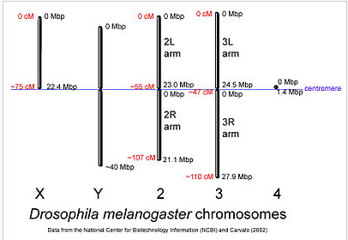

The X is also referred to as the First chromosome and designated with a “1.” In naming and symbolizing chromosome aberrations, the numeral is commonly used rather than the letter when the sex chromosome is involved. Females have two X chromosomes and males a single X and the Y. Both sexes have two sets of the autosomal second, third, and fourth chromosomes. The X is divided into two arms by the position of centromere, a large left arm (XL) and a much smaller right arm (XR), and is thus acrocentric. The Y is also acrocentric with a slightly longer long arm (YL) and a short arm (YS). The two larger autosomal chromosomes are metacentric with the centromere residing in the center of two roughly equal left and right arms. The fourth dot chromosome is acrocentric, similar to the X. The small arm is designated as left (4L) and the larger as right (4R). In sum, there are a total of 10 chromosome arms: XL, XR, YL, YS, 2L, 2R, 3L, 3R, 4L, and 4R.

The Y and fourth are also darkly staining and appear entirely heterochromatic in neuroblast preparations; however, the fourth does have a small euchromatic right arm. The regions of the X,

second, and third chromosomes adjacent to the centromeres are darkly staining and are referred to as the pericentric heterochromatin.

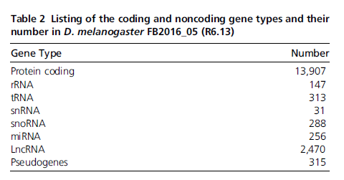

From the DM6 intro paper, As noted above, there are 17,728 genes annotated in the molecular genome. A total of 3622 of these have an associated mutant allele. Thus, the functional significance of a majority of the molecularly defined loci apart from an assumed role based on sequence identity remains to be determined. This latter point is coupled with the statistic that there are 14,348 mutant alleles that identify “genes” but these have not been mapped to the molecular genome. Are the 14,348 identified mutants assignable to the 17,728 or is the relationship more complicated? The answer is of course: “It’s more complicated.”

Also note the z/w interval conundrum.

**Duplications**:

Duplications are a bit more complicated in the sense that they can be of different types depending on the number of chromosome arms involved. The simplest type is the tandem duplication, designated, for example, Dp(2;2) followed by a unique identifier. The duplicated region can be either direct ABC:ABC or reversed ABC:CBA.

**Difference between DM3 and DM6:**

Release 6 is 4.2 Mb larger, even as the total assembly gap length has been reduced to 1.2 Mb, a decrease of 1.5 Mb. The main areas of **improvement are to the centric heterochromatin regions of the major chromosome arm scaffolds** (X, 2L, 2R, 3L, 3R, 4), which have incorporatedover 10 Mb of sequence from minor Release 5scaffolds (XHet, 2LHet, 2RHet, 3LHet, 3RHet andU). Thechromosome Y scaffold has been improved dramatically, increasingover 10-fold in size to 3.1 Mb. **Almost all remaining gaps in the chromosome arm scaffolds are in the heterochromatic region**s. Small, unmapped scaffolds are nowrepresented individually,

**Bowtie**

