TOURNAMENT REGISTRATION INSTRUCTIONS

To register for a tournament:

1. Go to advancedpokertraining.com
   1. For new players: Click the “Start Training” button to create your free account
   2. For existing account holders, Click “Log In” and enter your username and password (if you are not automatically logged in)

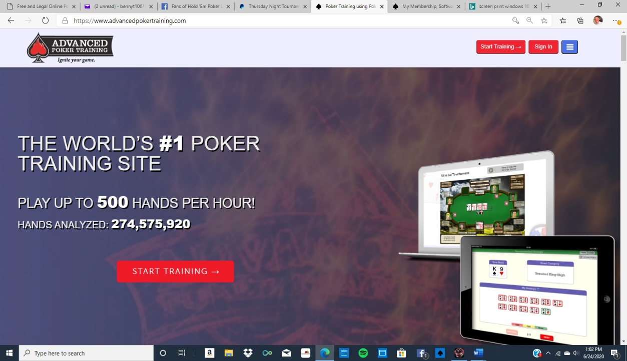

1. From the Home Screen, click the “Private Live Games” tab

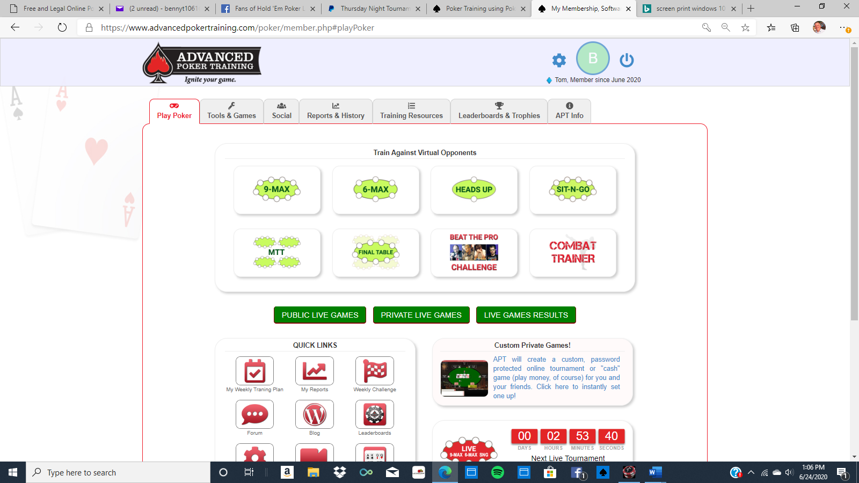

1. You are now at the Private Game Server Lobby. Click the Tournament tab to go to the list of available tournaments

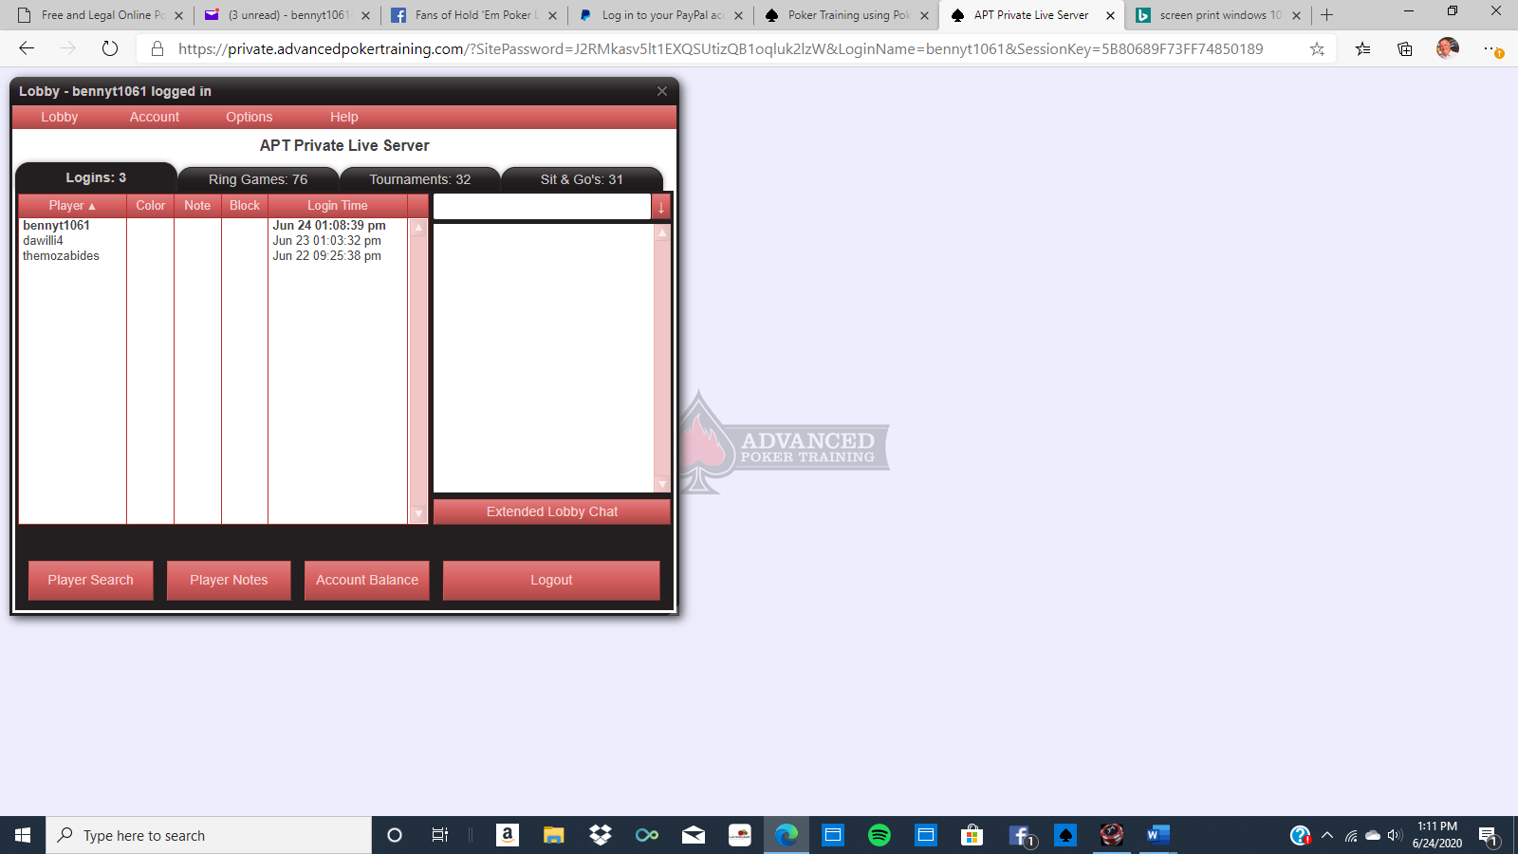

1. On the tournament tab, scroll down to and select the tournament you are registering for (Thursday: Thursday Throwdown; Saturday: Saturday Showdown)

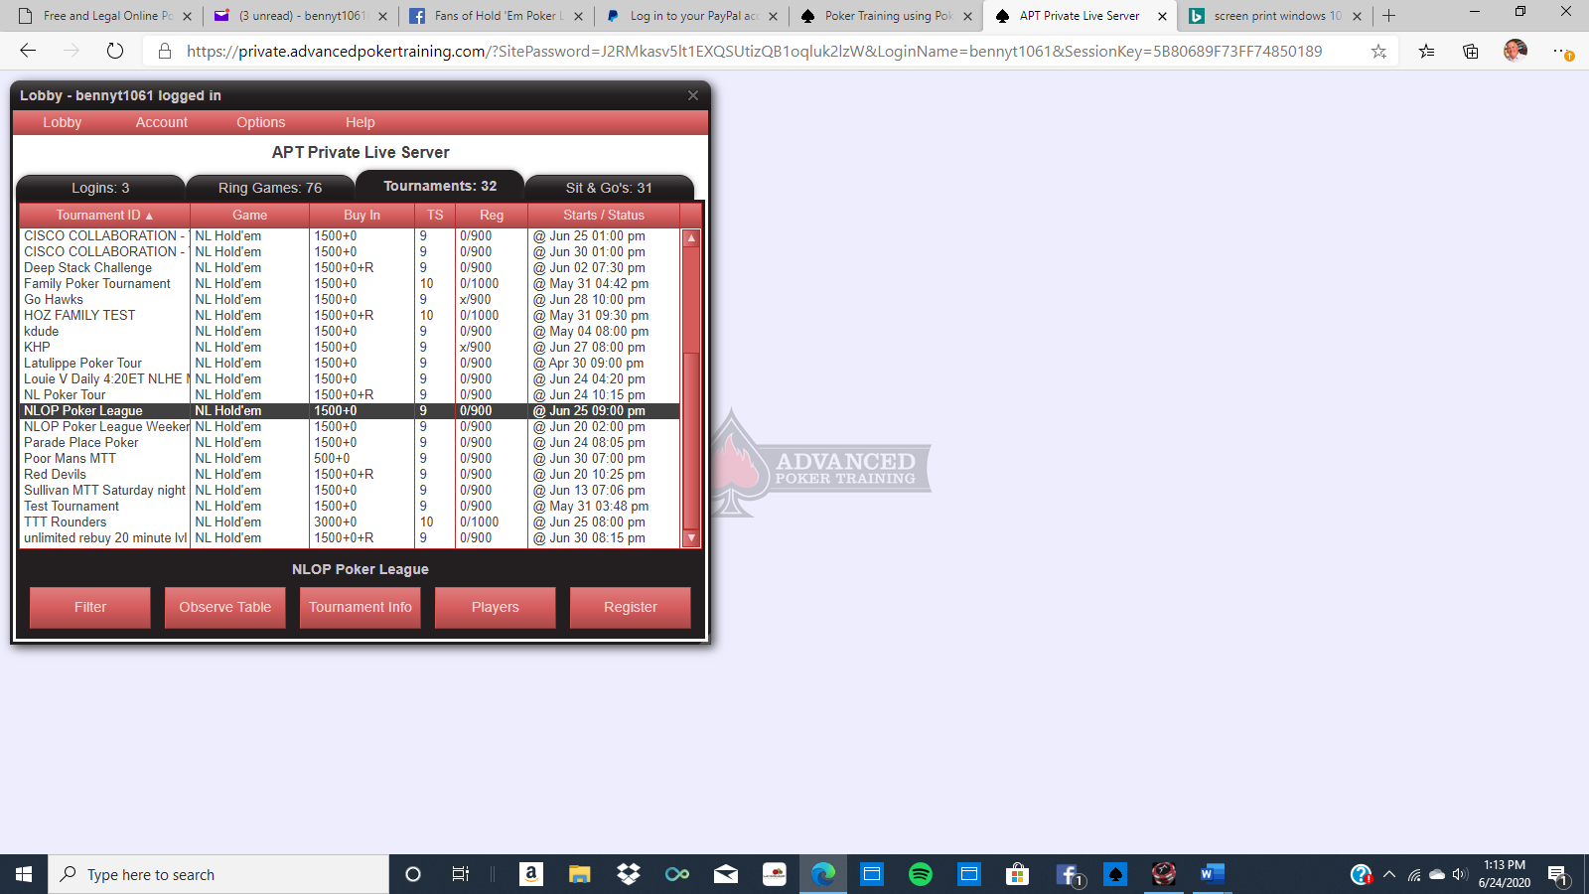

1. Click the “Register” button; you will be prompted for the password provided after the entry fee has been paid. Enter the password, click “OK”, and you are now registered!! 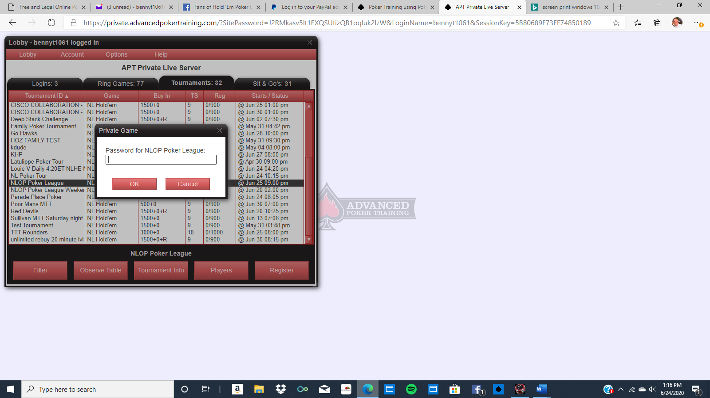
2. When it is time for the tournament to start, log in and register for the tournament. Once registered, you will be automatically seated when the tournament begins.