Context Level DFD

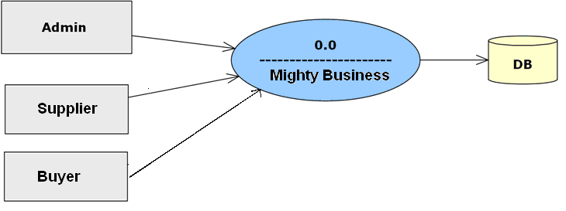

Level 1 DFD For Admin Process:-

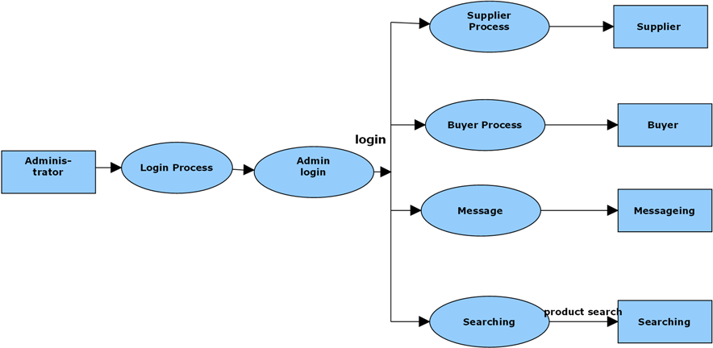

Level 1 DFD for Supplier Process:-

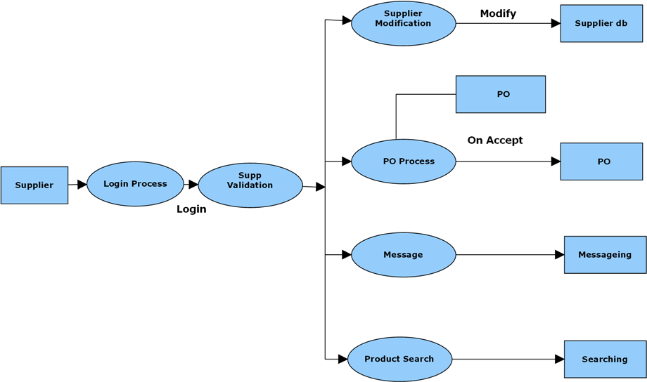

Level 1 DFD For Buyer Process:-

