# Name: Lingzi Jin

Note, in this homework, we will use FASTAPI web framework. (https://fastapi.tiangolo.com/)

## Step 1: design two docker apps. One is for city to zipcode, another one is zipcode to weather.

Create python venv, and install FASTAPI and uvicorn

python3 -m venv venv

pip3 install fastapi

pip3 install uvicorn

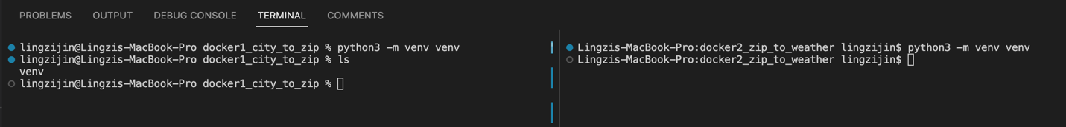

## Step 2: create code for the two apps using hard coded logic, commit change to git:

### 2.1 city to zip code: (host in 8000)

### 2.2 zip code to weather: (host in 8001)

## Step3: containerize the two web services:

### 3.1 city to zip code: (host in 8000)

Collect the dependency of our python program: pip3 freeze > dependency.txt

### Create docker file and create a work dir name is /city-to-zip-app, copy the dependency file into it and run pip install to install all dependency. Copy the app dir into the container /app folder, run python ./app/main.py at the end:

Compile docker container and run it at port 8000

docker build -t docker1-city-to-zip .

docker run -p 8000:8000 docker1-city-to-zip

lingzijin@Lingzis-MacBook-Pro docker1_city_to_zip % docker run -p 8000:8000 docker1-city-to-zip

INFO: Started server process [1]

INFO: Waiting for application startup.

INFO: Application startup complete.

INFO: Uvicorn running on http://0.0.0.0:8000 (Press CTRL+C to quit)

Test at localhost:

### 3.2 zip code to weather: (host in 8001)

Details are very similar to 3.1. we will only screen shot test result:

