Blackjack Game Database Design Document

1. Overview
This document describes the database design for our Blackjack game. We need to meet these basic requirements:
Support at least two players in a game
Real-time updates of shared game state
Record game history, view top players, etc.
Note: We’re using the Exposed framework for database operations. So we won’t be writing raw SQL queries directly - we’ll use the ORM instead. The SQL examples below are just to show what queries we need to do, but we’ll actually implement them using Exposed.

2. Database ER Diagram
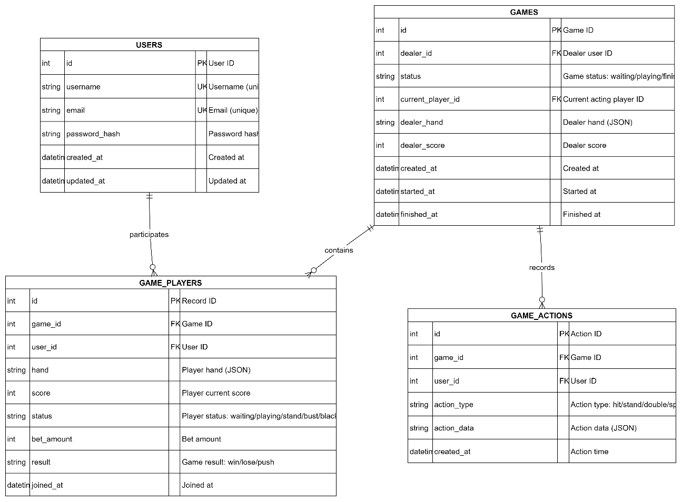

3. Detailed Table Design

3.1 Users Table (users)
This table stores basic user information.
Field Name | Type | Constraints | Description
id | INT | PRIMARY KEY, AUTO_INCREMENT | Unique user identifier
username | VARCHAR(50) | UNIQUE, NOT NULL | Username
email | VARCHAR(100) | UNIQUE, NOT NULL | Email address
password_hash | VARCHAR(255) | NOT NULL | Password hash value
created_at | DATETIME | NOT NULL, DEFAULT CURRENT_TIMESTAMP | Account creation time
updated_at | DATETIME | NOT NULL, DEFAULT CURRENT_TIMESTAMP ON UPDATE CURRENT_TIMESTAMP | Last update time
Indexes:
PRIMARY KEY (id)
UNIQUE KEY (username)
UNIQUE KEY (email)

3.2 Games Table (games)
This table stores information about each game session and its current state.
Field Name | Type | Constraints | Description
id | INT | PRIMARY KEY, AUTO_INCREMENT | Unique game identifier
dealer_id | INT | FOREIGN KEY, NOT NULL | Dealer user ID (references users.id)
status | ENUM(‘waiting’, ‘playing’, ‘finished’) | NOT NULL, DEFAULT ‘waiting’ | Game status
current_player_id | INT | FOREIGN KEY, NULL | Current acting player ID (references users.id)
dealer_hand | TEXT | NULL | Dealer hand (JSON format: [“A♠”, “K♥”])
dealer_score | INT | NULL | Dealer current score
created_at | DATETIME | NOT NULL, DEFAULT CURRENT_TIMESTAMP | Game creation time
started_at | DATETIME | NULL | Game start time
finished_at | DATETIME | NULL | Game finish time
Indexes:
PRIMARY KEY (id)
FOREIGN KEY (dealer_id) REFERENCES users(id)
FOREIGN KEY (current_player_id) REFERENCES users(id)
INDEX (status)
INDEX (created_at)
Status Descriptions:
waiting: Waiting for players to join
playing: Game in progress
finished: Game completed

3.3 Game Players Table (game_players)
This table keeps track of each player’s state and result in each game.
Field Name | Type | Constraints | Description
id | INT | PRIMARY KEY, AUTO_INCREMENT | Unique record identifier
game_id | INT | FOREIGN KEY, NOT NULL | Game ID (references games.id)
user_id | INT | FOREIGN KEY, NOT NULL | Player ID (references users.id)
hand | TEXT | NULL | Player hand (JSON format: [“A♠”, “5♥”])
score | INT | NULL | Player current score
status | ENUM(‘waiting’, ‘playing’, ‘stand’, ‘bust’, ‘blackjack’) | NOT NULL, DEFAULT ‘waiting’ | Player status
bet_amount | INT | NOT NULL, DEFAULT 0 | Bet amount
result | ENUM(‘win’, ‘lose’, ‘push’) | NULL | Game result
joined_at | DATETIME | NOT NULL, DEFAULT CURRENT_TIMESTAMP | Join game time
Indexes:
PRIMARY KEY (id)
FOREIGN KEY (game_id) REFERENCES games(id) ON DELETE CASCADE
FOREIGN KEY (user_id) REFERENCES users(id)
UNIQUE KEY (game_id, user_id) “Ensures each player has only one record per game”
INDEX (game_id)
INDEX (user_id)
Status Descriptions:
waiting: Waiting for game to start
playing: Currently acting
stand: Stand (stopped taking cards)
bust: Bust (exceeded 21)
blackjack: Blackjack (21 with two cards)
Result Descriptions:
win: Player wins
lose: Player loses
push: Push (tie)

3.4 Game Actions Table (game_actions)
This table records all actions that happen during a game, so we can show game history and maybe replay games later.
Field Name | Type | Constraints | Description
id | INT | PRIMARY KEY, AUTO_INCREMENT | Unique action identifier
game_id | INT | FOREIGN KEY, NOT NULL | Game ID (references games.id)
user_id | INT | FOREIGN KEY, NOT NULL | User ID who performed the action (references users.id)
action_type | ENUM(‘hit’, ‘stand’, ‘double’, ‘split’, ‘dealer_draw’) | NOT NULL | Action type
action_data | TEXT | NULL | Action-related data (JSON format, e.g., {“card”: “A♠”})
created_at | DATETIME | NOT NULL, DEFAULT CURRENT_TIMESTAMP | Action execution time
Indexes:
PRIMARY KEY (id)
FOREIGN KEY (game_id) REFERENCES games(id) ON DELETE CASCADE
FOREIGN KEY (user_id) REFERENCES users(id)
INDEX (game_id, created_at) “For querying game actions in chronological order”
Action Type Descriptions:
hit: Hit (request another card)
stand: Stand (stop taking cards)
double: Double down
split: Split
dealer_draw: Dealer draws a card

4. Data Storage Format

4.1 Hand Storage Format (JSON)
We’re storing hands as JSON arrays. Each element in the array is a card:
["A♠", "K♥", "5♦"]
Here’s how we represent cards:
Number cards: "2", "3", …, "10"
Face cards: "J", "Q", "K"
Ace: "A"
Suits: ♠ (spades), ♥ (hearts), ♦ (diamonds), ♣ (clubs)
Examples:
["A♠", "K♥"] - Ace of spades and King of hearts
["10♦", "5♣", "6♠"] - Ten of diamonds, Five of clubs, Six of spades

4.2 Action Data Storage Format (JSON)
The game_actions.action_data field can store extra data about an action:
{
"card": "A♠",
"new_score": 21,
"previous_hand": ["K♥"]
}

5. Core Query Scenarios
Here are the main queries we’ll need. We’ll implement these using Exposed, but I’ve included SQL examples below to show what we’re trying to do.

5.1 Get Current Game State
Using Exposed Framework (Kotlin):
// Get game basic information
val game = Games.select { Games.id eq gameId and (Games.status eq GameStatus.PLAYING) }.singleOrNull()
// Get all player states in the game
val players = (GamePlayers innerJoin Users)
.select { GamePlayers.gameId eq gameId }
.orderBy(GamePlayers.joinedAt)
.map { it[Users.username] to it[GamePlayers] }
-- Get game basic information
SELECT * FROM games WHERE id = ? AND status = 'playing';
-- Get all player states in the game
SELECT gp.*, u.username
FROM game_players gp
JOIN users u ON gp.user_id = u.id
WHERE gp.game_id = ?
ORDER BY gp.joined_at;

5.2 Get Player Game History
Using Exposed Framework (Kotlin):
// Get all game records for a player
val gameHistory = (Games innerJoin GamePlayers)
.select {
(GamePlayers.userId eq userId) and
(Games.status eq GameStatus.FINISHED)
}
.orderBy(Games.finishedAt, SortOrder.DESC)
.limit(20)
.map { it[Games] to it[GamePlayers] }
-- Get all game records for a player
SELECT g.*, gp.result, gp.bet_amount, gp.score
FROM games g
JOIN game_players gp ON g.id = gp.game_id
WHERE gp.user_id = ? AND g.status = 'finished'
ORDER BY g.finished_at DESC
LIMIT 20;

5.3 Get Top Player Statistics
Using Exposed Framework (Kotlin):
// Calculate player win rate (at least 5 games played)
val topPlayers = (Users innerJoin GamePlayers innerJoin Games)
.slice(
Users.id,
Users.username,
GamePlayers.id.count().alias("total_games"),
// ... aggregate calculations
)
.select { Games.status eq GameStatus.FINISHED }
.groupBy(Users.id, Users.username)
.having { GamePlayers.id.count() greaterEq 5 }
.orderBy(/* win rate calculation */, SortOrder.DESC)
.limit(10)
-- Calculate player win rate (at least 5 games played)
SELECT
u.id,
u.username,
COUNT(gp.id) as total_games,
SUM(CASE WHEN gp.result = 'win' THEN 1 ELSE 0 END) as wins,
SUM(CASE WHEN gp.result = 'lose' THEN 1 ELSE 0 END) as losses,
SUM(CASE WHEN gp.result = 'push' THEN 1 ELSE 0 END) as pushes,
ROUND(SUM(CASE WHEN gp.result = 'win' THEN 1 ELSE 0 END) * 100.0 / COUNT(gp.id), 2) as win_rate,
SUM(gp.bet_amount) as total_bet
FROM users u
JOIN game_players gp ON u.id = gp.user_id
JOIN games g ON gp.game_id = g.id
WHERE g.status = 'finished'
GROUP BY u.id, u.username
HAVING total_games >= 5
ORDER BY win_rate DESC, total_games DESC
LIMIT 10;

5.4 Get Game Action History
Using Exposed Framework (Kotlin):
// Get all actions for a game (in chronological order)
val actions = (GameActions innerJoin Users)
.select { GameActions.gameId eq gameId }
.orderBy(GameActions.createdAt, SortOrder.ASC)
.map { it[GameActions] to it[Users.username] }
-- Get all actions for a game (in chronological order)
SELECT ga.*, u.username
FROM game_actions ga
JOIN users u ON ga.user_id = u.id
WHERE ga.game_id = ?
ORDER BY ga.created_at ASC;

6. Database Constraints and Rules

6.1 Business Rules
Some important rules we need to follow:
- Player Count: Each game needs at least 2 players (including the dealer)
- Game Status Flow: waiting → playing → finished
- Player Status Flow: waiting → playing → stand/bust/blackjack
- Uniqueness: Each player can only have one record per game

6.2 Data Integrity
We’ve set up foreign keys to keep data consistent
When a game is deleted, all related player records and actions are automatically deleted (CASCADE)
Important fields are set to NOT NULL so we don’t get missing data

7. Future Extensions
The current design covers the basic requirements. If we want to add more features later, we could consider:
- Game Rooms/Lobby: Add a rooms table to manage different game rooms
- Player Matching: Add a matching queue table
- Tournaments: Add tournaments table and related tables
- Chat Functionality: Add a messages table
- Player Statistics Table: Pre-calculate stats to make queries faster

8. Database Schema Initialization
We’ll set up the database schema using Exposed. The framework will handle creating tables and migrations. Below is the SQL schema just to show what the database structure looks like:
-- Create database
CREATE DATABASE IF NOT EXISTS blackjack_game CHARACTER SET utf8mb4 COLLATE utf8mb4_unicode_ci;
USE blackjack_game;
-- Create users table
CREATE TABLE users (
id INT AUTO_INCREMENT PRIMARY KEY,
username VARCHAR(50) UNIQUE NOT NULL,
email VARCHAR(100) UNIQUE NOT NULL,
password_hash VARCHAR(255) NOT NULL,
created_at DATETIME NOT NULL DEFAULT CURRENT_TIMESTAMP,
updated_at DATETIME NOT NULL DEFAULT CURRENT_TIMESTAMP ON UPDATE CURRENT_TIMESTAMP
) ENGINE=InnoDB DEFAULT CHARSET=utf8mb4 COLLATE=utf8mb4_unicode_ci;
-- Create games table
CREATE TABLE games (
id INT AUTO_INCREMENT PRIMARY KEY,
dealer_id INT NOT NULL,
status ENUM('waiting', 'playing', 'finished') NOT NULL DEFAULT 'waiting',
current_player_id INT NULL,
dealer_hand TEXT NULL,
dealer_score INT NULL,
created_at DATETIME NOT NULL DEFAULT CURRENT_TIMESTAMP,
started_at DATETIME NULL,
finished_at DATETIME NULL,
FOREIGN KEY (dealer_id) REFERENCES users(id),
FOREIGN KEY (current_player_id) REFERENCES users(id),
INDEX idx_status (status),
INDEX idx_created_at (created_at)
) ENGINE=InnoDB DEFAULT CHARSET=utf8mb4 COLLATE=utf8mb4_unicode_ci;
-- Create game_players table
CREATE TABLE game_players (
id INT AUTO_INCREMENT PRIMARY KEY,
game_id INT NOT NULL,
user_id INT NOT NULL,
hand TEXT NULL,
score INT NULL,
status ENUM('waiting', 'playing', 'stand', 'bust', 'blackjack') NOT NULL DEFAULT 'waiting',
bet_amount INT NOT NULL DEFAULT 0,
result ENUM('win', 'lose', 'push') NULL,
joined_at DATETIME NOT NULL DEFAULT CURRENT_TIMESTAMP,
FOREIGN KEY (game_id) REFERENCES games(id) ON DELETE CASCADE,
FOREIGN KEY (user_id) REFERENCES users(id),
UNIQUE KEY uk_game_user (game_id, user_id),
INDEX idx_game_id (game_id),
INDEX idx_user_id (user_id)
) ENGINE=InnoDB DEFAULT CHARSET=utf8mb4 COLLATE=utf8mb4_unicode_ci;
-- Create game_actions table
CREATE TABLE game_actions (
id INT AUTO_INCREMENT PRIMARY KEY,
game_id INT NOT NULL,
user_id INT NOT NULL,
action_type ENUM('hit', 'stand', 'double', 'split', 'dealer_draw') NOT NULL,
action_data TEXT NULL,
created_at DATETIME NOT NULL DEFAULT CURRENT_TIMESTAMP,
FOREIGN KEY (game_id) REFERENCES games(id) ON DELETE CASCADE,
FOREIGN KEY (user_id) REFERENCES users(id),
INDEX idx_game_created (game_id, created_at)
) ENGINE=InnoDB DEFAULT CHARSET=utf8mb4 COLLATE=utf8mb4_unicode_ci;

9. ORM Framework Usage
We’re using the Exposed framework for database operations. It’s pretty useful because:
It gives us type-safe SQL DSL for Kotlin
Handles schema management automatically
Makes relationships between tables easier
Manages transactions for us
So instead of writing raw SQL, we’ll define our tables and write queries using Exposed’s DSL. It makes things easier while still keeping the relational database structure intact.

