Supplementary Figure 3, Villagomez, 2024
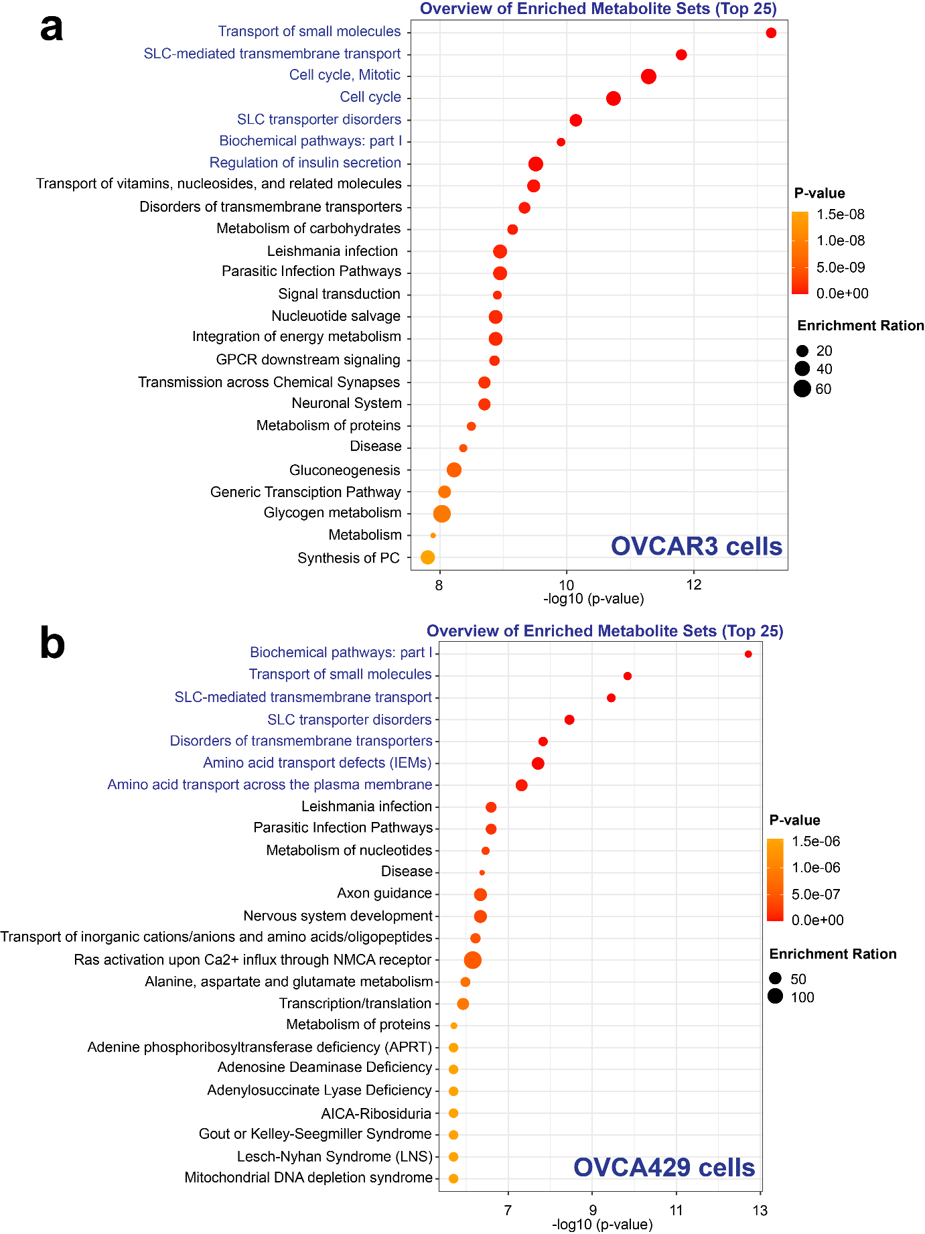
Supplementary Figure 3 (a) Enrichment analysis for significant different metabolites (global metabolomics) from claudin-4 downregulation in OVCAR3 and (b) OVCA429 (3 independent experiments; significance p<0.05) generated in MetaboAnalyst6.0.

