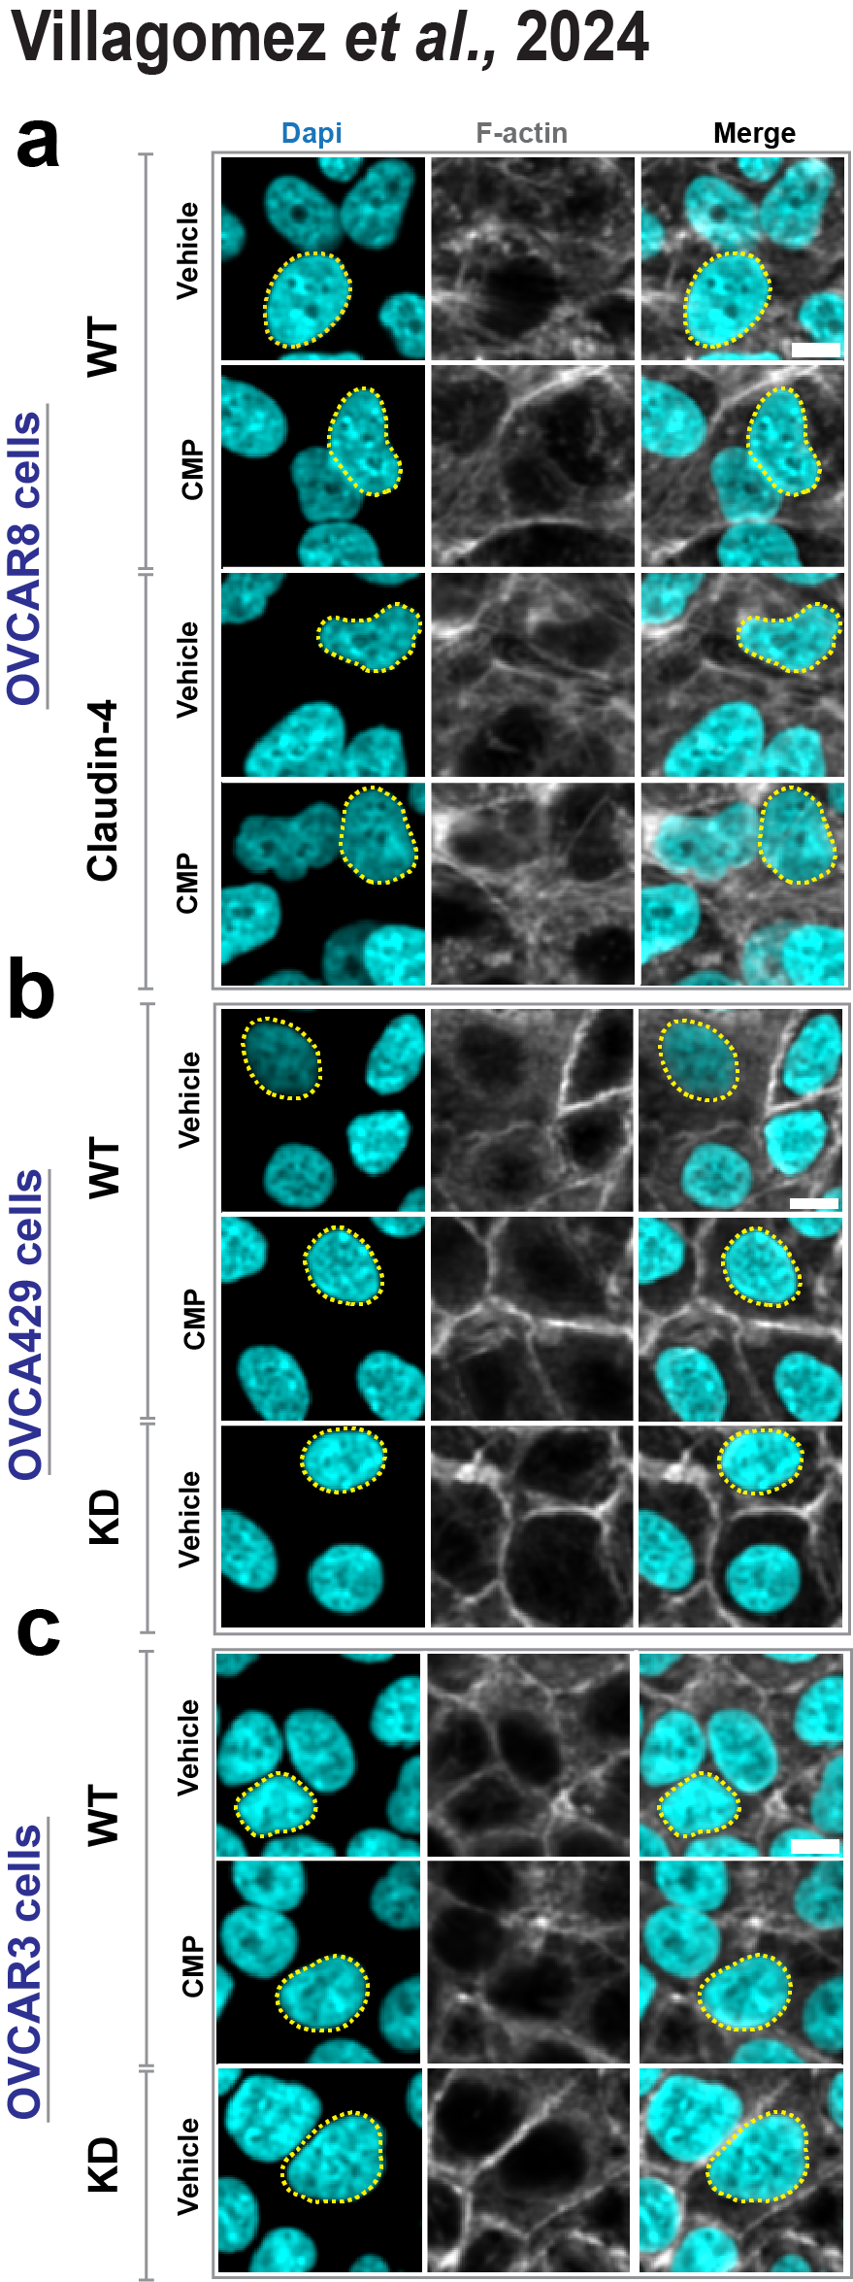

Supplementary Figure 4. Epithelial ovarian cancer cells were treated with CMP (400µmol/L) for 48h. Subsequently, cells were stained with dapi (nuclei) and phalloidin (F-actin) to carry out a morphometric characterization. (a), (b), and (c) show representative confocal images of OVCAR8, OVCA429, and OVCAR3 cells, respectively. Scale bar 10µm.

