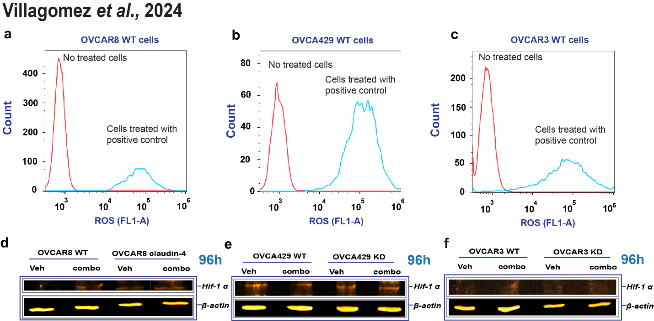
Supplementary Figure 8. (a), (b), and (c) are histograms confirming reactive oxygen species (ROS) generation by OVCAR8, OVCA429, and OVCAR3 cells, respectively, using TBHP at 250µM as a positive control. (d), (e), and (f) show HIF-1 alpha protein expression during tripartite combination treatment of olaparib (600nmol/L), FSK (5µmol/L), and CMP (400µmol/L) at 96h of treatment in OVCAR8, OVCA429, and OVCAR3 cells, respectively.

