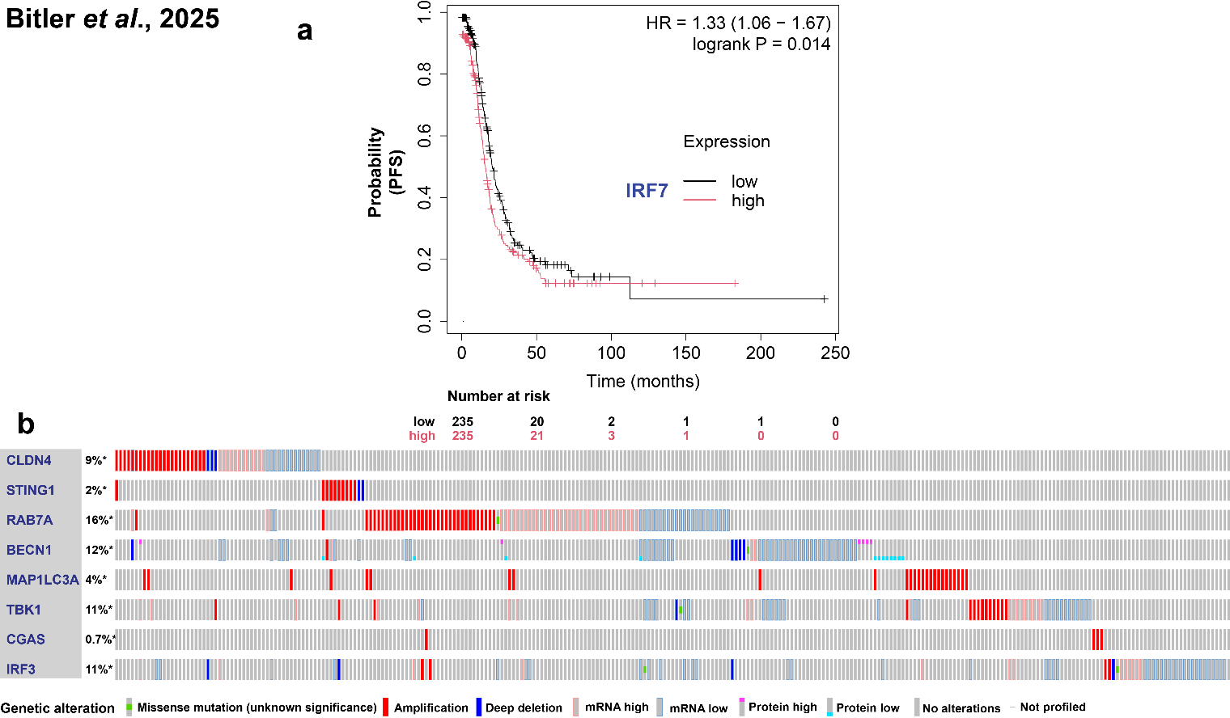
Supplementary Figure 1. Gene expression and mutational stratus. (a) Patient free survival during high and low expression of IRF7 in ovarian cancer patients. (b) Analysis of diverse mutations in selected genes (CLDN4, STING1, RAB7A, BECN1, MAP1LC3, TBK1, CGAS). Events per patient, queried genes are altered in 280 (47%) of queried patients; 287 (47%) of queried samples.

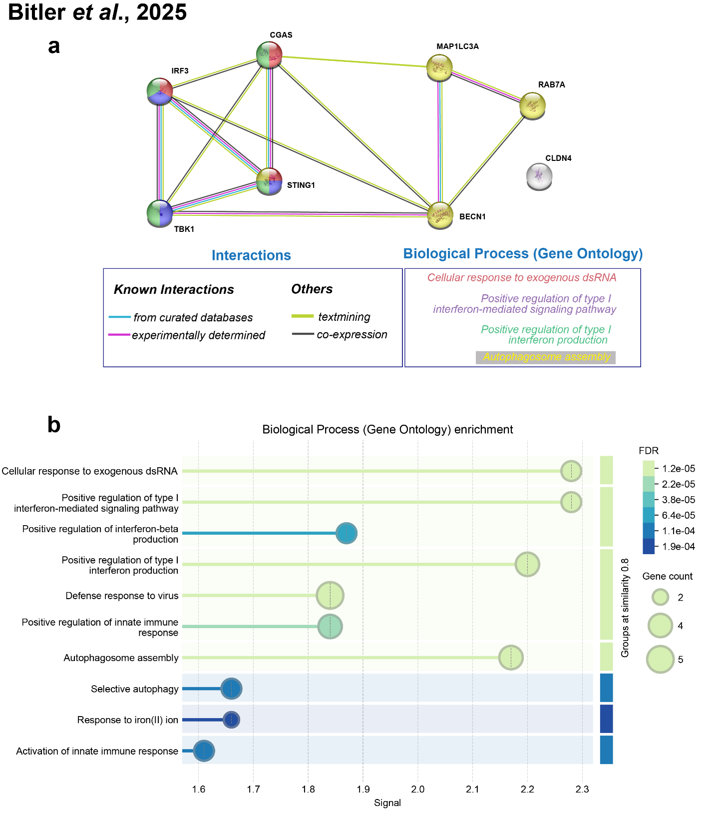

Supplementary Figure 2. The protein-protein interaction network of key elements participating in the cGAS-STING signaling and claudin-4. The interaction network was built from the STRING database with a confidence score > 0.4. (a) PPI network for CLDN4, STING1, RAB7A, BECN1, MAP1LC3, TBK1, CGAS and Gene Ontology enrichment analysis of them to find distinctive biological processes (b).

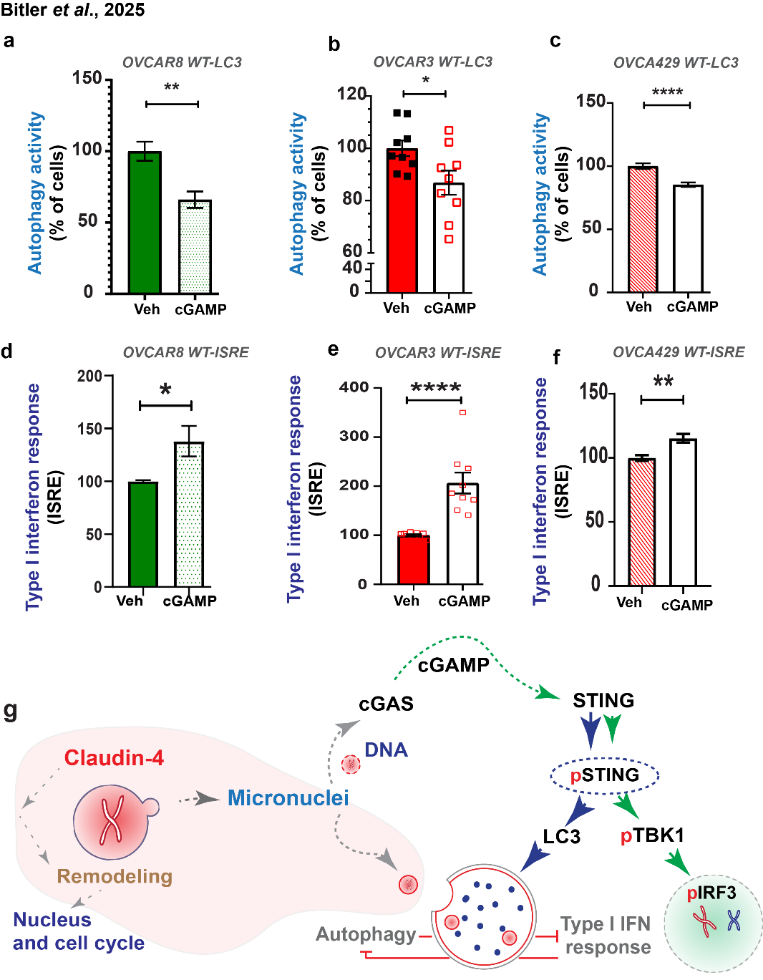

Supplementary Figure 3. Inverse effect of cGAMP on autophagy and type I interferon response in ovarian cancer cells. (a), (b), and (c) show the effect of cGAMP (1µg/mL; 5h; 3 independent experiments; normalized to vehicle) on autophagy flux in cells expressing GFP-mCherry-LC3. (d), (e), and (f) show the effect of cGAMP on type I interferon response (1µg/mL; 8h; 3 independent experiments; normalized to vehicle) in cells expressing interferon-stimulated response element (ISRE) (significance, p<0.05; two-tailed, unpaired t-test). (g) Model underscoring the intricate balance between cGAS-STING signaling in regulating both autophagy and type I interferon response, revealing their seemingly opposing roles and highlighting micronuclei/DNA as a shared functional link. This model also emphasizes the role of claudin-4 in this pathway, illustrating how claudin-4 influences nuclear remodeling and cell cycle progression to prevent genomic instability, while facilitating the clearance of micronuclei through autophagy, potentially avoiding micronuclei collapse and cytoplasmic DNA detection. These dynamic interactions suggest that claudin-4 may act as a key modulator in maintaining genomic stability and immune response regulation within the tumor microenvironment. Thus, highlighting the potential of targeting claudin-4 to modify the tumor immune microenvironment. Graphs show mean and standard error of the mean.
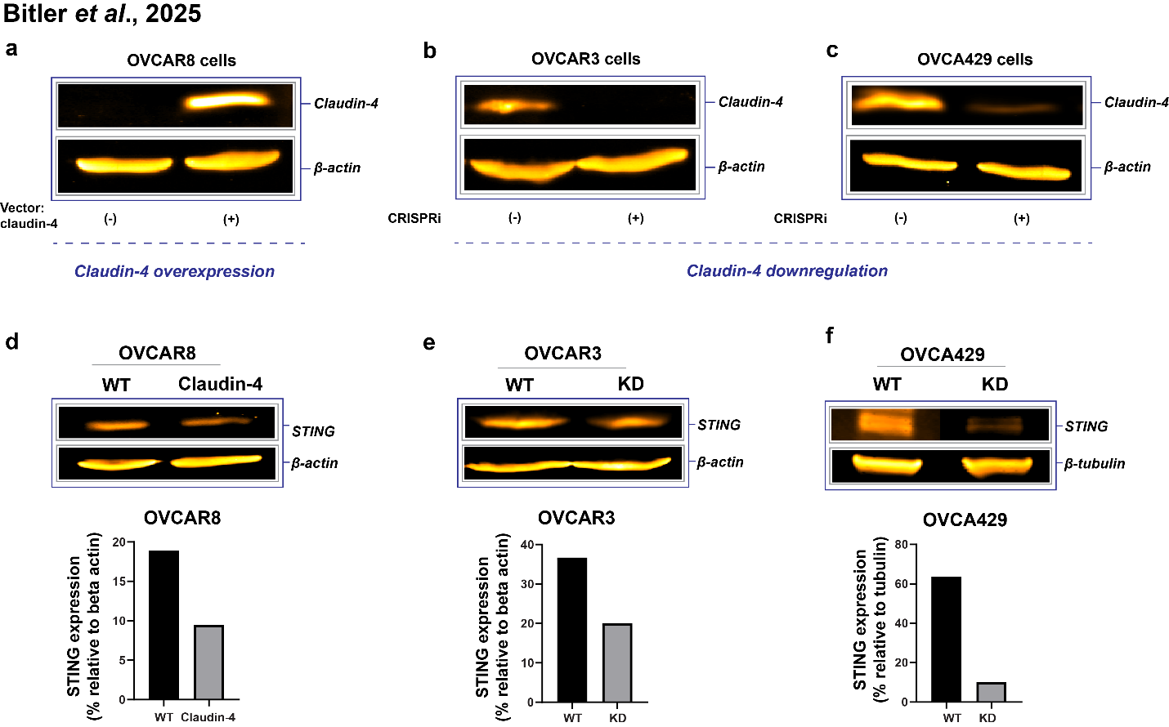
Supplementary Figure 4. Confirmation of claudin-4 expression a STING protein quantification. (a) Immunoblot analysis confirming claudin-4 overexpression in OVCAR8 cells, which lack endogenous claudin-4. (b, c) Immunoblot analysis showing claudin-4 downregulation in OVCAR3 (b) and OVCA429 (c) cells using CRISPR inhibition. Ovarian cancer cells were incubated for 48 hours, and protein lysates were analyzed by immunoblotting to assess STING expression during claudin-4 overexpression (d) or its downregulation in OVCAR3 (e) and OVCA429 (f) cells. STING protein levels were quantified relative to β-actin and β-tubulin (bottom panels).

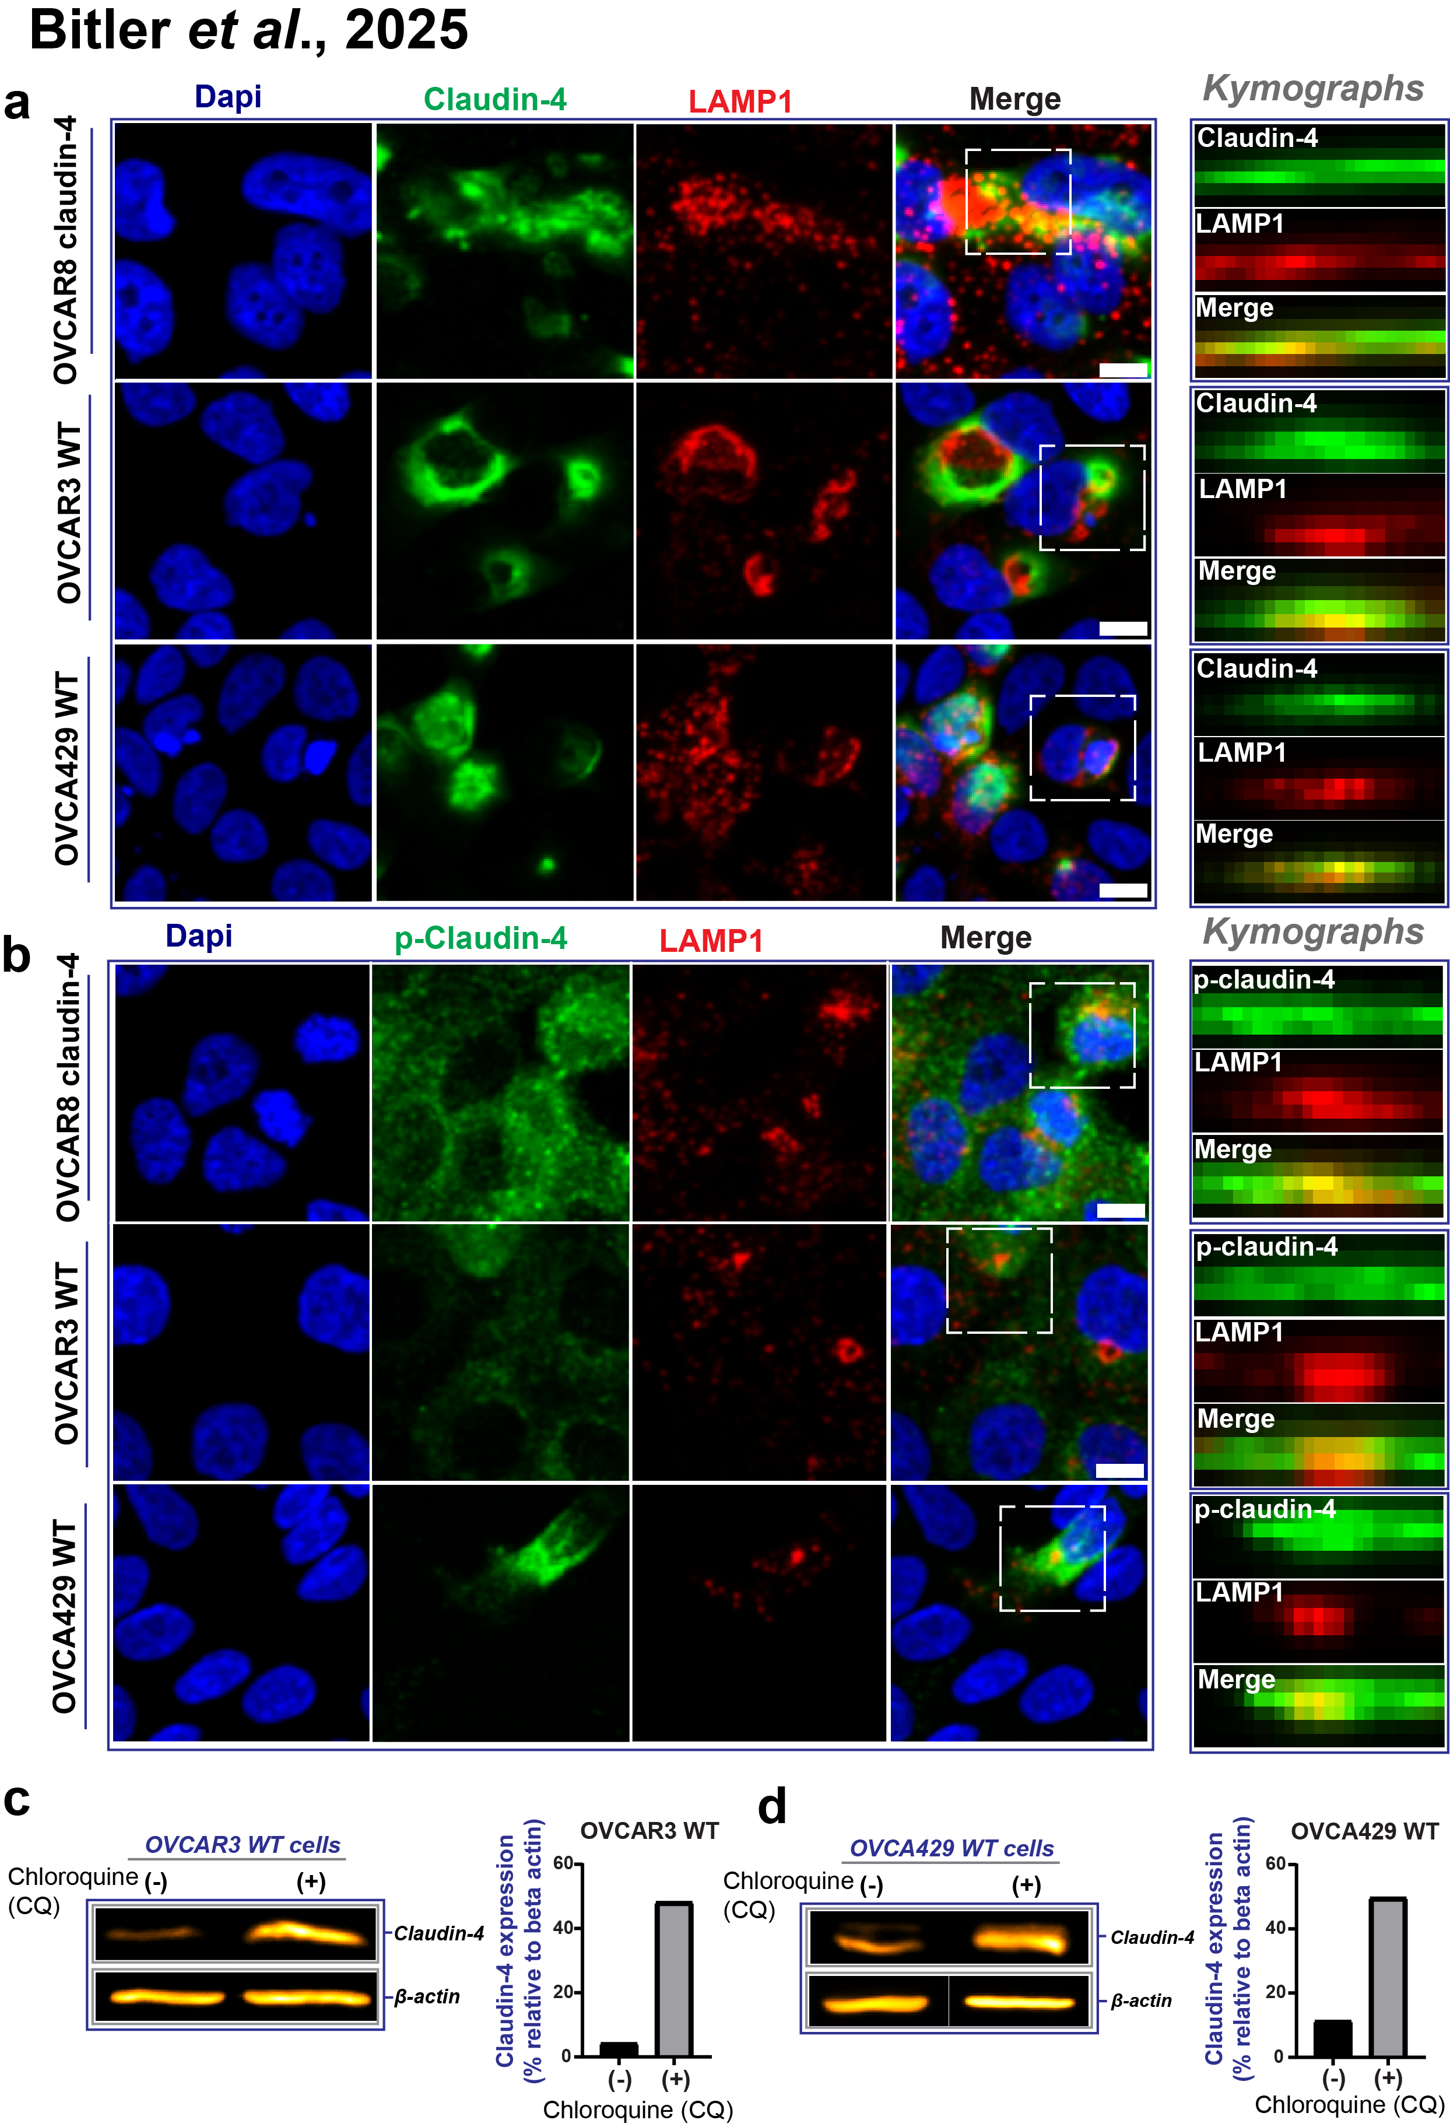

Supplementary Figure 5. Association of Claudin-4 with Lysosomes. (a, b) Panels highlight the colocalization of claudin-4 and its phosphorylated form (p-claudin-4) with LAMP1 in confocal images and kymographs from confocal z-stacks of ovarian cancer cells, respectively. (c, d) Immunoblotting analysis of claudin-4 during treatment with chloroquine, a lysosome function inhibitor.

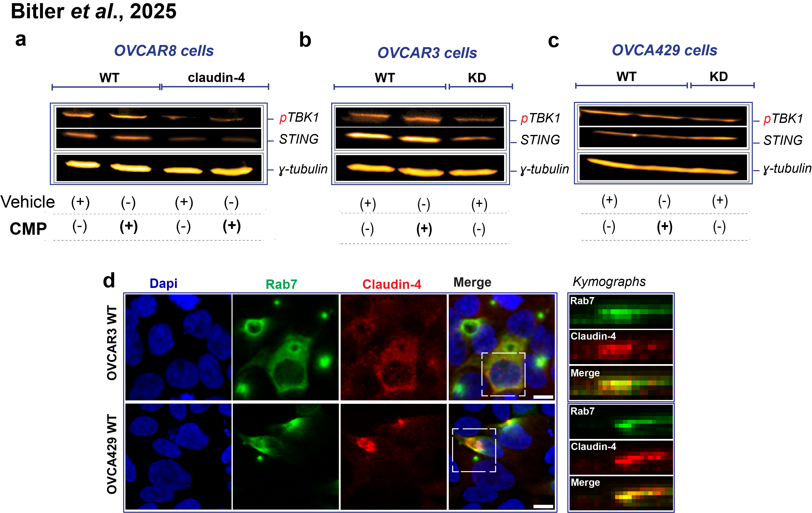

Supplementary Figure 6. ​Immunoblot Analysis of Key Components in the cGAS-STING Pathway and Claudin-4/Rab7 Colocalization. Protein lysates were collected from high grade serous carcinoma cells treated with claudin mimic peptide (CMP)ß (400 µM; 48 h). (a–c) Immunoblot analysis of phosphorylated TBK1 (pTBK1) and STING levels in OVCAR8 (a), OVCAR3 (b), and OVCA429 (c) cells. (d) Immunofluorescence analysis of claudin-4 and Rab7 intracellular distribution in ovarian cancer cells cultured under basal conditions for 24 h, highlighting their colocalization within kymographs.

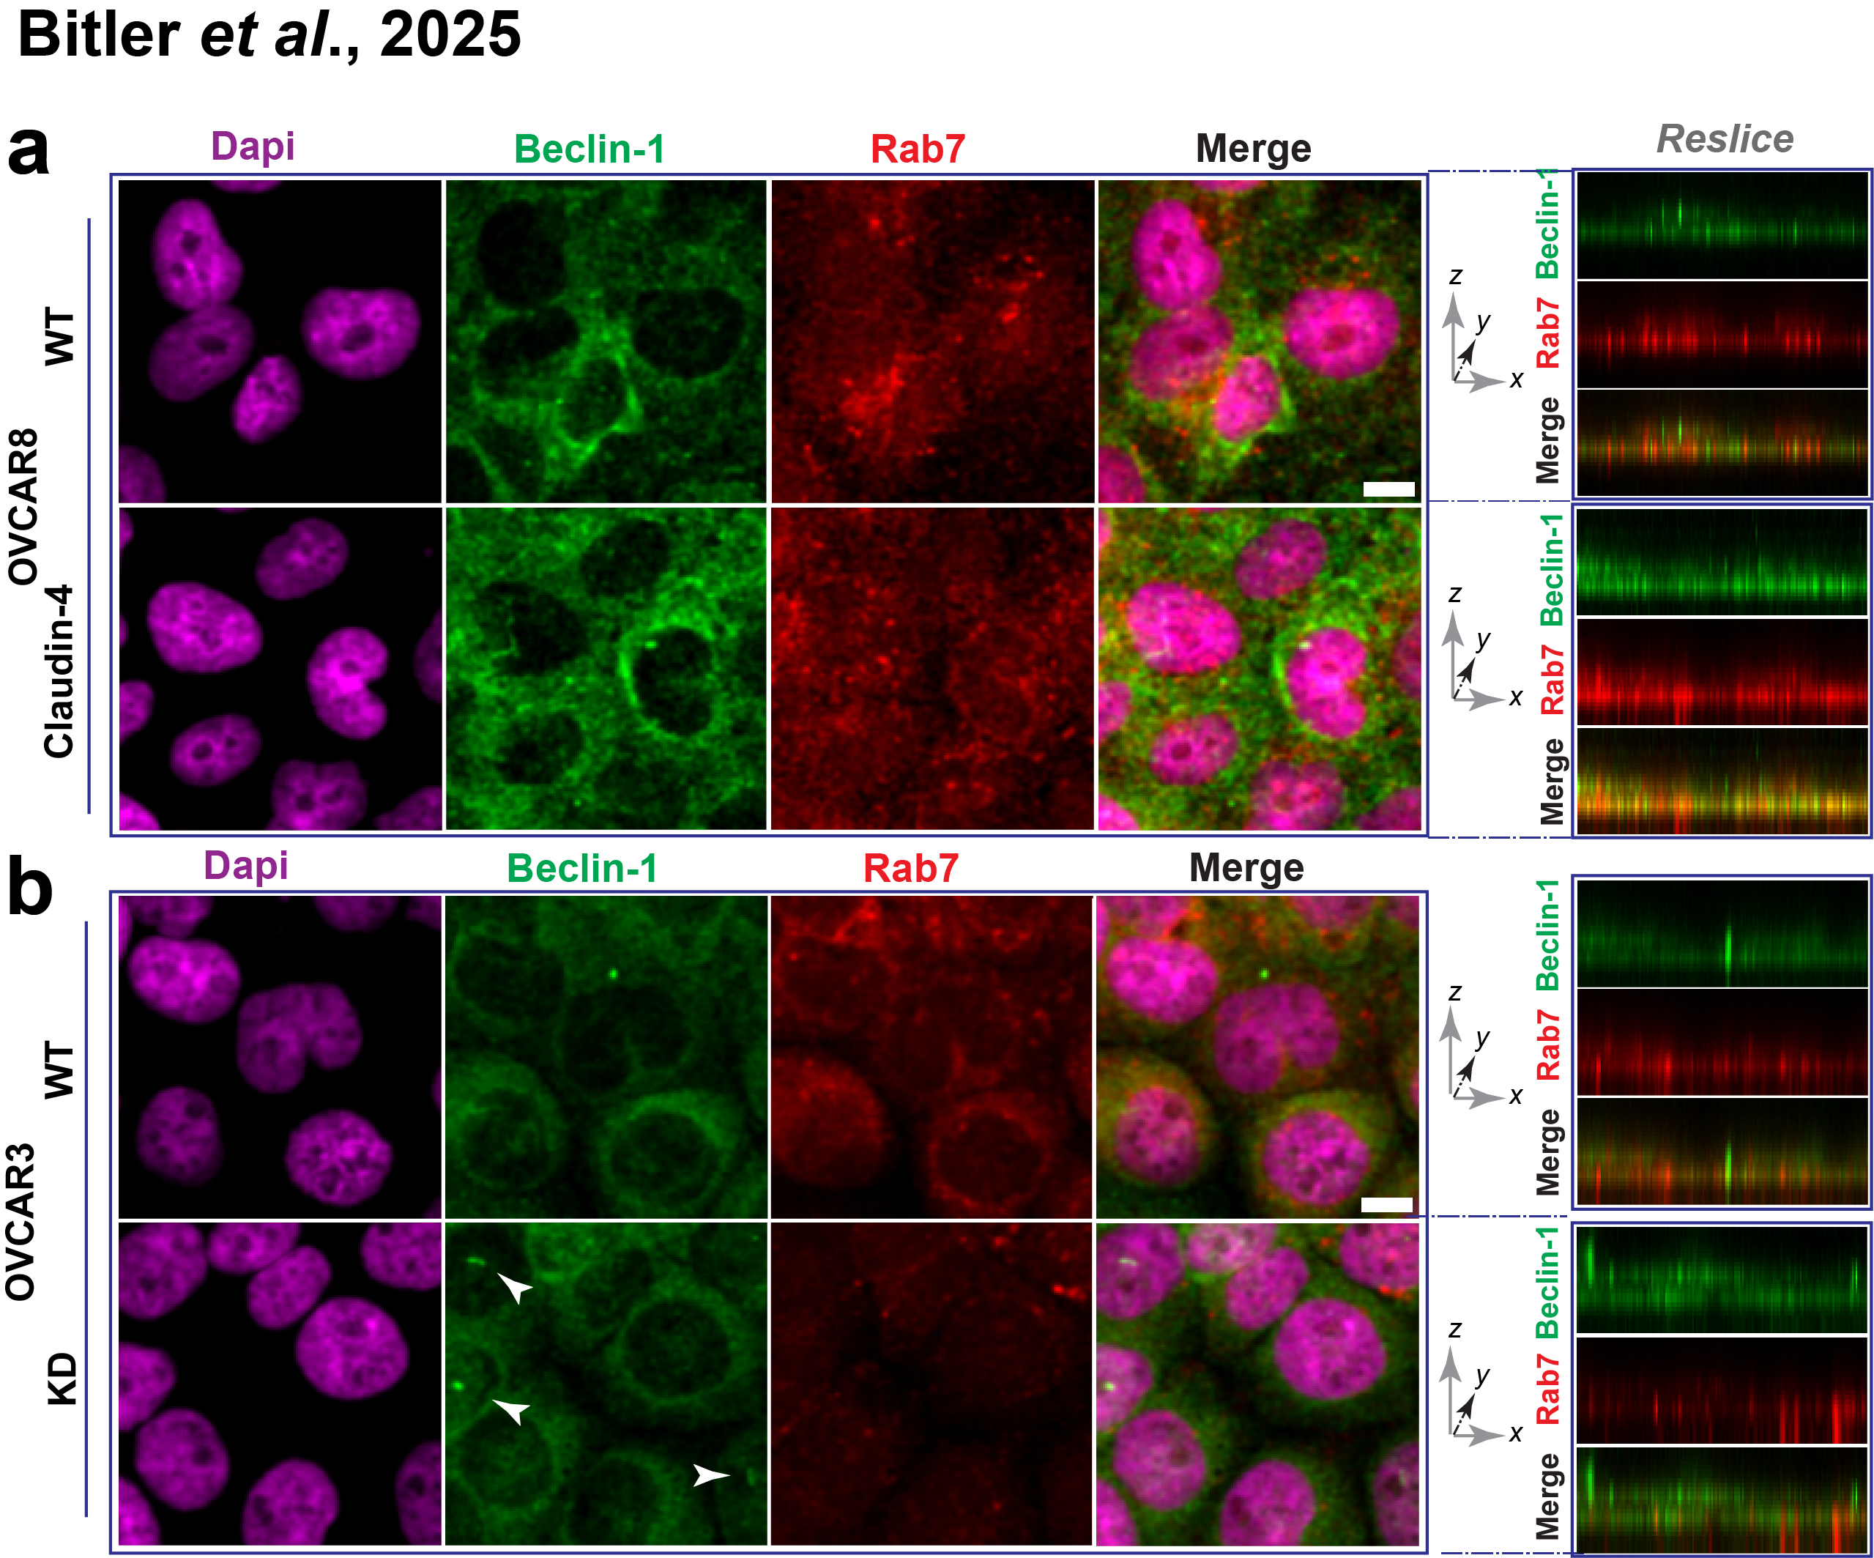
Supplementary Figure 7. Intracellular distribution of Rab7 and Beclin-1 in Claudin-4-modulated ovarian cancer cells. Ovarian cancer cells were cultured for 72 hours with no stimuli other than claudin-4 overexpression or downregulation. Following this, cells were stained to visualize the small GTPase Rab7 and Beclin-1. (a) Confocal images display the intracellular distribution of Rab7 and Beclin-1 during claudin-4 overexpression in OVCAR8 cells. The right panel shows resliced orthogonal views of the same confocal images. (b) Provides similar data for claudin-4 downregulation in OVCAR3 cells. Scale bar, 10µm.

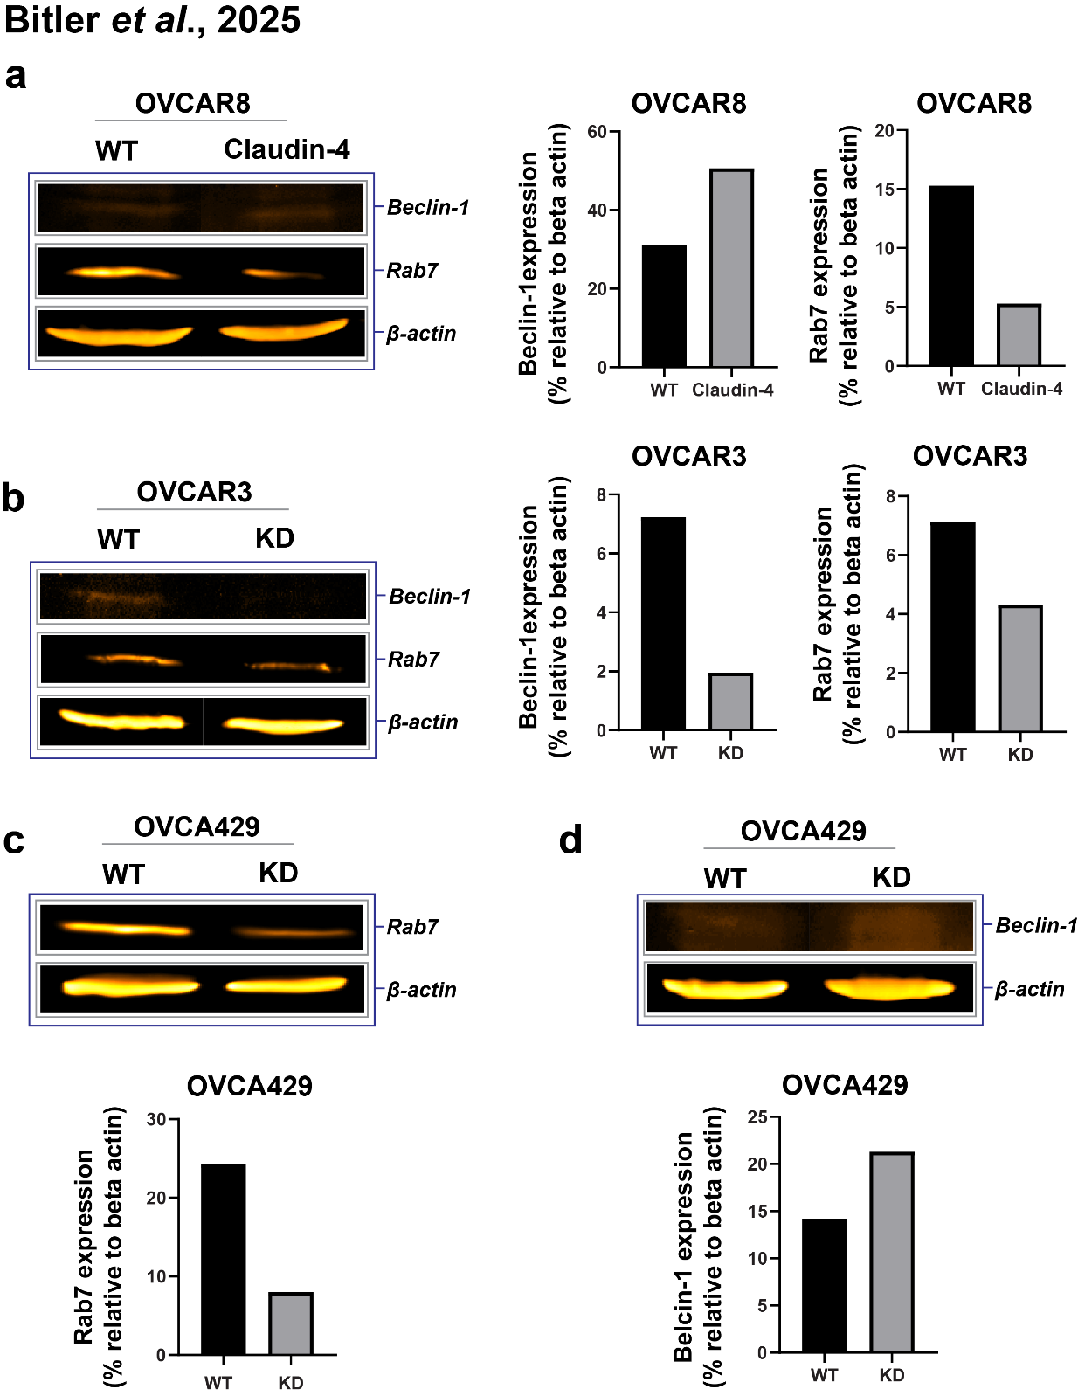
Supplementary Figure 8. Protein expression of Rab7 and Beclin-1 during claudin-4 modulation. Ovarian cancer cells were cultured under resting conditions for 48h. Protein lysate were immunoblotted for Rab7 and Beclin-1 in OVCAR8 (a), OVCAR3 (b), and OVCA429 (c) cells.

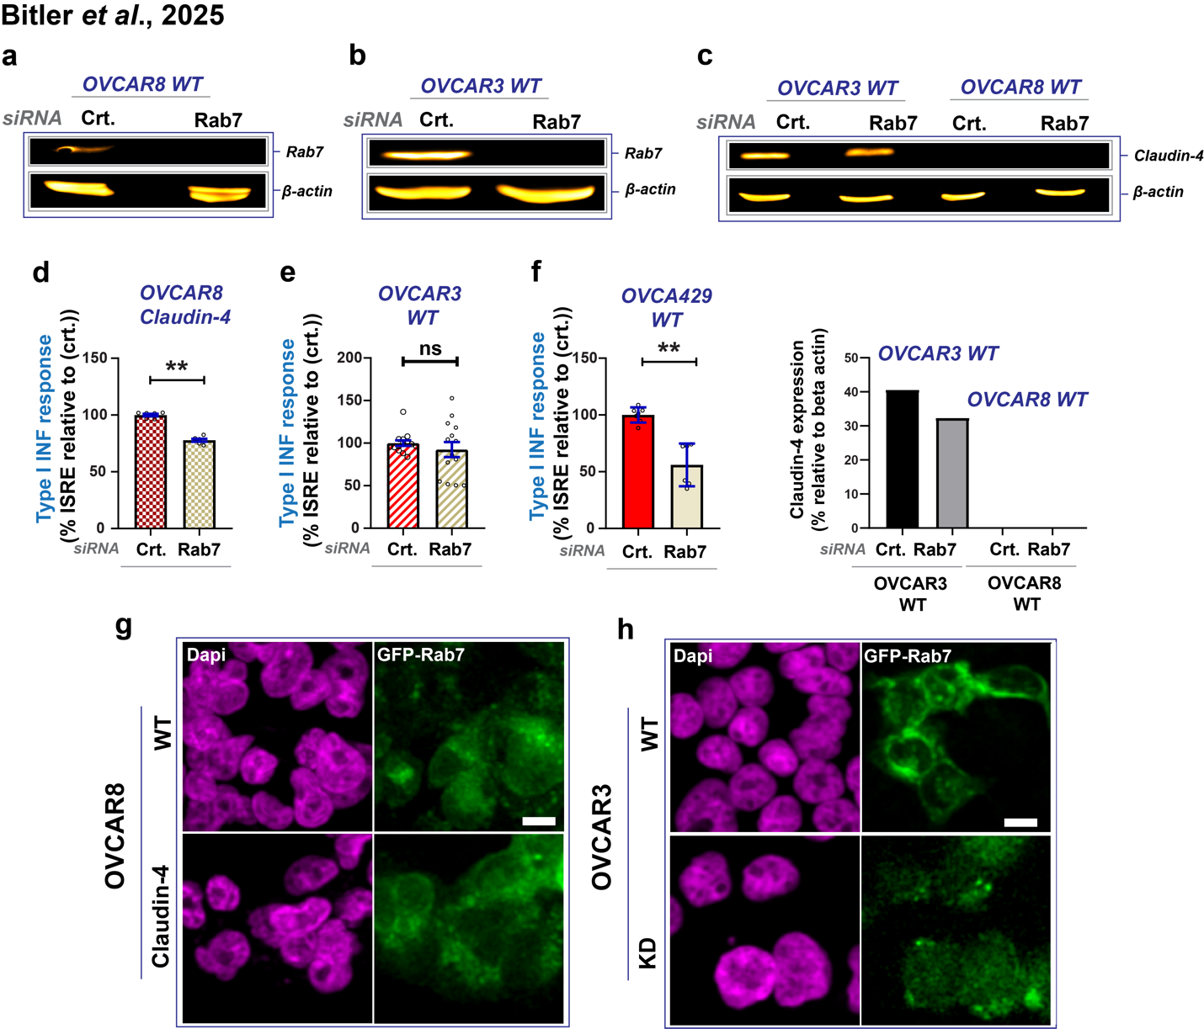
Supplementary Figure 9. ​Association of Claudin-4 with Rab7 and type I interferon response​ (a, b) Validation of Rab7 knockdown in OVCAR8 WT and OVCAR3 WT cells using specific siRNA, accompanied by immunoblotting to assess claudin-4 levels post-Rab7 silencing (protein quantification shown below) (c).​ (d) Evaluation of type I interferon response following Rab7 knockdown in cells engineered to overexpress claudin-4.​ (e, f) Assessment of type I interferon response in OVCAR3 WT and OVCA429 cells, both exhibiting endogenous claudin-4 overexpression.​ (g, h) Confirmation of GFP-Rab7 transfection in ovarian cancer cells. Crt. = control, scale bar represents 10 µm.

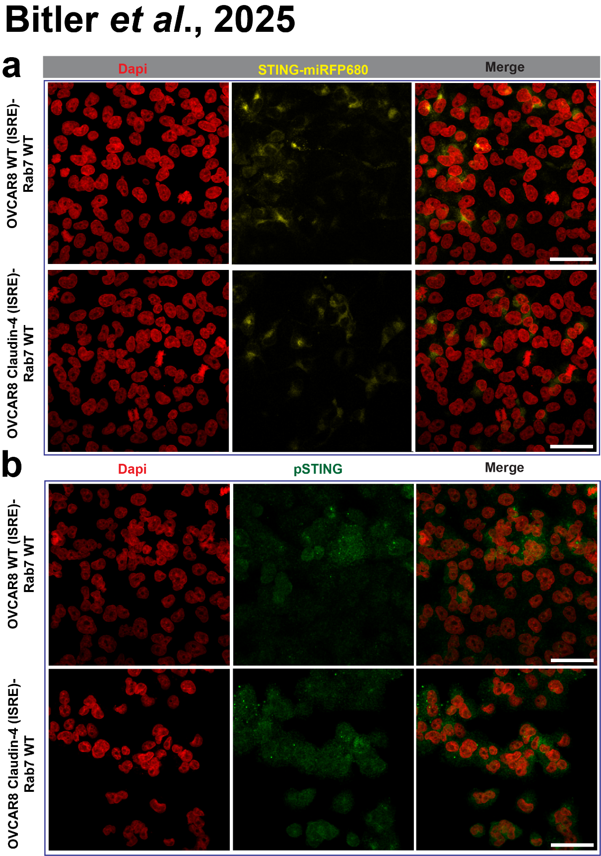

Supplementary Figure 10. (a) Confocal maximum projection images of OVCAR8 cells transiently transfected with Rab7 WT and transduced with STING-miRFP680. (b) Confocal images of OVCAR8 cells expressing ISRE, transiently transfected with Rab7 WT, and stained for pSTING. Scale bar: 50 µm.

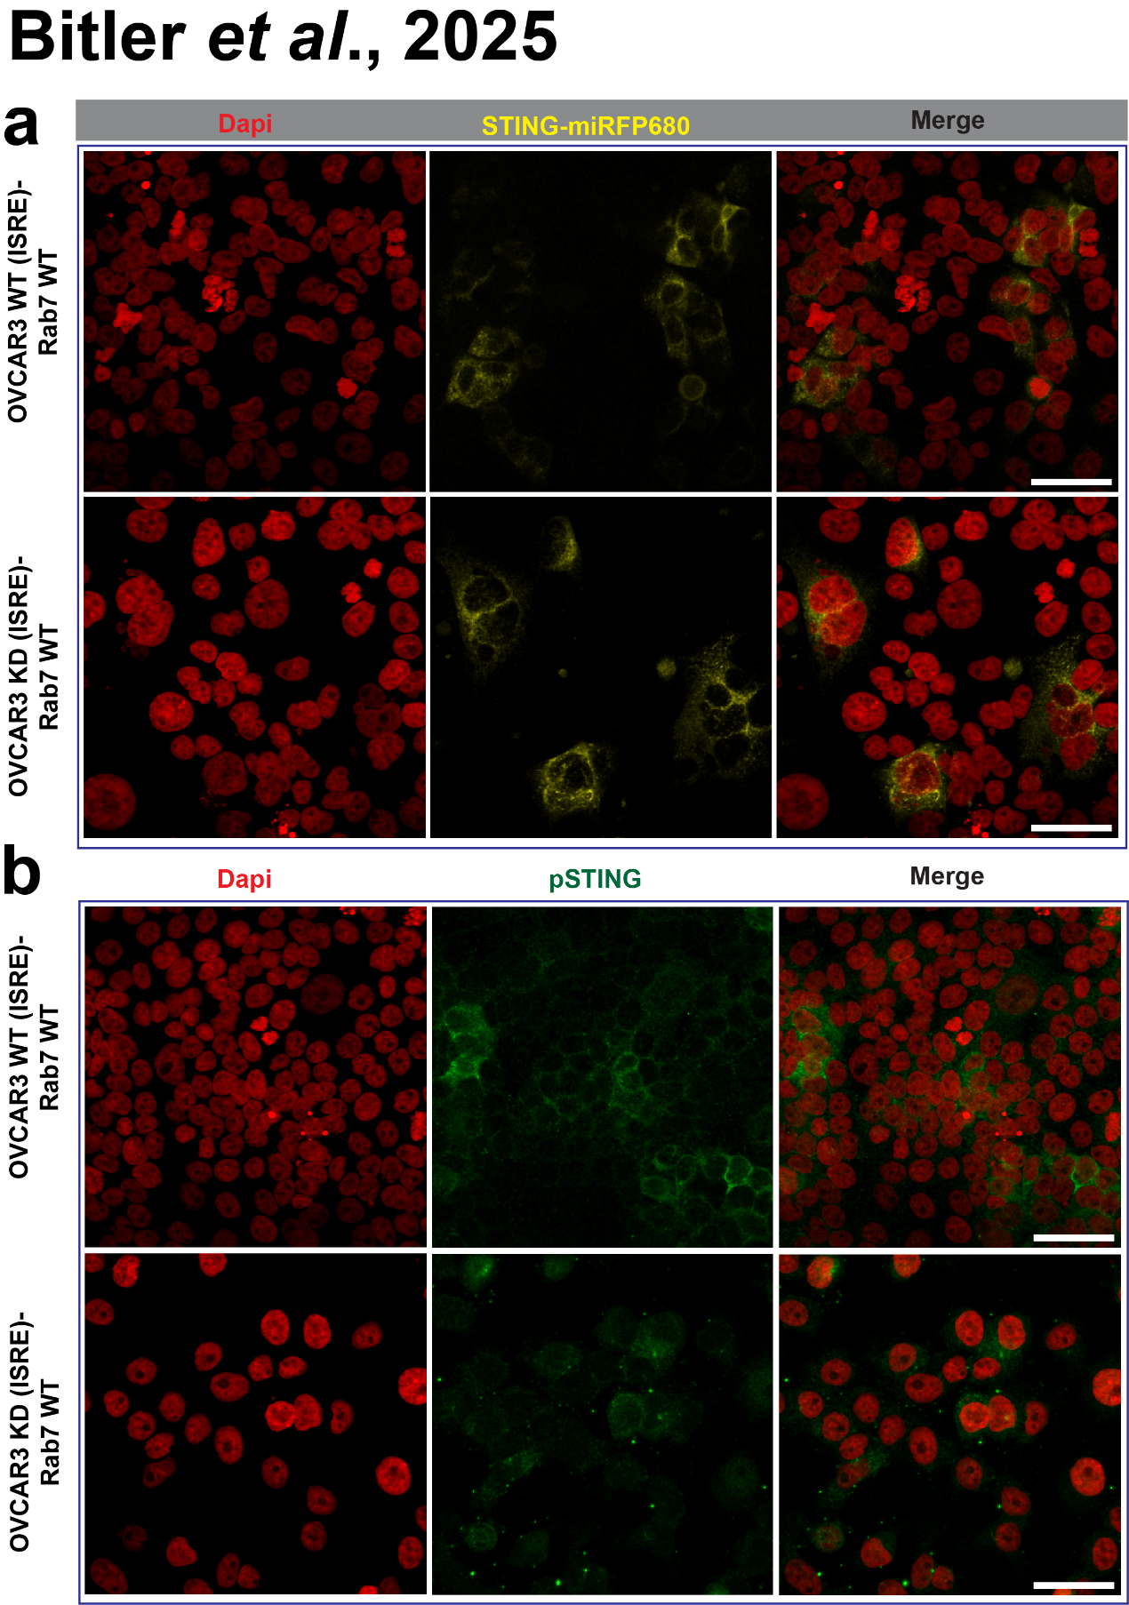

Supplementary Figure 11. (a) Confocal maximum projection images of OVCAR3 cells transiently transfected with Rab7 WT and transduced with STING-miRFP680. (b) Confocal images of OVCAR3 cells expressing ISRE, transiently transfected with Rab7 WT, and stained for pSTING. Scale bar: 50 µm.

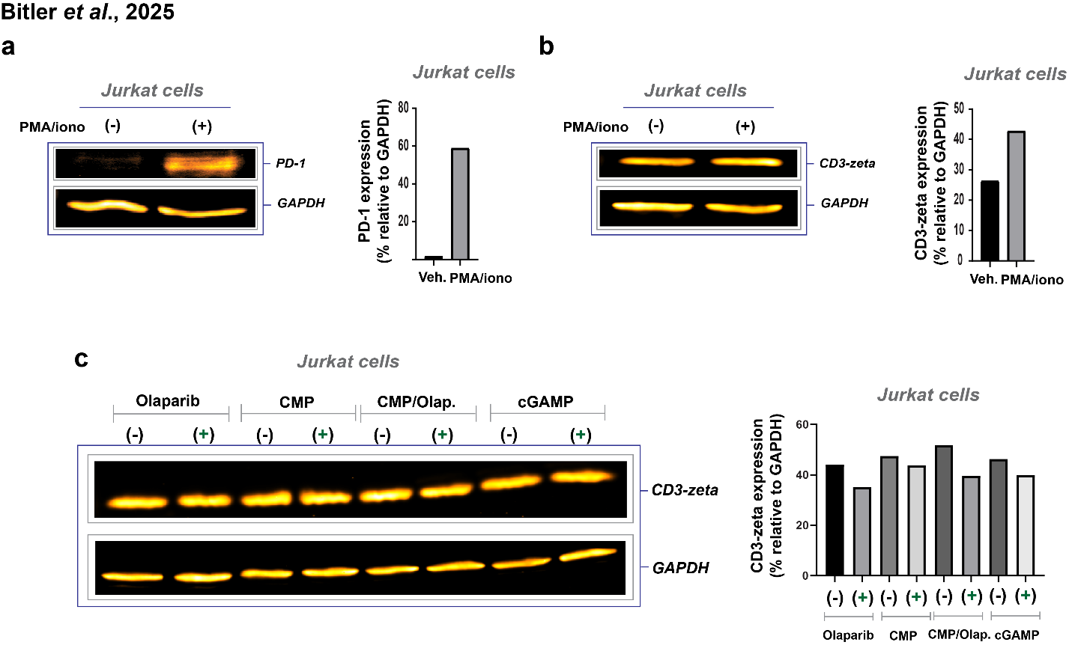
Supplementary Figure 12. Effect of PMA/Ionomycin treatment on PD-1 and CD3-Zeta expression in Jurkat cells. Jurkat cells were treated with phorbol 12-myristate 13-acetate (PMA; 100 nM) and ionomycin (iono, 500 nM) for 4 hours to induce early activation. Protein lysates were then subjected to immunoblotting to assess the expression levels of PD-1 and CD3-zeta. Panel (a) presents the immunoblot results for PD-1 and CD3-zeta (b), with corresponding protein quantifications shown on the right.​ Panel (c) displays immunoblot analyses of CD3-zeta expression under various treatment conditions over a 4-hour period: olaparib (600 nM), claudin mimic peptide (CMP; 400 µM), a combination of CMP (400 µM) and olaparib (600 nM), and cGAMP (2 µM). Quantification of CD3-zeta protein levels for each condition is provided on the right.

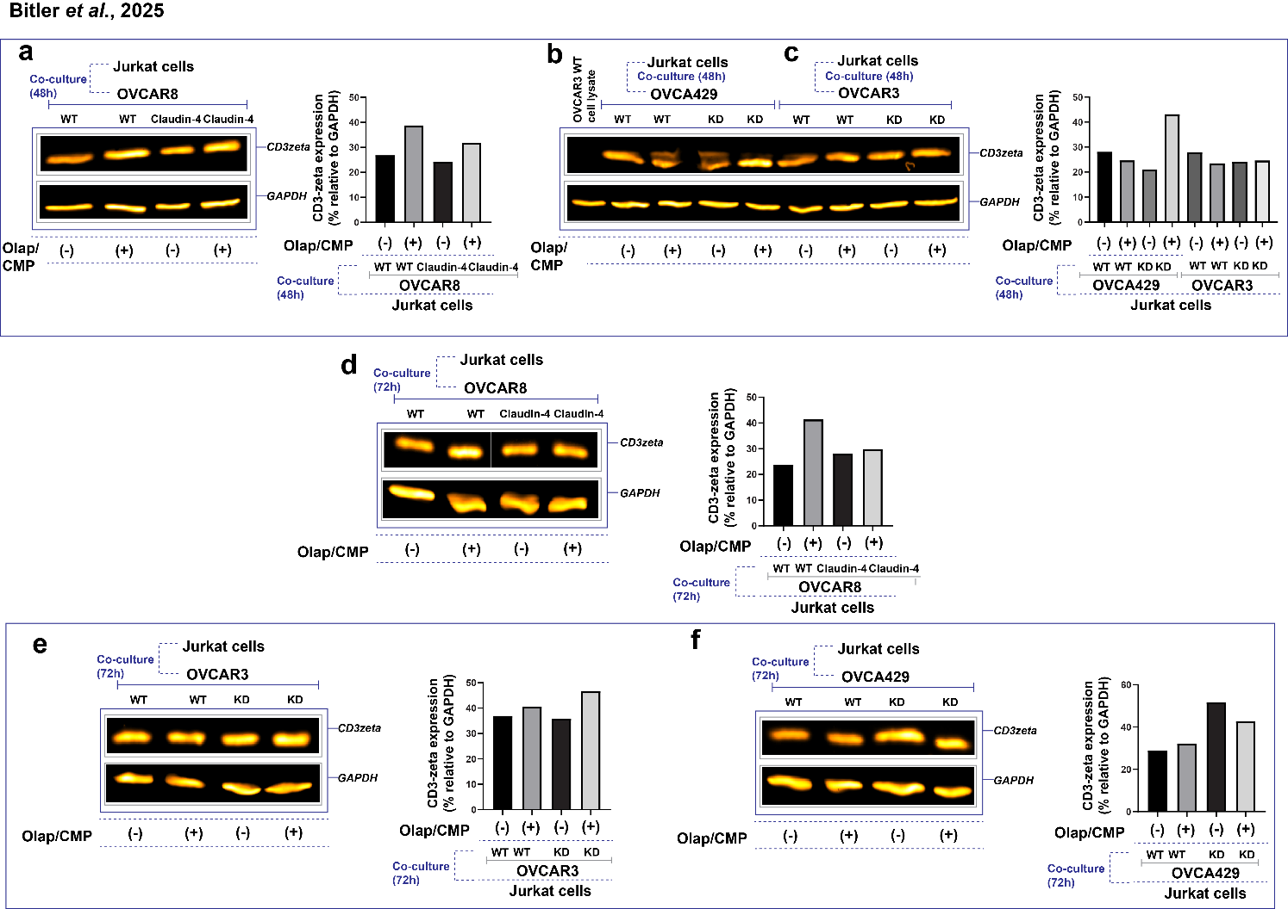
Supplementary Figure 13. Evaluation of CMP/Olaparib treatment on CD3-Zeta expression in Jurkat Cells co-cultured with ovarian cancer cells. Evaluation of CMP and Olaparib Treatment on CD3-Zeta Expression in Jurkat Cells Co-Cultured with Ovarian Cancer Cells. Jurkat cells were co-cultured with ovarian cancer cell lines—OVCAR8, OVCA429, and OVCAR3—for 48 and 72 hours, with or without treatment using claudin mimic peptide (CMP; 400 µM) and olaparib (600 nM). Following co-culture, protein lysates were subjected to immunoblotting to assess CD3-zeta expression levels.​ Panels (a), (b), and (c) display CD3-zeta expression in Jurkat cells after 48 hours of co-culture with OVCAR8, OVCA429, and OVCAR3 cells, respectively. Panels (d), (e), and (f) present CD3-zeta expression in Jurkat cells following 72 hours of co-culture with OVCAR8, OVCAR3, and OVCA429 cells, respectively. In each immunoblotting panel, the right side illustrates the relative protein quantification normalized to GAPDH.

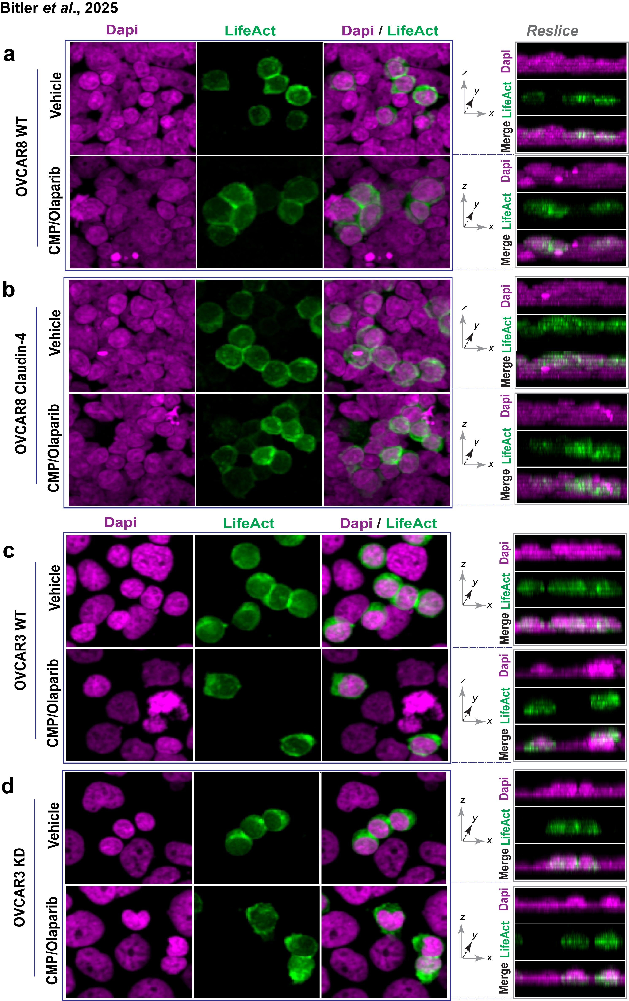

Supplementary Figure 14. Visualization of LifeAct-Expressing Jurkat Cells in Ovarian Cancer Co-Cultures. Jurkat cells expressing LifeAct were co-cultured for 72 hours with ovarian cancer cells, treated or untreated with claudin mimic peptide (CMP; 400 µM) and olaparib (600 nM). Confocal microscopy provided maximum projection images of cell interactions.​ Panels (a) and (b): Jurkat cells with OVCAR8 wild-type and claudin-4 overexpressing cells, respectively, with orthogonal views on the right.​ Panels (c) and (d): Jurkat cells with OVCAR3 wild-type (WT) and claudin-4 knockdown (KD) cells, respectively, with orthogonal views on the right.​
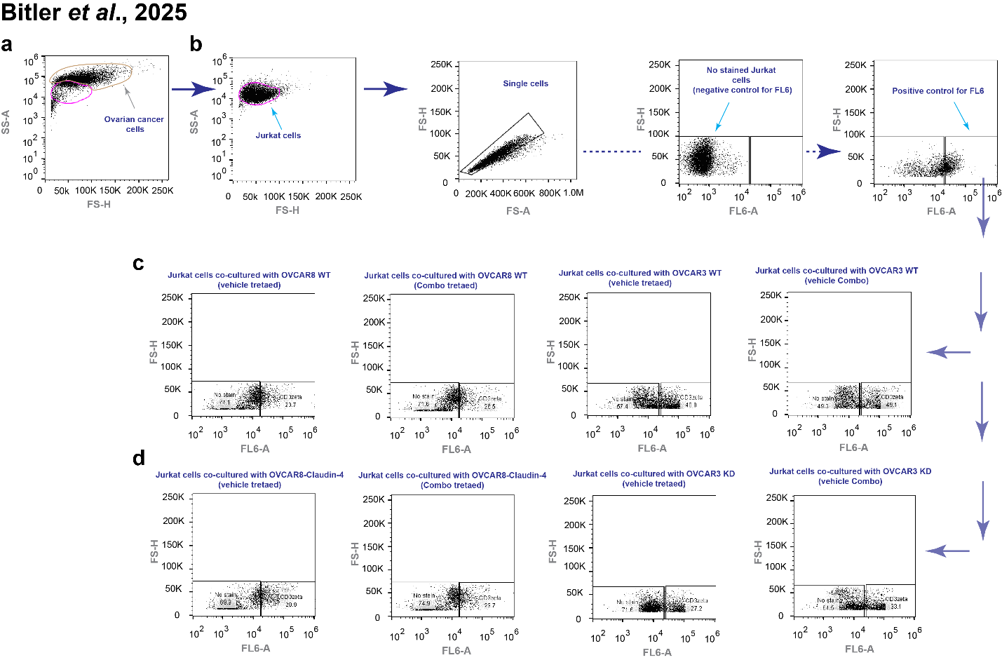
Supplementary Figure 15. Gating strategy to measure CD3-zeta chain expression in Jurkat cells. (a) Dot plot showing the gating (exclusion) of the ovarian cancer cell population. (b) Dot plot identifying the Jurkat cell population, singlets, and the positive fluorescence control. (c) Representative dot plots illustrating CD3-zeta chain expression in Jurkat cells co-cultured with OVCAR8 cells (wild-type and claudin-4 overexpressing) and treated with a combination of CMP (400 µM) and the PARP inhibitor olaparib (600 nM) for 72 hours. (d) Similar results are shown for co-cultures with OVCAR3 cells (wild-type and claudin-4 knockdown). Data were normalized to the mean CD3-zeta chain expression in Jurkat cells co-cultured with untreated wild-type cells.

.​

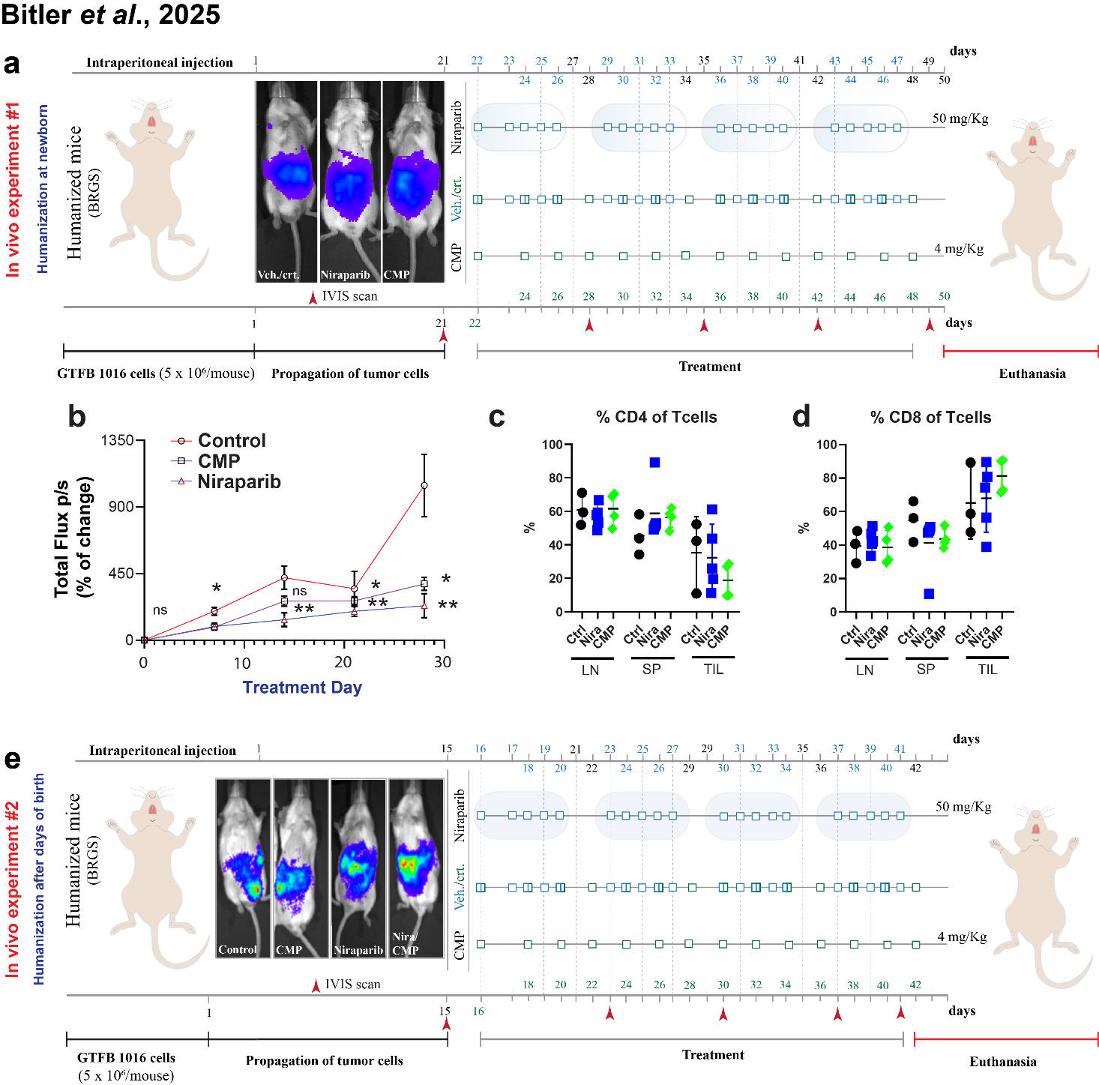
Supplementary Figure 16. (a), experimental design for targeting claudin-4 in primary tumor, in a humanized mouse model (experiment #1, newborn mice were treated to induced development of human immune system) (Tumor implantation was confirmed by IVIS scan). (b), tumor growth inhibition based on IVIS scan from experiment #1 (n= control peptide group 5; CMP, 6; and niraparib, 6 mice) (2-way ANOVA and Tukey multiple comparison test). (c) and (d), % T-CD4+ and T-CD8+ quantified in humanized tumor-bearing mice, from experiment #1. (e), experimental design for targeting claudin-4 in primary tumor, in a humanized mouse model (experiment #2, mice without weaning were treated to induced development of human immune system).

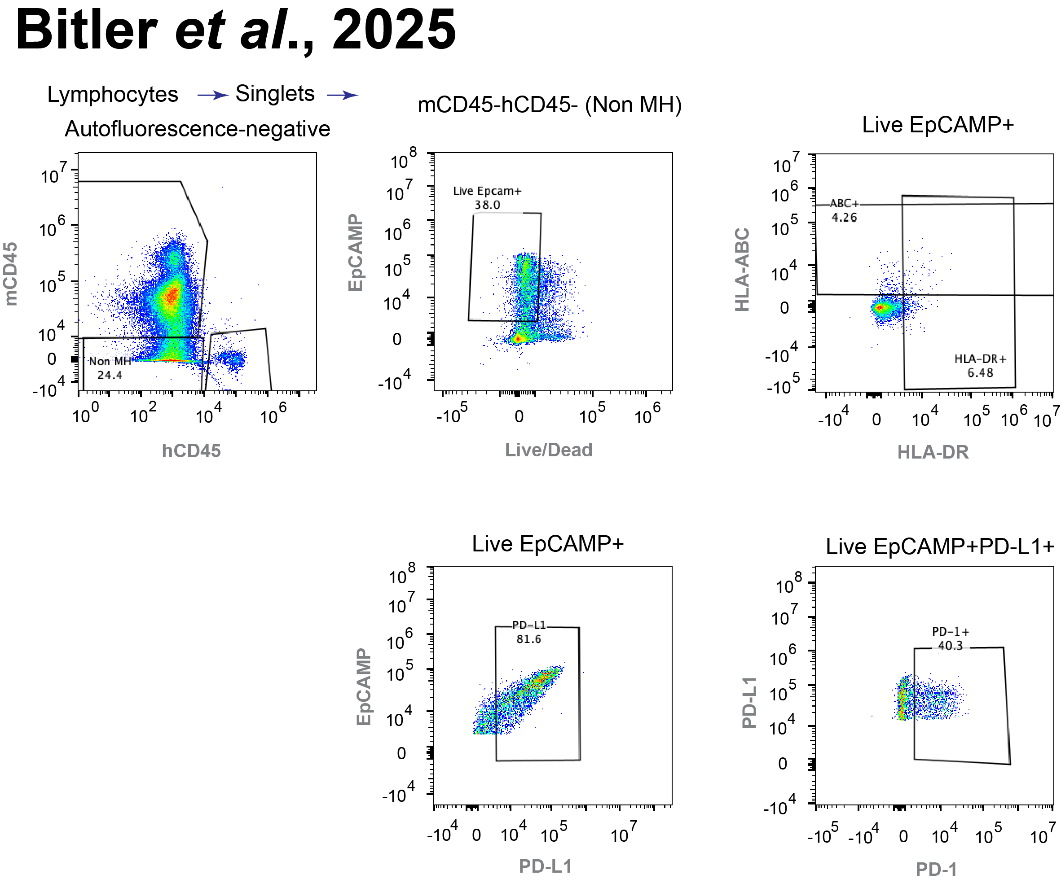

Supplementary Figure 17. Flow cytometric gating strategy used to measure the expression of human MHC Class I (HLA-ABC), Class II (HLA-DR), and the inhibitory receptors PD-L1 and PD-1 on live hEpCAM⁺ tumor cells, shown as an example. Cells were gated by excluding the immune (mouse or human) populations, with human EpCAM serving as a marker for human tumor cells. Labels above the flow plots indicate the parent gate.

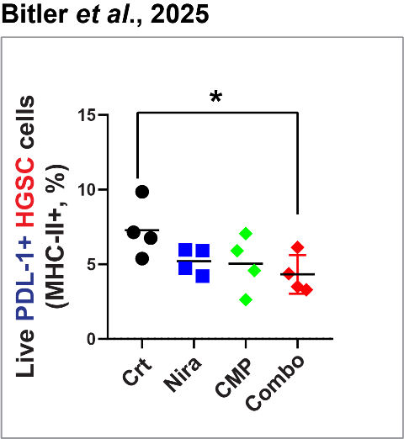

Supplementary Figure 18. From experiment #2, % of tumor cells with MHC-II that express PDL-1. (every symbol represents data from a different mouse) (n=Control (Crt.), 4 mice; CMP, 4 mice; niraparib, 4 mice; niraparib/CMP, 5 mice; Brown-Forsythe ANOVA test and unpaired t-test with Welch's correction; p<0.05). Graphs show mean.

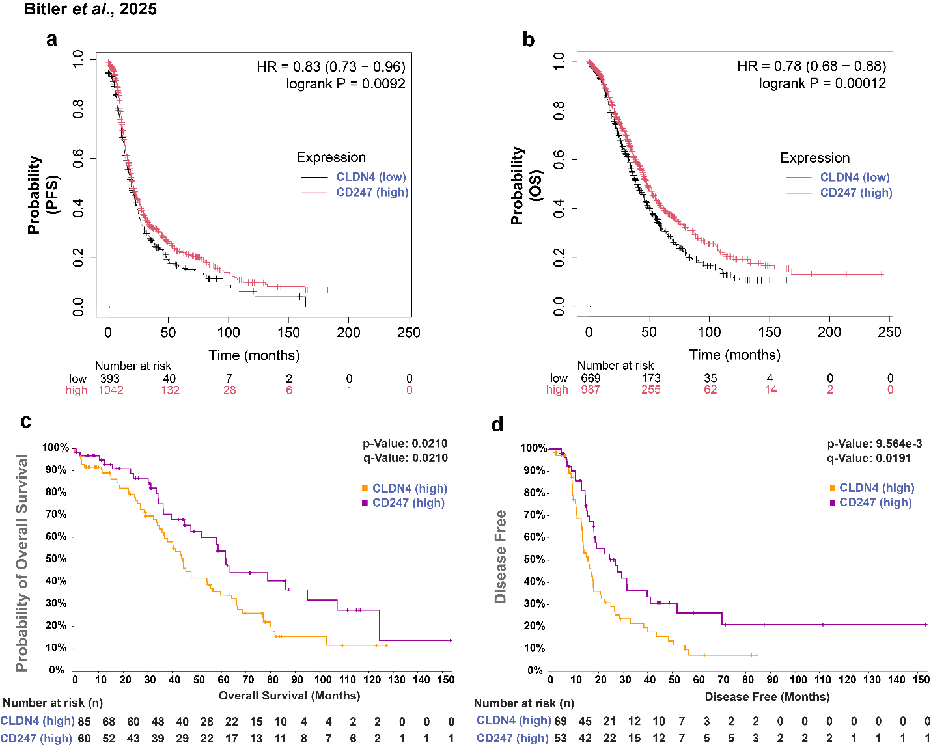
Supplementary Figure 19. CD247 (TCR-zeta chain) expression in ovarian cancer. (a, b) Panels display disease-free survival (PFS; n = 1,435) and overall survival (OS; n = 1,656) probabilities in ovarian cancer samples with low claudin-4 and high CD247 expression, respectively. (c, d) The panels show the probability of overall survival and disease-free survival associated with co-expression of high levels of claudin-4 (CLDN4) and CD247, based on data from ovarian serous cystadenocarcinoma samples (TCGA; n = 617) analyzed using cBioPortal.

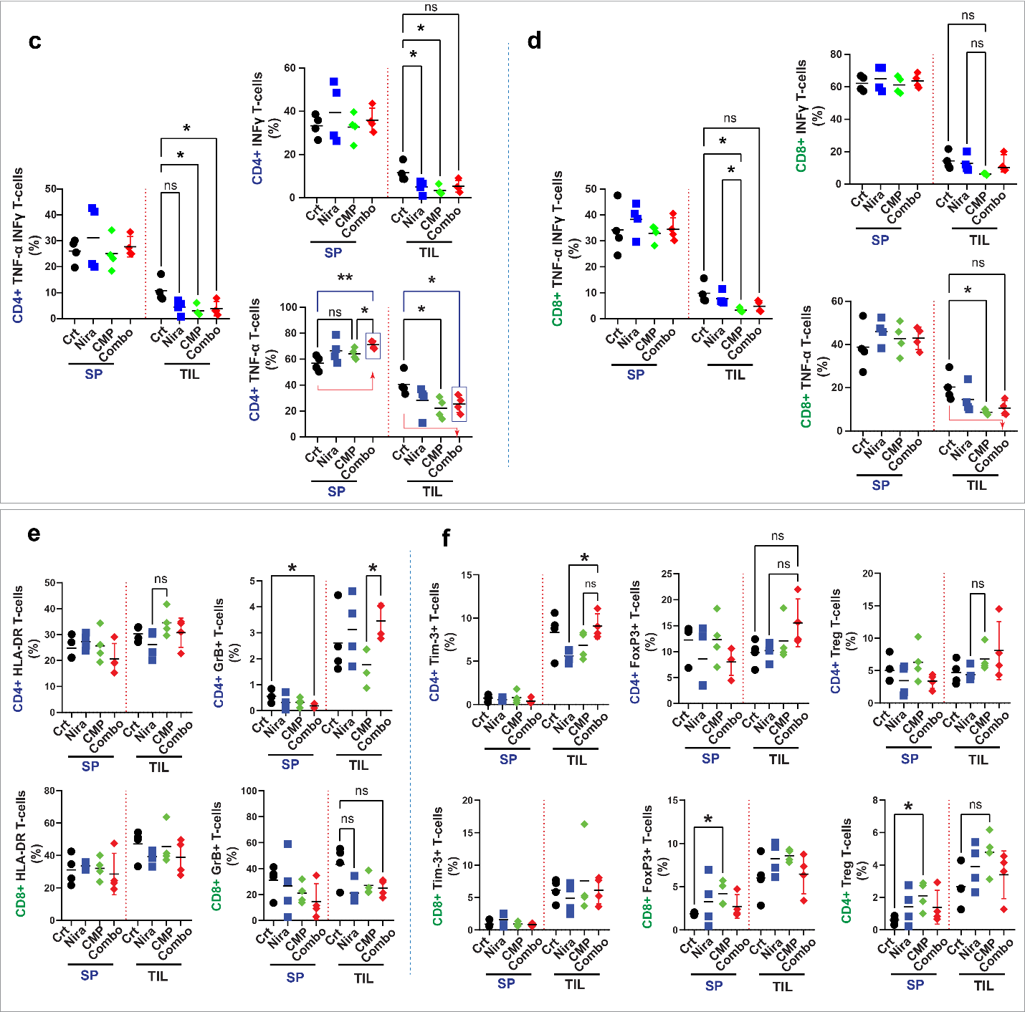
Supplementary Figure 20. From experiment #2, (a) and (b), identification of lymphocytes CD4+ and CD8+ producers of TNF-α and INF-ɣ by flow cytometry. (c) and (d), quantification of lymphocytes CD4+ and CD8+ positive for HLA-DR and GrB. (f) Identification of lymphocytes CD4+ and CD8+ with expression of Tim3, FoxP3, and Treg (T regulatory cell) phenotype, respectively (All data derives from gate: live human immune cells, T cells, CD4+ and CD8+, respectively). Graphs show mean (every symbol represents data from a different mouse) (n=Control, 4 mice; CMP, 4 mice; niraparib, 4 mice; niraparib/CMP, 5 mice; Brown-Forsythe ANOVA test and unpaired t-test with Welch's correction; p<0.05).

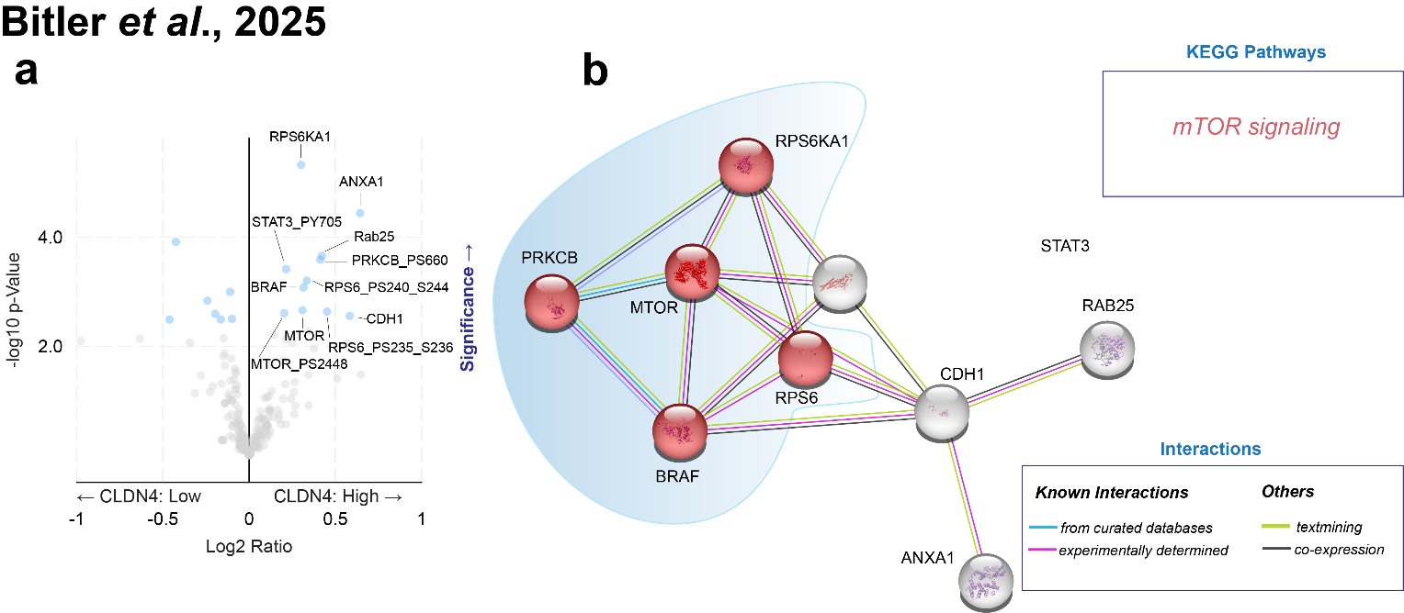

Supplementary Figure 21. Analysis of Claudin-4 (CLDN4) expression in ovarian tumors. (a) Significantly upregulated proteins (light blue circles) in tumors with high CLDN4 expression (Z-score >1; n=101/100) compared to those with low CLDN4 expression (Z-score <–1; n=73/72). (b) Protein–protein interaction network of the significantly upregulated proteins in the CLDN4-high group, highlighting the mTOR signaling pathway as a representative pathway based on KEGG annotations.

