Supplementary Figure 2, Villagomez, 2024
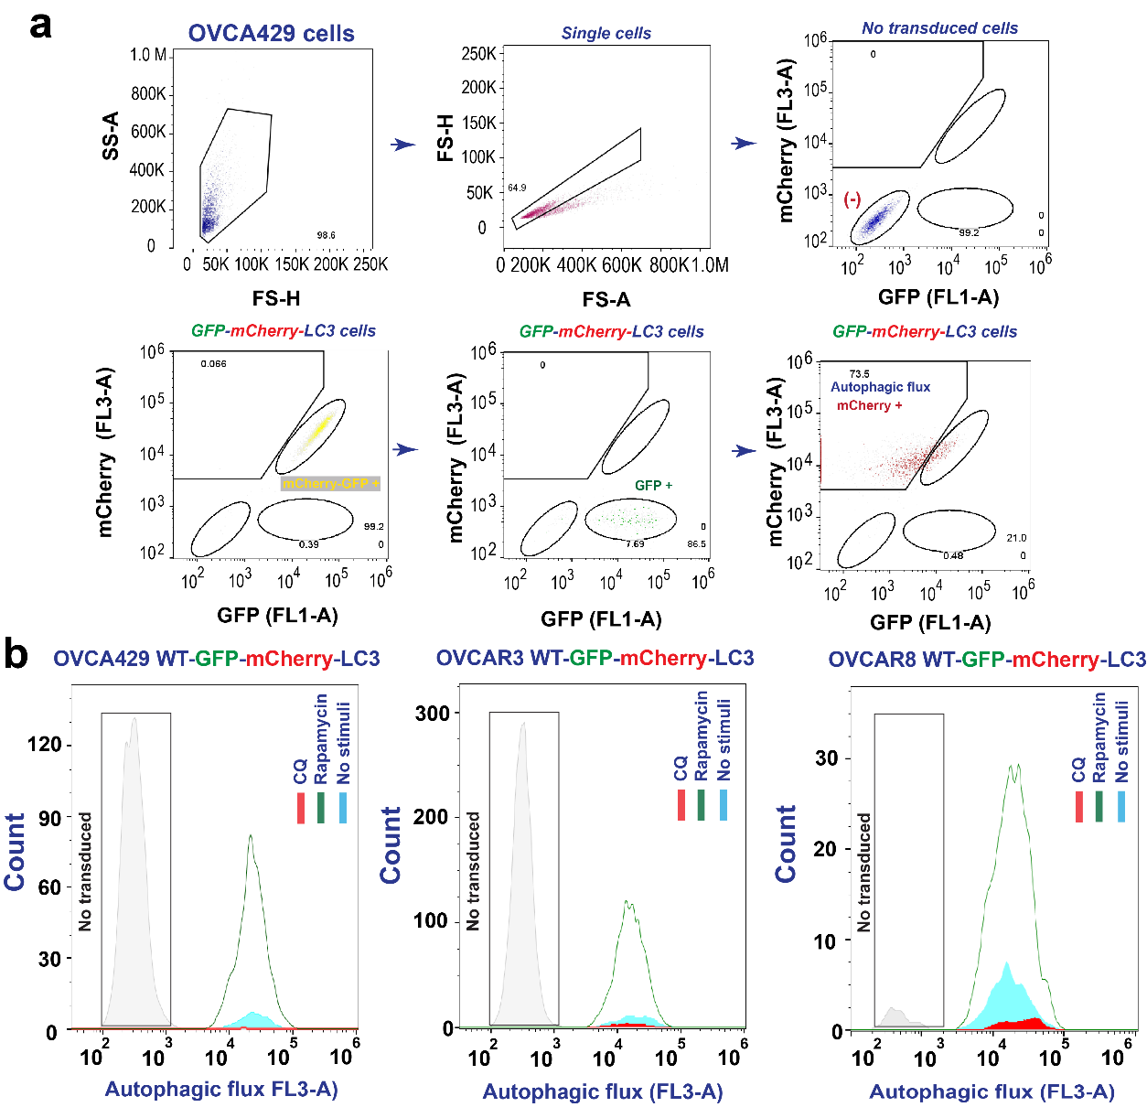

Supplementary Figure 2. (a) Autophagy flux strategy for flow cytometry using HGSC cells expressing GFP-mCherry-LC3. (b) Confirmation of autophagy flux in HGSC cells- GFP-mCherry-LC3 (OVCAR8 WT, OVCA429 WT, OVCAR3 WT). Chloroquine (CQ) at 40µM for 24h was employed to demonstrate the blocking of autophagy, while rapamycin (rap) at 8µM for 24h was used to illustrate the activation of autophagy.

