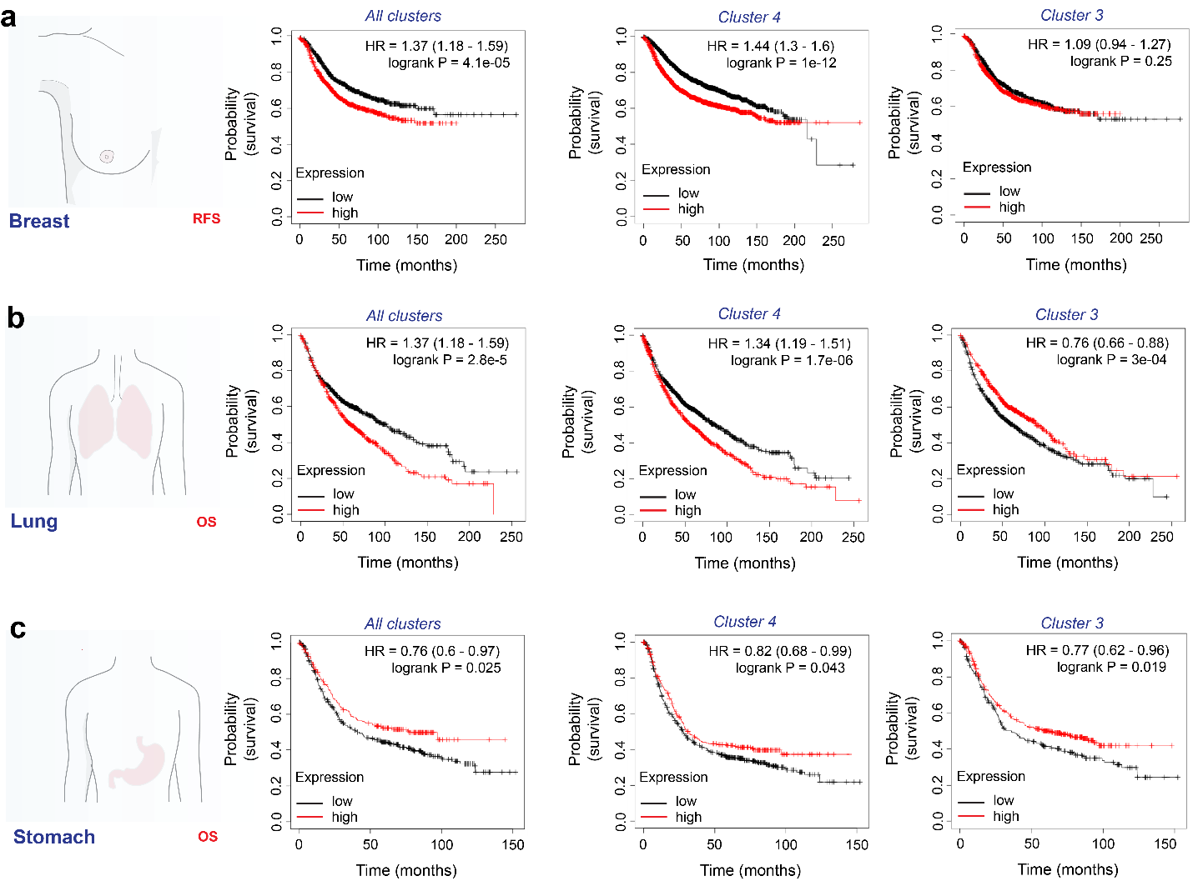
Supplementary Figure 4, Villagomez, 2024

Supplementary Figure 4. (a), correlation analysis of relapse-free survival (RFS) in breast cancer, (b) overall survival (OS) in lung, and OS in (c) stomach cancer with identified claudin-4 clusters (all, cluster 4 and cluster 3) (significance p<0.05) (Kaplan-Meir Plotter).

Supplementary bibliographic references:
1. Gehne, N., Lamik, A., Lehmann, M., Haseloff, R.F., Andjelkovic, A.V., and Blasig, I.E. (2017). Cross-over endocytosis of claudins is mediated by interactions via their extracellular loops. PloS one 12, e0182106. 10.1371/journal.pone.0182106.
2. Piontek, J., Winkler, L., Wolburg, H., Muller, S.L., Zuleger, N., Piehl, C., Wiesner, B., Krause, G., and Blasig, I.E. (2008). Formation of tight junction: determinants of homophilic interaction between classic claudins. FASEB J 22, 146-158. 10.1096/fj.07-8319com.
3. Baumgartner, H.K., Beeman, N., Hodges, R.S., and Neville, M.C. (2011). A D-peptide analog of the second extracellular loop of claudin-3 and -4 leads to mislocalized claudin and cellular apoptosis in mammary epithelial cells. Chem Biol Drug Des 77, 124-136. 10.1111/j.1747-0285.2010.01061.x.
4. Hicks, D.A., Galimanis, C.E., Webb, P.G., Spillman, M.A., Behbakht, K., Neville, M.C., and Baumgartner, H.K. (2016). Claudin-4 activity in ovarian tumor cell apoptosis resistance and migration. BMC Cancer 16, 788. 10.1186/s12885-016-2799-7.

