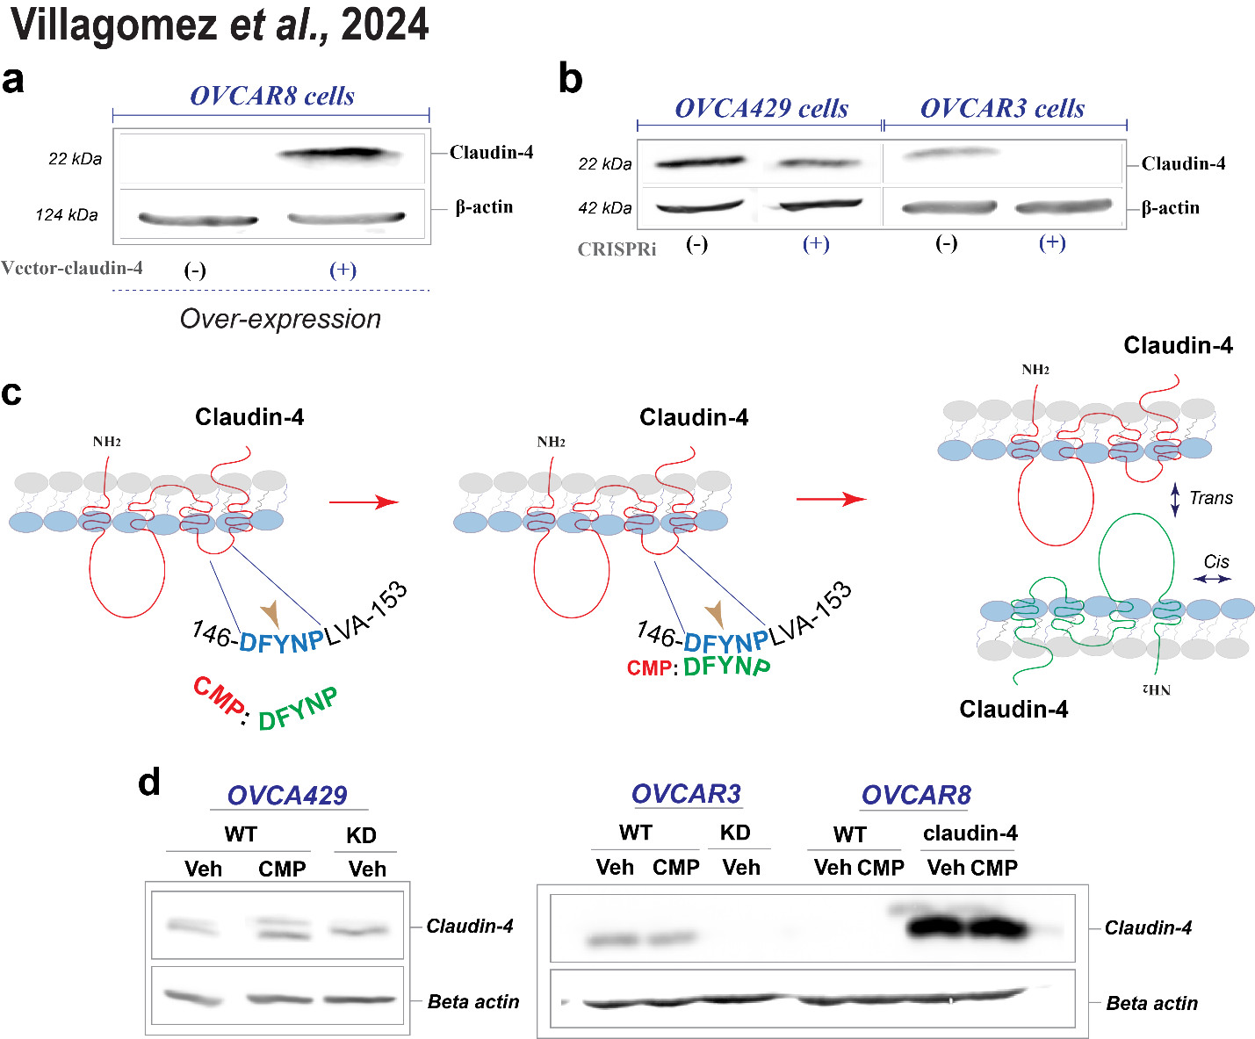
Supplementary Figure 1. (a) Verification of claudin-4 overexpression (left) in OVCAR8 cells (which do not express claudin-4) and its downregulation (knockdown using CRISPRi in OVCA429 and OVCAR3 cells) (b) by immunoblotting. (c) Drawing highlighting the structure of claudin-4, observing two extracellular loops (large and small). It also illustrates that CMP (claudin mimic peptide), a small peptide containing 5 amino acids (DFYNP), targets a conserved sequence in claudin-4 localized in the small extracellular loop, which potentially interferes with claudin-4 interaction with other protein partners. (1-4) (d) Immunoblotting for claudin-4 after treatment CMP treatment (400µmol/L (µM) for 48h), highlighting no evident changes in claudin-4 expression due to CMP treatment.

