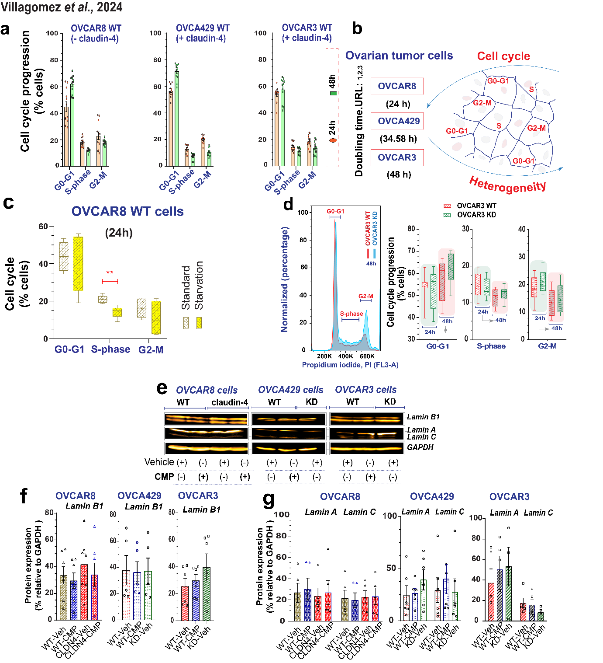
Supplementary Figure 2. (a) Graphs show WT ovarian tumor cells in different phases of the cell cycle (green symbol at 24h; red symbol at 48h). (b) Drawing highlighting heterogeneity of ovarian tumor cells, indicated as localization in different phases of cell cycle (references: URL 1-3). Also, it highlights differences in doubling time among different ovarian tumor cells. (c) Representative histograms of cell cycle phases during claudin-4 downregulation in OVCAR3 cells at 24h and 48h (4 independent experiments, Two-tailed Unpaired t test; significance p<0.05; Graphs show min to max, + indicates mean). (d) Quantification of cell cycle progression by flow cytometry of propidium iodide-stained OVCAR8 WT cells during standard (RPMI, 10% FBS) culture conditions or starvation (RPMI, 1% FBS). (e) immunoblotting for lamin B1 and lamin A/C and corresponding quantification (f, lamin B1; g, lamin A/C) relative to loading control (4 independent experiments), respectively. (One-way ANOVA and Tukey's multiple comparisons test; p<0.5). Graphs show mean and SEM.

