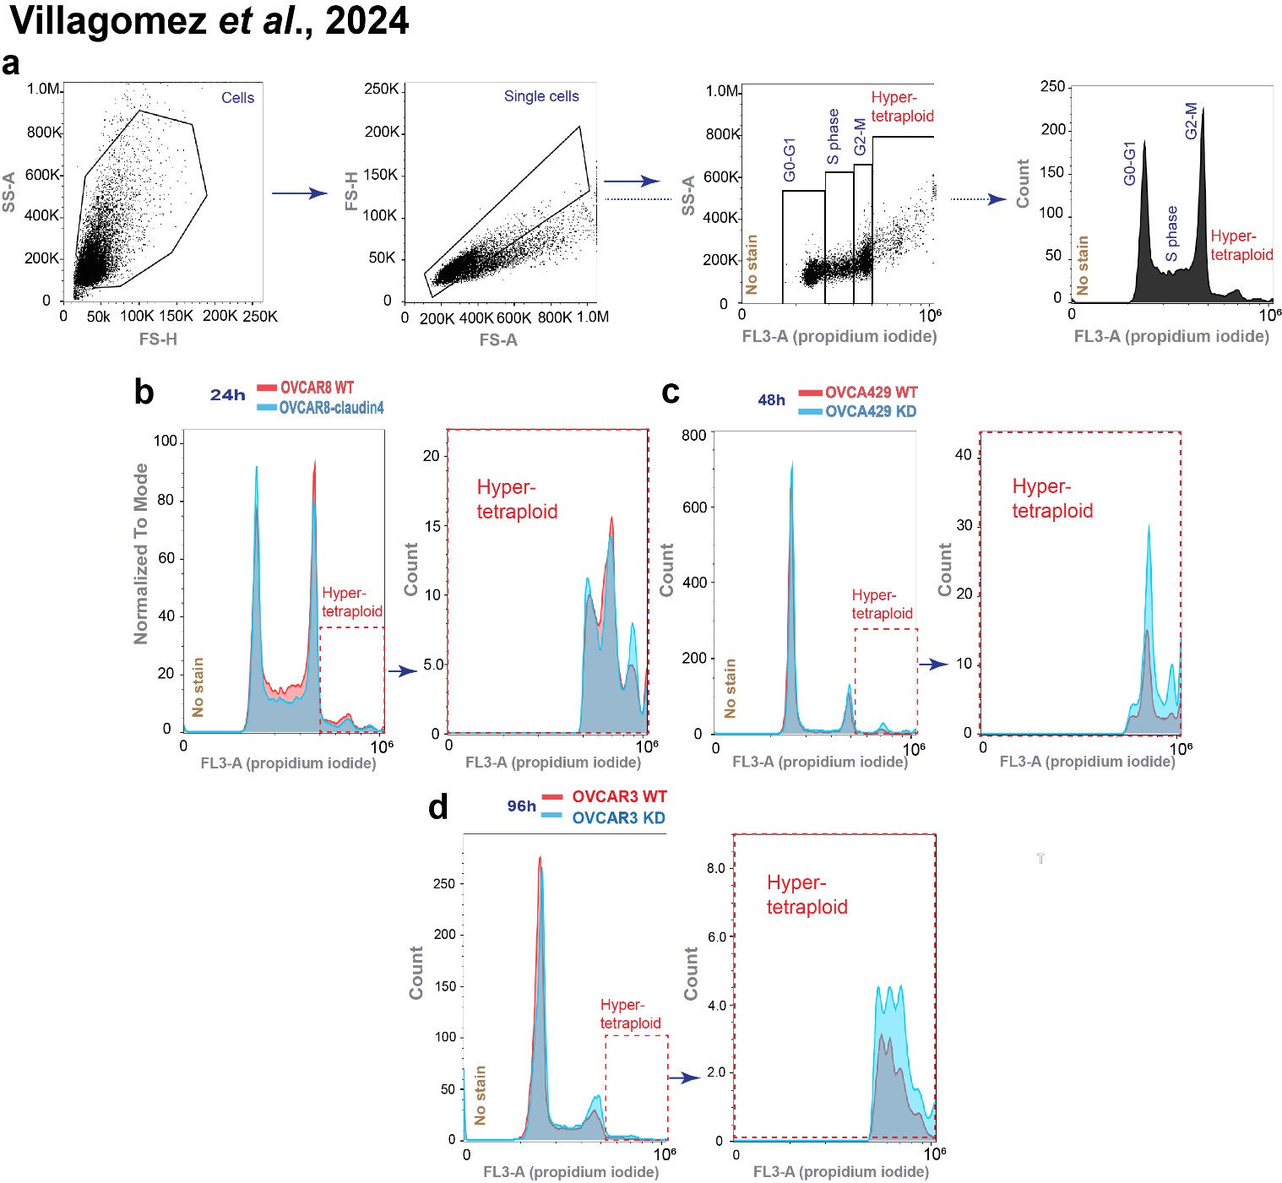
Supplementary Figure 3. Flow cytometry strategy to localize hypertetraploid aneuploidy in epithelial ovarian cancer cells. (a) Dot plots show a population of cells, then a gate for single cells, and finally a gate for propidium iodide (PI) positive cells. On the right, the same gate is shown in histogram. (b) Selected histogram for OVCAR8 cells positive for PI during cell cycle at 24h and gate for hypertetraploid aneuploidy. (c) Similar information is shown for OVCA429 at 48h and OVCAR3 cells at 96h (d).

