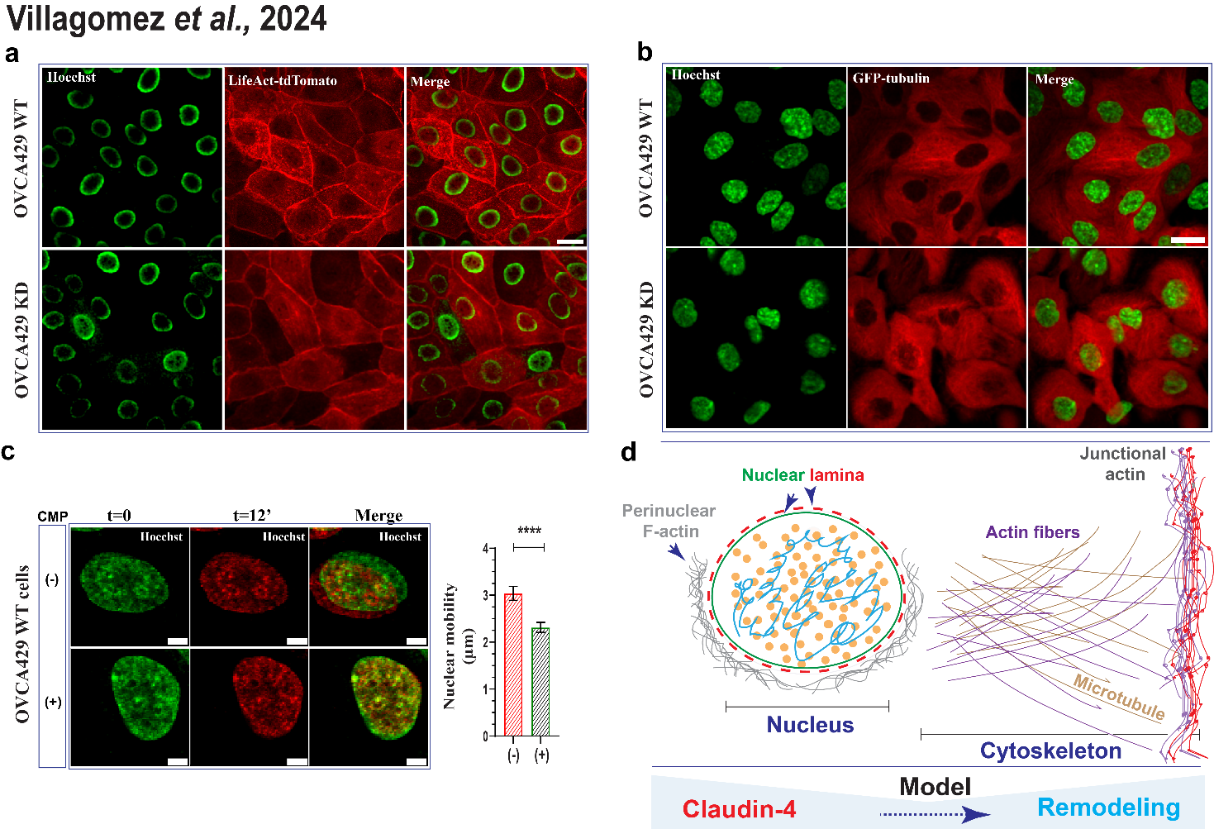
Supplementary Figure 5. Live cell imaging evaluation of ovarian tumor cells. (a) Shows representative confocal images of living cells expressing LifeAct-tdTomato (marker of F-actin) without any stimuli. (b) shows representative confocal images of living cells (xyt; maximum projections) of cells expressing GFP-tubulin without any stimuli. (c) Shows selected confocal images (xyt/30min/37ºC) of nucleus at different time points (cells treated with CMP; 400µmol/L for 24h or left untreated), which were overlaid to highlight the nuclear mobility; right, quantification of nuclear mobility (n= no treated, 44 cells; CMP treated, 41 cells; 4 independent experiments; Kruskal-Wallis test and Dunn’s multiple comparison test, p<0.5). (d) Presents a model that highlights our findings on the role of claudin-4 in the remodeling of the nucleus and cytoskeleton. Nuclear remodeling was linked to alterations in lamin B1 localization, resulting in changes to the nuclear lamina, along with the accumulation of perinuclear F-actin. Cytoskeletal remodeling involves changes in actin fibers, the microtubule network, and junctional F-actin, which supports cell-to-cell junctions, potentially impacting nucleus positioning, cell cycle, and cell morphology. Graph shows mean and SEM, scale bars 5µm (c) and 20µm (a, b).

