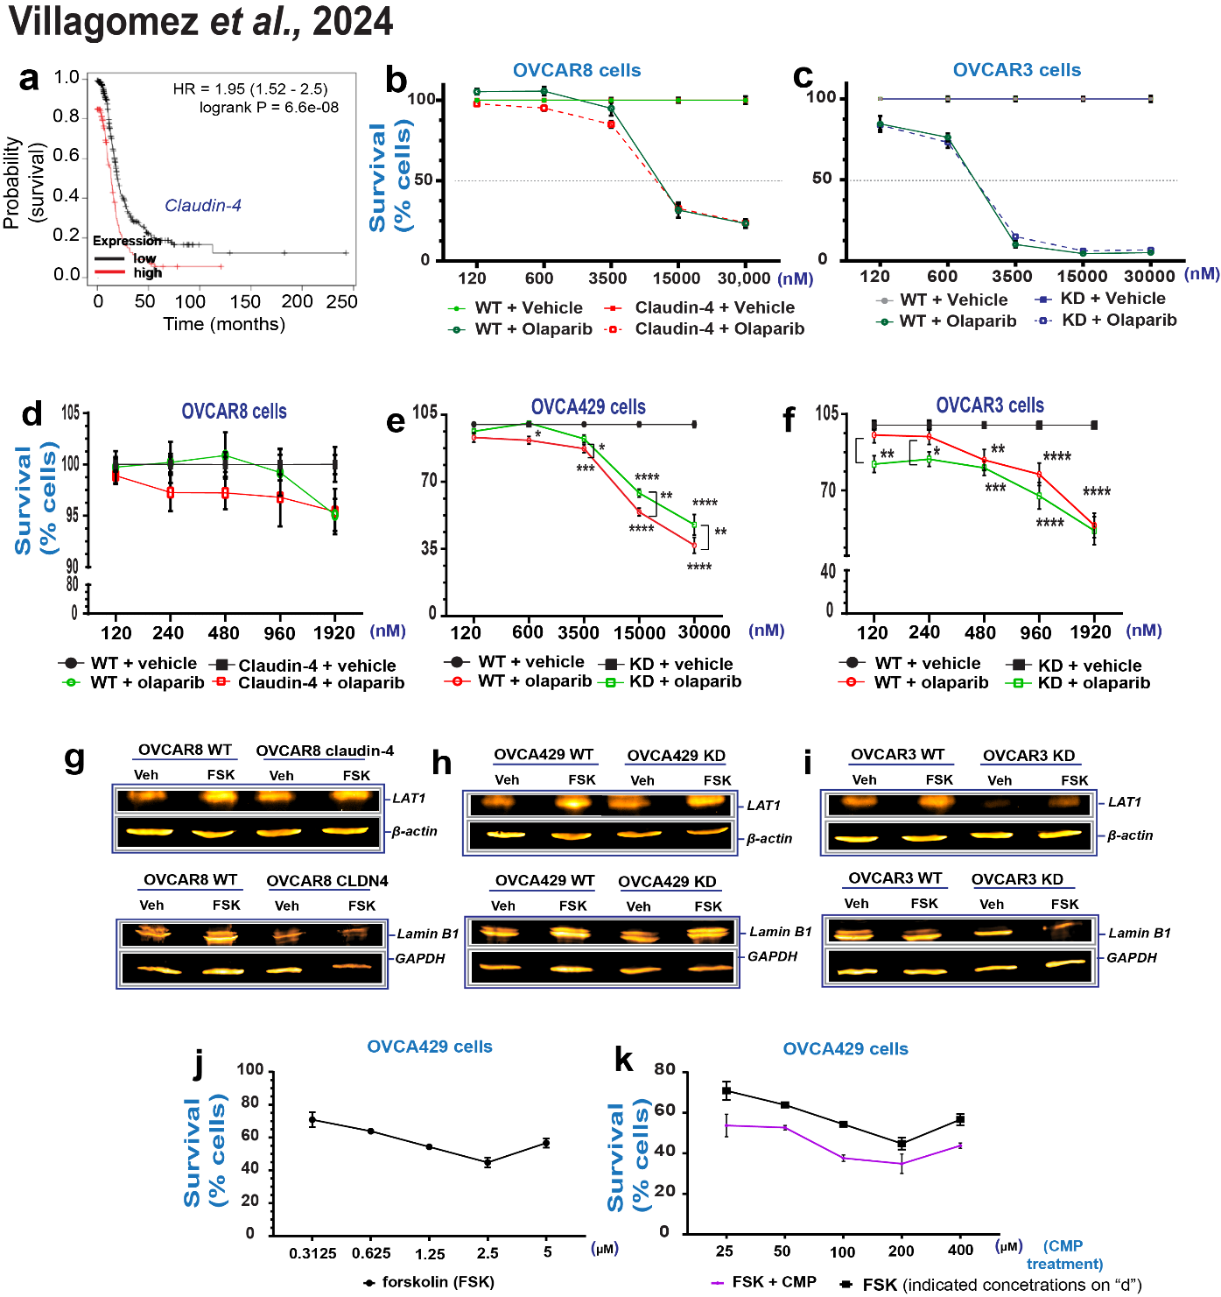
Supplementary Figure 6. (a) shows a Kaplan-Meier curve based on claudin-4 expression in human ovarian tumors (Kaplan-Meier Plotter), highlighting the association of higher claudin-4 expression with reduced patient survival. (b) and (c) show survival of ovarian tumor cells treated with varying concentrations of olaparib treatment in cells where claudin-4 was overexpressed (OVCAR8 cells) or downregulated (OVCAR3 cells) to determine proper concentrations to evaluate resistance to olaparib. (d) Shows percentages of cell survival during treatment with selected concentrations of olaparib for OVCAR8, (e) OVCA429, and (f) OVCAR3 cells. Immunoblotting for LAT1 and lamin B1 after forskolin treatment (5µmol/L/48h) during claudin-4 overexpression in OVCAR8 cells (g, and bottom), and similar information during claudin-4 downregulation in OVCA429 cells (h, and bottom) and OVCAR3 cells (i, and bottom). (j) and (k), show percentages of ovarian tumor cell survival during various concentrations of forskolin (FSK) and a comparison with a combination of FSK at 5µmol/L with various concentrations of CMP, respectively. Graphs show mean and SEM.

