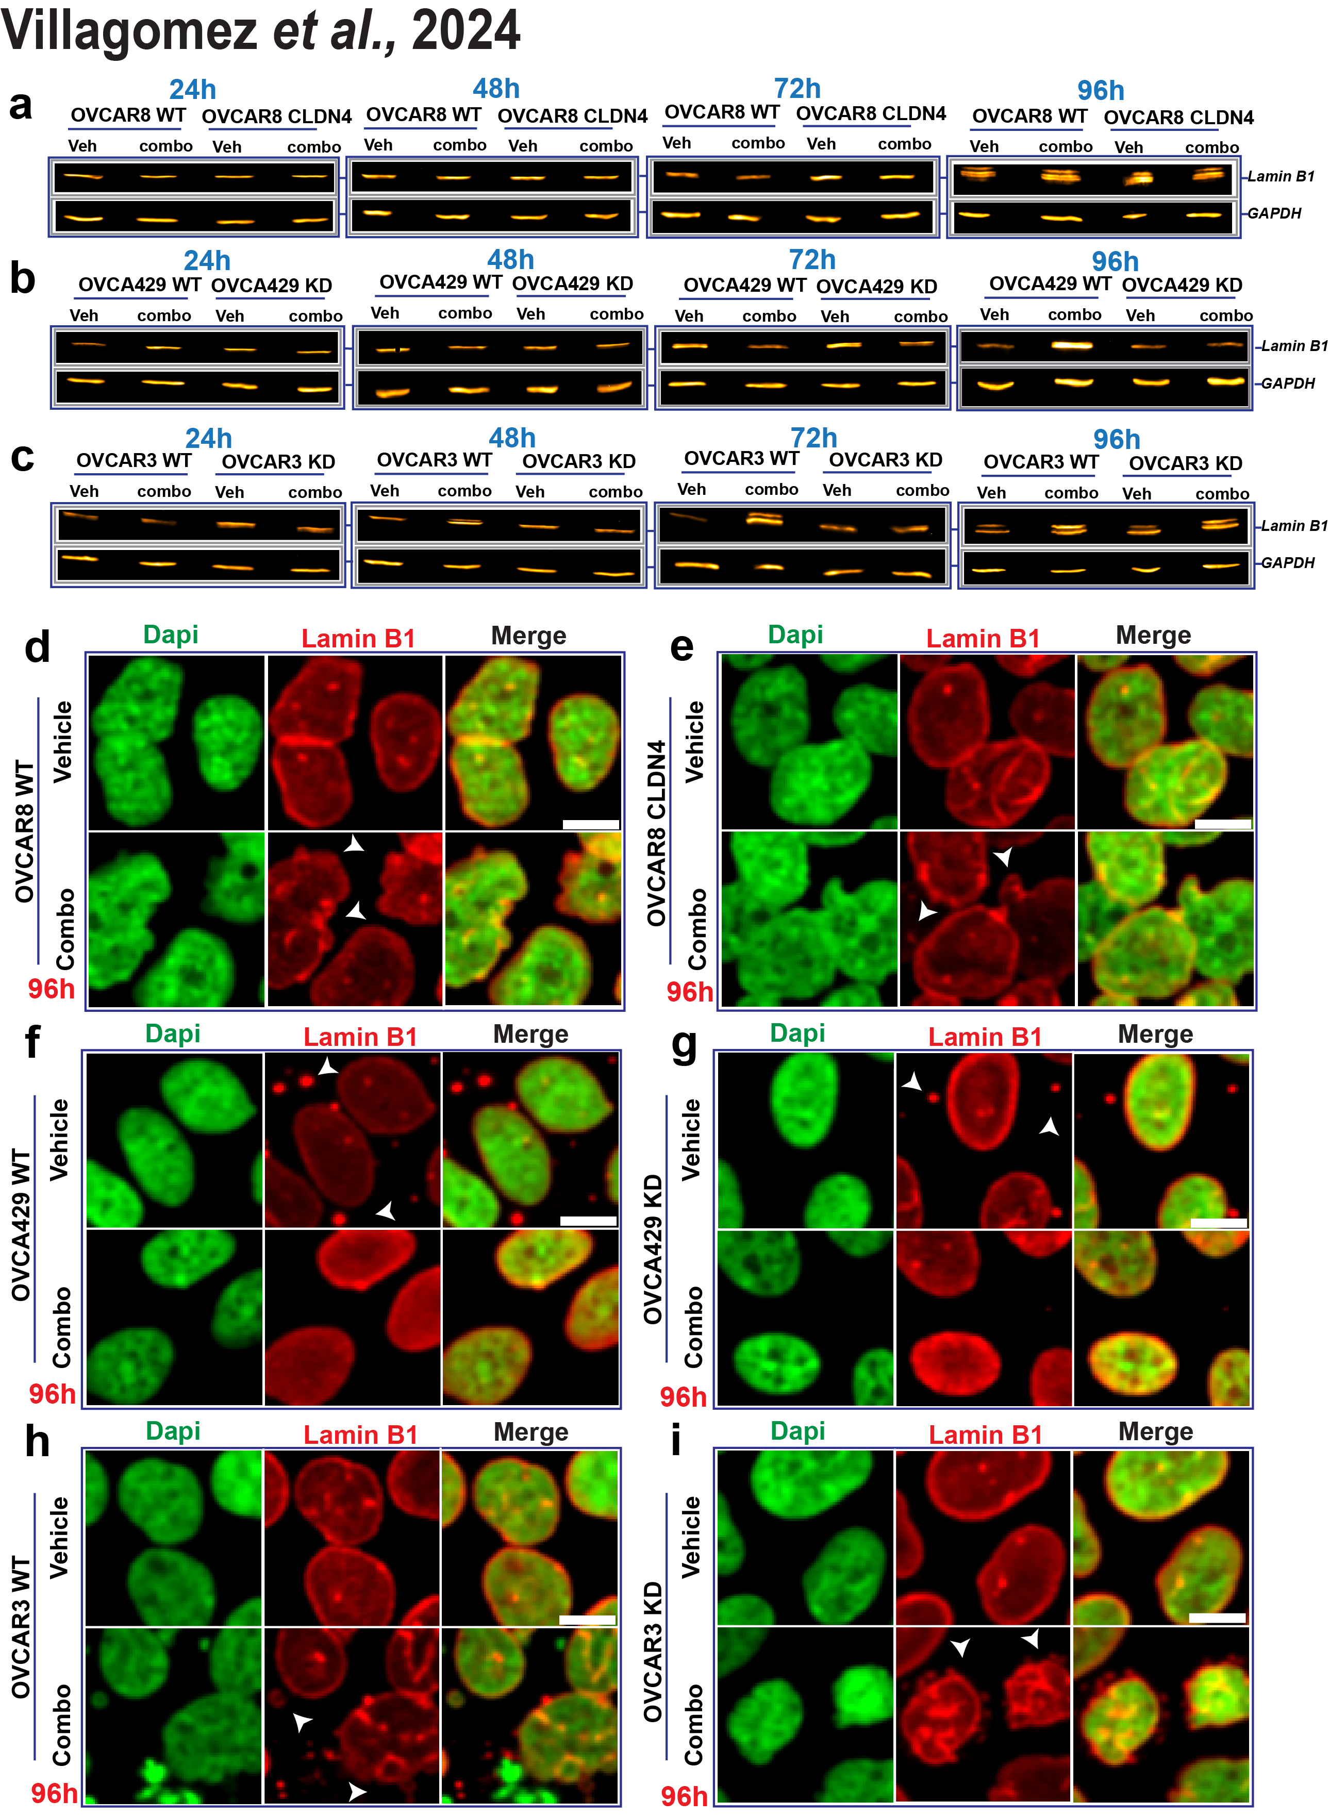
Supplementary Figure 7. (a-c) Displays lamin B1 expression via immunoblotting (IB) during tripartite treatment with olaparib (600 nmol/L), FSK (5 µmol/L), and CMP (400 µmol/L) over 24–96h in OVCAR8 (WT and claudin-4-overexpressing cells, CLDN4), OVCA429 (WT and claudin-4 knockdown cells, KD), and OVCAR3 (WT and KD) cells, respectively. Lamin B1 intracellular distribution during the same treatment at 96h is shown in OVCAR8 WT (d) and CLDN4 cells (e). Similar data are presented in (f and g) for OVCA429 WT and KD cells, and in (h and i) for OVCAR3 WT and KD cells, respectively. Scale bar: 10 µm.

