Jinyao and Reed
NEUR122
Professor Yuqing Zhu
December 5th, 2025
Anticipating Memory Lapses within Chickadee’s Hippocampal Barcoding

Introduction

Memory can be seen through a neuroscientific lens as the interaction of spiking and idle between neurons within the hippocampus. Episodic memory is defined as, “our ability to reinstate the what, where and when of past experiences” (Kolibius et al., 2023). The hippocampus can be seen as an editor for our episodic memories. They add and amend memories but also delete memories on a daily basis. Within Chettih et al., 2024’s research on Chickadees – small birds known for their food-caching traits – barcoding was discovered as a unique way specific events of time and space are stored within the hippocampus. Hippocampal neurons generate specific “barcodes” that are unique for an individual cache of food and are only regenerated when the memory is recalled (i.e when retrieving the cache). The ability to contextualize memory within specific neuronal firing is an important step of understanding the biological specificities of memory. Specifically, we aim to understand how the loss of memory is perceived and how memory is reinforced through activities that call back on specific details. Prior research of memory lapses fall short in identifying specific, unique coding of memory within hippocampal activity, focusing more on memory on a macro scale, unable to account for region-specific neuronal changes. Within Chickadee’s barcoding a broader implication of episodic memory is demonstrated. The birds would have unique neuronal activation for an unique “episode,” highlighting that our memory is less a combination of specific factors (i.e location, time, relevant subjects, etc) and instead all unique interpretations. Episodic memory is defined as a, “[memory that ]requires binding together these stimuli and their spatial, temporal, and conceptual relationships to form coherent memory representations” (Voss et al., 2018). Within this paper, we will reexamine Chettih’s data to determine the specific effect of time lapse on the integrity of episodic memory in the form of barcoding.

Methods
Chettieth et al stored caching information in the form of individual instances (files) with names affirming the ID of specific birds, with time stamps specific to the second. Through locating and isolating the caching activities of individual birds, patterns in retrieval efficacy (memory) can be discovered and analyzed. We focus our analysis on the barcodes as it is seen as synonymous to episodic memory within Chickadees. We examine the strength of individual barcodes by analyzing the
First, 54 sessions were recorded, including both a record of special location and electrophysiological neural recording. These recordings were conveniently sorted to discover the Caching related neurons involved in each session. Though in different sessions there existed a composition of different neurons reactive to the activity of caching, they shared a similarity in barcoding activity. The relevant data of individual neurons in barcoding action was unfortunately unavailable, labeled () and unpublished. As a remediation, an alternate method to summarize barcode data was surmised, to analyze individual sessions and caching activity within them. Specifically, all of the firing activity of a particular caching action was averaged, to produce an overall firing rate. Given that the selection of neurons involved in caching were generally activated, the values yielded by these averages were non-0 and seemingly random, demonstrating potential for full processing. This average was then sorted by EventID to group caching activity by location. The theory is that over time the barcode produced at the same location would possess a level of similarity despite Chettih’s argument that barcodes are completely independent from place codes and the locations they imply.
Initially, we organized figure 1, which represented the average barcode firing rate for individual caches in individual sessions. It was sorted in such a way so that caches in the same location were placed next to each other, allowing a visual examination which revealed the potential for a relationship between barcodes and place.
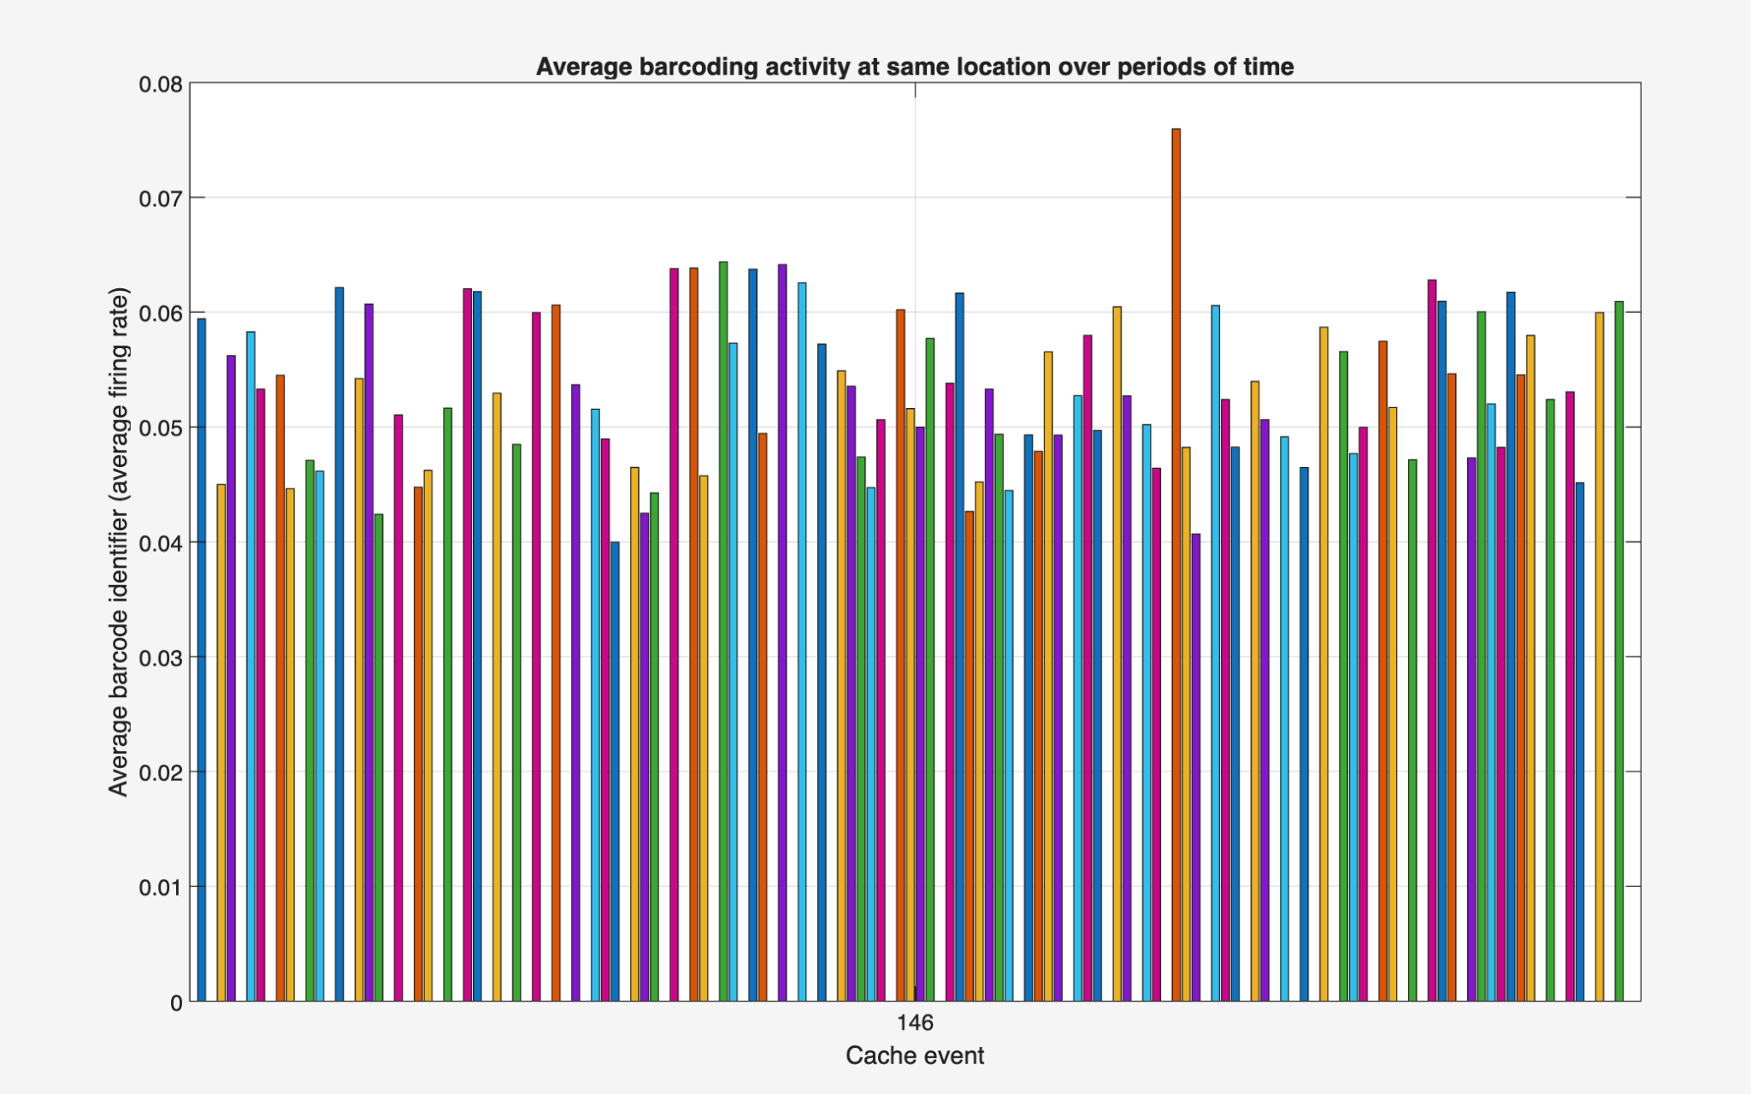
Figure 1: Average barcode activity of coupled caches in session 1.

Averaging a barcode is a surprisingly good way to summarize the barcode because it, as a mean, actively summarizes the inhibitory and inhibitory neuron firing rates, which in itself represents the bar code. The barcode is unique, and the average of all neuron captures that unique combinatory signature whilst breaking it down to a primary component, allowing it to be compared to other barcodes. A potential limitation is the possibility of another set of neurons having the same firing rate, but if a relationship could be proven in the same neurons, demonstrating differing over different periods of time, a statistical relationship could still be established. To further investigate this potential relationship, the indexes of cache events were paired with timestamps stored in a separate dataframe called eventTimes. Through pairing each barcode average with a time, a difference in time and barcode could be computed, which captures the relationship between time passed and barcode similarity- demonstrating that the chickadee indeed actively “forgets” caching locations. The times were tertiled into bins because they demonstrated the highest level of separability when the time interval was split into threes.
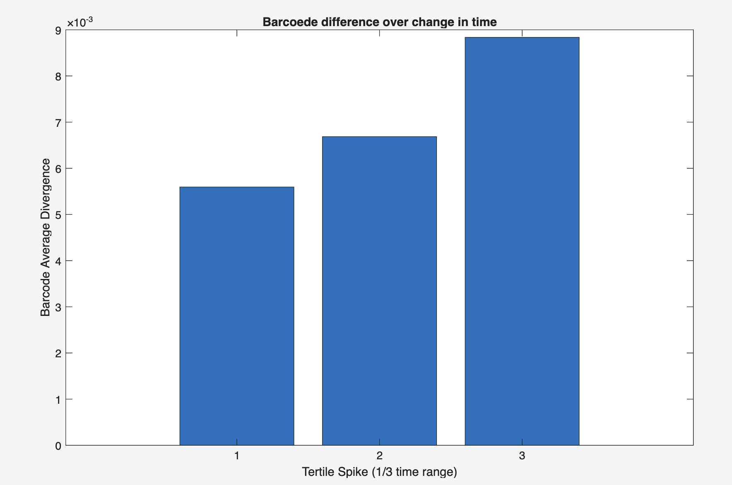
Figure 2: Different magnitude of time intervals in overlapping locations demonstrating significant divergences in barcode average divergence
This relationship was visibly strong for session 1, meaning that as the time intervals increased, so did the difference in barcode behaviour, so the analysis was repeated and averaged for every single bird and every single session, which, as discussed in the results section, yielded less visible outcomes.
Results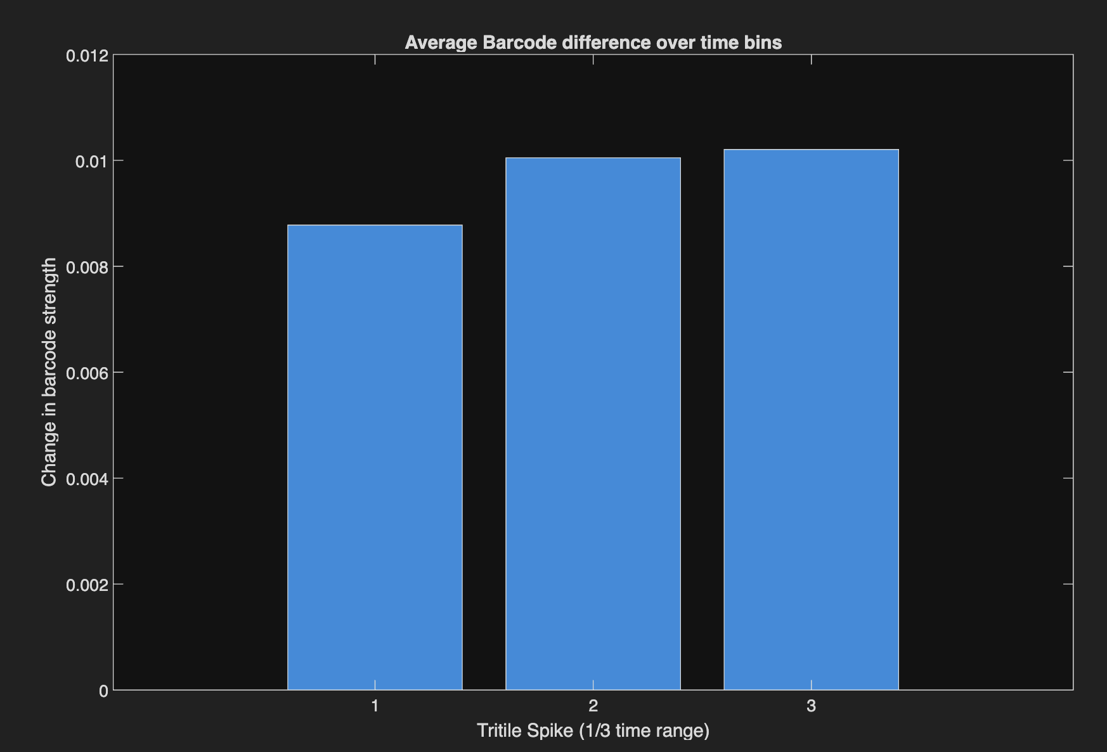
Figure 3A: Barcode Difference Over Time
We examined an average of 6 model birds’ barcoding e over 1/180th of a second. The result shows a nontrivial difference in the change of barcode signature over a rapid period of time. This suggest that the brain optimizes the encoding of episodic-specific neurons within the hippocampus due to the finite amount of resources needed in the storage, retrieval, alteration, and deletion of memories. It potentially challenges the idea of “fully unique” episodic barcoding, and instead showcases how the brain optimizes for efficiency while keeping memory signature in tact. It should be acknowledged here that due to the short (1/60th second) time bin recorded the long term effects of barcoding is unknown and needs to be further explored in the limitations.
Discussion
Within Figure 3A, the barcode strength for the same locations decreases over time, emulating the theory of the brain optimizing memory storage referenced by Davis & Zhong, 2018. It suggests that the specific neurons responsible for a given cache event decrease its sensitivity to the episode as time lapses, freeing the affected neurons for further episodic memory. Within Chickadee’s the barcode strength deteriorates rather rapidly as seen in figure 3A, which suggests that the barcode itself is representative of forming a higher-order memory of such experience. After such synapse is formed, its importance is lowered and neurons are thus freed up for subsequent episodic events. However, due to the short nature of the recordings within Chickadees, we are unsure if barcodes reach an equilibrium after their decrease, which may then suggest a transition from short-term to long-term storage of memory. This showcases a potential for an observation of how episodic-specific neurons are strengthened and weakened over a longer lapse of time.
A common theme within animal hippocampal activity is the existence of neurons coding for specific episodic memory. A theoretical research done by Goode et al., 2020 coins the term hippocampal engrams, the sparse set of neurons active in a given activity (episode). These engrams function as an index for memories, acting simply as an activation guide for higher order memory processing within the brain. This is contrasted with the traditional view of place coding as it offers insight into how specific activity (what, when, where) links with retrieval of specific, episodic memory. Indeed, “[w]hat is presumed to make these patterns of activity unique from other experience-induced patterns in the brain, such as ensemble activity in the sensory cortex activated by a stimulus, is their conjunctive and associational nature and the ability of the hippocampal ensemble to reinstate the original spatial and temporal patterns of cortical/subcortical activity of an experience” (Goode et al., 2020). Viewing our results under this framework would suggest that the barcodes within caches is not itself representative of a memory, instead the barcode is solely the synaptic connection of lower level stimulus to higher-level memory processing. Thus the decrease in strength of the barcode is not itself synonymous with forgetting of memory, instead it showcases the original, precognitive perceptions that are associated with the higher level processing of such memory. This adds a unique perspective in viewing our understanding of memory, showing that episodic memory may not be a single, all-encompassing feature within our brain, but instead relies on lower level processes to retrieve and recall such memory. Results in figure 3A showing that the strength of episodic-specific barcodes diminish over time from exposure to the action may therefore suggest that the upkeep of episodic memory involves a continued exposure to episode specific elements, such as retrieving or reaching a specific event. Furthermore, this showcases that within barcoding neurons, there may remain an intrinsic, hierarchical pathway that encompasses certain “grandmother” stimuli that is present as a general feature of the episodic memory (i.e food caching or eating food). This would explain why there are high similarities throughout different caching occasions even within barcoding neurons.
The significance of such results concerns our broader intuitions on understanding the nature of episodic memory within humans. For instance, a key symptom of certain neurodegenerative diseases such as Alzheimer’s and epilepsy involves the dysfunction of episodic recall. As demonstrated by Kolibius et al., 2023, within the human hippocampus also exists episodic-specific neurons that function as indexes for the recall of episodic memories. They discovered that within epileptic patients, single, episodic-specific neurons are responsible for forming the distinct episode as opposed to any abstract element (time, space) within the episode. This is relevant as it showcases within the neuronal scale how memories are recalled and could offer insight in possible remedies for memory-degenerative diseases such as pivoting the treatment of the specific receptors of lower level stimulus of patients as opposed to treating episodic memory as a single, large entity. Furthermore, it showcases how within such diseases there might be a confusion of indices, which may be a result of the inability to recall episodic-specific stimulus. This is an important step in understanding how to minimize the effects of such diseases.

Conclusion
This paper explores the phenomenon of episodic memory lapse over time within Chickadee’s food caching abilities. It examines how the hippocampal neurons encode for memory “engrams” – index cells that reference a unique episodic experience – and discovers how the facilitation of storage of these memories happens within Chickadees. A rather rapid deterioration is uncovered which reinforces our understanding that the brain must facilitate an intricate yet rapid organization of memory perception. It must constantly free up space, termed passive forgetting (Davis & Zhong, 2017). Numerous similarities have also been seen through Chickadee (Chettih et al., 2024), mice (Lee & Han, 2023), and human (Kolibius et al., 2024), showcasing the broad phenomenon of hippocampal engram. Furthermore, it showcases how hippocampal engram neurons are not solely responsible for the storage of memory, instead serving solely as an stimuli index that facilitates the recall and retrieval from storage, which could render further discussion in better understanding and treating neurodegenerative diseases whose main symptoms concern the deterioration of episodic memories.
References
Kolibius, L. D., Roux, F., Parish, G., Ter Wal, M., Van Der Plas, M., Chelvarajah, R., Sawlani, V., Rollings, D. T., Lang, J. D., Gollwitzer, S., Walther, K., Hopfengärtner, R., Kreiselmeyer, G., Hamer, H., Staresina, B. P., Wimber, M., Bowman, H., & Hanslmayr, S. (2023). Hippocampal neurons code individual episodic memories in humans. Nature Human Behaviour, 7(11), 1968–1979. https://doi.org/10.1038/s41562-023-01706-6
Goode, T. D., Tanaka, K. Z., Sahay, A., & McHugh, T. J. (2020). An Integrated Index:
Engrams, Place Cells, and Hippocampal Memory. Neuron, 107(5), 805–820. https://doi.org/10.1016/j.neuron.2020.07.011
Davis, R. L., & Zhong, Y. (2017). The Biology of Forgetting-A Perspective. Neuron, 95(3),
490–503. https://doi.org/10.1016/j.neuron.2017.05.039
Payne, H. L., Lynch, G. F., & Aronov, D. (2021). Neural representations of space in the
hippocampus of a food-caching bird. Science (New York, N.Y.), 373(6552), 343–348. https://doi.org/10.1126/science.abg2009
Chettih, S. N., Mackevicius, E. L., Hale, S., & Aronov, D. (2023). Barcoding of episodic
memories in the hippocampus of a food-caching bird. bioRxiv : the preprint
server for biology, 2023.05.27.542597. https://doi.org/10.1101/2023.05.27.542597
Voss, J. L., Bridge, D. J., Cohen, N. J., & Walker, J. A. (2017). A Closer Look at the
Hippocampus and Memory. Trends in cognitive sciences, 21(8), 577–588. https://doi.org/10.1016/j.tics.2017.05.008
Lee, H. S., & Han, J. H. (2023). Activity Patterns of Individual Neurons and Ensembles
Correlated with Retrieval of a Contextual Memory in the Dorsal CA1 of Mouse Hippocampus. The Journal of neuroscience : the official journal of the Society for Neuroscience, 43(1), 113–124. https://doi.org/10.1523/JNEUROSCI.1407-22.2022

