Introduction:
Hexxed is a unity-based cross platform mini-game designed to collect data on human and agent learning patterns. The user attempts to maximally grow an area within a single lobe of a hexagon to its full size (but no further) and subsequently collect it. The game becomes more complex as more lobes develop with differentiating numbers of taps required to grow to full area- requiring constant adjustments and new theories to be formed in order to excel at the game. The task can be represented by a Markov Decision process, where there are states for either terminating the process and collecting the existing number of points, expanding the same lobe, or traversing the hexagon(Quendera et al., 2022). For example, the MDP for level 1, where there is only a single lobe, would be:
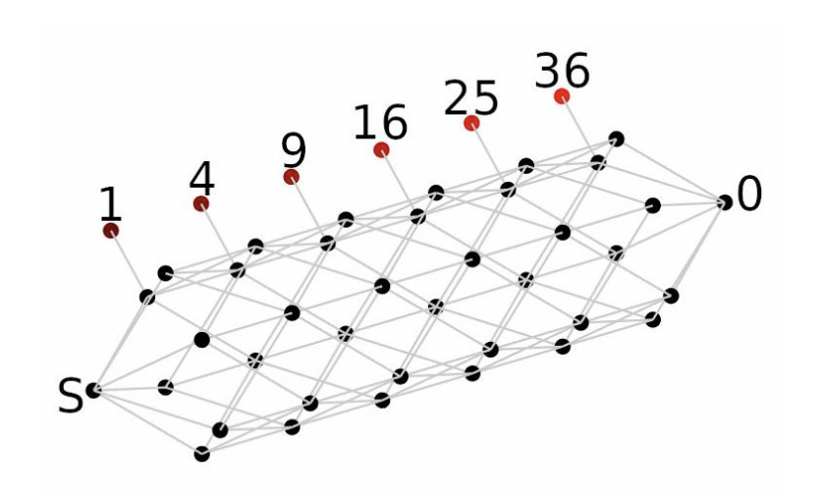
Figure 1: Hexxed MDP (Quendera et al., 2022)

Furthermore, the reward system is complicated by the binary nature of winning and losing. The agent or human does not need to find the perfect solution to hexagons, only enough to collect a certain number of points in order to advance to a further level. This is why prior agents generally tended to perform worse than humans- agents performing bottom-up learning, or gradient descent, struggle to adapt to new game mechanisms, which requires further learning. Humans, on the other hand, possess a certain level of visual intuition, possibly matching game mechanisms with ideas in theory space, corresponding to a process known as top-down learning. 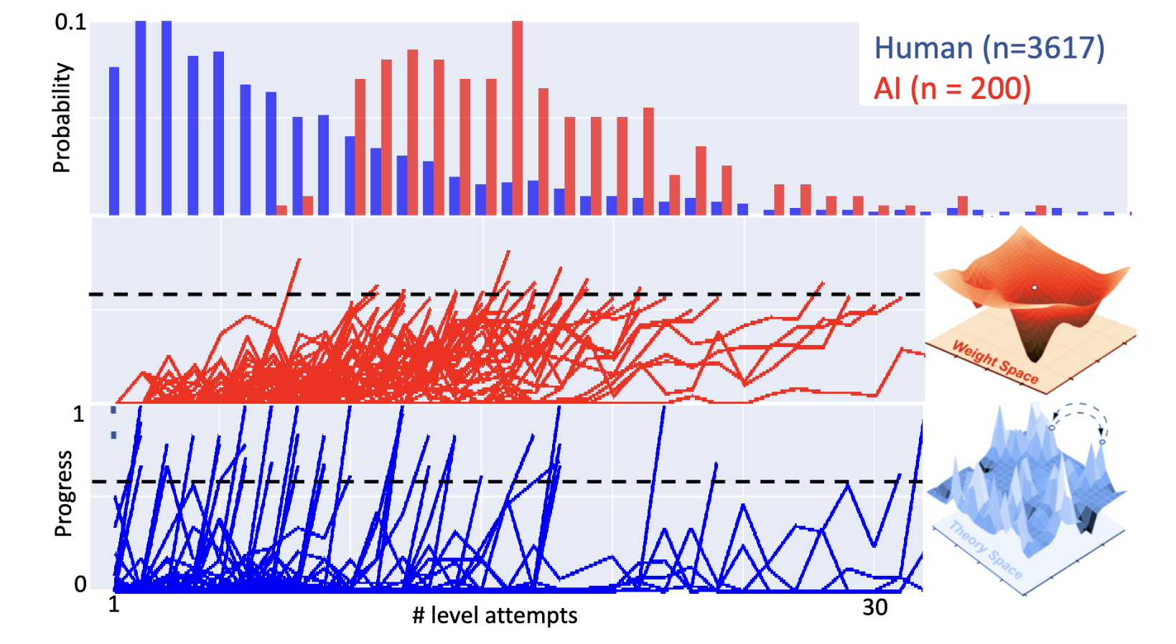
Figure 2: Humans learn differently from AI, Mani Hamidi. The diagram shows the weight space and theory space occupied by artificial intelligence and human beings. Whereas the AI relies on the weight space, making minor adjustments until they thrive at the game, Humans try to test underlying theories and “learn” systemic methodologies to solve the game.

The purpose of this research is to improve the agent’s ability to maximize reward within the MDP, through driving optimizations in the input layer and utilizing a convolutional neural network.

The present method of solving Hexxed with a neural network involves Deep Q learning, which assigns value to each state based on a calculation of all future values. The Deep Q Network (DQN) DQN presents itself as a non optimal choice because this game mainly rewards the successful completion of a level, so the discovery of the most optimal choice requires random exploration until actual reward is accrued. On the other hand, humans are picky, and find themselves only picking more optimal choices after reasoning through the consequences of their choice (See figure 3).
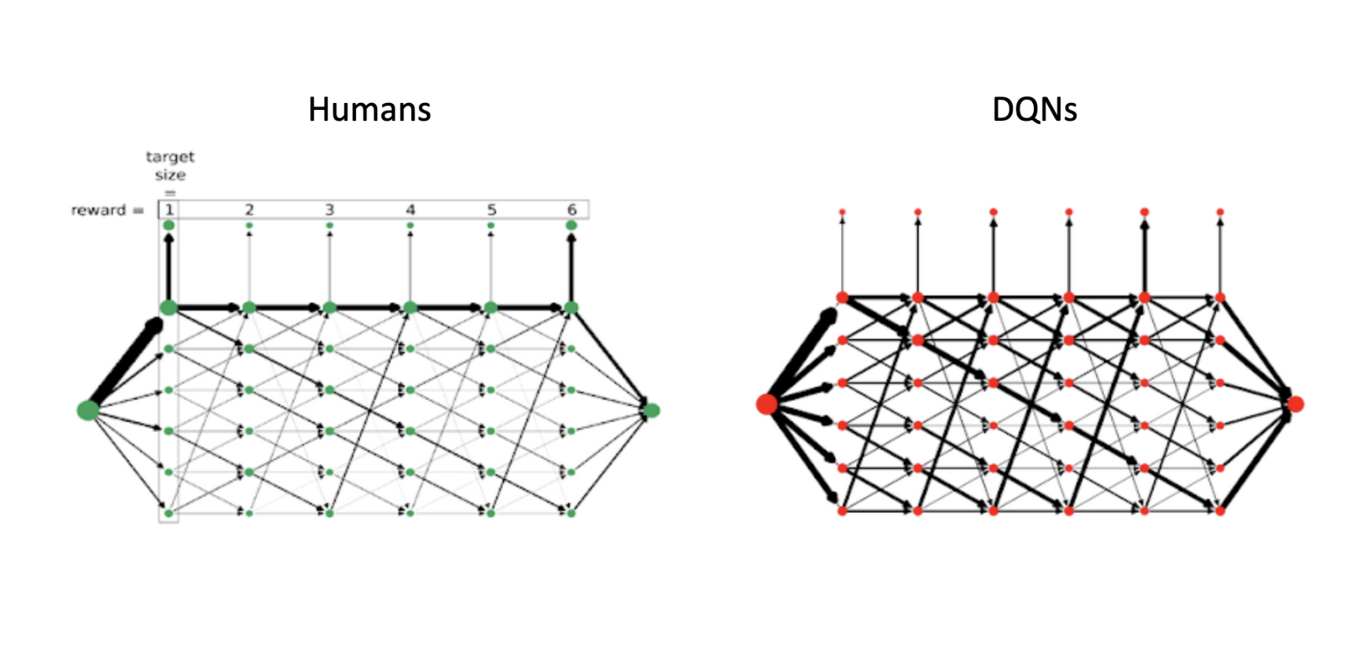
Figure 3: Humans are Picky, Gautam Agarwal. The diagram shows the density of actions for both DQNs and Humans. While Humans maintained a particular focus and density of choices towards the correct choice, the DQNs conducted a significant amount of experimentation and do not exhibit sufficient understanding of the underlying rules of the game.

More specifically, as shown in figure 3, DQNs struggle to understand the consequence of transitions. A potential cause of this struggle is the manner in which data is fed into the input layer of the DQN: a 12-by-6 matrix linearized into a 72-digit vector containing information on all of the lobes and the extent to which they have been filled. The concern is that there is a limited amount of continuity between the states which are next to each other, which is central to the optimal strategy underlying the solving of the game [a lot more filler is required once more information is known]. This research attempts to use a CNN to observe the matrix in its original form, with each column representing each lobe of the hexagon and each row representing the level of each hexagon, allowing for more adjacency relationships to be discovered. The adjacency effect should serve as a level of “intuition,” more easily allowing the CNN to understand the underlying rules and strategies to maximalise reward.

Hypothesis:
The key problem in the difference in learning mechanisms between humans and AI lies in the theory space, or the ability to understand the problem at a higher level rather than simply trying to make minor adjustments. The DQN agent is built to process linearized vectors. As a consequence, the Hexxed “game” is represented by a flattened, 1D array that compresses each of twelve rows, representing the 12 possible activation states. Because of this compression, the DQN is playing a very different number processing game which in no way replicates the spatial nature of the Hexxed game.

The proposed hypothesis is that a CNN, which extracts features from matrices, normally images, would be far more advantageous in that the feature extractors take in matrices in a way where adjacent numbers vertically as well as horizontally will be placed under consideration in the determination of actions. As a consequence, the Markov decision process would be approached in a way that values adjacency and collection in nearby places, which in theory would lead to behaviour that mimics the human intuition for repetitively clicking the same or nearby locations to collect rewards, leading to a rise in efficiency compared to DQN agents with the same amount of training. In other words, the hypothesis is that by providing an observation space more similar to the real life problem and using a neural network structure that places emphasis on adjacency, the efficiency in collecting rewards can be improved compared to a DQN agent.

Methods
Originally, small modifications in network structure from a SB3 DQN to a NatureCNN was planned as the mode of action. The NatureCNN module refers to the CNN created for a journal published in Nature, where a cnn was trained to excel at Atari style games (Mnih et al. 2015). However, several challenges related to minimum sizing, channel expectations, as well as general incompatibility with the gym environment of the Hexxed game required the design of a CustomCNN, where self selection of layers and layer design was allowed.
Two convolutional layers were created to search for different features that allow for the solving of the game, and then the ability to reap rewards was compared to the DQN agent. An increase in efficiency would represent that understanding the game with more emphasis on spatial adjacency helps in agentic performance, thereby affirming the hypothesis that sensations help build the theory space for the game.

