SIT215 - Computational Intelligence
Assignment #1: Problem Solving Task
Jin Kim (223715707)
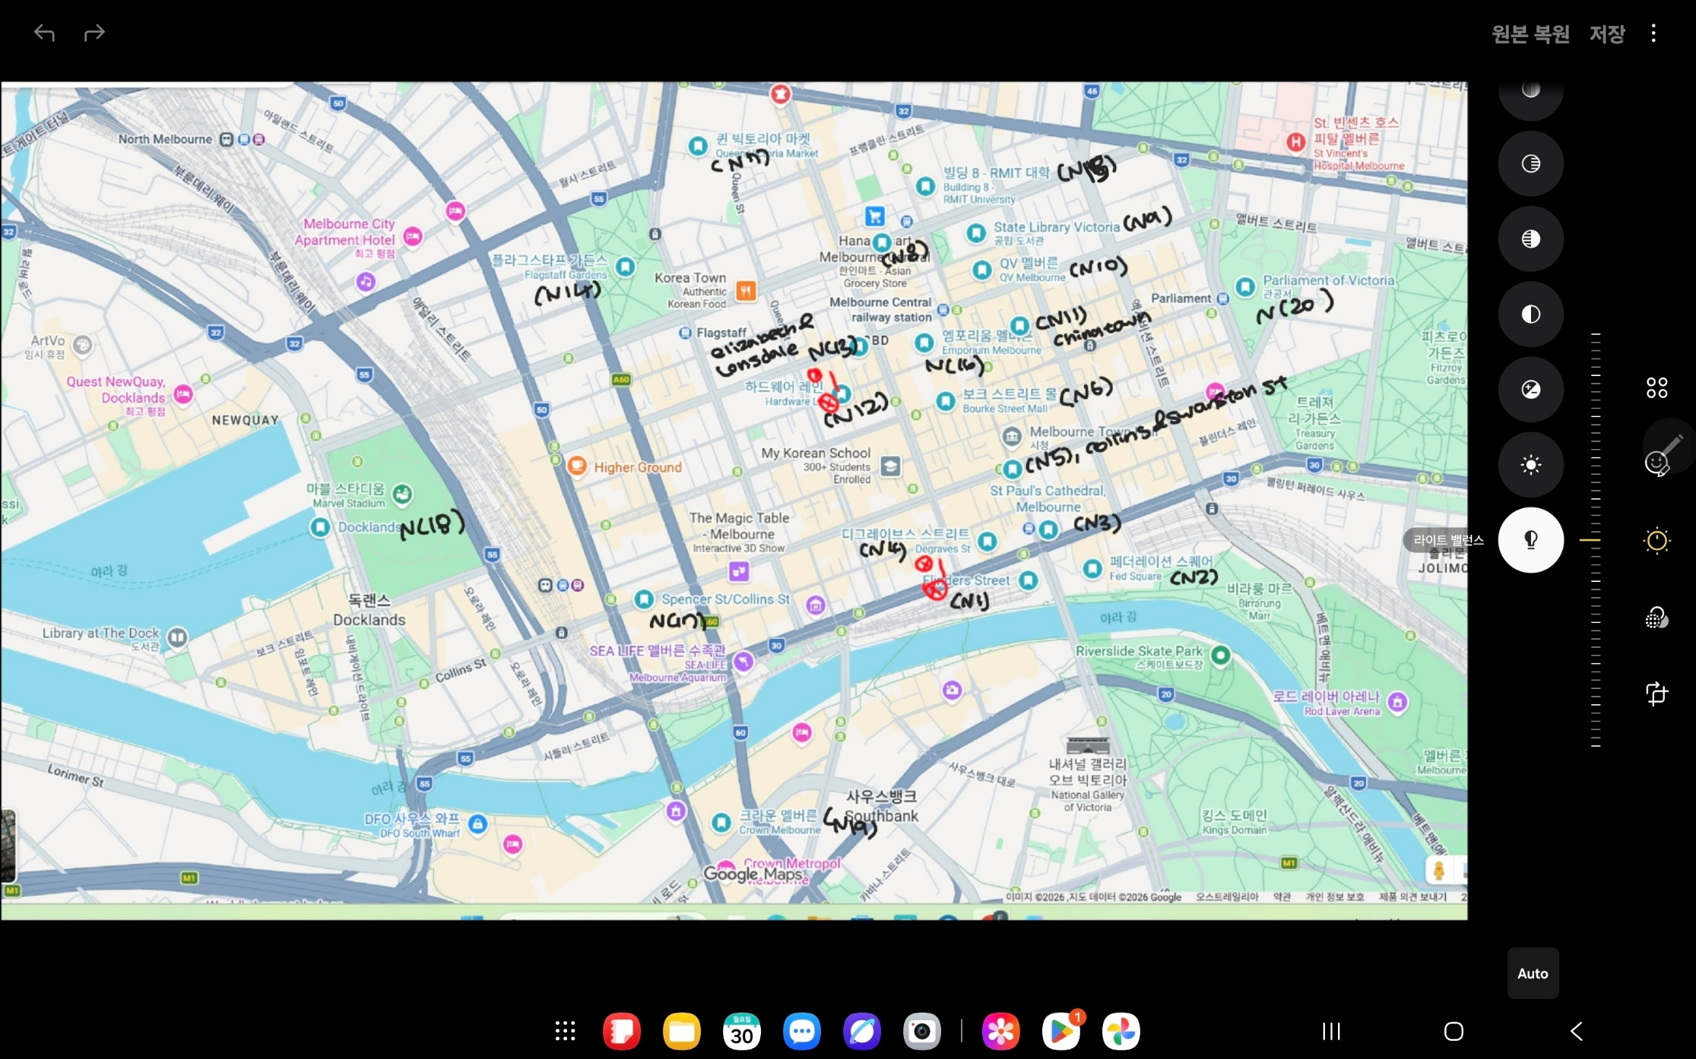

Landmark Inventory (20 Nodes)
ID | Landmark Name | Brief Description
N1 | Flinders Street Station | [Start] Major transport hub with high pedestrian density.
N2 | Federation Square | Open public space with complex movement patterns.
N3 | St Paul's Cathedral | Historic site with restricted vehicle access for large agents.
N4 | Degraves St Entrance | Narrow laneway; dynamic cost due to high cafe activity.
N5 | Collins & Swanston Jct | Critical tram network hub with multiple intersection points.
N6 | Bourke St Mall (East) | Pedestrianised zone with significant time-dependent congestion.
N7 | Victoria Market | Major Grocery shopping center
N8 | Melbourne Central Station | Major shopping and transport hub; a high-traffic node.
N9 | State Library of Victoria | [Goal] Cultural precinct and the final delivery destination.
N10 | QV Melbourne | Mixed-use development featuring complex internal path networks.
N11 | Chinatown (Little Bourke) | High-demand dining district with narrow street constraints.
N12 | Hardware Lane | Historic dining lane with evening access restrictions for vehicles.
N13 | Elizabeth & Lonsdale Jct | Area with heavy bus traffic and potential congestion points.
N14 | Flagstaff Gardens | Open Park area with potential surface and elevation constraints.
N15 | RMIT Building 8 | Educational precinct with high student pedestrian flow.
N16 | Emporium Melbourne | Large-scale retail hub connecting multiple city blocks.
N17 | Southern Cross Station | Regional transport hub marking the western boundary.
N18 | Docklands Waterfront | Exposed waterfront area with environmental factors like wind.
N19 | Crown Melbourne | Riverside pathway subject to occasional event-based closures.
N20 | Parliament House | Government precinct requiring strict security-based rerouting.

Melbourne Landmark Graph (Edges)
The final graph contains 20 landmarks and 37 weighted path segments, which aligns with the recommended graph size for the assignment.
Access restrictions are present in certain areas such as Hardware Lane (N12) and Degraves Street (N4), where access for delivery trucks is limited due to pedestrian-only conditions. As a result, these locations are treated as constrained nodes in the graph.
The diagram represents an urban delivery network designed to analyse possible routes from Flinders Street Station (N1) to the State Library of Victoria (N9)

Costed Graph
Path costs were assigned to reflect travel difficulty in the abstract delivery environment. A base cost of 1 was used for standard road segments. A moderate cost of 2 was assigned to busy inner-city areas with likely congestion or complex movement patterns, such as Federation Square, Bourke Street Mall, QV, and Chinatown. A higher cost of 3 was assigned to constrained laneway segments, especially Degraves Street (N4) and Hardware Lane (N12), to reflect truck-specific access difficulty.
Cost 1 = Standard Road segment with relatively smooth truck movement
Cost 2 = Busy inner-city segment or major intersection with moderate congestion
Cost 3 = Constrained laneway segment with reduced suitability for truck access
Table: Melbourne CBD Delivery Network Adjacency List
Origin Node (ID) Connected Successors (Cost)
N1 Flinders St Station N2(2), N3(1), N19(1)
N2 Federation Square N1(2), N3(2), N5(2)
N3 St Paul’s Cathedral N1(1), N2(2), N4(3), N5(1)
N4 Degraves St N3(3), N6(3)
N5 Collins & Swanston N2(2), N3(1), N6(2), N8(1), N10(1), N15(1)
N6 Bourke St Mall N4(3), N5(2), N11(2), N12(3), N16(2)
N7 Victoria Market N13(1), N14(1), N15(1)
N8 Melbourne Central N5(1), N9(1), N10(2), N11(2), N13(1), N15(1), N16(1)
N9 State Library N8(1), N10(2), N15(1)
N10 QV Melbourne N5(1), N8(2), N9(2), N11(2), N15(1)
N11 Chinatown N6(2), N8(2), N10(2), N12(3), N16(2)
N12 Hardware Lane N6(3), N11(3), N13(3)
N13 Elizabeth & Lonsdale N7(1), N8(1), N12(3), N14(1), N17(1)
N14 Flagstaff Gardens N7(1), N13(1), N17(1)
N15 RMIT Building 8 N5(1), N7(1), N8(1), N9(1), N10(1)
N16 Emporium Melbourne N6(2), N8(1), N11(2)
N17 Southern Cross N13(1), N14(1), N18(1)
N18 Docklands N17(1)
N19 Crown Melbourne N1(1), N20(1)
N20 Parliament House N9(1), N19(1)
Figure 1 shows the full weighted state-space graph of the Melbourne CBD delivery environment. Each node represents a landmark, and each weighted edge represents the travel cost of moving between two connected landmarks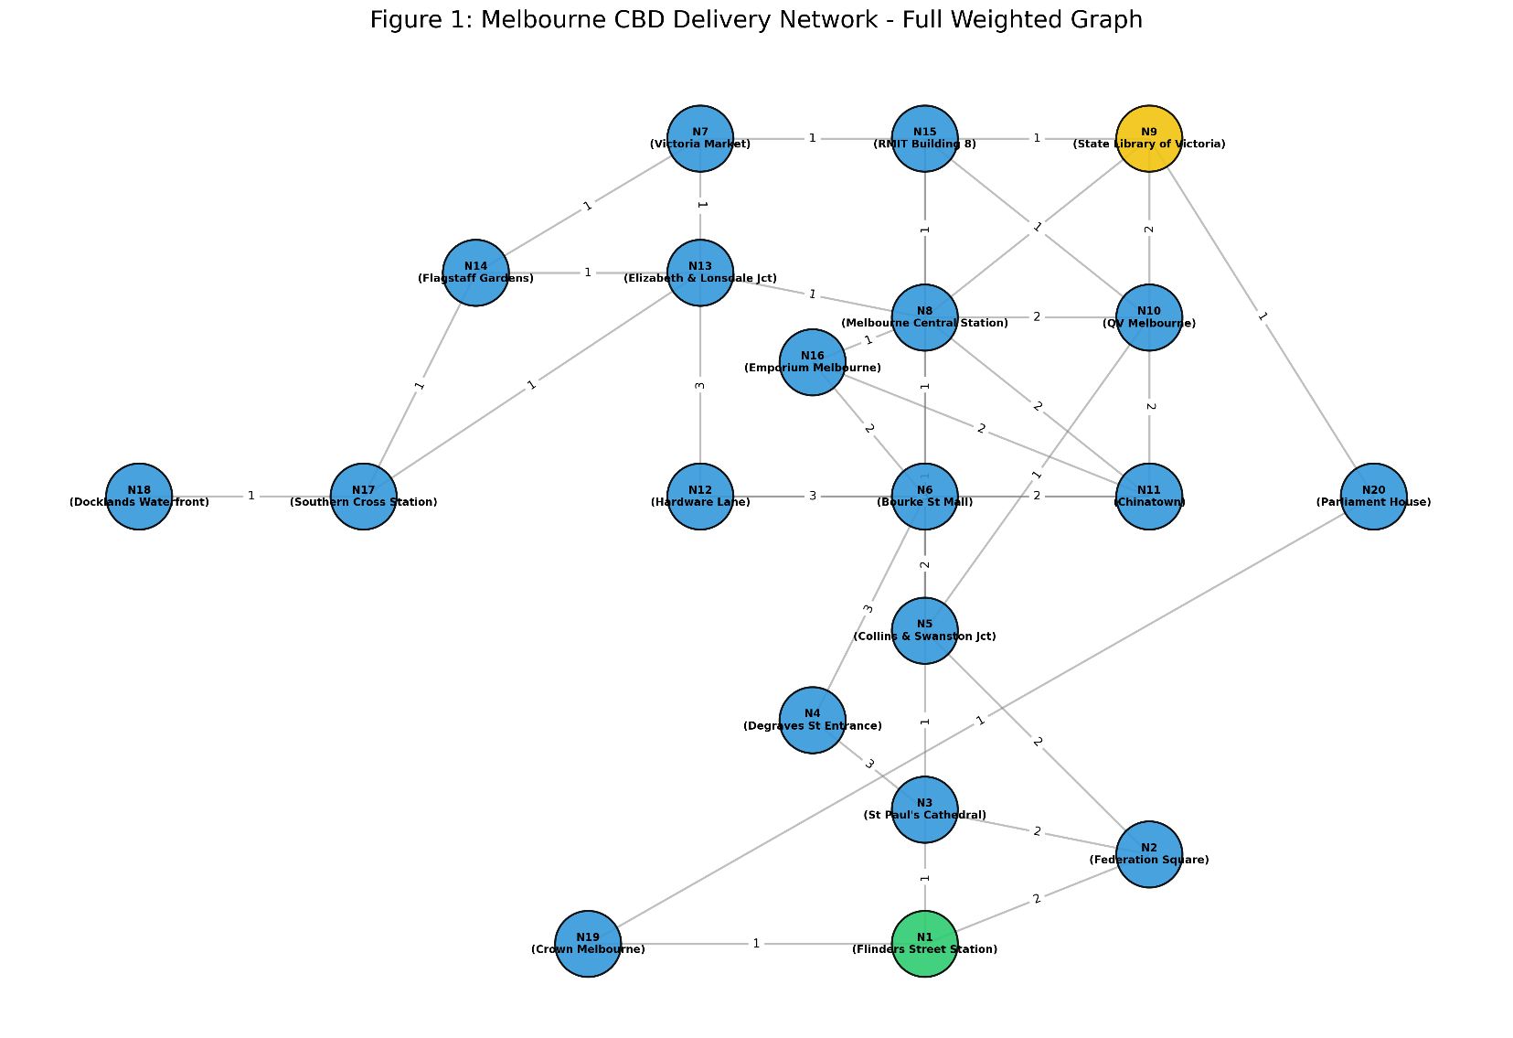
Figure 2: highlights the constrained nodes, Degraves Street (N4) and Hardware Lane (N12), which are less suitable for truck navigation due to narrow access and pedestrian-heavy conditions. These nodes remain feasible in the graph but are associated with higher traversal costs. 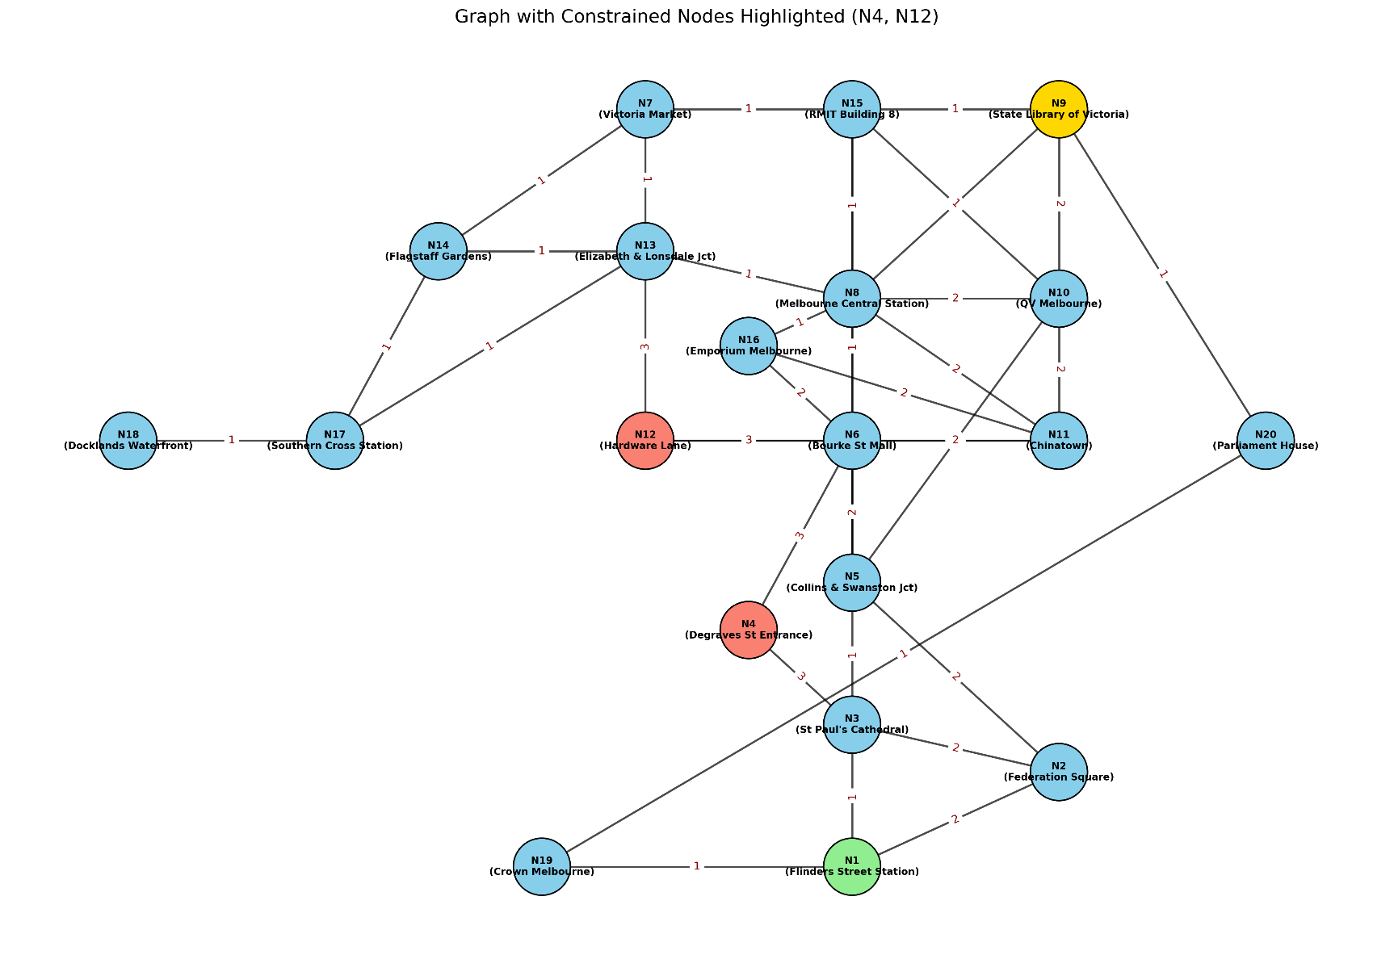
Figure 3 illustrates an example optimal route from N1 to N9 based on weighted path cost. The highlighted route demonstrates how the search process favours lower-cost paths while avoiding constrained areas where possible.
To avoid limiting the evaluation to a single delivery scenario, additional start–goal pairs were tested using the same graph. The results are summarised in Table 1. 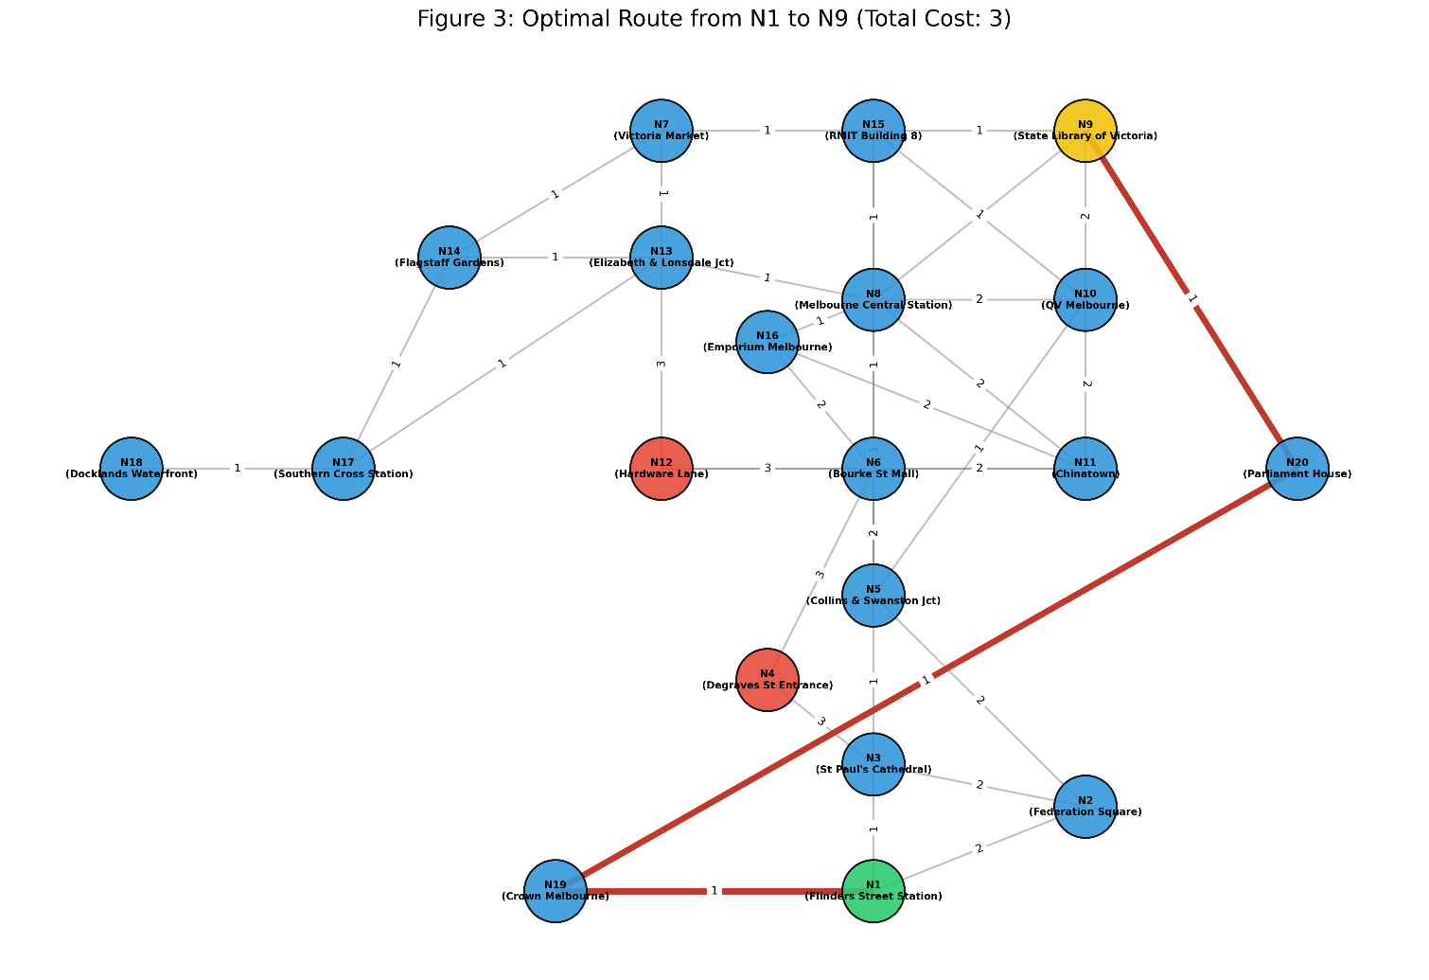

SIT215 Assignment 1: Problem Formulation & Search Strategy
Problem Definition
The aim of this task is to design an autonomous delivery agent that can navigate through the Melbourne CBD and find an efficient path to its destination. The agent starts at Flinders Street Station (N1) and needs to reach the State Library of Victoria (N9).
The environment is a complex urban area with 20 landmarks, including transport hubs, shopping areas, and narrow laneways. Some areas experience heavy pedestrian traffic or temporary restrictions, which makes navigation more challenging.
The goal of the agent is to reach the destination efficiently while avoiding unnecessary delays.

PEAS Formulation
To design a rational agent, the PEAS framework is used to describe the task environment.
Performance Measure
The agent should minimise travel time, avoid highly congested areas such as Bourke Street Mall (N6), and successfully reach the goal node (N9) without failure.
Environment
The environment is the Melbourne CBD road network, including transport hubs, retail precincts, intersections, and constrained laneways. Some locations are more difficult for truck traversal due to congestion, narrow access, or heavy pedestrian activity.
Actuators
The agent uses movement controls such as moving forward, turning, and adjusting direction. It may also include communication systems to send updates.
In the abstract graph model, these actions are simplified as transitions from one connected node to another. Sensors
Sensors
The agent relies on GPS for location tracking, traffic information systems, and proximity sensors to detect nearby obstacles or pedestrians.
In the search model, sensing is abstracted as knowledge of the current node, connected successors, and associated edge costs.
Constraint Analysis
To better understand the environment, constraints can be divided into two categories: static and dynamic.
Static Constraints
These are time-invariant factors that define the permanent structure of the search space.
- Structural Graph Connectivity: The fundamental road network and predefined edges between the 20 landmarks.
- Physical Dimension Restrictions: As a heavy delivery truck, the agent must account for road width and turning radii. For instance, narrow laneways like Degraves St (N4) or Hardware Lane (N12) are modelled as static constraints where truck movement remains feasible but less desirable due to narrow road width, limited turning radius, and pedestrian-heavy conditions. These constrained segments are therefore assigned higher path costs rather than being completely removed from the graph.
- One-Way Traffic Systems: Fixed traffic flow directions in the Melbourne CBD that dictate the permitted actions at each node.
Dynamic Constraints
These represent environmental variables that change depending on the state and time, affecting the cost of the edges.
- Pedestrian Surge & Congestion: Areas such as Bourke St Mall (N6) and Federation Square (N2) exhibit high pedestrian density. These act as dynamic costs that can significantly slow down the agent or require temporary re-routing.
- Event-Based Access Control: Locations like Crown Melbourne (N19) or Parliament House (N20) are subject to sudden closures due to public events or security protocols, temporarily invalidating previously feasible paths.
- Traffic Signal Cycles: Stochastic delays at major junctions, such as Collins & Swanston (N5), which influence the total travel time performance metric.
Note on Problem Relaxation: In the relaxed version of this problem used for search implementation, all dynamic constraints are removed to create a deterministic environment. Only the static connectivity and physical access constraints are enforced to ensure the benchmark algorithms can identify an optimal path within a stable state space.

Relaxed Problem Formulation
In order to apply search algorithms such as BFS and A*, the real-world delivery environment needs to be simplified into a more manageable form.
The Melbourne CBD is a complex and constantly changing environment, so directly applying search algorithms would be difficult. For this reason, the problem is relaxed by removing dynamic elements that are unpredictable in nature.
For example, factors such as pedestrian congestion at Bourke Street Mall (N6) or traffic delays at busy intersections like Collins & Swanston (N5) are not included in this model. These conditions change over time and would require a more advanced or probabilistic approach, which is beyond the scope of basic search algorithms.
Instead, the focus is placed on static constraints that remain consistent. This includes fixed road connections between landmarks and the general accessibility of locations for a delivery truck. In some cases, narrow or impractical paths, such as Degraves Street (N4), remain traversable in the relaxed model, but they are penalised through higher edge costs to reflect truck access difficulty.
By simplifying the environment in this way, the problem can be represented as a stable graph where each movement has a clear and consistent cost. This allows the search algorithms to operate effectively and makes it easier to evaluate their performance.
These modelling choices are important because they directly shape the search behaviour of the delivery agent. In this environment, path feasibility is not determined only by connectivity, but also by whether a route is practically suitable for a truck. By assigning higher costs to constrained laneways such as N4 and N12, the model captures the fact that some paths remain reachable but are less desirable. This abstraction allows the search algorithms to distinguish between merely possible routes and operationally sensible routes, which is essential for intelligent behaviour in an urban delivery setting.
Overall, this relaxed model provides a clear starting point for analysing different search strategies before considering more complex real-world conditions.
State Space Modeling
The problem is represented as a graph where each landmark corresponds to a state.
- State: Each node (N1 to N20) represents a location in the city
- Initial State: Flinders Street Station (N1)
- Goal State: State Library of Victoria (N9)
- Actions: Moving from one node to another based on the defined edges
- Step Cost: Each movement has a weighted cost based on the corresponding edge in the graph. Standard road segments are assigned a cost of 1, busy inner-city segments are assigned a cost of 2, and constrained laneway segments are assigned a cost of 3.
- Transition Model: A move is allowed only if a weighted edge exists between the current node and the next node in the graph
This representation allows the problem to be solved using standard search algorithms.

Search Algorithm Analysis & Comparison
Two search strategies are used to evaluate the agent’s performance: Breadth-First Search (BFS) and A* Search.
Breadth-First Search (BFS) was selected as the uninformed baseline because it provides a clear contrast with A*. BFS expands nodes level by level without using cost or heuristic information, which makes it useful for showing how an uninformed strategy behaves in the same deterministic environment. This comparison is appropriate because it highlights the added intelligence of A*, particularly in a weighted urban graph where the number of steps and the total travel cost are not always the same.

New Heuristic Design
To improve A* performance in an urban delivery context, a customised heuristic called Truck-Optimized Priority Heuristic (TOP-H) is proposed.
Manhattan distance is used as a baseline because the Melbourne CBD can be approximated as a structured urban layout. It provides a simple estimate of the remaining distance, but it does not account for delivery-specific constraints.
The proposed heuristic is defined as:
h(n) = Manhattan Distance(n, goal) + Traffic_Penalty(n)
In this formulation, the Manhattan distance estimates how far a node is from the goal, while the Traffic_Penalty(n) reflects how suitable a location is for truck movement. Nodes on major roads are assigned lower penalties, whereas constrained areas such as narrow laneways and pedestrian zones are given higher penalties.
This encourages the agent to prioritise routes that are not only short in distance, but also operationally suitable.
Because the additional term represents a preference rather than a strict distance estimate, TOP-H is best interpreted as a guidance-oriented heuristic rather than a purely geometric lower bound. Therefore, Manhattan distance is treated as the baseline for theoretical comparison, while TOP-H is evaluated based on practical route quality.
This introduces a trade-off. While Manhattan distance provides a consistent estimate, it ignores real-world delivery constraints. In contrast, TOP-H incorporates domain-specific knowledge and guides the search away from less suitable areas. As a result, it improves decision making during search while still maintaining a reasonable and effective heuristic estimate.
Overall, TOP-H provides a more practical heuristic for this problem, as it aligns the search behaviour with real-world delivery requirements rather than relying only on geometric distance.
Implementation Overview
The environment is modelled as a weighted graph using the NetworkX library, where each landmark represents a node and each connection represents a possible route with an associated travel cost. The node data links each node ID to a real-world location, while the edge weights reflect delivery conditions. For example, constrained areas such as N4 and N12 are assigned higher costs to represent limited suitability for truck movement.
To evaluate routes, the implementation applies weighted shortest path logic, where the total path cost corresponds to g(n) in search terminology. Although a built-in function is used, the behaviour aligns with cost-based search strategies, where lower-cost paths are prioritised over shorter but less suitable routes.
A drawing function is used to generate visual representations of the graph, including highlighting the start and goal nodes, constrained areas, and the final selected path.
Overall, the implementation reflects practical route selection by favouring operationally suitable paths rather than simply minimising the number of steps. This ensures that the agent avoids constrained areas when better alternatives are available.

A. Breadth-First Search (BFS)
Mechanism
BFS explores all nodes at the current level before moving to the next level. It expands nodes layer by layer.
Example Trace (Simplified)
Start at N1 → expand N2, N3, N19
Then expand N2 → N5 → N15 → N9
Path Found
N1 → N2 → N5 → N15 → N9
Evaluation
BFS is complete and guarantees the shortest path in terms of number of steps, but it does not consider edge costs and therefore may not produce the lowest-cost solution in a weighted graph. However, it requires a large amount of memory because it stores all nodes at each level.
B. A* Search
Mechanism
A* search uses both the actual cost (g(n)) and a heuristic estimate (h(n)) to guide the search.
In this problem, the heuristic is based on the proposed TOP-H function, which combines Manhattan distance and a traffic penalty.
Evaluation
A* is complete and can guarantee optimal solutions when used with an admissible heuristic. In this project, it is applied in a practical context where heuristic guidance is prioritised to improve route suitability. Compared to BFS, it explores fewer nodes by focusing on more promising paths. This makes A* more efficient and more suitable for real-world navigation scenarios.
BFS has a time and space complexity of O(b^d), as it explores all nodes at each depth level without guidance. In contrast, A* reduces the effective branching factor through heuristic guidance, allowing it to reach the goal more efficiently while using less memory in practice.
Evaluation Table

Criterion | Breadth-First Search (BFS) | A* Search (Informed)
Completeness | Yes | Yes
Optimality | Not cost-optimal in a weighted graph | Yes (with admissible heuristic)
Search Efficiency | Expands all nodes level by level without direction | Guided towards goal using heuristic
Nodes Expanded | High; explores many unnecessary paths | Lower; avoids irrelevant branches

Multiple Start–Goal Pair Evaluation
To evaluate the delivery model more comprehensively, three different start–goal pairs were tested on the same weighted graph. This allows the search behaviour to be examined across multiple delivery scenarios within the Melbourne CBD network.
Table 1. Comparison of weighted and BFS results

Start | Goal | Weighted Path Found | Total Cost | BFS Path | BFS Steps
N1 | N9 | N1 → N19 → N20 → N9 | 3 | N1 → N19 → N20 → N9 | 3
N17 | N10 | N17 → N13 → N8 → N10 | 4 | N17 → N13 → N8 → N10 | 3
N18 | N15 | N18 → N17 → N13 → N7 → N15 | 4 | N18 → N17 → N13 → N7 → N15 | 4

The evaluation of the N17 to N10 route clearly demonstrates the fundamental difference between the two strategies. BFS identifies a path with only 3 steps (N17 → N13 → N8 → N10), as it only aims to minimize the number of nodes visited. However, A* accounts for the edge costs. Even if a path requires more steps, it selects the route with the minimum total cost. This confirms that while BFS is efficient for unweighted graphs, A* is a more suitable approach for urban delivery scenarios where traversal costs vary.

The results show that feasible delivery routes exist for all tested scenarios. However, the total path cost varies depending on the network structure, proximity to constrained nodes, and congestion-prone areas.
The BFS-style results demonstrate that while BFS can find paths efficiently in terms of steps, it does not consider edge weights and therefore does not always produce the minimum-cost solution in a weighted graph.
The consistency of feasible paths across multiple scenarios demonstrates that the model is robust and not limited to a single predefined route.
Conclusion & Recommendation
Based on the analysis, A* search is a more suitable solution for the Melbourne CBD delivery problem.
While BFS guarantees the shortest path in terms of the number of steps, it does not necessarily produce the minimum-cost solution in a weighted graph because it does not consider edge weights. In addition, BFS expands many unnecessary nodes, making it less practical for real-world navigation.
In contrast, A* demonstrates more intelligent behaviour by using heuristic information to guide the search. With the proposed TOP-H heuristic, the agent is able to consider both distance and road suitability, which is important for a delivery truck operating in a busy urban area. This allows the agent to avoid narrow laneways and high-risk pedestrian zones while still maintaining an optimal path.
The results also show that the model performs consistently across multiple start–goal scenarios, indicating that it is robust and not limited to a single predefined route.
Therefore, A* is recommended as the final approach, as it provides a strong balance between efficiency, optimality, and real-world applicability. This makes it a more practical solution for urban delivery systems where both cost and environmental constraints must be considered.
References
NetworkX Developers. (2026). Shortest paths
https://networkx.org/documentation/stable/reference/algorithms/shortest_paths.html
Russell, S., & Norvig, P. (2022)
https://aima.cs.berkeley.edu/
Google. (2026). My Maps
https://www.google.com.au/maps
A Formal Basis for the Heuristic Determination of Minimum Cost Paths" (1968)
https://ieeexplore.ieee.org/document/4082128

