SIT215 – Computational Intelligence
Assignment 2: Intelligent System Design with Fuzzy Logic
Jin Kim (223715707)

Cover Page Checklist
Task 1: Problem definition and fuzzy variables ✔
Task 2: Fuzzy system design with graphical representation ✔
Task 3: Reasoning demonstration and evaluation ✔

1. Problem Context and Fuzzy Variables
In Assignment 1, the delivery problem focused on finding efficient truck routes through the Melbourne CBD by considering road connectivity, congestion-prone areas, and constrained laneways such as Degraves Street and Hardware Lane. The route planning model means that a delivery agent should not simply choose any reachable path, but should prefer routes that are more suitable for truck movement and less risky in practice.
Building on that same delivery setting, this assignment looks at a different but related decision: how strongly a cargo item should be prioritised for careful handling during delivery. In a real urban delivery environment, this is not always a simple yes-or-no decision. A cargo item may be somewhat fragile rather than extremely fragile, and traffic conditions may be moderately congested rather than completely blocked. Because of this, using a fuzzy approach makes more sense for this type of decision.
I developed this fuzzy system to calculate Delivery Handling Priority, specifically focusing on how Cargo Fragility and Traffic Congestion interact in a busy urban setting like the Melbourne CBD. Cargo Fragility is the mandatory variable required in the task sheet, while Traffic Congestion is chosen as the second input because it connects well with the Assignment 1 delivery environment. In the Melbourne CBD, congestion, pedestrian-heavy zones, and constrained roads can all affect vibration, delay, stop-start movement, and overall handling difficulty during transport. A fuzzy approach allows these uncertain conditions to be represented more realistically than a rigid threshold-based system.
Variable Definition Table
Variable | Linguistic Labels | Numeric Range | Input/Output | Contextual Justification
Cargo Fragility | Low, Medium, High | 0 to 10 | Input | Cargo Fragility is the mandatory input variable and represents how easily an item may be damaged during transport. In a city delivery context, some items such as packaged glass, electronics, or delicate goods are much more vulnerable than standard boxed items. A 0–10 scale gives enough range to distinguish between strong, moderately delicate, and highly fragile cargo.
Traffic Congestion | Low, Medium, High | 0 to 10 | Input | This variable reflects the surrounding delivery conditions in the Melbourne CBD. In Assignment 1, locations such as Federation Square, Bourke Street Mall, Degraves Street, and Hardware Lane were associated with higher movement difficulty, congestion, or restricted truck suitability. A 0–10 scale is suitable because congestion changes gradually rather than instantly, so it fits fuzzy modelling well.
Delivery Handling Priority | Low, Medium, High | 0 to 10 | Output | This output represents how strongly the system recommends prioritised and careful cargo handling. A low value means normal handling is acceptable, while a high value means the item should receive stronger attention, safer placement, and greater care. A 0–10 range allows the output to reflect gradual changes in delivery risk instead of forcing a binary decision.

2. Membership Function Design and Rules
2.1 Membership Function Design
The fuzzy system uses three linguistic levels for each variable: Low, Medium, and High. This structure is simple, but it is strong enough to represent ambiguity clearly and to support interpretable rules. The same 0–10 range is used for all variables so that the system stays consistent and easy to explain.
For each variable, overlapping membership functions are used. The Low and High sets are represented using trapezoidal edge functions, while the Medium set is represented using a triangular function in the centre. The design is shown below.
Cargo Fragility
- Low: 0, 0, 2, 4
- Medium: 3, 5, 7
- High: 6, 8, 10, 10
Traffic Congestion
- Low: 0, 0, 2, 4
- Medium: 3, 5, 7
- High: 6, 8, 10, 10
Delivery Handling Priority
- Low: 0, 0, 2, 4
- Medium: 3, 5, 7
- High: 6, 8, 10, 10
Figure 1. Cargo Fragility Membership Functions
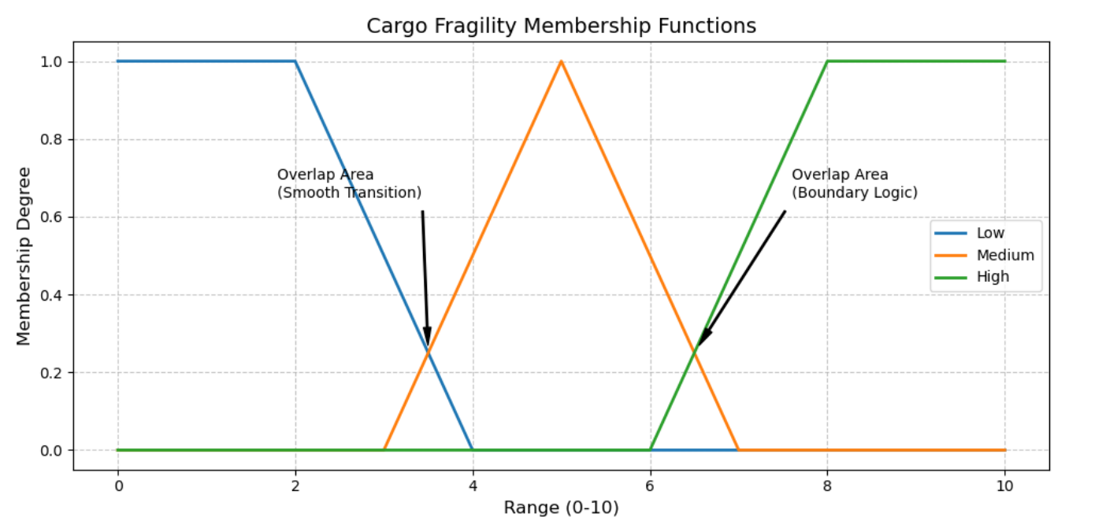
Description: The overlap between adjacent sets allows a smooth transition when cargo is not clearly low, medium, or high in fragility.
Figure 2. Traffic Congestion Membership Functions
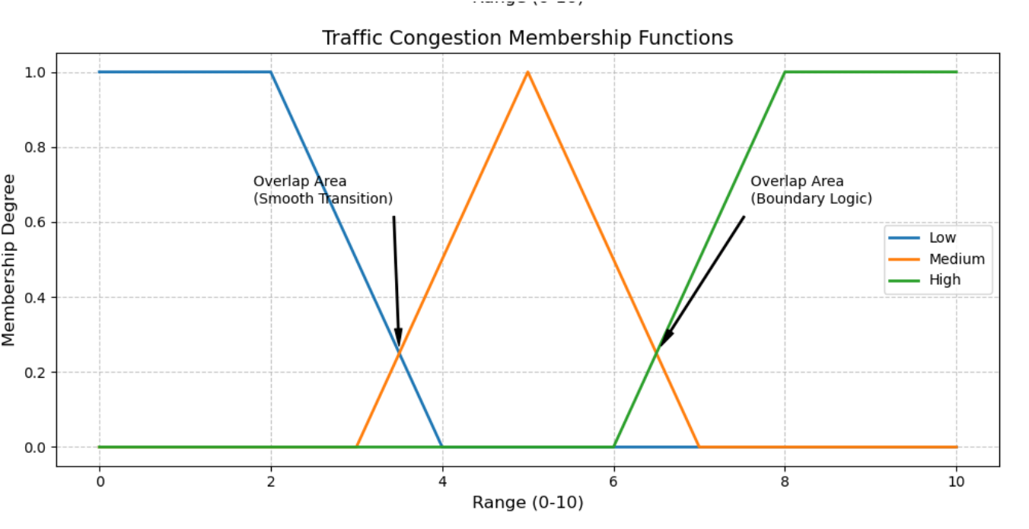
Description: The overlap supports a gradual interpretation of changing traffic conditions in the Melbourne CBD delivery environment.
Figure 3. Delivery Handling Priority Membership Functions
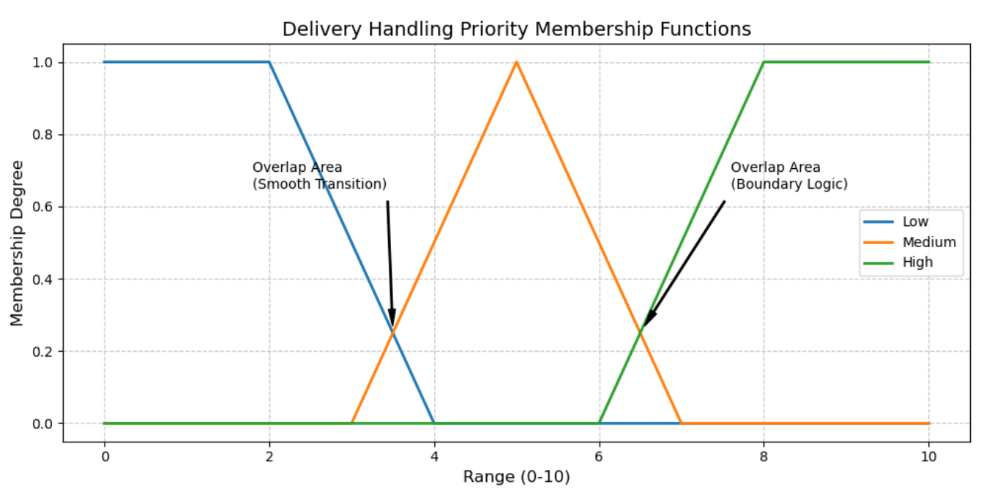
Description: The output sets support balanced fuzzy reasoning and centroid-based final decision making for cargo handling care.
This design helps the system move smoothly between neighbouring categories instead of making hard decisions. For example, a fragility value of 6.5 does not need to be treated as fully medium or fully high. Instead, it can belong partly to both sets. The same idea applies to traffic congestion, where a value around 6.5 may reasonably reflect both medium and high congestion at the same time.
This overlap is important because delivery conditions in the Melbourne CBD are not perfectly separated into fixed categories. In Assignment 1, the environment included high-traffic areas, constrained laneways, and practical differences in truck suitability. These conditions naturally vary by degree rather than changing at one exact boundary. The overlap therefore helps the fuzzy system model uncertainty in a more realistic way. It also allows several rules to activate together, which supports smoother and more balanced reasoning.
Design Justification: The boundary values were chosen to create clear low, medium, and high regions while still allowing overlap between neighbouring sets. This works well for delivery decisions because cargo condition and traffic difficulty usually change gradually instead of at exact cut-off points. The trapezoidal edges for Low and High represent clearly safe or clearly risky situations, while the triangular Medium set captures the uncertain middle range.
2.2 Why the Overlap is Necessary
The overlap between fuzzy sets is necessary for three main reasons.
One of the main reasons I included overlapping sets is to move away from rigid, unrealistic thresholds. In a real delivery, a small change in traffic doesn't suddenly flip the entire handling strategy. If a congestion value changes from 6.4 to 6.5, the delivery situation does not suddenly become completely different in real life. A fuzzy overlap allows the system to reflect this gradual change.
Second, it supports ambiguous cases, which are common in delivery operations. A cargo item may not be fully safe or fully fragile, and traffic may not be clearly smooth or clearly severe.
Third, it supports the rule base. Because neighbouring sets overlap, more than one rule can be partially activated at the same time. This leads to a final output that better reflects the mixed nature of the situation.
2.3 Rule Matrix
The fuzzy rules are designed to reflect practical trade-offs between the two inputs. In general, higher fragility should increase handling priority, and higher congestion should also increase handling priority because difficult road conditions can make safe delivery harder.
Rule Matrix for Delivery Handling Priority
Fragility \ Congestion | Low | Medium | High
Low | Low | Low | Medium
Medium | Low | Medium | High
High | Medium | High | High

This matrix is based on what I observed in Assignment 1. I wanted to make sure that even more durable items are handled more carefully when moving through narrow or congested areas like Degraves Street. For example, even if traffic is not too heavy, highly fragile cargo still needs extra attention. At the same time, even less fragile items may require higher handling priority when congestion is high, since frequent stopping, crowd density, and difficult city movement can increase delivery risk.
2.4 Fuzzy Rule Base
The full IF–THEN rule base is:
- IF Cargo Fragility is Low AND Traffic Congestion is Low THEN Delivery Handling Priority is Low.
- IF Cargo Fragility is Low AND Traffic Congestion is Medium THEN Delivery Handling Priority is Low.
- IF Cargo Fragility is Low AND Traffic Congestion is High THEN Delivery Handling Priority is Medium.
- IF Cargo Fragility is Medium AND Traffic Congestion is Low THEN Delivery Handling Priority is Low.
- IF Cargo Fragility is Medium AND Traffic Congestion is Medium THEN Delivery Handling Priority is Medium.
- IF Cargo Fragility is Medium AND Traffic Congestion is High THEN Delivery Handling Priority is High.
- IF Cargo Fragility is High AND Traffic Congestion is Low THEN Delivery Handling Priority is Medium.
- IF Cargo Fragility is High AND Traffic Congestion is Medium THEN Delivery Handling Priority is High.
- IF Cargo Fragility is High AND Traffic Congestion is High THEN Delivery Handling Priority is High.
These rules are intentionally simple and interpretable. The strongest output occurs when both fragility and congestion are high, because this represents the most operationally risky situation. On the other hand, the lowest output occurs when both inputs are low, because the cargo is durable and the surrounding movement conditions are manageable.
2.5 Aggregation and Defuzzification
The fuzzy outputs from all activated rules are combined using the max aggregation method. This is suitable because it preserves the strongest membership degree contributed by the active rules in each output region.
For the final crisp decision, the system uses the centroid defuzzification method. This method is suitable because it produces a balanced weighted average of the aggregated fuzzy output and gives a single interpretable value for the final handling priority. In this report, centroid is preferred because it is widely used, easy to explain, and fits the goal of producing a smooth decision rather than a rigid one.

3. Worked Example
To demonstrate the behaviour of the fuzzy system, one ambiguous delivery case is selected.
Example Scenario
A truck is carrying a somewhat delicate cargo item through a moderately to heavily congested part of the Melbourne CBD. This is not an extreme case, but it is clearly not risk-free either. The chosen input values are:
- Cargo Fragility = 6.5
- Traffic Congestion = 6.5
These values are useful because they lie near the overlap regions of the membership functions, which allows multiple rules to fire at the same time.
Worked Example Table
Key stage | Your example value/logic | Technical process
Crisp inputs | Cargo Fragility = 6.5, Traffic Congestion = 6.5 | The system begins with two crisp input values that represent the current delivery situation. The cargo is moderately to highly fragile, while the road environment is moderately to heavily congested.
Fuzzification | $$μMedium(6.5) = (7 - 6.5) / (7 - 5) = 0.25$$  $$μHigh(6.5) = (6.5 - 6) / (8 - 6) = 0.25$$  These values apply to both Cargo Fragility and Traffic Congestion, since they share the same membership function design.  Therefore, the fuzzified values are:  Fragility: Medium ≈ 0.25, High ≈ 0.25  Congestion: Medium ≈ 0.25, High ≈ 0.25  This means that both inputs lie in the overlapping region between Medium and High, allowing multiple rules to be activated simultaneously. | To see how the system handles ambiguity, I tested it with x = 6.5. I calculated the membership degrees manually using linear interpolation to verify that the logic holds in overlapping regions  . Because 6.5 lies near the boundary between Medium and High for both variables, each input belongs partly to both sets.
Rule activation | Rule 5 activates: Medium AND Medium → Medium, strength = min(0.25, 0.25) = 0.25. Rule 6 activates: Medium AND High → High, strength = min(0.25, 0.25) = 0.25. Rule 8 activates: High AND Medium → High, strength = min(0.25, 0.25) = 0.25. Rule 9 activates: High AND High → High, strength = min(0.25, 0.25) = 0.25. | The min operator is used to calculate the firing strength of each rule antecedent. Since both inputs lie in overlapping regions, several rules are activated at the same time.
Inference | Medium output clipped at 0.25, High output clipped at 0.25 | The consequents of the activated rules are applied to the output membership functions. The resulting fuzzy output contains support in both the Medium and High regions.
Output | Final Delivery Handling Priority is approximately 7.0 | The clipped output sets are aggregated using max, and the final crisp value is obtained using centroid defuzzification. The result falls in the upper range of Medium, leaning towards High priority due to the combined risks.
Explanation of the Result
In this case, the result sits between medium and high handling priority because both inputs increase the overall delivery risks. The cargo is fragile enough to require extra care, while the traffic level suggests more stop-start movement, delay, and less stable transport conditions in the Melbourne CBD. Fuzzy reasoning is useful here because it allows both inputs to belong partly to more than one category at the same time. This leads to a more realistic decision compared to using a fixed threshold and better reflects uncertainty in real urban delivery operations.

4. Conclusion
This fuzzy system extends the Assignment 1 Melbourne CBD delivery environment in a meaningful way. Assignment 1 focused on route planning and showed that delivery decisions should account for congestion, constrained roads, and truck suitability. In this assignment, those same practical conditions are reflected in a fuzzy cargo-handling decision model.
Using Cargo Fragility and Traffic Congestion as inputs, the system produces an interpretable Delivery Handling Priority output that reflects uncertainty more effectively than a rigid threshold approach. The membership functions, rule matrix, and worked example all show that fuzzy reasoning is well suited to urban delivery situations where neither the cargo condition nor the surrounding environment is completely clear-cut. Overall, the system is simple to understand and works well for the delivery scenario used in this assignment.

References
Russell, S., & Norvig, P. (2022). Artificial Intelligence: A Modern Approach.
https://aima.cs.berkeley.edu/
NetworkX Developers. (2026). Shortest Paths.
networkx.org
Google. (2026). My Maps.
https://www.google.com/maps/about/mymaps/
Hart, P. E., Nilsson, N. J., & Raphael, B. (1968). A Formal Basis for the Heuristic Determination of Minimum-Cost Paths.
https://ieeexplore.ieee.org/document/4082128
SIT215 Assignment 1 submission by Jin Kim.
SIT215 Assignment 2 task sheet.

