Chapter 1 ECMiner™ Overview

ECMiner™ is a data analytics software developed by ECMiner Co., Ltd. Most of the features of ECMiner™ are pull-down menus easily accessible to non-technical users. Academics with expertise in analytical algorithms collaborated in the early days of the development ECMiner™. Subsequent versions are developed for providing a variety of data management, transforming, and model evaluation for real-world problems.

The key advantage of ECMiner™ is the following:
- Large-Scale Data Handling
It supports various types of database formats, ECL (a proprietary data structure), TEXT, EXCEL, etc. Large volumes of data are manageable.
- User-friendly tool
Pull and drag option for modeling is very convenient to users from loading data to analytics. Easily modified model deleting to adding nodes in analytical schema.
- Scalability
Configuration of full model is easily modified.
- Diverse Analytical Features
Prediction, classification, clustering, and Association Rules (AR), a powerful preprocessing node, a data browser, and charting for data visualization.

1.1 System Requirements

Recommended System Requirements
CPU | Intel® Core i5 or higher
Memory | 16 Gbytes or more
Operating System | Windows 10 or higher
Hard Disk space | 3.5 Gbytes + Free space at least 2x the amount of data to be analyzed

System Minimum Requirements
CPU | Intel® Core 2 Duo 2.4 GHz
Memory | 4 Gbytes
Operating System | Windows 8 or higher
Hard Disk space | 3.5 Gbytes + Free space at least 2x the amount of data to be analyzed

NOTE The performance of the system may vary depending on the number of users and the size of the database; the database size generally increases by about 500 Mbytes per year, assuming 1 Gbyte for each
year (500 Mbytes x 2) of data entry is typical.

1.2 Install and Uninstall ECMiner™
Install
Download the setup file and run it to install the software. For a trial version, you can download the trial version from the ECMiner Co., Ltd. website at www.ecminer.com.
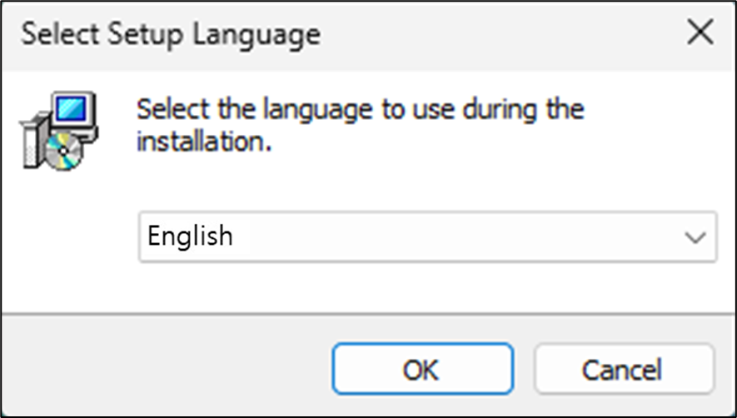
Select Setup Language “English”.
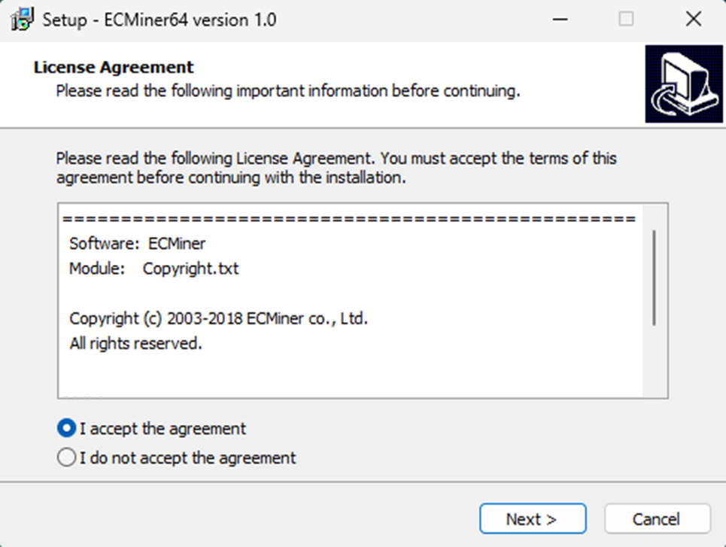
Select [I accept the agreement(A)] and then click [Next(N)].
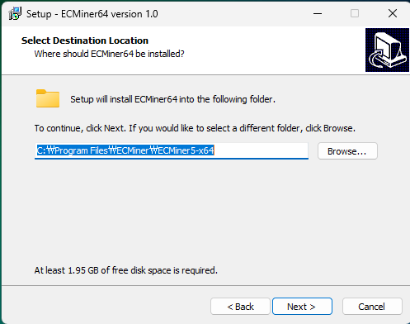
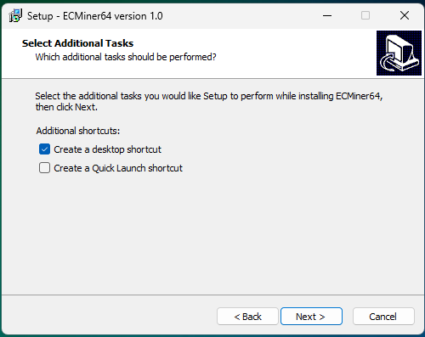
Choose whether to Create a desktop shortcut or Create a Quick Launch shortcut. ‘Create a desktop shortcut’ is recommended.
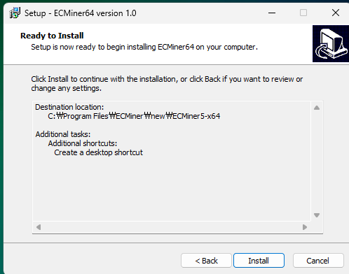
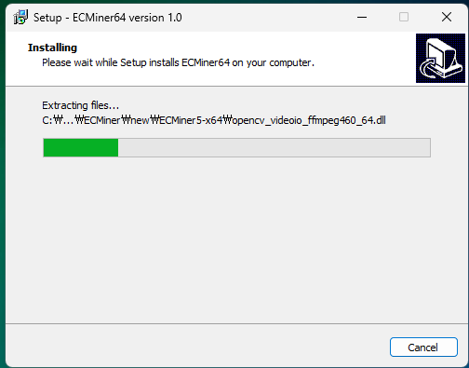
Installation is processing.
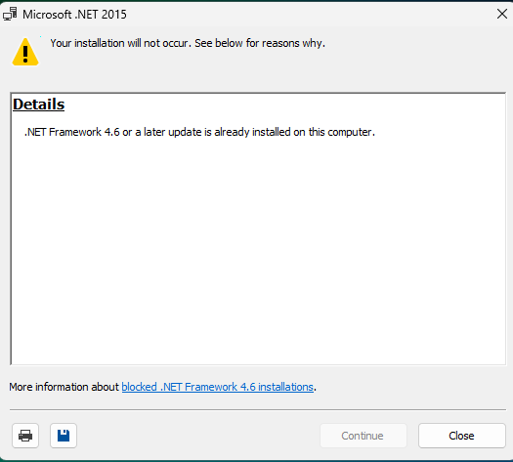
It checks the necessary .NET framework version for ECMiner operation. If it is already installed, this display does not come up.
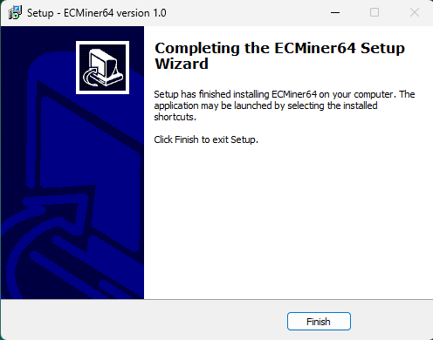
The installation is complete. Clicking 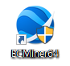 icon, the program starts.
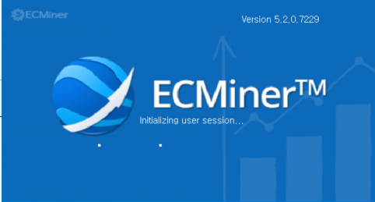

Uninstall
In "Windows Settings (Control Panel)” _ "Apps > Installed apps", select ECMiner™ and click the 'Uninstall' button
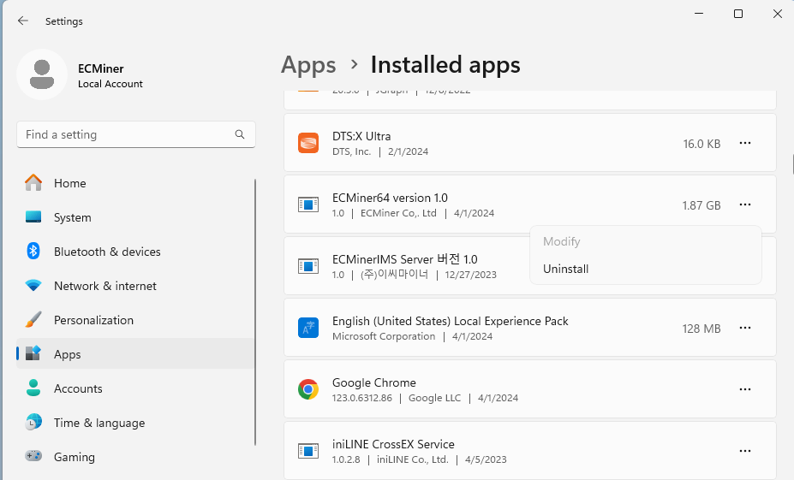

1.3 User Interface
ECMiner™ offers a user-friendly interface. Users can create various analytical models depending on the purpose.
Main Window
ECMiner™ provides the following main window to enable easy and efficient data mining.
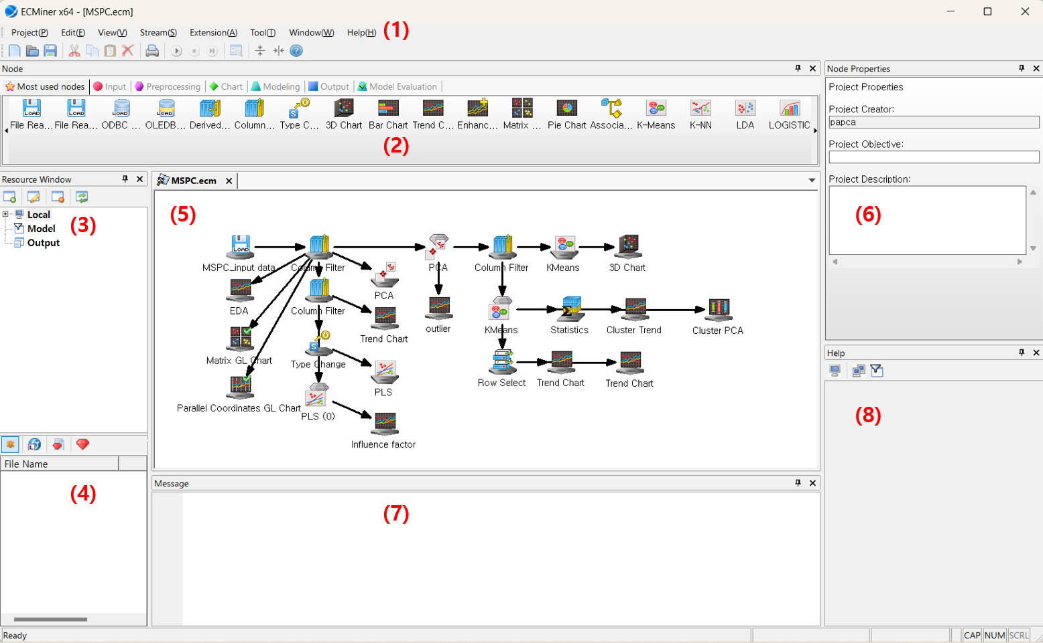
Num. | Window name |  | Description
(1) | Menu |  | Creating/editing/saving project and files
(2) | Node |  | Node for ‘Data’, ‘Chart’, “Modeling’, ‘Output’ and ‘Model Evaluation’. Data loading (data input), data manipulation to filter, derive variables and define indep. & dep. variables.
(3) | Resource  Window | Resource Menu | The resource window displays with Local, Model, and Output.  - Local displays the list of the current working folder.  - Model stores the current data analytical node.  - Output stores the results of executing the current project.
(4) | Resource  Window | Resource  List | The window displays the contents of the selected menu (Local, Model, Output) in the Resource menu.
(5) | Workspace |  | Working space for data handling and model configuration
(6) | Node Property |  | Information for data and model specification and output at each node
(7) | Message |  | Log messages about errors and process information
(8) | Dynamic Help |  | The help for the node properties

1.3.1 Menu
The menu is located at the top of the screen. It provides menus such as Project(P), Edit(E), View(V), Stream(S), Extension(A), Tool(T), Window(W), Help(H), and others.

Project(P) | Edit(E)
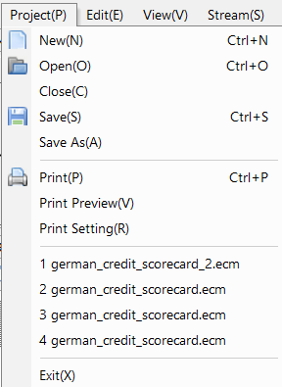 | 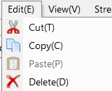
View(V) | Stream(S)
Determines the visibility of the Toolbar, various windows, and the Status bar.  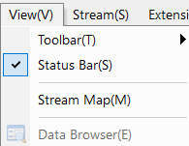 | 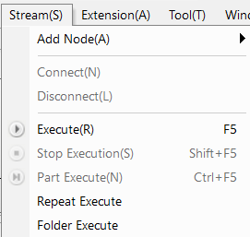
Extension(A) | Window(W)
You can perform Design of Experiments (DOE) and Probability Distribution analysis, etc.  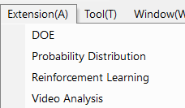 | 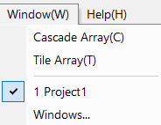
Help(H) | Tool(T)
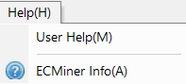 | 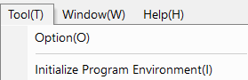

Tool's Option allows to set up the user-specific option.
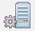 | Program Settings | Setting for Date/Time Format, Reading Data, Designate File Extensions to Display on Resource Window
 | Default Database Setting | Set the default driver and login information for ODBC or OLE DB.
 | Edit Frequently Used Nodes | Add or delete the most used nodes.

Tool Bar
 | New (Ctrl + N) |  | Open (Ctrl + O)
 | Save (Ctrl + S) |  | Cut
 | Copy |  | Paste
 | Delete |  | Print (Ctrl + P)
 | Execute (F5) |  | Stop Execution (Shift + F5)
 | Part Execute (Ctrl + F5) |  | Data Browser
 | About |  | User Help

1.3.2 Node
Data loading, data preprocessing, modeling and evaluation. Select and drag each node in order in the working space, and connect to each in turn.
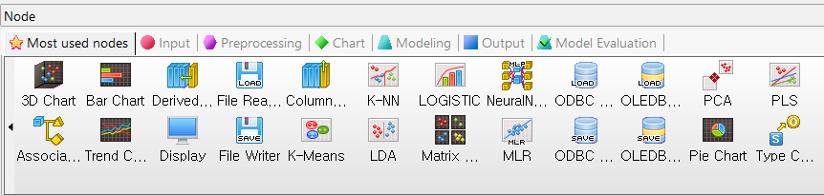

The node window is classified into a total of seven categories.
Classification | Description
Most used nodes | Frequently used nodes. Add or exclude in ‘Most used nodes’ in Tool’s options
Input Node | Load data
Preprocessing Node | Data manipulation nodes for filtering, sorting, and splitting.
Chart Node | Graphics for data visualization
Modeling Node | Analytical techniques for prediction, classification, clustering, and AI algorithms
Output Node | Save a DB or file
Model Evaluation Node | Model evaluation, ROC chart

1.3.3 Project Window
Start with Input Node, ‘Column filter’ and ‘Type change’ to define indep. & dep. Variables, and select either ‘Continuous’ or ‘Discrete’. Connect to modeling node.
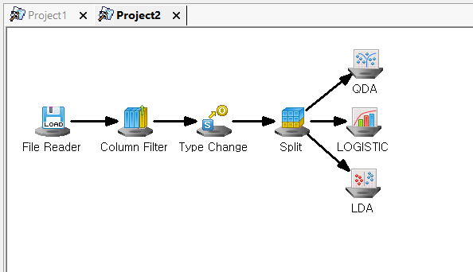
The project window shows the flow map of the data analysis.

Select Project
To activate a project, press the tab on the top.
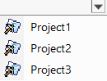
Close Project
Select "Project > Close" or press “X” button.
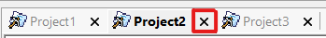.
Nodes
Various types of icons for different tasks.
ICON | Type | Underline
 | Input Node | Circle
 | Preprocessing Node | Hexagon
 | Chart Node | Rhombus
 | Modeling Node | Trapezoid
 | Output Node, Model Evaluation Node | Rectangle
 | Model Node | Diamond

Context Menu
Right-clicking in the project window displays all the menu nodes.
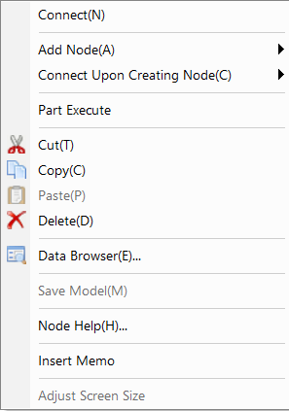
The newly added feature in this latest version, 'Insert Memo', is added for users to make notes when configuring nodes and projects

1.3.4 Node Properties
It shows the properties of the project or the selected node.

Project Properties
In the project properties window, you may add a memo of the project's objective and description. The Project Creator shows the username of the person logged into Windows and cannot be changed.
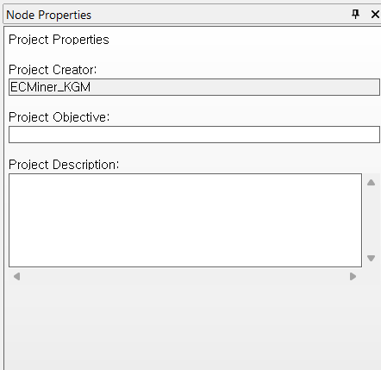
Node Property about data
- Node property for data tells the variable names and data type. Data types can be changed.
- Exclusion of variable in ‘Column Filter’.
- Define the dependent and independent variables in ‘Type Change’.
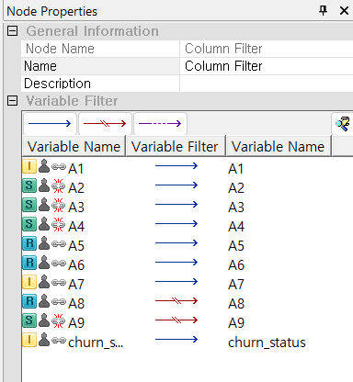

1.3.5 Resource Window
In ECMiner™, resources refer to all files including data, results, models, and project files.
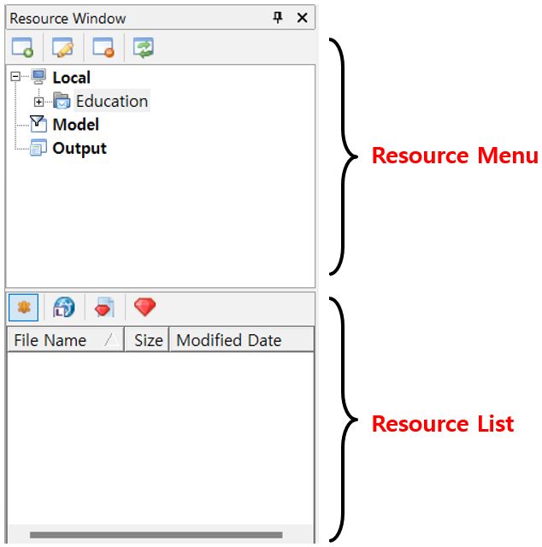

Resource Menu
- Local menu displays a list of files in the resource list.
- Model menu shows the list of model files. You may utilize it for future runs.
- Output menu displays the list of output for each project.

Resource List
- When selecting the Local menu
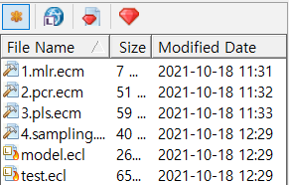
From the resource lists, you can filter the files using the toolbar buttons at the top.
- When selecting the Model menu
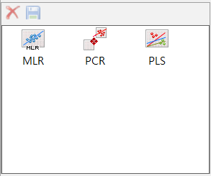
After running modeling, the output models are listed. You may take out a model in the list which is not necessary.
- When selecting the Output menu
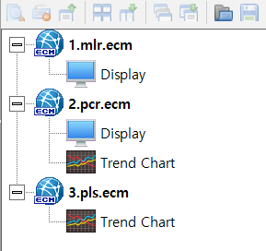
After running modeling, the output results are listed in the project with sub-tree. Select the results you want to view. It shows the results for comparison. Additionally, it offers the ability to save results or view previously saved results.

1.3.6 Resource Window -Local
Task Folder
A task folder in ECMiner™ is a frequently used one, which can be renamed (aliased) with another name. Users need to add the task folder themselves, and once added, the work folders will appear in the Local menu within the resource window.
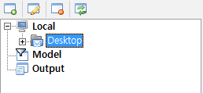
You may Add/Delete/Modify the folder using the toolbar

Add Task Folder
Set the path where you want to add as a "Task Folder" pressing the button, and give a folder name.
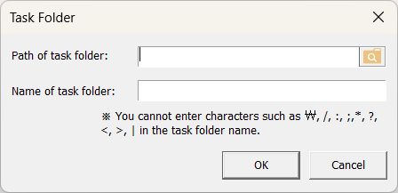
- Modify Task Folder
To change the contents (folder path, folder name), click the button in the toolbar.
- Delete Task Folder
To delete a task folder, click the button in the toolbar. A message box will pop up asking, "Are you sure you want to delete?" Pressing the ‘Yes’ button will delete the folder.
- Reload
To reload the file list of the task folder, click the button in the toolbar.
- Create New Folder
Right-clicking on the task folder in the Resource menu.
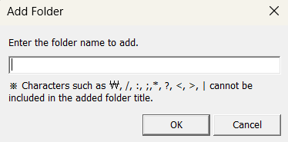
Give the name of folder, it will add the task folder.

Utilizing Task Folders
- Project Management
By creating a work folder and gathering all files generated during analysis, such as data files, project files, and model files, you can manage everything in one place. This makes it easy to understand the content of the project without searching through multiple folders.
- Data Sharing
Creating work folders with the same name allows users to share data files without additional effort, accommodating differences in user environments.
Resource List
The file lists of the selected folder.
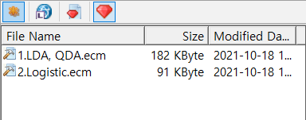
ICON | Description
 | Displays all types of files specified in the ECMiner™ options.
 | Data files, which are *.ecl files.
 | Model files (*.gms) created in ECMiner™.
 | ECMiner™ project files (*.ecm).

Utilizing the Resource List
If the data file you want to use is in the task folder, you can easily create an Input Node by drag & drop the file.
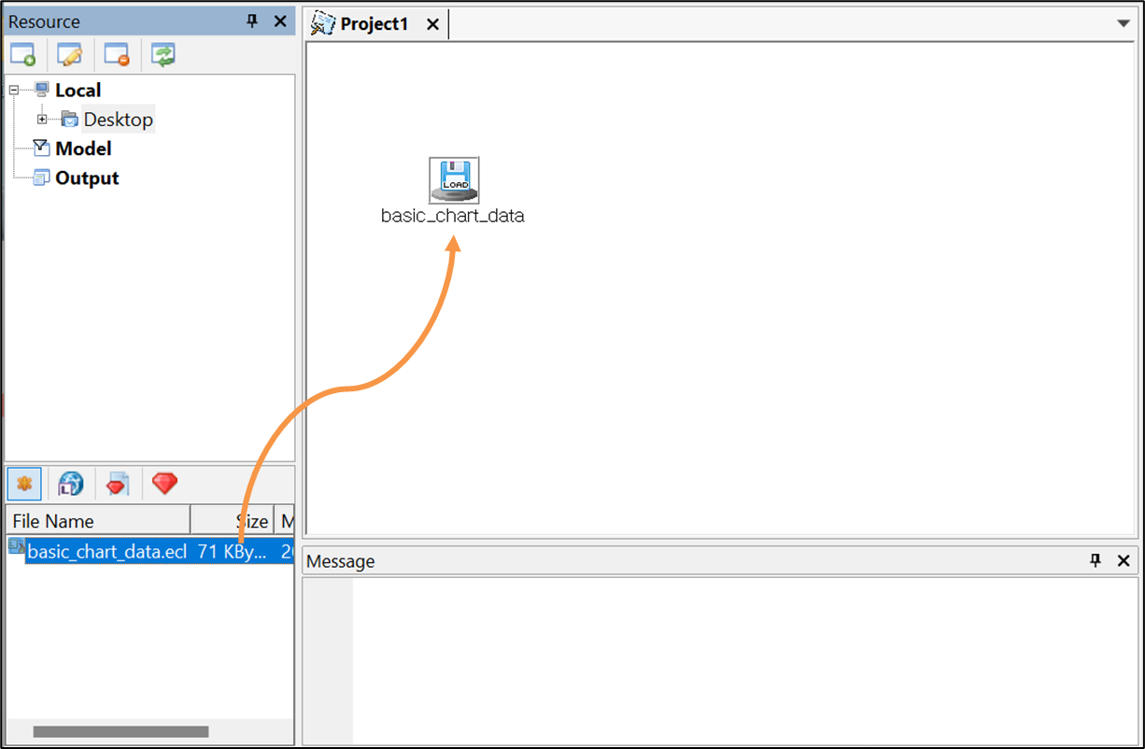

1.3.7 Resource Window -Model
After running the model stream, temporary models are listed in the resource window.
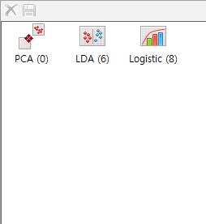
Temporary Model
Files in the resource window are the result of executing the stream. The name executing result is identical with model node name.
Delete Model
To remove an output file in the list, press
Save Model
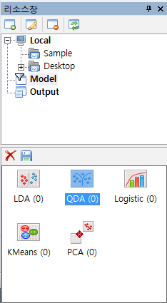
To save a temporary model for another use, press
Give the model name and specify the path, "given_model name.gms" is saved in the task folder.
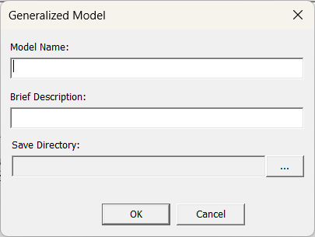
Another method to store a temporary is to ‘drag & drop’ into the task folder (subfolder).
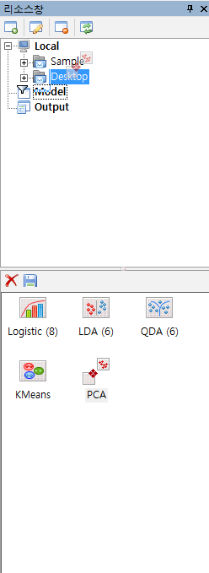
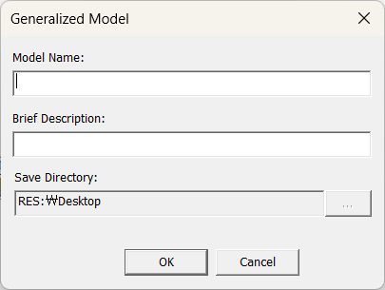
In the dialog box that appears, enter the name and a brief description for the model upon globalization. After specifying the save path, press the OK button. This will create a global model file named "global model name.gms" in the task folder (or subfolder) where you dropped it, indicating the save path.

1.3.8 Resource Window -Output
The results created after executing the stream will appear in the list when the Output menu is selected.
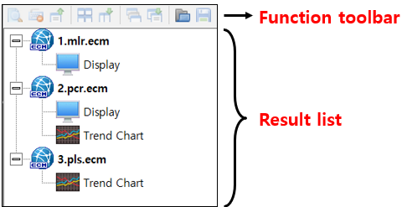
Output Review
To view a generated output again, double-click the output from the Result list. Alternatively, after selecting one or more outputs, press the button located on the toolbar.
Output toolbar
The toolbar provides the following functions:
- Open Output
Display all selected outputs from the list.
- Delete Output
Delete all selected outputs from the list
- Close All Outputs
Close all open output windows.
- Output Window Grid Alignment
If two or more output windows are currently open, arrange them into a grid format.
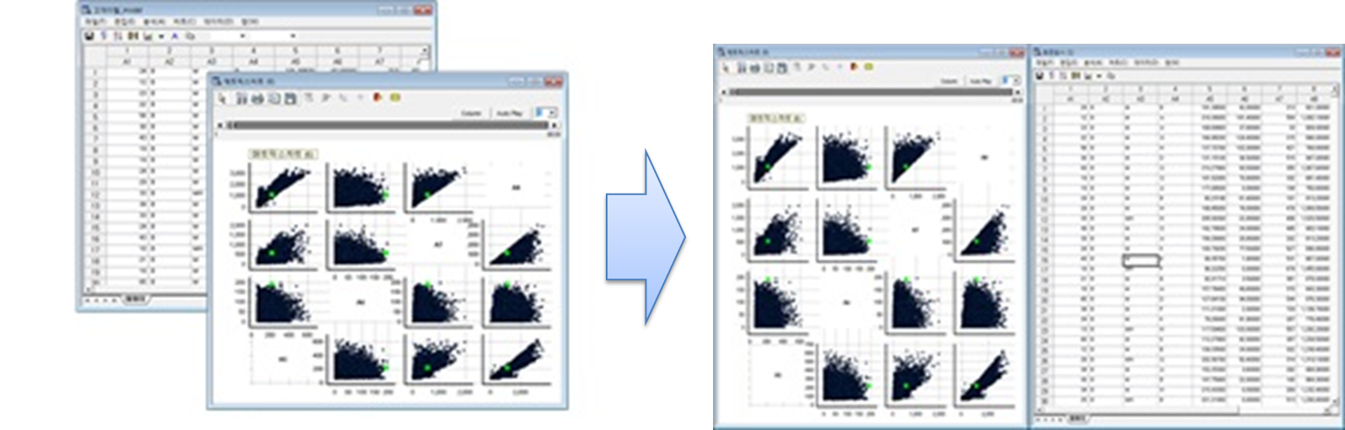
- Display Grid Alignment
Similar to the feature described above, when you open two or more selected closed outputs, the outputs will be arranged in a grid format.
- Output Window Cascade Alignment
Arranges the currently open output windows in a cascading format.
- Display Cascade Alignment
Similar to the feature described above, when you open two or more selected closed outputs, the outputs will be arranged in a cascading format.
- Save output
Save the output to the desired path in the *.ept file format
- Load saved output
Open the saved output file(*.ept). The results will be added to the list under the "Other” category
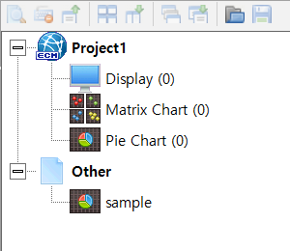

NOTE
Since the output of the Display Node is generated as data, it should be saved as a data file(*.ecl) rather than as an output file (*.ept). Therefore, you must use the save button within the Display Node screen to save the output.
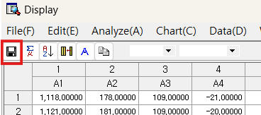

1.3.9 Message Window
The Message window displays execution information and errors related nodes during stream execution.
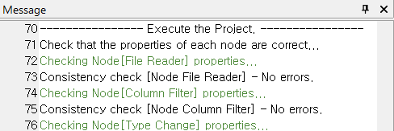

Type of Messages
The types of messages can be categorized into five categories, differentiated by color as follows:
Num. | color | content
1 |  | General Message
2 |  | Emphasized message.
3 |  | General Error Message
4 |  | Critical Error Message
5 |  | Note Message

1.3.10 Dynamic Help
When you edit a node’s properties, a brief description of the selected property will be shown in the Dynamic Help section.
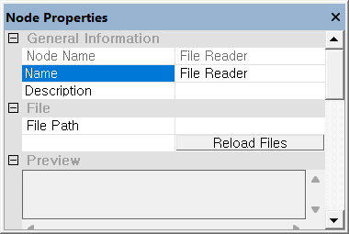 |  | 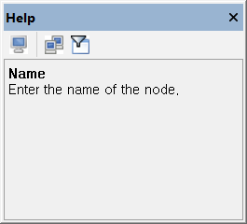

The toolbar provides following functions:
- Toggle Help
Navigate to the help for the selected node
Note: Pressing the button again will return to the dynamic help
- Index Search
Open the help window and search for the desired topic

1.3.11 Window Control
All control windows in ECMiner™ can be repositioned and resized to fit the user's preferences.

Reposition
To reposition the windows, follow each step:
- 1. Left-click and hold the title of the control window with the mouse
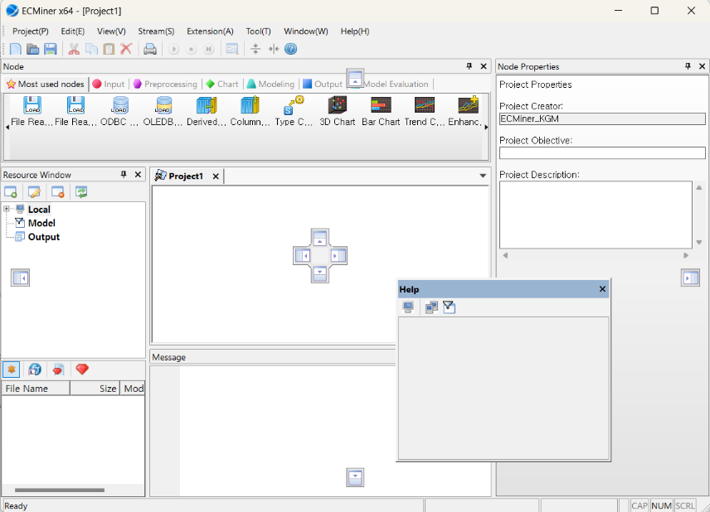
- 2. While dragging, move the mouse pointer over the icon of the location where you want to place the control window.
  - Central four-direction icon
These icons indicate the top, bottom, left, and right sides within the control window that the mouse moves during the dragging process
  - Surrounding four-direction icon
These icons indicate the top, bottom, left, and right sides of the entire program window.
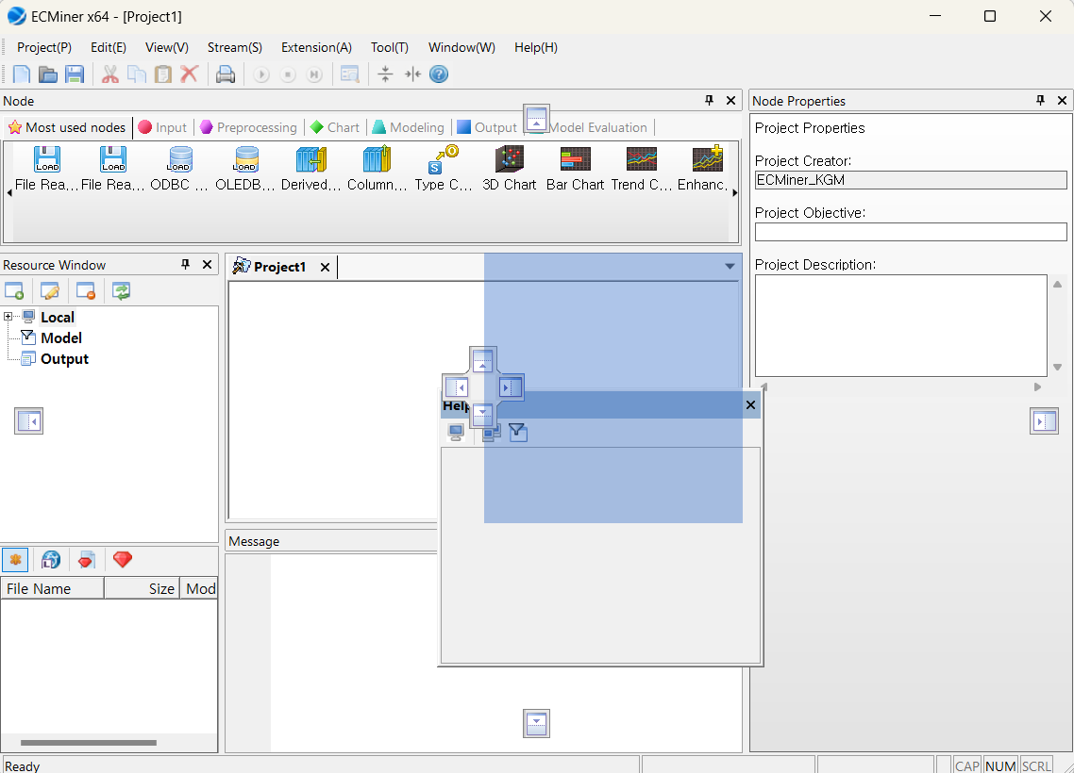
- 3. A blue rectangle will indicate where the control window will be located. Once you confirm the position, release the mouse button to change the location of the control window.
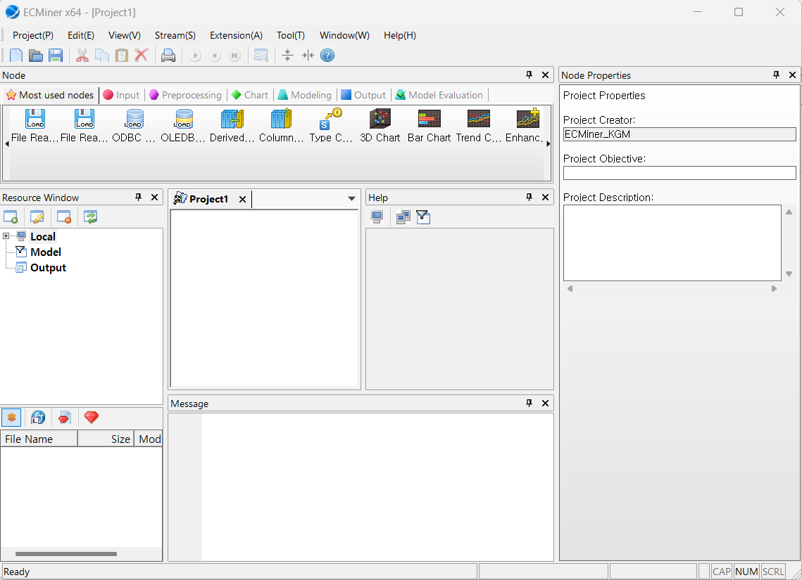

NOTE
If the mouse is released outside of the direction icon, the control window will open independently.

The position of the workspace cannot be changed.

Resize
To resize the control window, left-click and drag its border when the mouse pointer changes to the resize shape ( , ).

Close the control window
To close the control window, press “X” button or select "View > Toolbar" from the main menu.

Open control window
To open a closed (invisible) control window, select "View > Toolbar" from the main menu.

Auto-Hide control window
Pressing the button will minimize the control window and can be found right side of the entire program window. If you hover the mouse pointer over the marked tab, it will pop up.
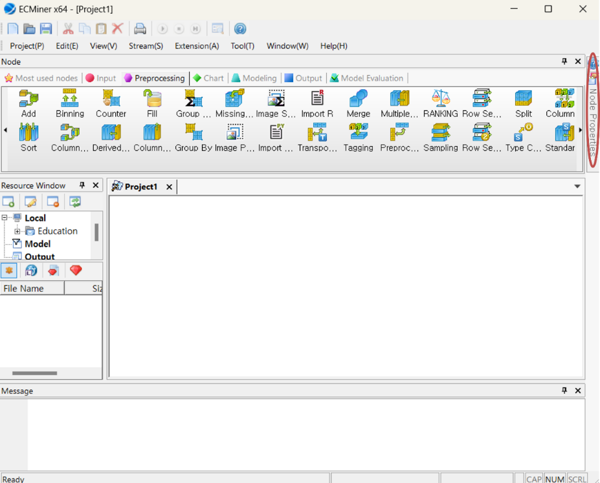

1.4 Mouse usage
A left-click is used for function menus, a right-click is for support menus, and a double left-click is for results display.
Drag & Drop
Drag & drop the nodes you need in your ‘Stream’ in the Project window.
Click Left Button
Clicking on a node in the Project window will display its properties.
Click Right Button
Right-clicking pops up a menu for connect or disconnect nodes, delete nodes.
Left Button Double Click
Double-clicking on results icon displays information about the result in the Output window.

1.5 Shortcut key
The shortcut key is shown in the table. F5 is for ‘execute’ and Ctrl & S is for ‘save’ and so on.
Shortcut | function | Shortcut | function
Ctrl + N | New | Alt + V, T | Toolbar
Ctrl + O | Open | Alt + V, T, S | Standard Toolbar
Ctrl + S | Save | Alt + V, T, N | Node
Ctrl + P | Print | Alt + V, T, P | Node Properties
F5 | Execute | Alt + V, T, E | Resource Window
Shift + F5 | Stop Execution | Alt + V, T, H | Dynamic Help
Ctrl + F5 | Part Execute | Alt + V, S | Status Bar
Alt + P | Project | Alt + V, E | Data Browser
Alt + P, N | New | Alt + S | Stream
Alt + P, O | Open | Alt + S, A | Add Node
Alt + P, C | Close | Alt + S, C | Connect Upon Creating Node
Alt + P, S | Save | Alt + S, N | Connect
Alt + P, A | Save As | Alt + S, L | Disconnect
Alt + P, P | Print | Alt + S, R | Execute
Alt + P, V | Print Preview | Alt + S, S | Stop Execution
Alt + P, R | Print Setting | Alt + S, N | Part Execute
Alt + P, X | Exit | Alt + T | Tool
Alt + E | Edit | Alt + T, O | Option
Alt + E, T | Cut | Alt + T, I | Initialize Program Environment
Alt + E, C | Copy | Alt + W | Window
Alt + E, P | Paste | Alt + W, C | Cascade Alignment
Alt + E, D | Delete | Alt + W, T | Grid Alignment
Alt + V | View | Alt + H | Help
Alt + V, T, M | Message | Alt + H, A | ECMiner™ Info

1.6 Program Settings
The Program Settings opens when you select [Tool (T)] – [Option (O)] from the menu.
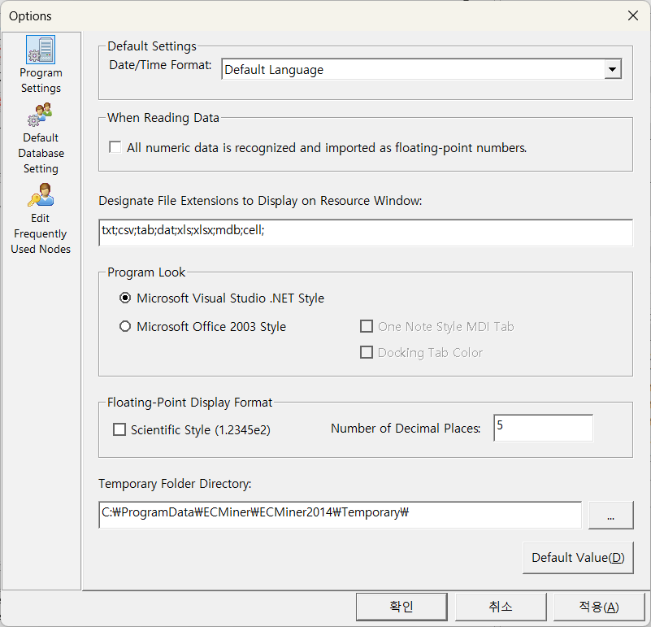

The options are organized into menu tabs, and when a tab is selected, an editing window appears. The options that can be set include General Program Settings, Default Database Setting, and Editing Frequently Used Nodes, among others.

The dialog is divided into tabs for these menus, allowing for selective settings according to the relevant option.
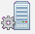 | Program Settings | Set the program defaults for Date/Time Format, Reading Data, Designate File Extensions to Display on Resource Window, Program Look, etc.
 | Default Database Setting | Set the default driver and login information for ODBC or OLE DB.
 | Edit Frequently Used Nodes | You can add or delete the most used nodes.

1.6.1 Program Settings
When you select the Program Settings under Tool(T) - Option(O), the following options window will appear. In this options window, you can set the Data/Time Format by country, the recognition method for numerical data, designate File Extensions to Display on the Resource window, and the Program Look method.
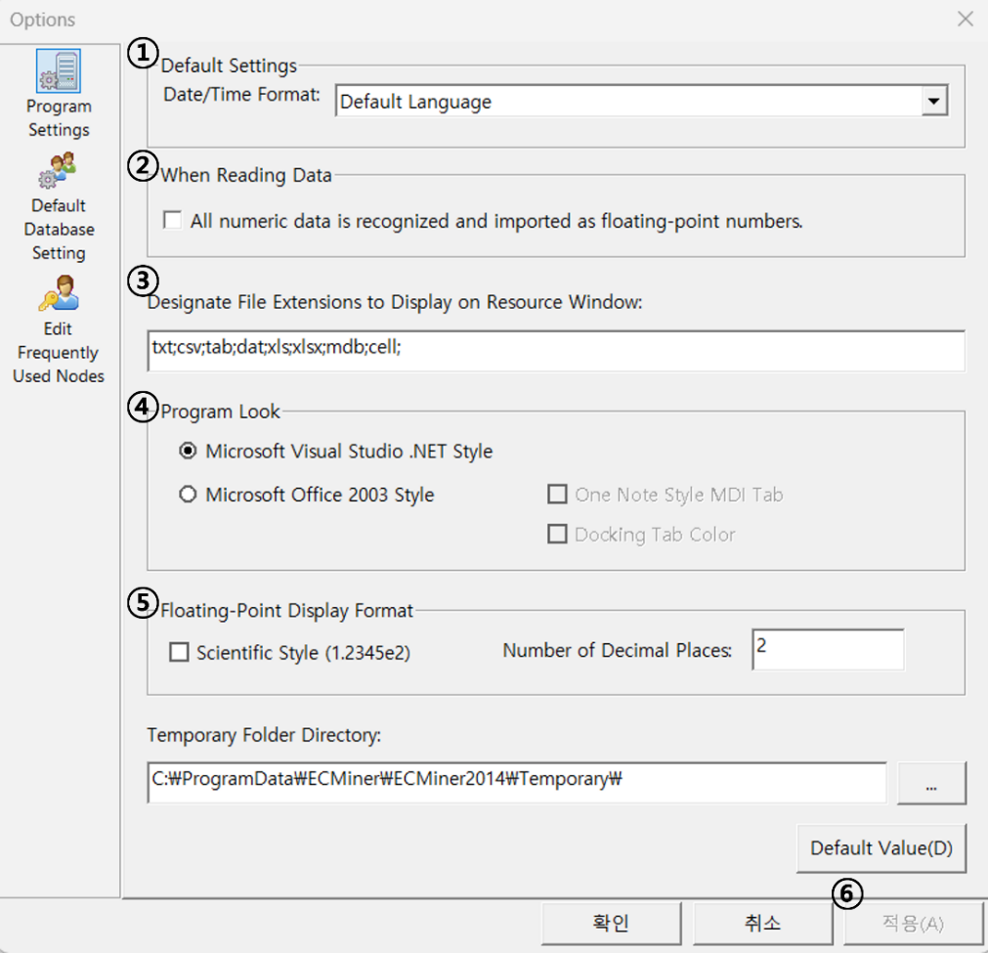
Num. | description
(1) | You select the date/time display format based on the language.
(2) | Choose this option if you want to treat all numerical data as floating-point numbers when reading data.
(3) | Specify the types of files to be displayed in the Resource window. Enter the file extensions you want to display, separated by ";". Extensions like ecm, ecl, ept, gms, etc., are selected by default even if not specified.
(4) | Specify the overall look of the program. Set it to a form that is visually pleasing to the user.
(5) | Specify the display format for floating-point numbers when presenting data on screen or in reports.

1.6.2 Default Database Setting
Selecting Default Database Setting from Tool (T) - Option (O) opens the following options window. The databases supported by ECMiner™ are ODBC and OLE DB. By entering the driver and login information in the options window below, it can be set as the default database information for database operations in the Project window, making it convenient to use.
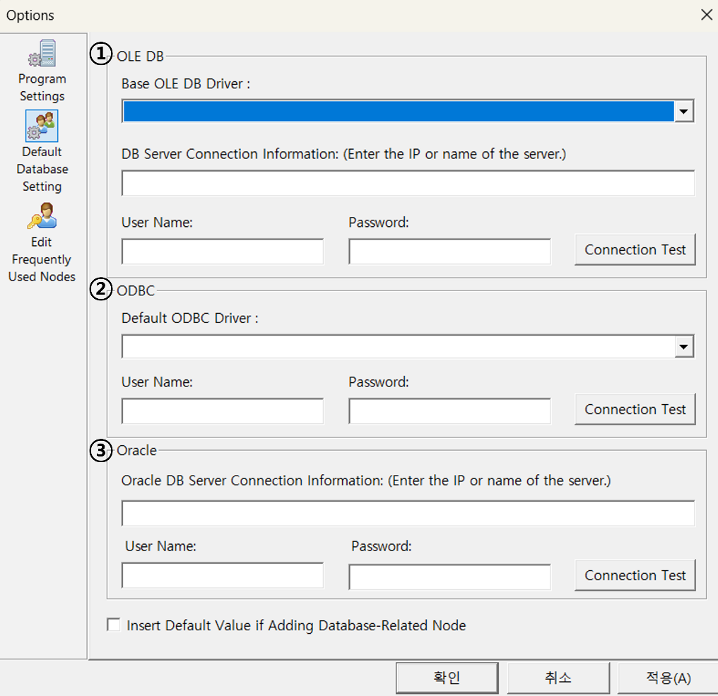
Num. | description
(1) | Enter the database connection information for nodes related to OLE DB.
(2) | Enter the database connection information for nodes related to ODBC.
(3) | Selecting this option will automatically fill in the database connection information when adding nodes related to the database.

1.6.3 Edit Frequently Used Nodes
Selecting Edit Frequently Used Nodes (Favorites) from Tool (T) - Option (O) brings up the following options window. Use the function buttons to add or remove nodes from Most used nodes. Added or removed nodes can be checked in the Most used nodes tab of the Node window.
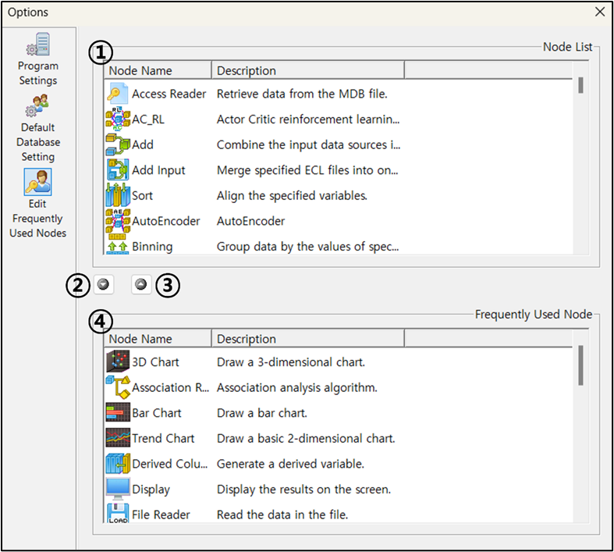
Num. | description
(1) | All nodes supported by ECMiner™ are listed.
(2) | (1) is used to add the selected node to "Most used nodes".
(3) | To remove a node from "Most used nodes," select the node to be removed at (4) and press this button.
(4) | This is the current list of nodes added to "Most used nodes."

Function button
icon | function
 | Adds the selected node to the Most Used Nodes list.
 | Deletes the selected node from the Most Used Nodes list.

