SPI Master Core

Specification

Author: Simon Srot
simons@opencores.org

Rev. 0.7

Revision History

Rev. | Date | Author | Description
0.1 | June 13, 2002 | Simon Srot | First Draft
0.2 | July 12, 2002 | Simon Srot | Document is lectured.
0.3 | December 28, 2002 | Simon Srot | Support for 64 bit character len added.
0.4 | March 26, 2003 | Simon Srot | Automatic slave select signal generation added.
0.5 | April 15 2003 | Simon Srot | Support for 128 bit character len added.
0.6 | March 15, 2004 | Simon Srot | Bit fields in CTRL changed.
0.7 | October 11, 2010 | Mark Peryer | Replaced Wishbone bus with APB interface

Contents

Contents ii
Introduction 1
IO ports 2
2.1 APB interface signals 2
2.2 SPI external connections 2
Registers 3
3.1 Core Registers list 3
3.2 Data receive registers[RxX] 3
3.3 Data transmit register [TxX] 4
3.4 Control and status register [CTRL] 4
3.5 Divider register [DIVIDER] 5
3.6 Slave select register [SS] 6
Operation 7
4.1 APB interface 7
4.2 Serial interface 9
Architecture 10
Core configuration 11

1
Introduction

This document provides specifications for the SPI (Serial Peripheral Interface) Master core. Synchronous serial interfaces are widely used to provide economical board-level interfaces between different devices such as microcontrollers, DACs, ADCs and other. Although there is no single standard for a synchronous serial bus, there are industry-wide accepted guidelines based on two most popular implementations:

- SPI (a trademark of Motorola Semiconductor)
- Microwire/Plus (a trademark of National Semiconductor)

Many IC manufacturers produce components that are compatible with SPI and Microwire/Plus.
The SPI Master core is compatible with both above-mentioned protocols as master with some additional functionality. The host bus interface is implemented as a 32 bit APB slave.

Features:
- Full duplex synchronous serial data transfer
- Variable length of transfer word up to 128 bits
- MSB or LSB first data transfer
- Rx and Tx on both rising or falling edge of serial clock independently
- 8 slave select lines
- Fully static synchronous design with one clock domain
- Technology independent Verilog
- Fully synthesizable

2
IO ports

2.1 APB interface signals

Port | Width | Direction | Description
PCLK | 1 | Input | APB Bus clock
PRESETn | 1 | Input | Asynchronous Reset
PADDR | 32 | Input | Address Bus
PSEL | 1 | Input | APB Peripheral Select signal
PWDATA | 32 | Input | Data input bus
PRDATA | 32 | Output | Data output bus
PWRITE | 1 | Input | Write enable
PENABLE | 1 | Input | Enables transfer cycle
PREADY | 1 | Output | Peripheral ready to complete transfer
PCLK | 1 | Input | APB Bus clock
PRESETn | 1 | Input | Asynchronous Reset
PADDR | 32 | Input | Address Bus
Table 1: APB interface signals

All output APB signals are registered and driven on the rising edge of PCLK. All input APB signals are latched on the rising edge of PCLK.

2.2 SPI external connections

Port | Width | Direction | Description
/ss_pad_o | 8 | Output | Slave select output signals
sclk_pad_o | 1 | Output | Serial clock output
mosi_pad_o | 1 | Output | Master out slave in data signal output
miso_pad_i | 1 | Input | Master in slave out data signal input
Table 2: SPI external connections

3
Registers

3.1 Core Registers list

Name | Address | Width | Access | Description
Rx0 | 0x00 | 32 | R | Data receive register 0
Rx1 | 0x04 | 32 | R | Data receive register 1
Rx2 | 0x08 | 32 | R | Data receive register 2
Rx3 | 0x0c | 32 | R | Data receive register 3
Tx0 | 0x00 | 32 | R/W | Data transmit register 0
Tx1 | 0x04 | 32 | R/W | Data transmit register 1
Tx2 | 0x08 | 32 | R/W | Data transmit register 2
Tx3 | 0x0c | 32 | R/W | Data transmit register 3
CTRL | 0x10 | 32 | R/W | Control and status register
DIVIDER | 0x14 | 32 | R/W | Clock divider register
SS | 0x18 | 32 | R/W | Slave select register
Table 3: List of core registers

All registers are 32-bit wide and accessible only with 32 bits (all wb_sel_i signals must be active).

3.2 Data receive registers[RxX]

Bit # | 31:0
Access | R
Name | Rx
Table 4: Data Receive register
Reset Value: 0x00000000

RxX
The Data Receive registers hold the value of received data of the last executed transfer. Valid bits depend on the character length field in the CTRL register (i.e. if CTRL[9:3] is set to 0x08, bit RxL[7:0] holds the received data). If character length is less or equal to 32 bits, Rx1,Rx2 and Rx3 are not used, if character length is less than 64 bits, Rx2 and Rx3 are not used and so on.

NOTE: The Data Received registers are read-only registers. A Write to these registers will actually modify the Transmit registers because those registers share the same FFs.

3.3 Data transmit register [TxX]

Bit # | 31:0
Access | R/W
Name | Tx
Table 5: Data Transmit register
Reset Value: 0x00000000

TxX
The Data Receive registers hold the data to be transmitted in the next transfer. Valid bits depend on the character length field in the CTRL register (i.e. if CTRL[9:3] is set to 0x08, the bit Tx0[7:0] will be transmitted in next transfer). If character length is less or equal to 32 bits, Tx1, Tx2 and Tx3 are not used, if character len is less than 64 bits, Tx2 and Tx3 are not used and so on.

3.4 Control and status register [CTRL]

Bit # | 31:14 | 13 | 12 | 11 | 10 | 9 | 8 | 7 | 6:0
Access | R | R/W | R/W | R/W | R/W | R/W | R/W | R | R/W
Name | Reserved | ASS | IE | LSB | Tx_NEG | Rx_NEG | GO_BSY | Reserved | CHAR_LEN
Table 6: Control and Status register
Reset Value: 0x00000000

ASS
If this bit is set, ss_pad_o signals are generated automatically. This means that slave select signal, which is selected in SS register is asserted by the SPI controller, when transfer is started by setting CTRL[GO_BSY] and is de-asserted after transfer is finished. If this bit is cleared, slave select signals are asserted and de-aserted by writing and clearing bits in SS register.

IE
If this bit is set, the interrupt output is set active after a transfer is finished. The Interrupt signal is deasserted after a Read or Write to any register.

LSB
If this bit is set, the LSB is sent first on the line (bit TxL[0]), and the first bit received from the line will be put in the LSB position in the Rx register (bit RxL[0]). If this bit is cleared, the MSB is transmitted/received first (which bit in TxX/RxX register that is depends on the CHAR_LEN field in the CTRL register).

Tx_NEG
If this bit is set, the mosi_pad_o signal is changed on the falling edge of a sclk_pad_o clock signal, or otherwise the mosi_pad_o signal is changed on the rising edge of sclk_pad_o.

Rx_NEG
If this bit is set, the miso_pad_i signal is latched on the falling edge of a sclk_pad_o clock signal, or otherwise the miso_pad_i signal is latched on the rising edge of sclk_pad_o.

GO_BSY
Writing 1 to this bit starts the transfer. This bit remains set during the transfer and is automatically cleared after the transfer finished. Writing 0 to this bit has no effect.

NOTE: All registers, including the CTRL register, should be set before writing 1 to the GO_BSY bit in the CTRL register. The configuration in the CTRL register must be changed with the GO_BSY bit cleared, i.e. two Writes to the CTRL register must be executed when changing the configuration and performing the next transfer, firstly with the GO_BSY bit cleared and secondly with GO_BSY bit set to start the transfer.
When a transfer is in progress, writing to any register of the SPI Master core has no effect.

CHAR_LEN
This field specifies how many bits are transmitted in one transfer. Up to 64 bits can be transmitted.
CHAR_LEN = 0x01 … 1 bit
CHAR_LEN = 0x02 … 2 bits
…
CHAR_LEN = 0x7f … 127 bits
CHAR_LEN = 0x00 … 128 bits

3.5 Divider register [DIVIDER]

Bit # | 31:16 | 15:0
Access | R | R/W
Name | Reserved | DIVIDER
Table 7: Divider register
Reset Value: 0x0000ffff

DIVIDER
The value in this field is the frequency divider of the system clock wb_clk_i to generate the serial clock on the output sclk_pad_o. The desired frequency is obtained according to the following equation:

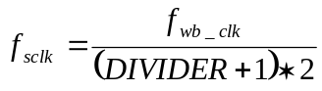

3.6 Slave select register [SS]

Bit # | 31:8 | 7:0
Access | R | R/W
Name | Reserved | SS
Table 8: Slave Select register
Reset Value: 0x00000000

SS
If CTRL[ASS] bit is cleared, writing 1 to any bit location of this field sets the proper ss_pad_o line to an active state and writing 0 sets the line back to inactive state. If CTRL[ASS] bit is set, writing 1 to any bit location of this field will select appropriate ss_pad_o line to be automatically driven to active state for the duration of the transfer, and will be driven to inactive state for the rest of the time.

4
Operation

This core is an SPI and Microwire/Plus compliant synchronous serial controller. At the host side, it is controlled via registers accessible through an APB interface.
MISO MOSI SCLK/SS
SLAVE 0
MISO MOSI SCLK/SS
SLAVE 1
MISO MOSI SCLK/SS
SLAVE 2
APB
/ss_pad_o[0]
/ss_pad_o[1]
/ss_pad_o[2]
MASTER
sclk_pad_o

mosi_pad_o
miso_pad_i

/ss_pad_o[0]
/ss_pad_o[1]
/ss_pad_o[2]
MASTER
sclk_pad_o

mosi_pad_o
miso_pad_i
MISO MOSI SCLK /SS

SLAVE 0

MISO MOSI SCLK / SS

SLAVE 1

MISO MOSI SCLK /SS

SLAVE 2

APB

4.1 APB interface

The SPI core has five 32-bit registers accessible via the APB interface. The timing diagrams for the transfers over this interface are as follows:

The APB bus cycles follow these timing diagrams:

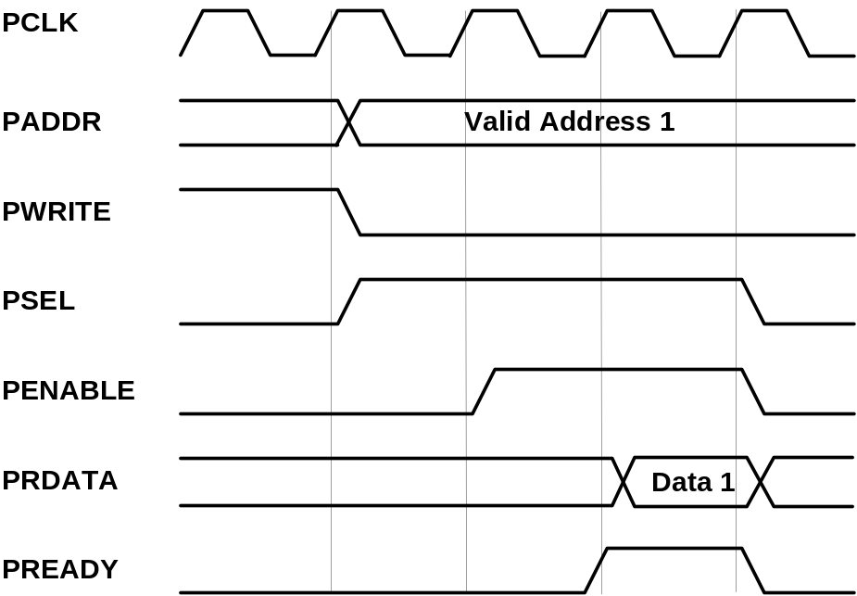

APB Read Cycle Timing – With one wait state

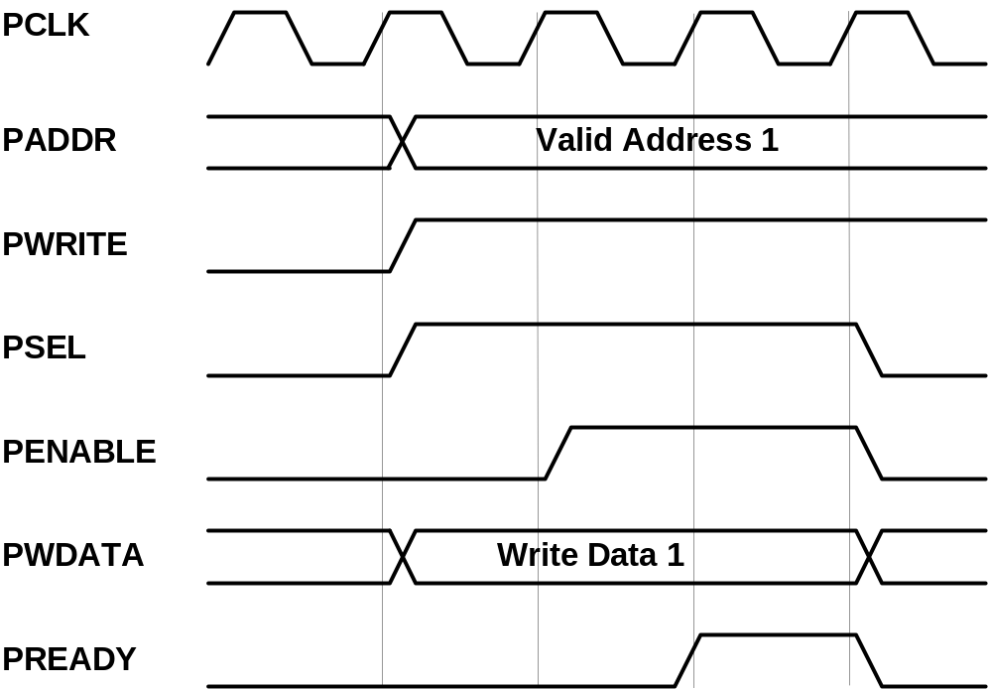

APB Write cycle timing – with one wait state

4.2 Serial interface

The serial interface consists of slave select lines, serial clock lines, as well as input and output data lines. All transfers are full duplex transfers of a programmable number of bits per transfer (up to 64 bits).
Compared to the SPI/Microwire protocol, this core has some additional functionality. It can drive data to the output data line in respect to the falling (SPI/Microwire compliant) or rising edge of the serial clock, and it can latch data on an input data line on the rising (SPI/Microwire compliant) or falling edge of a serial clock line. It also can transmit (receive) the MSB first (SPI/Microwire compliant) or the LSB first.
It is important to know that the RxX and TxX registers share the same flip-flops, which means that what is received from the input data line in one transfer will be transmitted on the output data line in the next transfer if no write access to the TxX register is executed between the transfers.

ss_pad_o

sclk_pad_o

mosi_pad_o
MSB
(Tx[7])
LSB
(Tx[0])

miso_pad_i
MSB
(Rx[7])
LSB
(Rx[0])

CTRL[LSB] = 0, CTRL[CHAR_LEN] = 0x08, CTRL[TX_NEG] = 1, CTRL[RX_NEG] = 0

ss_pad_o
mosi_pad_o
miso_pad_i
CTRL[LSB] = 1, CTRL[CHAR_LEN] = 0x0a, CTRL[TX_NEG] = 0, CTRL[RX_NEG] = 1
sclk_pad_o

LSB
(Tx[0])
MSB
(Tx[9])

LSB
(Rx[0])
MSB
(Rx[9])

5
Architecture

The SPI Master core consists of three parts shown in the following figure:

Clock generator

spi_clgen.v

WHISHBONE SOC Bus
WHISHBONE Interface
Serial Interface

spi_shift.v
spi_top.v
ss_pad_o
mosi_pad_o
miso_pad_i
sclk_pad_o

Appendix A
Core configuration

To meet specific system requirements and size constraints on behalf of the core functionality, the SPI Master core can be configured by setting the appropriate define directives in the spi_defines.v source file. The directives are as follows:

SPI_DIVIDER_BIT_NB
This parameter defines the maximum number of bits needed for the divider. Set this parameter accordingly to the maximum system frequency and lowest serial clock frequency:
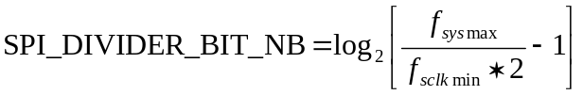
Default value is 16.

SPI_MAX_CHAR
This parameter defines the maximum number of bits that can be received/transmitted in one transfer.
The default value is 64.

SPI_SS_NB
This parameter defines the number of slave select lines.
The default value is 8.

