About our server(TSServerProject) repository

1. sign in your account.
2. Change to org account follow, and select”TSOrgServerPro”

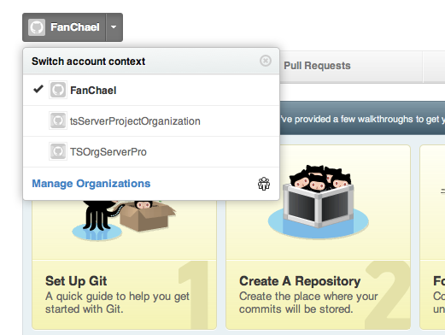

1. That’s okay, you will go into the org code repository, likes this follow, and click it.

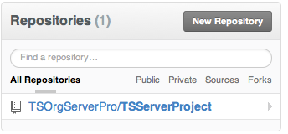

1. On the page, you already have gone to our public org project repository. But you can’t pull & push or any actions, you would fork a new branch on your github account space(I have help you to do this step).
2. change to your github space, check out your repositories. You will find the public org reporitory(TSServerProject) already have been existed in your space.
3. On this step, the project that you can pull & push is only on your own, so you should asyn with the public org project. Do with follow:

Example for new a file:

a. add a new file into your space.

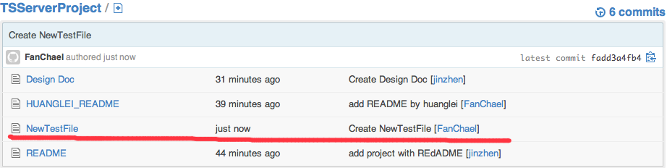

b. asyn to the public org repository(use “Pull Request”).



c. that’s like this follow, and click “Send pull request” button.

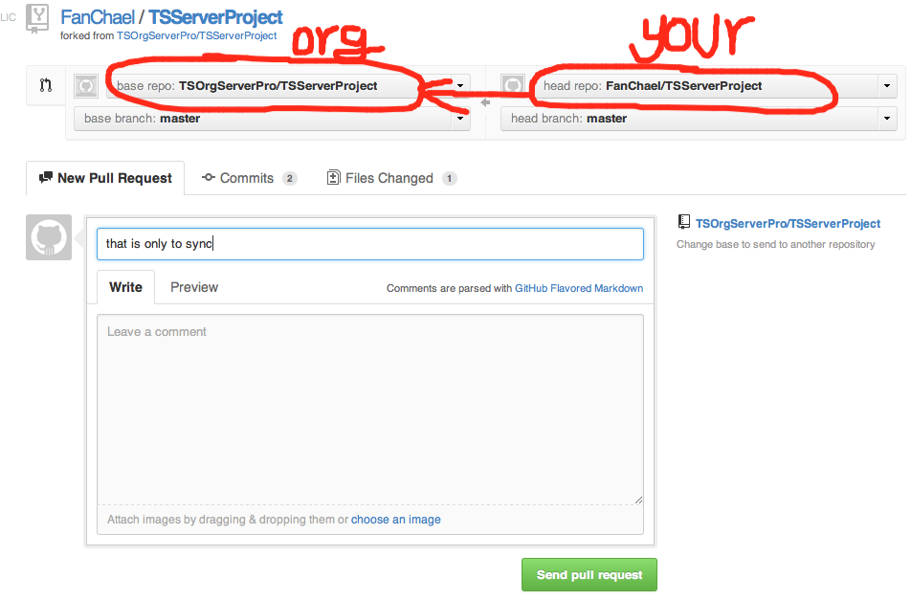

d. Into the follow page, you need to merge the file into the master branch.

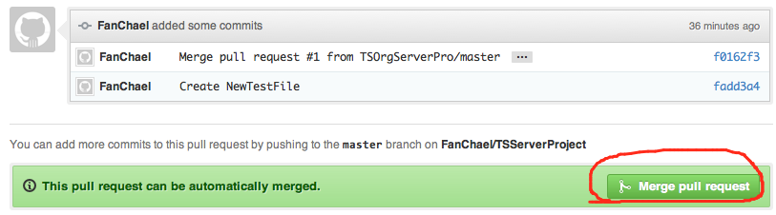

1. That’s okay, the top steps is do:

pull & push

pull & push

my repository

branch: your repository

public org repository