Pam is used here as a partitioning method:

Code:

library("cluster")

raw.data <- read.table("Deluc_Grapes_Dataset1.txt", sep="\t",header= TRUE, skip=1)

head(raw.data)

dim(raw.data)

k<-20

head(raw.data)

pamx<-pam(raw.data[,-1],k)

pamx

summary(pamx)

plot(pamx)

Note that indexes are used as gene ID references.

K=5:

Medoids:

ID X21 X42 X49 X56 X63 X84 X112

[1,] 1240 10.04 9.94 10.09 10.09 10.13 10.10 10.14

[2,] 1938 8.21 8.30 8.34 8.36 8.44 8.44 8.45

[3,] 954 3.33 3.39 3.30 3.38 3.35 3.46 3.35

[4,] 1564 6.85 6.97 6.99 6.86 6.85 6.93 7.01

[5,] 1444 5.42 5.30 5.25 5.24 5.32 5.04 5.13

Numerical information per cluster:

size max_diss av_diss diameter separation

[1,] 308 9.302000 2.188026 12.178403 0.1615549

[2,] 445 6.584596 1.556913 11.135883 0.1615549

[3,] 598 4.643232 1.121953 6.136489 0.2611513

[4,] 353 5.491339 1.612958 9.322355 0.2323790

[5,] 296 5.433682 1.771341 8.323671 0.2611513

Top 3 genes:

[1] 17,1549,789

[2] 1305, 1927, 1336

[3] 1016, 380, 1121

[4]1637, 1250, 1564

[5] 504, 27, 1444

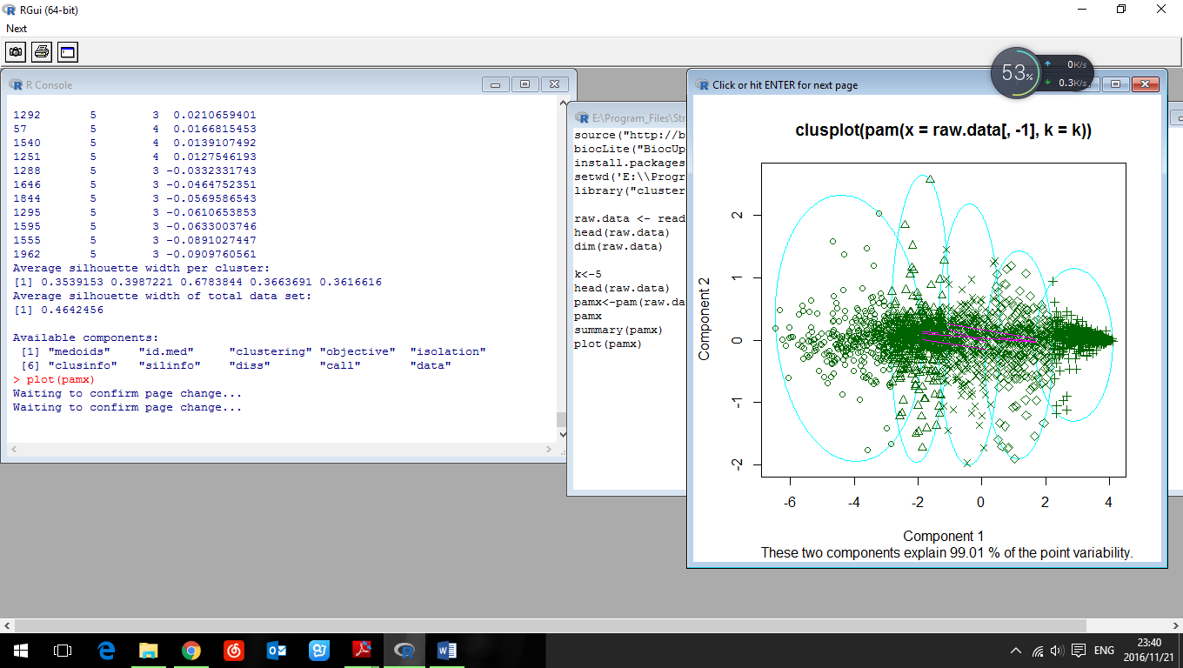

For K=10:

Medoids:

ID X21 X42 X49 X56 X63 X84 X112

[1,] 1703 10.95 10.81 10.97 10.86 10.90 10.59 10.75

[2,] 640 8.27 8.39 8.38 8.32 8.43 8.54 8.58

[3,] 1068 3.38 3.34 3.31 3.35 3.43 3.54 3.42

[4,] 117 9.34 9.28 9.32 9.23 9.29 9.25 9.31

[5,] 1138 7.59 7.70 7.58 7.55 7.63 7.54 7.57

[6,] 905 2.95 2.95 2.92 2.90 2.92 2.98 2.97

[7,] 795 6.75 6.70 6.80 6.60 6.63 6.53 6.56

[8,] 1792 5.69 5.69 5.76 5.82 5.57 5.82 5.91

[9,] 155 4.05 4.00 4.02 3.76 4.04 4.19 3.98

[10,] 1101 5.10 5.00 4.95 4.83 4.89 5.17 5.11

Numerical information per cluster:

size max_diss av_diss diameter separation

[1,] 155 9.329812 1.8080153 12.033453 0.2037155

[2,] 256 6.595044 1.2103929 11.135883 0.2114237

[3,] 218 1.650424 0.5181581 2.196065 0.1288410

[4,] 241 5.452761 1.3442842 9.620265 0.2037155

[5,] 241 4.312957 1.2509028 7.893713 0.2114237

[6,] 228 1.281405 0.4542264 2.021213 0.1288410

[7,] 196 5.312231 1.3973415 7.701084 0.2321637

[8,] 151 4.845844 1.4547383 8.344070 0.2376973

[9,] 180 4.047493 0.9328486 5.576235 0.2151743

[10,] 134 5.683045 1.3491382 7.926323 0.2376973

Top 3 genes:

[1] 911, 1785, 1147

[2]640,167,497

[3]1855,55,212

[4] 591, 490,65

[5]1794,233,1234

[6]1161,110,1743

[7] 795, 1859, 1168

[8] 1792, 642, 586

[9] 656, 1448,1298

[10] 449, 595, 1101

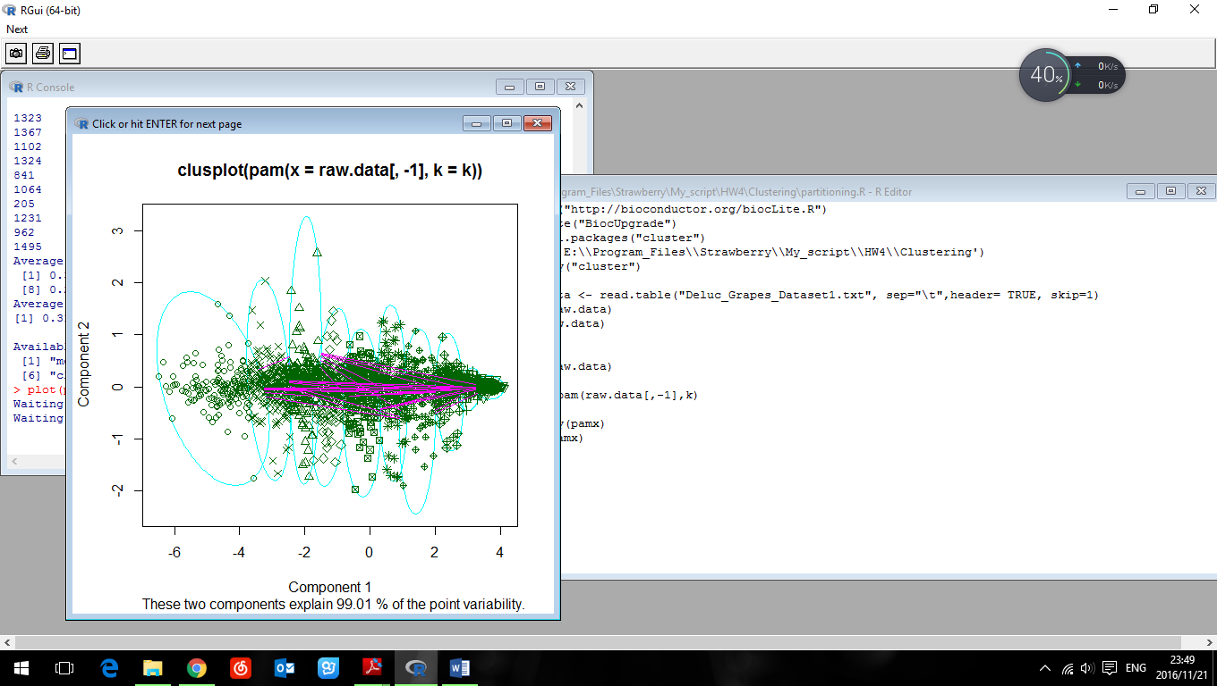

For K=20:

Medoids:

ID X21 X42 X49 X56 X63 X84 X112

[1,] 1032 11.78 11.84 11.68 11.87 11.62 11.78 11.73

[2,] 654 8.16 8.53 8.38 8.55 8.61 8.77 8.89

[3,] 1855 3.40 3.50 3.45 3.38 3.67 3.65 3.52

[4,] 1331 9.07 9.20 9.15 9.17 9.08 9.20 9.26

[5,] 7 8.02 7.89 7.91 7.97 8.03 8.06 8.09

[6,] 269 9.32 8.98 9.02 8.95 8.39 7.99 8.13

[7,] 17 10.78 10.73 10.87 10.62 10.75 10.58 10.73

[8,] 1016 3.12 3.16 3.13 3.15 3.16 3.20 3.20

[9,] 1161 2.75 2.81 2.80 2.83 2.90 2.87 2.83

[10,] 795 6.75 6.70 6.80 6.60 6.63 6.53 6.56

[11,] 1473 8.24 7.68 7.59 7.44 6.87 6.36 6.50

[12,] 1189 5.59 5.54 5.61 5.38 5.46 5.55 5.62

[13,] 1884 4.30 4.28 4.21 4.27 4.28 4.48 4.24

[14,] 1482 7.56 7.32 7.39 7.33 7.29 7.43 7.43

[15,] 1101 5.10 5.00 4.95 4.83 4.89 5.17 5.11

[16,] 1872 6.62 6.66 6.83 6.95 7.43 7.48 7.48

[17,] 1186 6.07 6.00 6.10 6.17 6.17 6.23 6.14

[18,] 1222 3.78 3.74 3.75 3.71 3.86 3.96 3.91

[19,] 1998 9.60 9.64 9.69 9.73 9.77 9.88 9.96

[20,] 1894 7.90 5.88 5.02 4.65 4.11 4.07 4.14

Numerical information per cluster:

size max_diss av_diss diameter separation

[1,] 42 2.7531800 1.2436057 4.605703 0.5331979

[2,] 125 5.1056341 0.9936880 6.654202 0.2389561

[3,] 127 1.7087715 0.4545347 2.196065 0.1363818

[4,] 128 2.3400427 0.9059182 3.986715 0.2588436

[5,] 158 2.2923351 0.9391382 4.118458 0.2039608

[6,] 69 9.1127658 1.5025726 10.187551 0.3067572

[7,] 88 4.7612078 1.1421983 7.179102 0.2289105

[8,] 167 0.8758995 0.3597116 1.302958 0.1542725

[9,] 141 0.9913627 0.3592755 1.525123 0.1542725

[10,] 92 3.4068754 1.0365062 5.311808 0.3171750

[11,] 51 4.0820461 1.4833853 5.265434 0.4598913

[12,] 103 3.2928863 1.1108712 5.404073 0.3321144

[13,] 97 2.6131590 0.8879571 4.381187 0.2426932

[14,] 117 1.6086019 0.8506069 2.670318 0.2039608

[15,] 82 3.8836581 1.0614577 6.048620 0.2868798

[16,] 72 6.3536761 1.2269795 7.221385 0.2321637

[17,] 91 4.1959743 1.2219067 7.192656 0.4460942

[18,] 109 3.1933838 0.5770606 3.945947 0.1363818

[19,] 116 5.1000490 1.1650893 7.228997 0.2289105

[20,] 25 4.0287095 2.0916689 7.006997 0.4284857

Top 3 genes:

[1,] 11,1155,1713

[2,] 654, 1156, 1305

[3,] 55, 404, 1855

[4,] 1398, 1331, 731

[5,] 482, 817, 1931

[6,] 1197, 1644, 1248

[7,] 789, 1688, 67

[8,] 1016, 380, 1399

[9,] 1978, 1743, 275

[10,] 795, 116, 746

[11,] 1674, 1136, 1239

[12,] 799, 1160, 1189

[13,] 389, 1034, 1514

[14,] 1482, 1738, 1913

[15,] 595, 449, 1101

[16,] 104, 81, 47

[17,] 1540, 215, 728

[18,] 1457, 1096, 797

[19,] 1932, 1440, 590

[20,] 1017, 1242, 1779

