on top of a very large swirling black hole feet hanging over the side looking down, surrounded by starfield multicolour, nebula distant, beautiful, huge scene --v 4 --ar 2:3
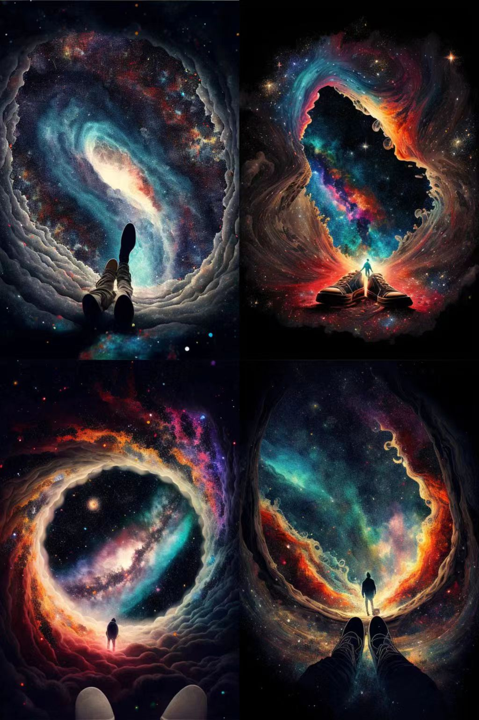

50k fireworks winter surreal life --c 99 --q 2 --ar 2:3 --v 4
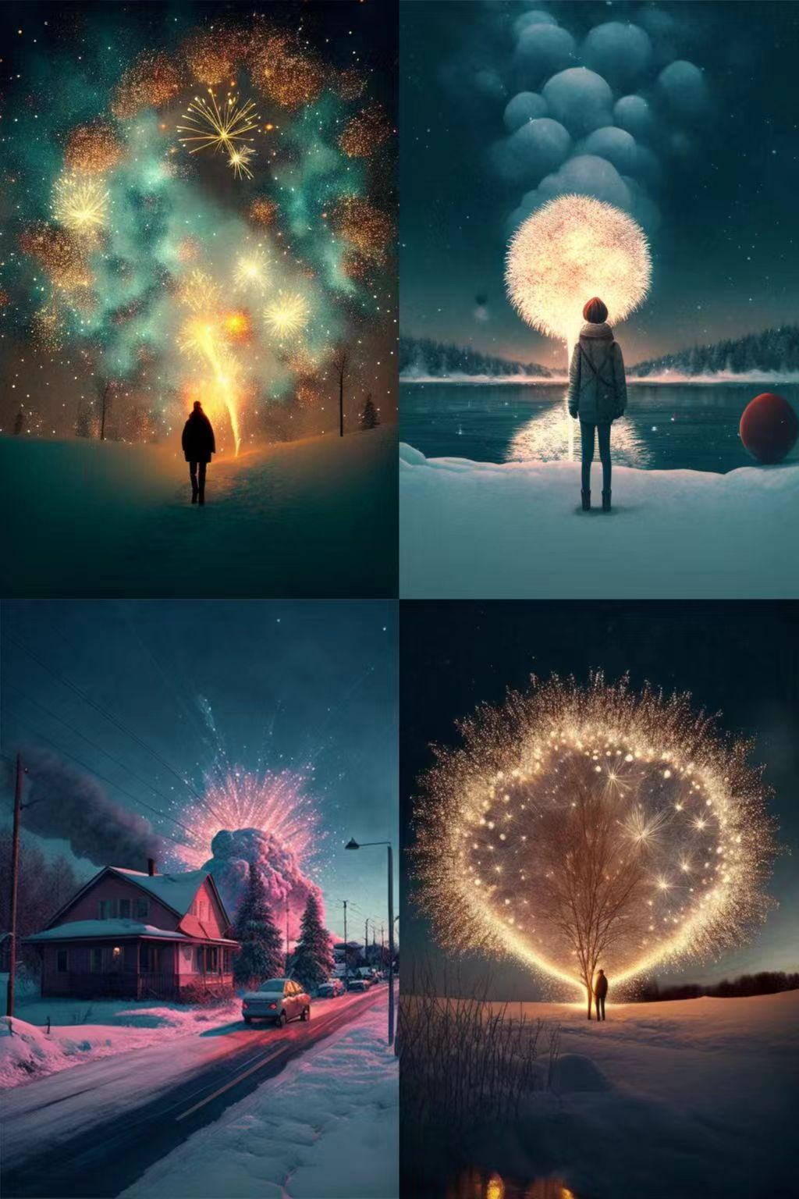

Dream and fairy flying moon Chinese style elegance, peach blossom,quiet ,beautiful ,high details, soft moonlight, Jade Rabbit, soft colors, soft lighting, 8K new happiness, deep details, clear layers, high quality, high definition and new love rendering HD --ar 2:3 --v 4
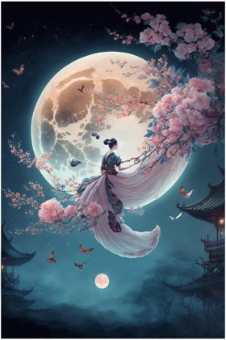

清晨, 爆发雪,道路,街道,被厚厚的白雪的覆盖,金色树枝上挂着的雪 --v 4 --v 4
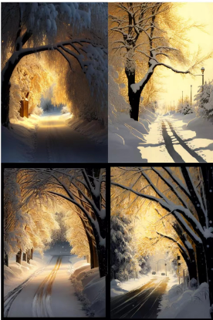
江南小镇依河成街,街桥相连,水镇一体。小桥、人家,绿树成荫,河旁边二层小楼,古香古色,梨花,烟雨江南,意境美,高清 --ar 2:3 --v 4
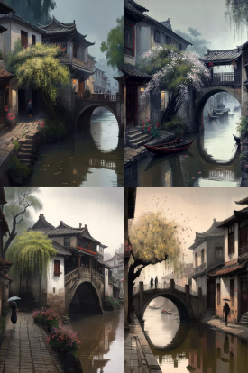

玫瑰充满整个画面,色彩绚丽,玫瑰花树生长在夜空中,玫瑰花细节清晰,月牙,温暖,光线柔和,高清,两只鸟儿在树上,超现实主义,3d --ar 2:3 --v 4
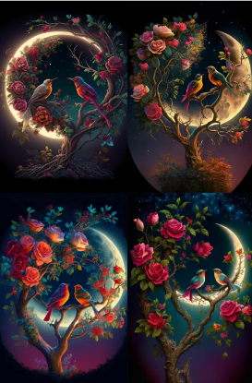

蓝色的天空,天空还有很多细闪彩钻,下面是一个超大蓝色摩天轮,开满了各种颜色的花朵,地面上也是开满了鲜花,特别浪漫,摩天轮有微弱的光,8k高清 --v 4 --v 4
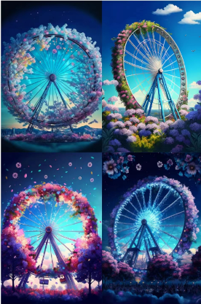

Tradition Chinese Ink Painting style of Snow scenery, morning fog,sunny,white background, white background,white background,Gorgeous blue Peony Garden,Created by Krenzu Cschart Relseiy Miho --v 4 --ar 2:3
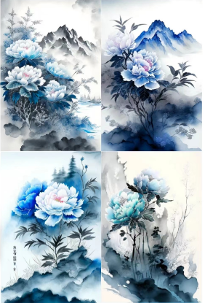
many Beautiful Spectral light pink lotus flowers , drop reflection light, reflection, bright, Super clear, Transparent metal armor, patronus, transparent, caustics, optics, portrait profile, ultra realistic, magic, fantasy, composition, dark, trending on artstation, 8k, hd --ar 2:3 --v 4
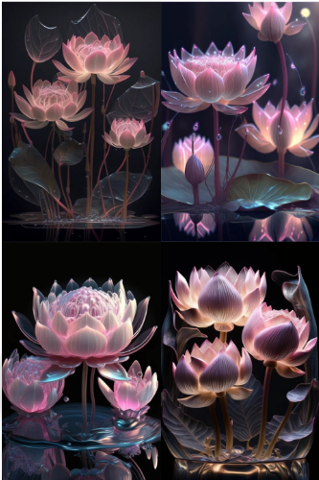

Photograph of Snow, morning fog, fine, white background, white background, white background, gorgeous red peony garden, created by Krenzu Cschart Relseiy Miho --ar 2:3 --v 4
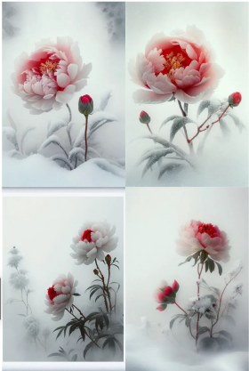

Beautiful and romantic snow scene, delicate and beautiful snowflakes condensed into crescent shape with moon halo, There is a fairytale snow house with lights on the snowflake path,lights, many heart shaped crystal stones shining on the snow, light pink rose, very clear and beautiful, surreal, pink gold color scheme, Soft and clear edges, lighting effects, ultra-beautiful, ultra-high-definition, ultra-detailed, epic CG rendering, dreamy and beautiful, 8K HD --ar 2:3 --v 4
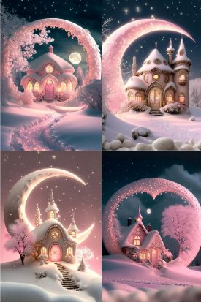

adorable translucent little alien creature, extremely cute, huge endearing eyes, shimmering sparkling, flames fire , inner glow, magical, mystical, otherworldly, gorgeous mesmerizing macro photography --v 4 --ar 3:2 --chaos 50 --no border, frame


winter,snow,In the dense primeval forest there was a pool of water after the rain,Crystal butterfly,The light from the cracks of the trees shone on the pool like a mirror, and deep snow covered the land,sun light,concept, art, fantasy,Ghibli, Hayao Miyazaki,4k,cinematic, --ar 2:3 --v 4 --uplight
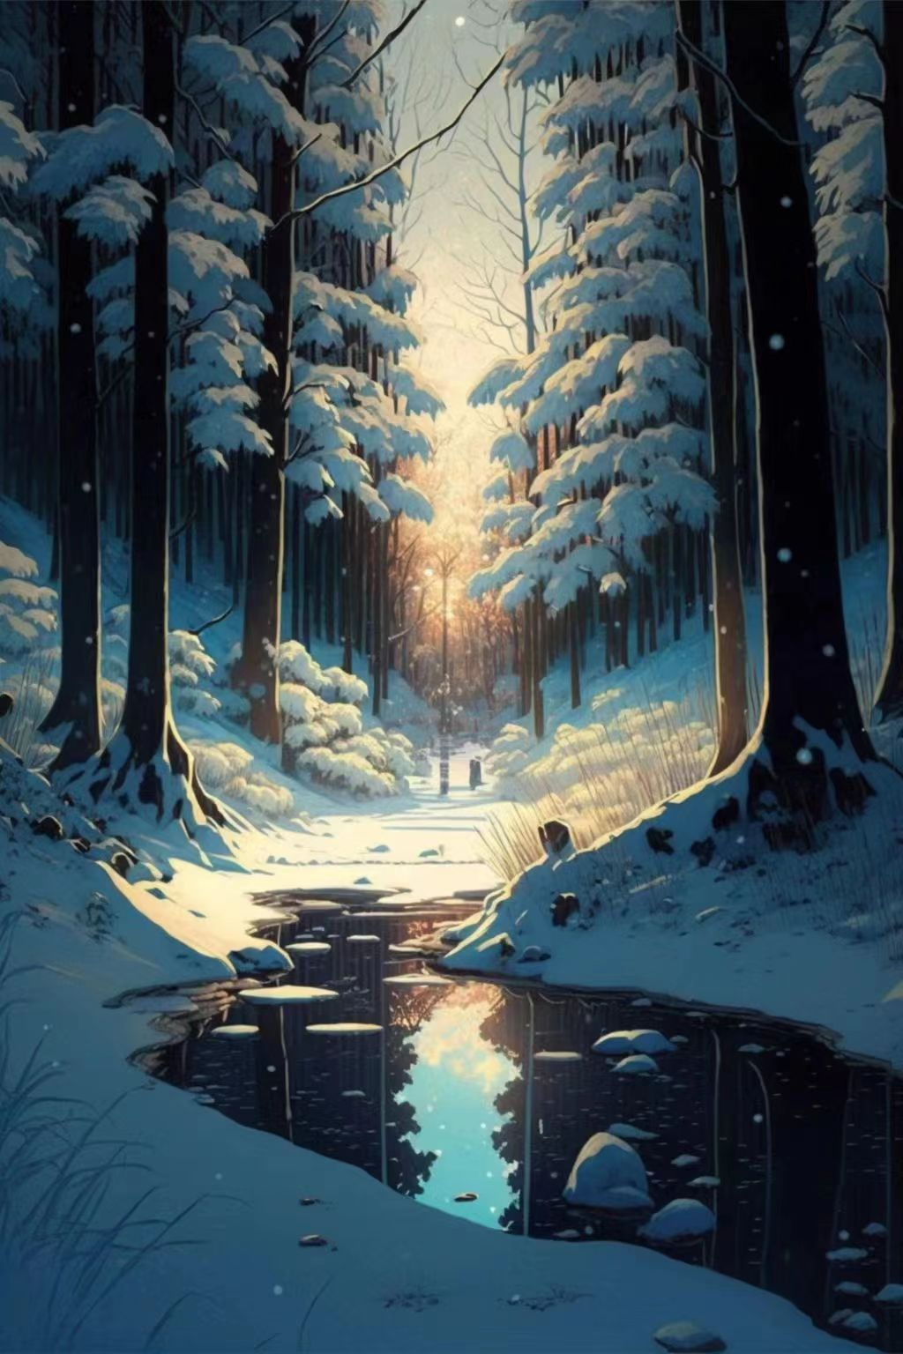

high quality, cinematic lighting, hyper realistic, volumetric, 8k --q 2 --ar 2:3 --v 4
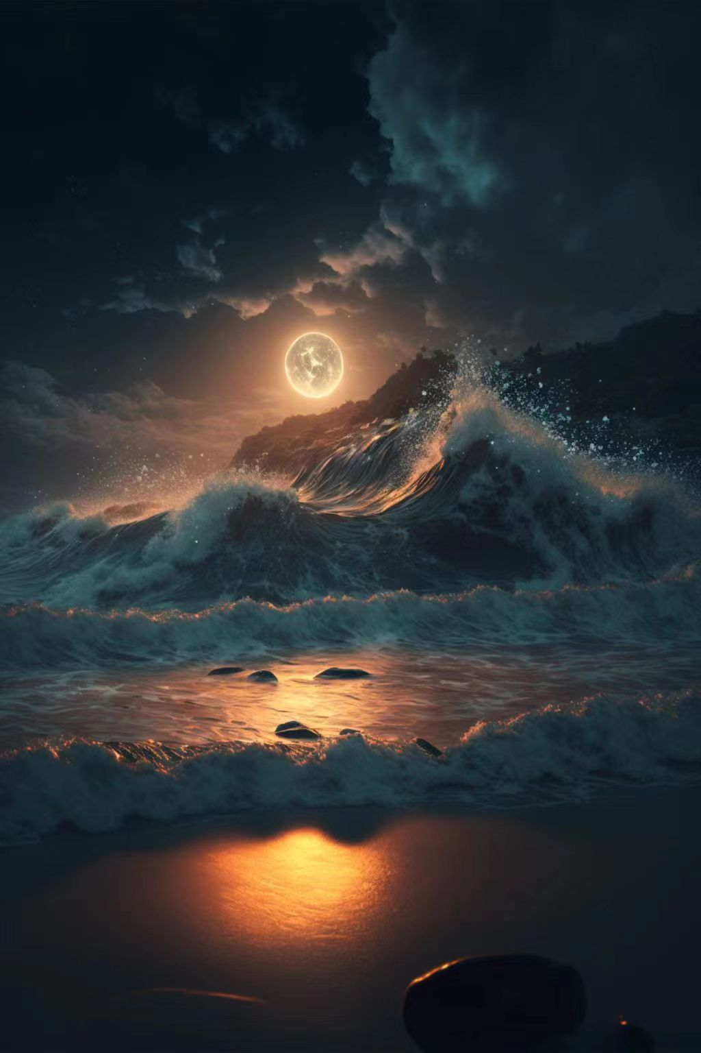
a little girl Plays with seal and fishs under the sea, illustration style --v 4


Candid oblique-angle full-body of waifu looking back reaching for the photographer in a bakery by samdoesarts+ufotable+ghibli, perfect-eyes-symmetrical hair-flowing-iridescent, glowing expression hopeful, glows, sparkles, embers rtx, high contrast, soft-morning-glow --ar 2:3 --v 4
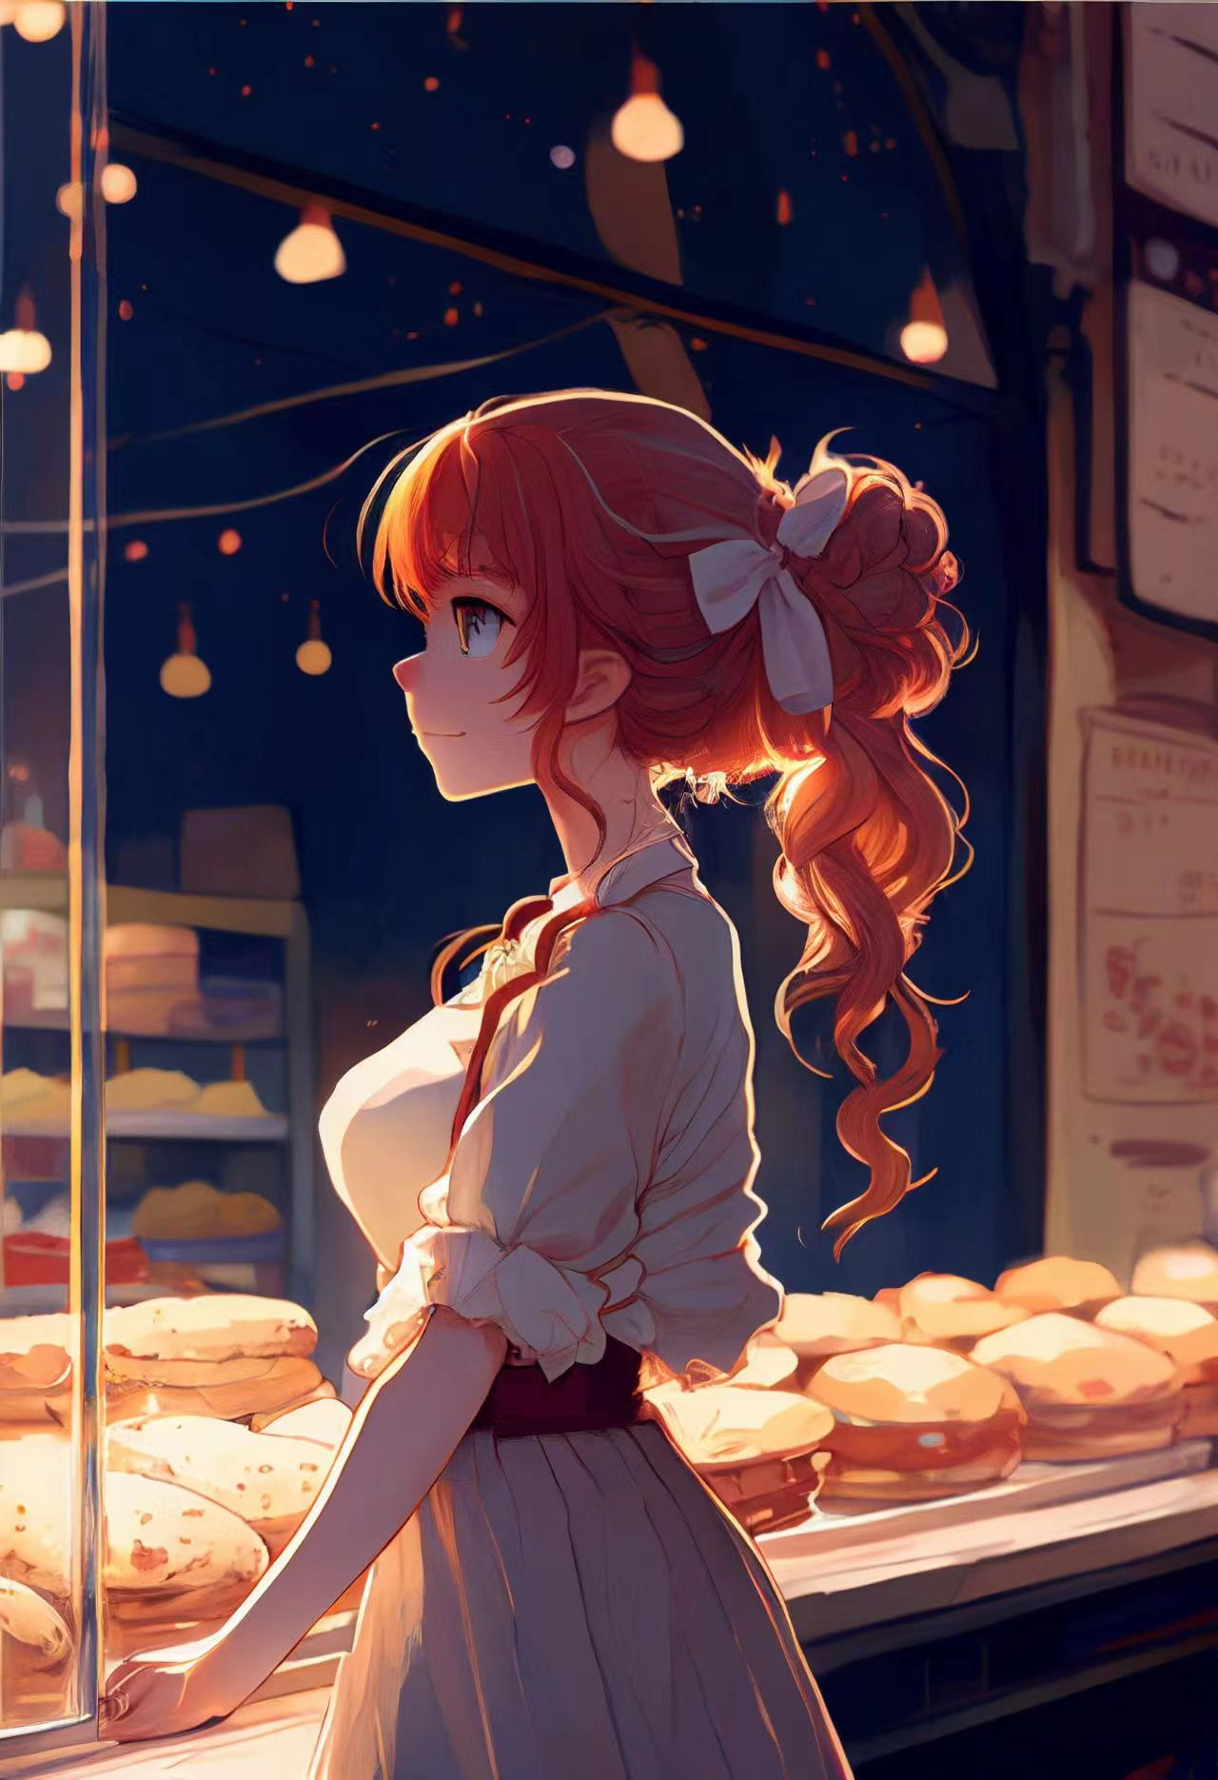

wooly orange mouse doing skate stunts cinematic wes Anderson style, ultra-realistic photography, 8k, uhd --v 4



fantasy landscape, matte painting by Justin Sweet, rolling, green hills, fertile fields, small villages, towns, larger cities, kingdom's capital, gentle slopes, rugged terrain, network of rivers, streams, wide variety of flora, fauna, sprawling forests, verdant meadows, fertile farmlands --ar 3:2 --v 4 --q 2

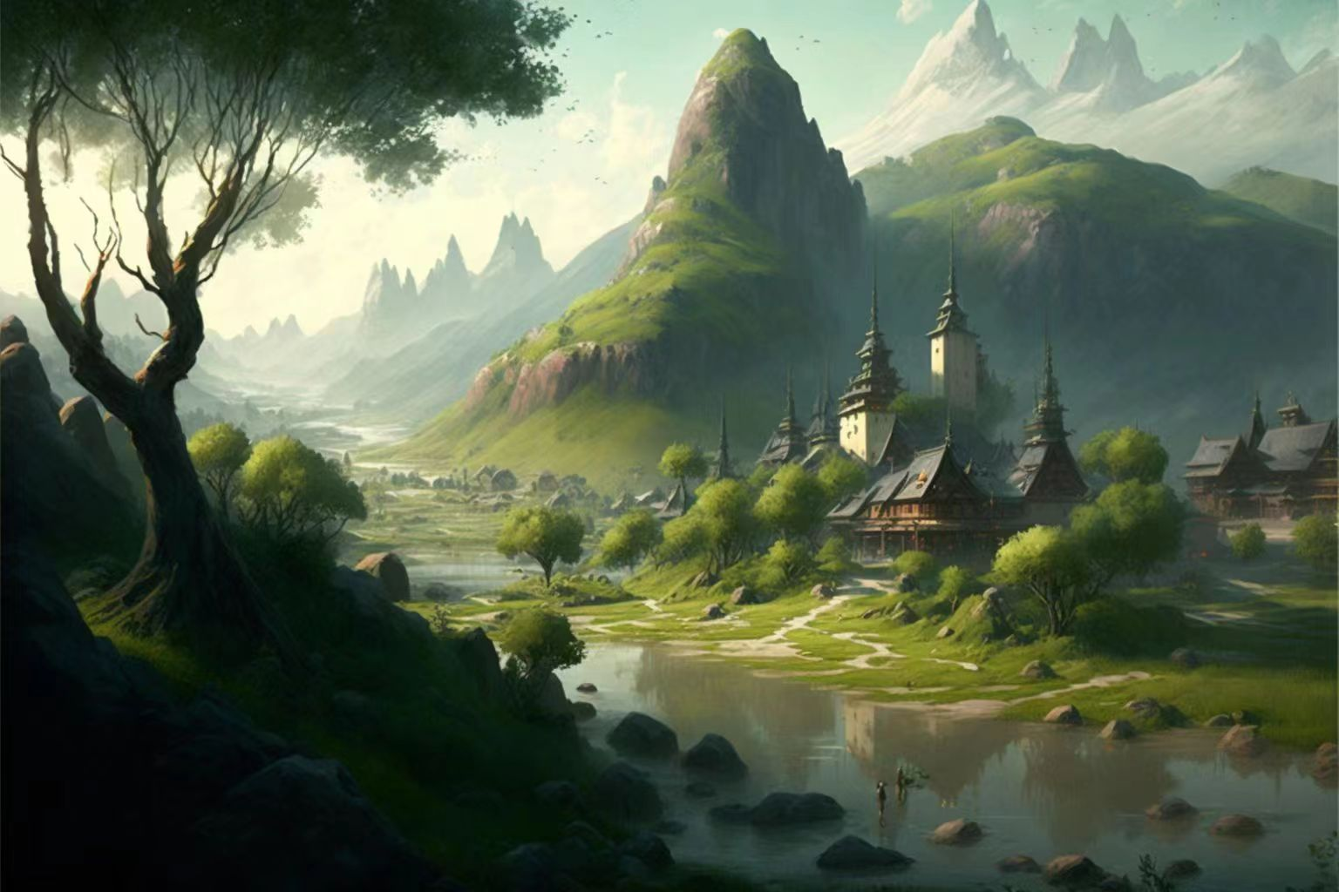

hazy::2, starry::1, HDR::1, sentient entity::.9, calming brainwaves, subtle visible frequences, cosmozoa, lighting effects, spikes, detailed macro closeup, --no human-like features, --ar 3:2 --q 2 --upbeta --v 4


adorable little fire alien wearing ornate vantablack armor acid-etched with intricate glowing fractal patterns, bejeweled with fire opals and citrine, shimmering sparkling iridescent opalescent, extremely cute, kawaii, endearing, happy, magical, mystical, enchanted, celestial, cosmic, serene, surreal, designed by Naoto Hattori, designed by Jon Klassen, designed by Yoshitomo Nara, designed by Studio Ghibli, flames , gorgeous photograph --v 4 --ar 2:3 --chaos 30

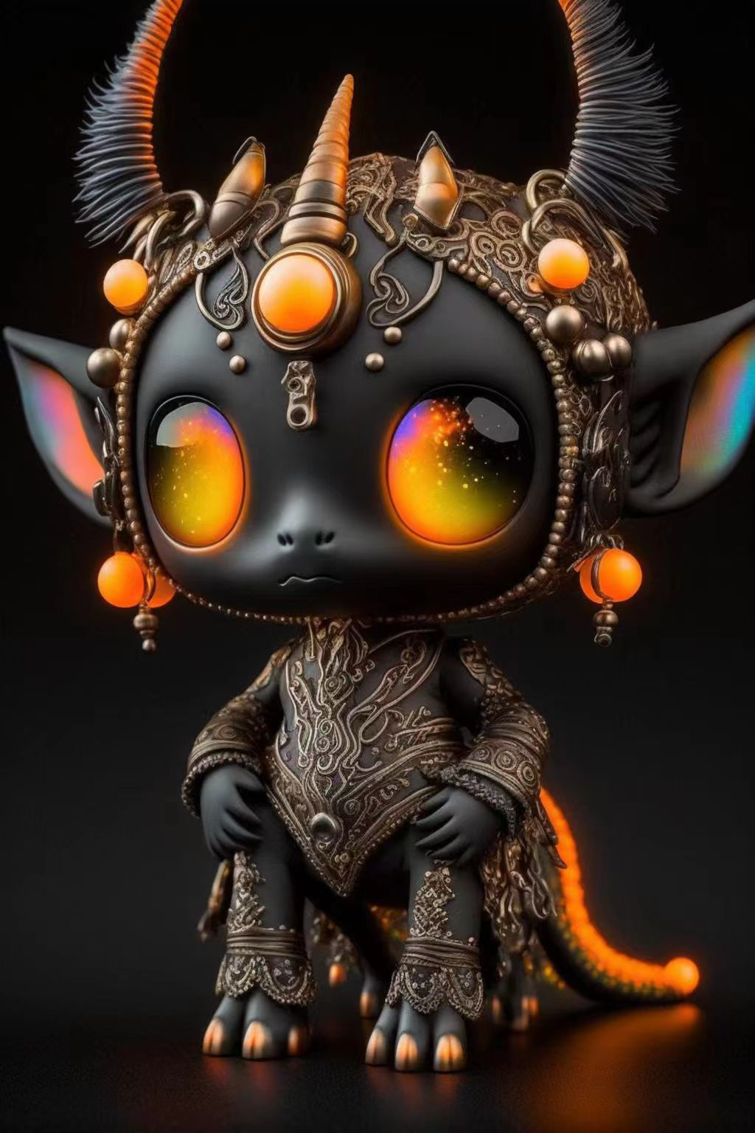

epic guitar from hell, digital design by studio ghibli --ar 2:3 --v 4
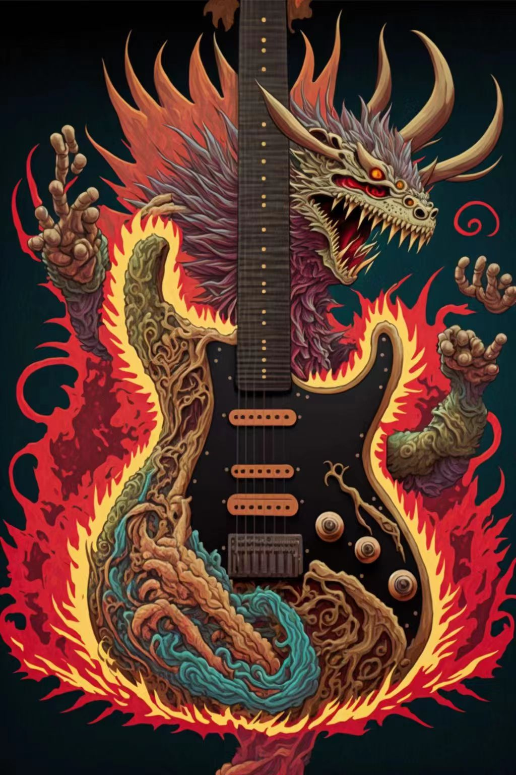

ghostly flowers --ar 2:3 --v 4 --uplight

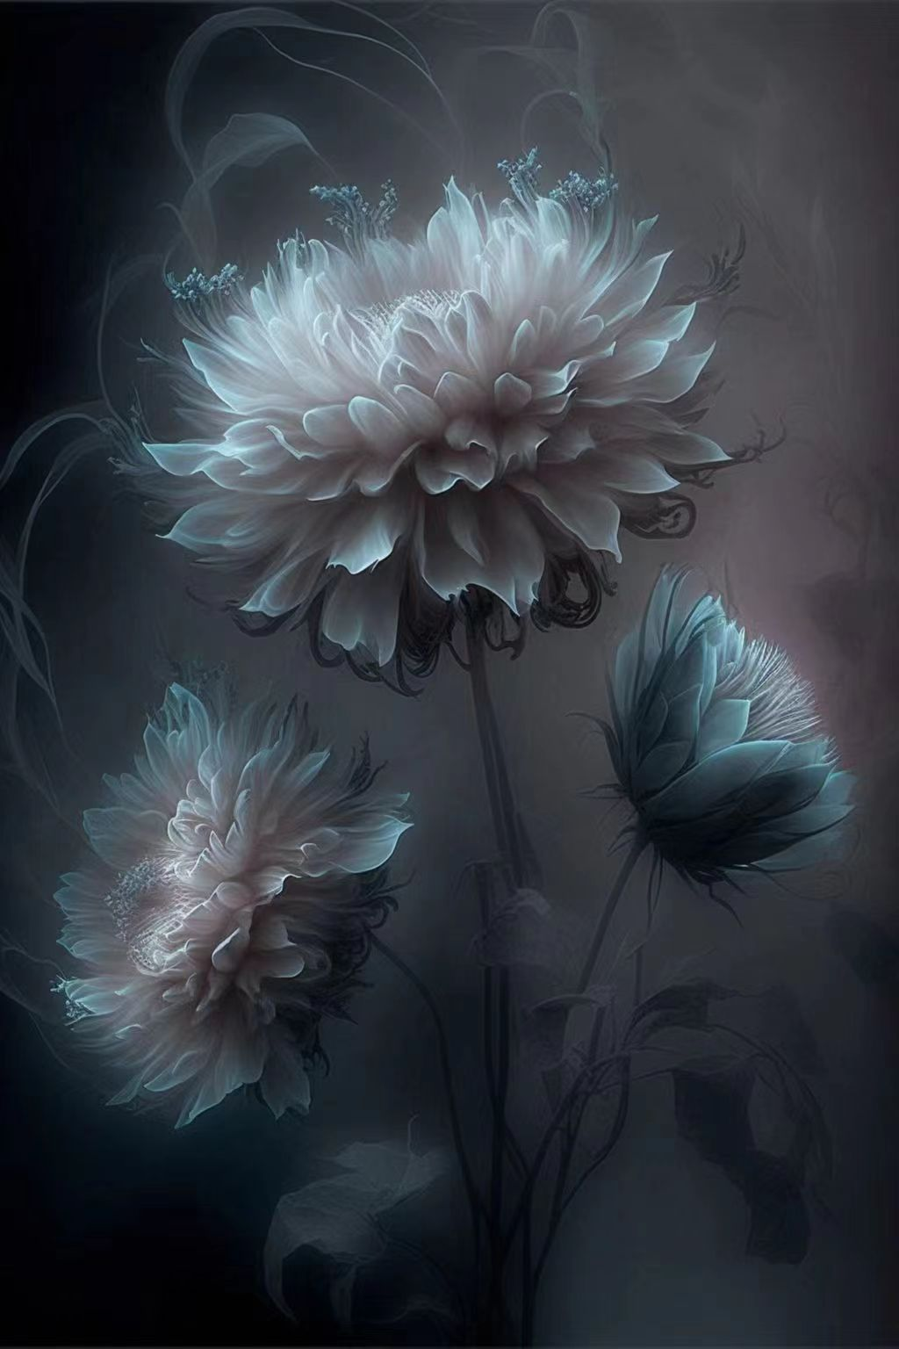

graffiti flowers --ar 2:3 --v 4 --uplight
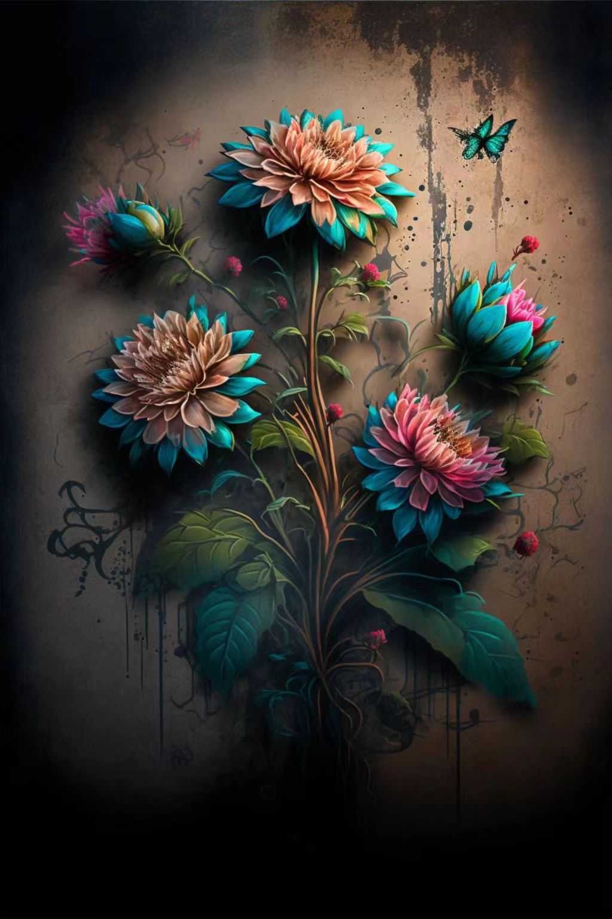
many tall red roses are covered with transparent snow and pink roses snow red roses in chinese fairy tales outdoor romantic wedding stage garden landscape, sunset, yellow sunshine red clear snow red roses, tranquility, beauty, soft moonlight, soft colors, soft lighting, 8k, new happiness, deep detail, clear level of detail, high picture quality, high definition, new love presents high definition realityar 23 v 4 2 --v 4 --ar 2:3
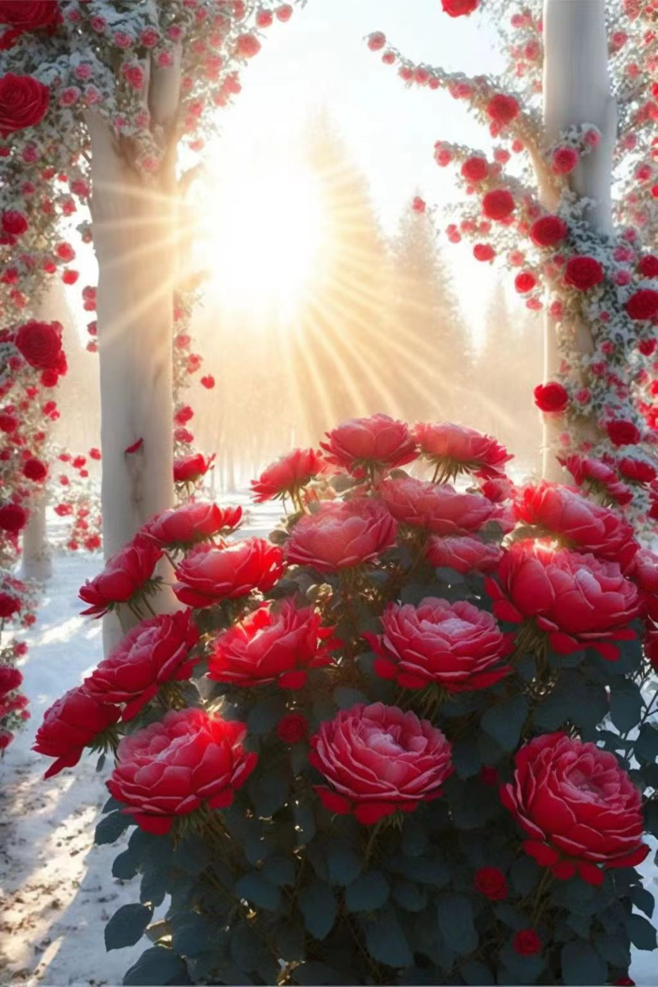
stunning mountain peak, lush vegetation, soft fluffly epic clouds, max rive, vibrant, colorful, dramatic cinematic lighting, volumetric rays, 4k, 8k, --ar 2:3 --style 4b --stylize 1000 --v 4 --q 2

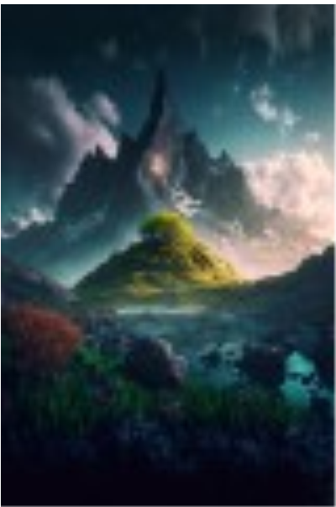
The picture is transparent, on the golden sandy beach covered with pure white snow clean and transparent, red roses forming two hearts floating on the snow forming two hearts, an arrow passing through two hearts, stars sparkling roses, glowing, Romance, HD, works HD 4k video, super wide angle, unreal engine 2 --v 4 --ar 2:3



Christmas, Santa Claus descends from the sky on a golden crystal sleigh pulled by crystal reindeer, Santa Claus, Christmas Eve, romance, rainbow starry sky, heavy snow, house, little snowman, Christmas tree, snow forest, dreamy and beautiful, super wide-angle lens, virtual engine 5, cg Rendering, Cinematic Lighting Effects, Glow Paths, Super Intricate Detail, HD, 8k 1 --v 4 --ar 2:3


3D, the picture is light pink and light yellow transparent, a large transparent crystal crescent sprinkled on the golden sand, the pink crescent is studded with diamonds and small pink roses, the roses form two hearts floating on the sand to form Two love hearts, pink roses sprinkled on the beach, romantic atmosphere lights, bright, realistic, glowing, volumetric light, octane rendering, super wide-angle, 8K, high-definition, 1 --ar 2:3 --upbeta --q 2 --v 4



3D, transparent white crystal with diamond-studded capital letters "LOVE" on golden sand beach under starry sky, many red roses inside the crystal, red roses sprinkled on sandy beach, beautiful, shining, spectrum light, delicate, delicate, super wide angle , vista, vista, octane render 1 --ar 2:3 --upbeta --q 2 --v 4


**<https://s.mj.run/m55SxCz7FV4> surprise me with some amazing interesting creative and cool christmas styled artworks title with: Surreal Winter, multiple exposure. Photorealistic, photography, canon, 50mm, Rule of third, cinematic light, 8k, amazing background, photo artistoc, editing effects, --ar 2:3 --style 4a --c 30 --v 4

The blue sea, the golden sandy beach is covered with pure white snow, on the snow, there is a crystal heart-shaped circle composed of gold and red roses, transparent like glass, the crystal heart-shaped circle is decorated with golden three-dimensional letters "l love you", Romance, fantasy, fantasy, surreal, CG image quality engine, super wide-angle, super distant view, distant view, ultra-high-definition details, surrealism, clear texture, 8k ultra-definition-high-definition quality--v 4 --ar 2:3 --v 4



Romantic blue ocean , sparkling snow beach , orange rose on the beach , dark blue love shaped beach , lovers ’ embrace , orange heart cloud , Milky Way , meteor , many sparkling small creatures , orange and white rose crystals , Maldives , tundra , iceberg , fantasy , high detail , 8K, octane rendering , lifelike , complex details , ultra wide perspective , panoramic lens , volume light , HD 8K,16K HD picture,hd --ar 2:3 --v 4


