爆款山茶花：

https://s.mj.run/puCg-8z45Ug A camellia tree in full bloom。 overgrow with dense white camellia,More than 1000White camellias covered with trees，Green leaves, white flowers，The background is an old Chinese house，Look up，Super wide-angle，distant view，light and shadow art, super details, real，soft light, ultra-high definition, 8K, super aestheticism --v 4 --ar 2:3

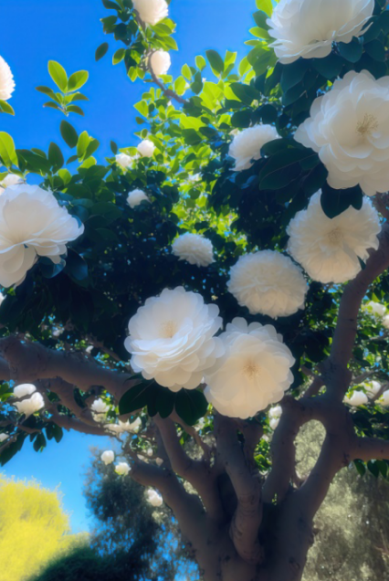

爆款栀子花关键词：
https://s.mj.run/AAnbOe2ooGo There are floating white jasmine flowers in the water tank. The white jasmine flowers are beautiful in high-definition. The water tank is surrounded by a Chinese classical courtyard, backlit, 8K, beautiful, high-definition –ar 2:3 –v 4

