# 问题收集

1. TestNG + JMockit + EclEmma 覆盖率测试时抛异常

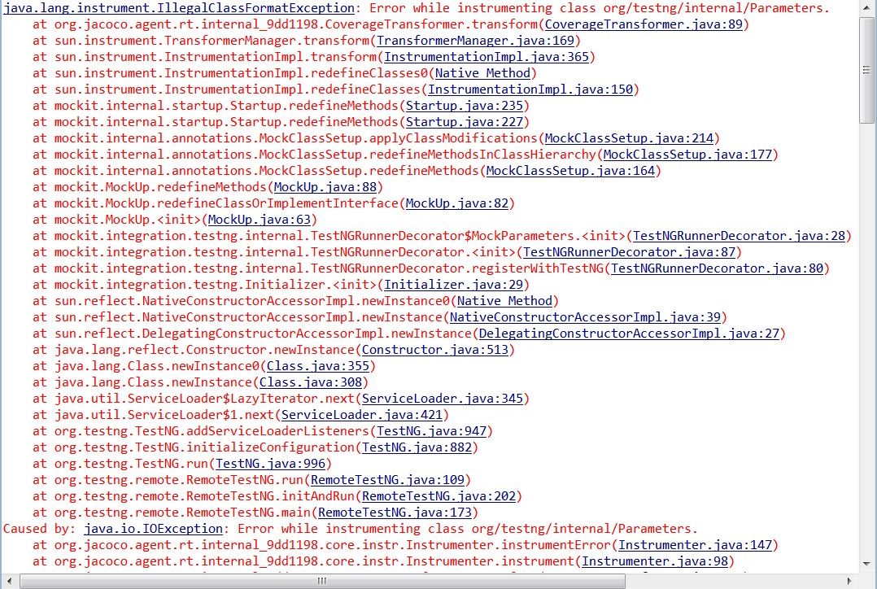

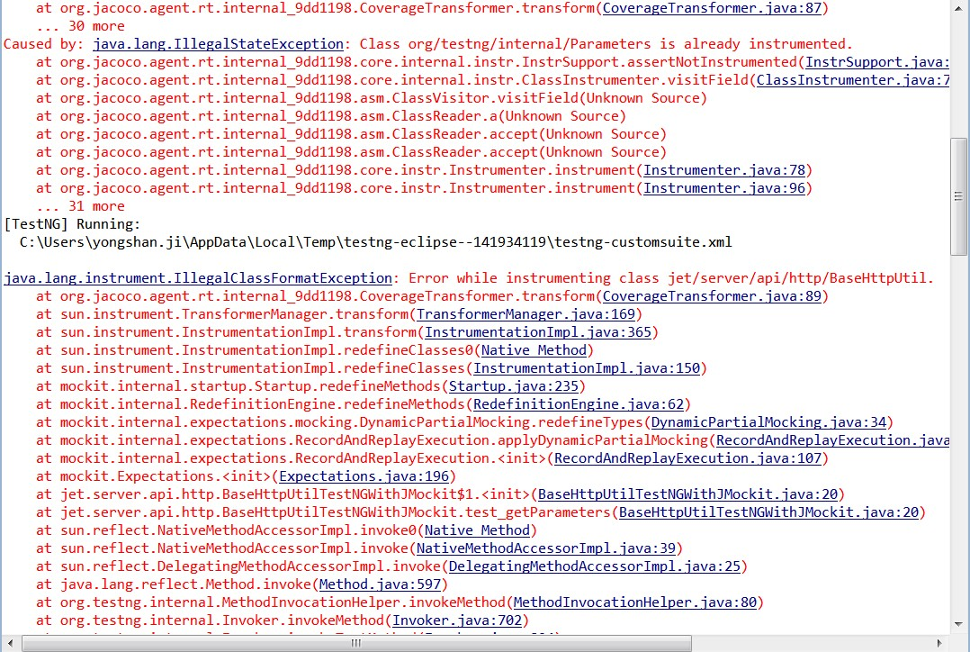

解决办法:

1. 网上收集设置下列参数，但本人在Eclipse JUDO版本中实验失败！

if I add "-javaagent:/jmockit/jmockit.jar" (your exact path may vary) in the "VM arguments" field of the "Run configurations" window, then it works. It also works if instead I add "-javaagent:/jmockit/jmockit.jar" in the "Default VM arguments" field of the "Edit JRE" window (under "Preferences -> Installed JREs -> <the JDK being used> -> Edit")

1. 设置Java > Code Caverage中的Includes和Excludes只能过滤与设置相关的部分。

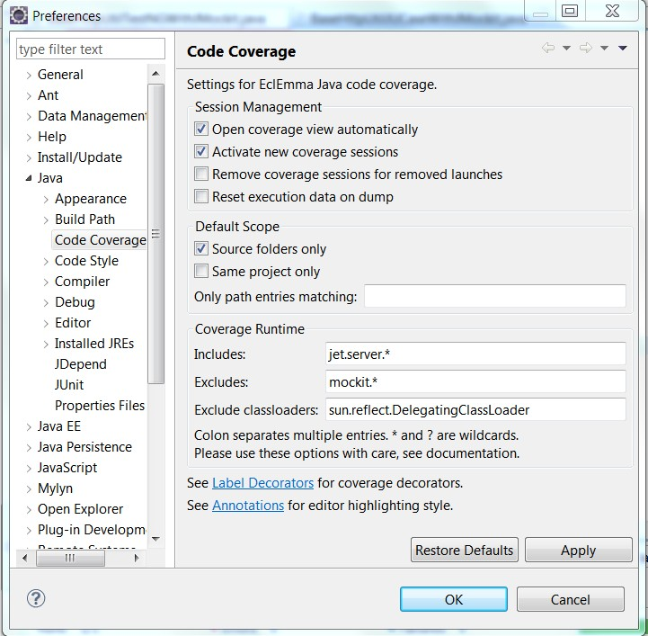

1. TestNG + PowerMock 代码写法，注意高亮部分。

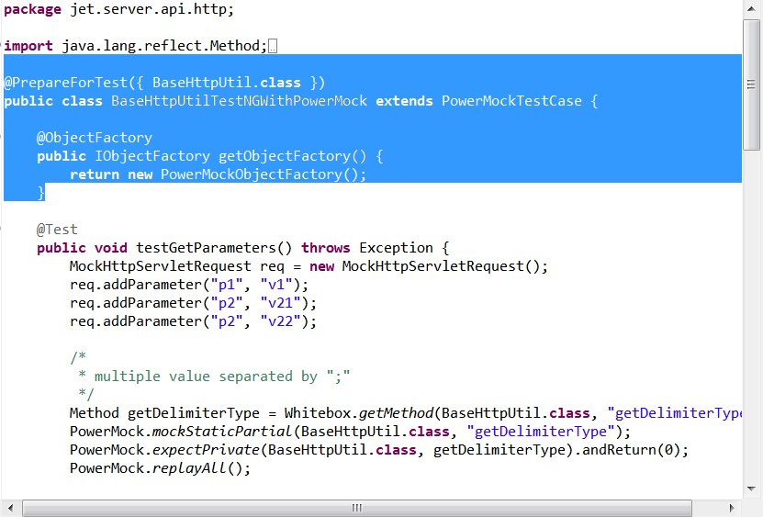

1. JUnit + JMockit问题：jmockit.jar必须在junit.jar之前

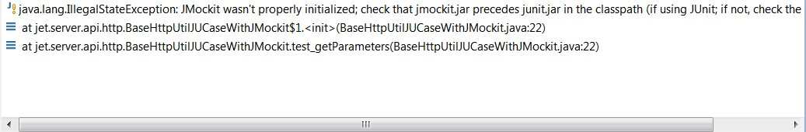

解决办法：

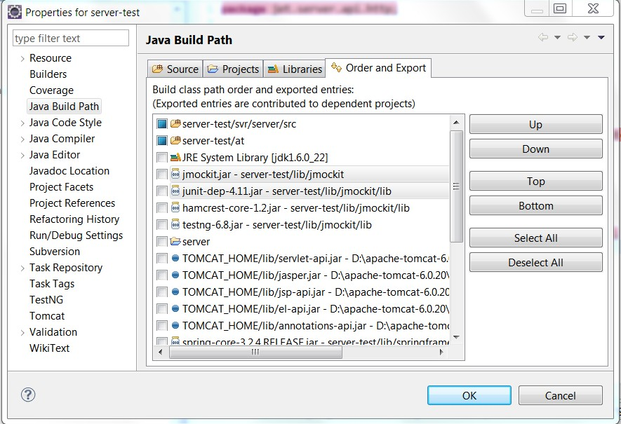

1. JUnit + JMockit + EclEmma: Caverage As > JUnit Test 测试程序停住不动

解决办法：如下图所示，但控制台任然有异常抛出！



