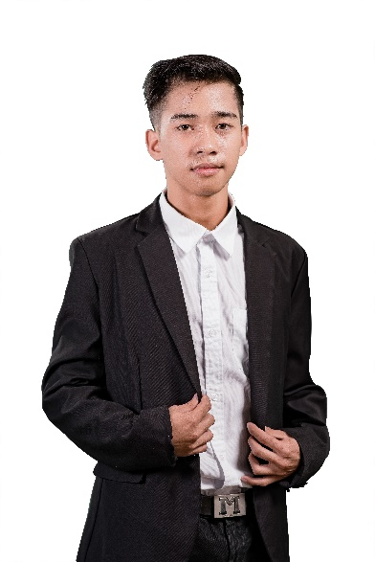**John Irson Ordesta**

P-2b Pigdaulan, Butuan City, 8600 (PH)  
johnirson.ordesta@carsu.edu.ph  
09484672382

## **PROFESSIONAL SUMMARY**

Hands-on, successful Software Engineer with decades of verifiable success leading teams in delivering appropriate technology solutions for desktop and mobile products.  Comprehensive knowledge of platform development, enterprise architecture, agile methodologies, cloud services, and web-based applications.  Innovative change agent with a unique mix of high-level technology direction and deep technical expertise.

## **EMPLOYMENT HISTORY**

**Intern front-end developer, John Vincent Fiel. Misamis Oriental, Cagayan De Oro**

Aug. 2021 – Oct. 2021

Front end developer

* Write, design, or edit web page content, or direct others producing content.
* Perform or direct web site updates.
* Design, build, or maintain web sites, using authoring or scripting languages, content creation tools, management tools, and digital media.
* Identify problems uncovered by testing or customer feedback, and correct problems or refer problems to appropriate personnel for correction.
* Create searchable indices for web page content.

## **EDUCATION**

**Caraga State University, Butuan City, Philippines**

Bachelor of Science, Computer Science, Jul. 2022

SKILLS

|  |  |
| --- | --- |
| HTML  CSS  React-Redux  Redux | ReactJS  Java  GDScript  Python |