**Finding Location Using Pattern Recognition**

# ABSTRACT

The A/C industry has a long history of meeting national and global goals through international cooperation and technology innovation. Manufacturers successfully transitioned from ODS. Under the Montreal Protocol, and continually innovate to deliver products with higher efficiency and performance at lower costs. HFC refrigerants are replacing HCFC and CFC refrigerants and now dominate the industry in developed countries. However, HFC refrigerants have high global warming potential (GWP). In a proposed amendment to the Montreal Protocol, the United States, Mexico and Canada target GWP weighted HFC consumption reductions of 85% during the period of 2019-2026. While international negotiations continue, the A/C industry continues to innovate on the next generation of refrigerants with lower GWPs to reduce direct environmental impacts while also improving A/C system efficiency to reduce indirect impacts

# INTRODUCTION

In order to overcome the limitations of existing air conditioning functions, it is necessary to first investigate the requirements. It is divided into product requirements and customer requirements

First, in the customer’s requirement, it is needed minimalized volume of the machine, minute temperature change, competitive price, and automatic shutdown in the absence of personnel.

The product requirements are divided by two that is general and specific requirements.

In general, firstly the change in temperature should be predicted so that the operation could be performed before the temperature changes, not after it happens.

Second, it should reduce not only direct gas emission but also indirect energy consumption.

In other words, it needs environmentally friendly power.

Third, it must reduce the consumer burden by using inverter compressor.

Lastly, it should find a method to reduce the ambient temperature of outdoor equipment for energy efficiency.

In specific requirement, first, it is necessary to detect the change of the temperature according to the inflow of people then adjust the temperature accordingly.

Second, it needs to aware of the heat generated by the machine and other materials. Also alternative options are required

Next, there should be no heating and cooling restrictions on the structure of the building.

Fourth, the operation of the machine through contextual programming is needed

Finally, it must distinguish people from other moving objects

**Limitation of previous research**

The air conditioner of the artificial intelligence technology which is sold on the market moves only the direction of the fan by grasping the movement of the person on the spot.

**Needs of the research**

The ambient temperature rises when a large number of people enter a certain space or doing activities such as exercise, however since the air conditioner can’t flexibly recognize the temperature change, it is necessary to control the temperature according to the number of persons or specific actions.

# OBject

Our final goal is to make efficient air-conditioner system by finding location using pattern recognition on raspberry pi. In order to build the features, the strength and direction of the air-con automatically changes based on intensity of people. Also it changes according to the specific gestures regarding how people act when the room is hot such as making wind by their hands with all their fingers straighten up or grab their top part of shirt and shake.

# Processing

We focused on software to achieve our goals. Therefore, we first analyze human behavior when the weather is hot and proceed with face recognition, motion recognition, and human temperature sensing.

We came up with a conclusion that people use hand motions when it’s hot. Therefore we implemented the code which works regarding to hand

In order to recognize people we distinguished a person from an object through face recognition. In addition, since the temperature rises in the place where there are many people, we used the code which can recognize many face recognition.

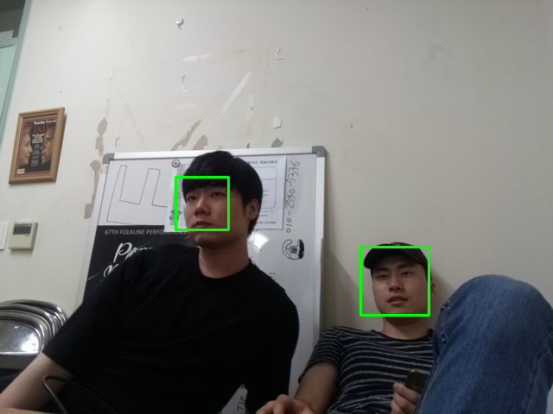

Next, we implemented a code that counts inflows of people by separating the entrance and exit sections to identify the influx of people.

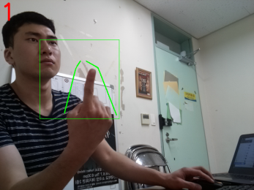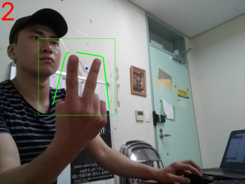

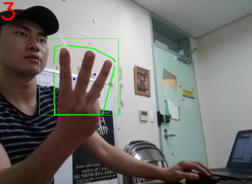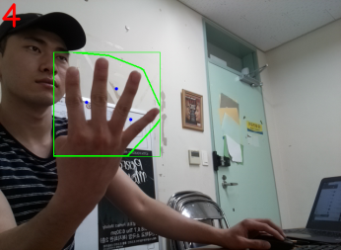

# Conclusion

We implemented face recognition through some codes but there were some problems in this process. The first problem was the slow speed of face recognition. We fixed this problem using LBP Cascade Classifier instead of Haar Cascade Classifier. 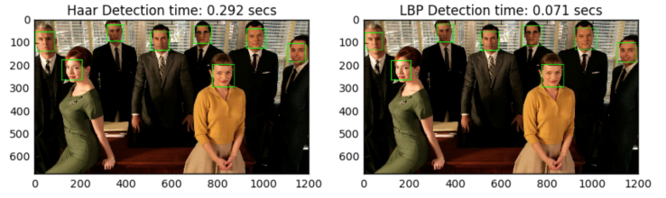

Secondly, there was a problem recognizing faces of many people at once. As a solution to this problem, we implemented code to count the number of people by dividing the entrance and exit sections instead of using face recognition. Also there was a difficulty about the speed of input and output. The race per unit of both was way too fast. And it is solved by fixing code valuations

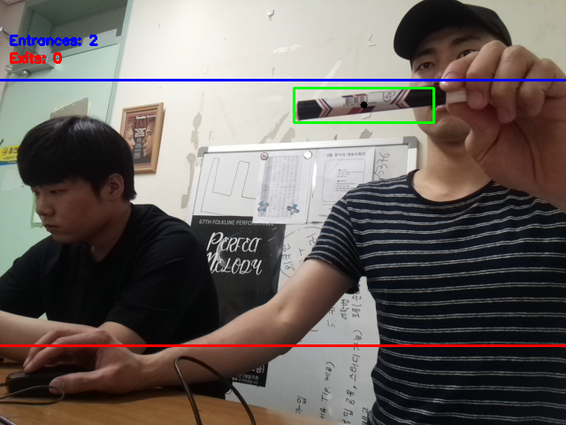

Lastly, when a code of face recognition was applied, it indicated not only human faces but also other objects because of the poor quality. We resolved this problem by obtaining additional codes to acquire the best algorithm after running them though on PI each one by one.