1. Select the make_name, vehicle_id, and model_name of all vehicles, regardless of whether they are on the lot or not, which have a first production year of 1987.

π Make.make_name, Vehicle.vehicle_id, Model.model_name(σ Model.first_production_year = 1987(( Vehicle ⨝ Vehicle.fk_make_id = Make.make_id (Make))⨝ Vehicle.fk_model_id= Model.model_id (Model)))

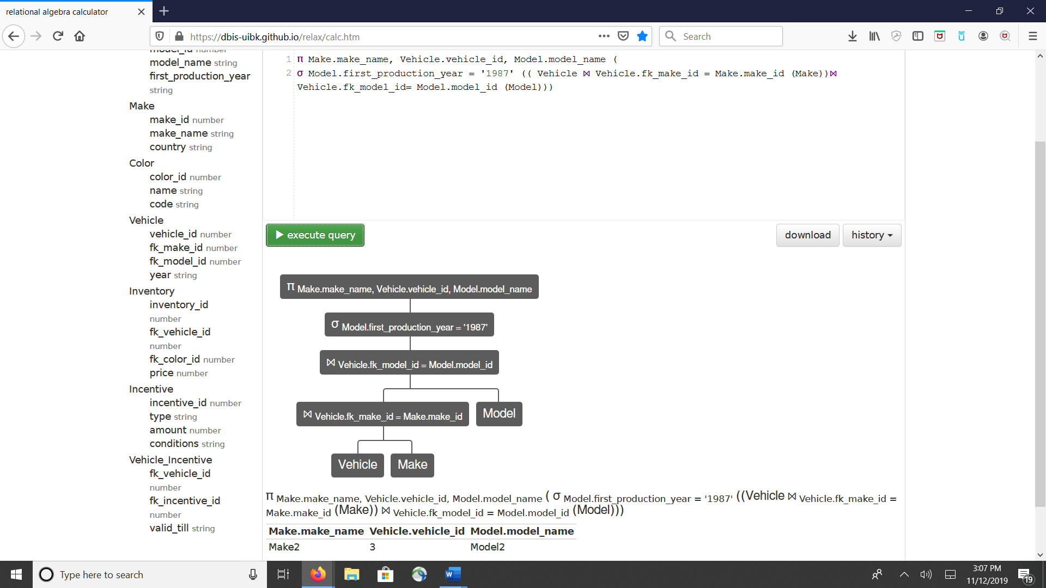

2. Select the make_name, vehicle_id, and model_name of all vehicles with the color name “Sky Blue” and which are on the lot.

π Make.make_name, Vehicle.vehicle_id, Model.model_name (σ Color.name="Sky Blue" ((((Vehicle ⨝ Vehicle.fk_make_id = Make.make_id(Make))⨝ Vehicle.fk_make_id = Model.model_id(Model))⨝ Inventory.fk_vehicle_id = Vehicle.vehicle_id (Inventory))⨝ Inventory.fk_color_id= Color.color_id(Color)))

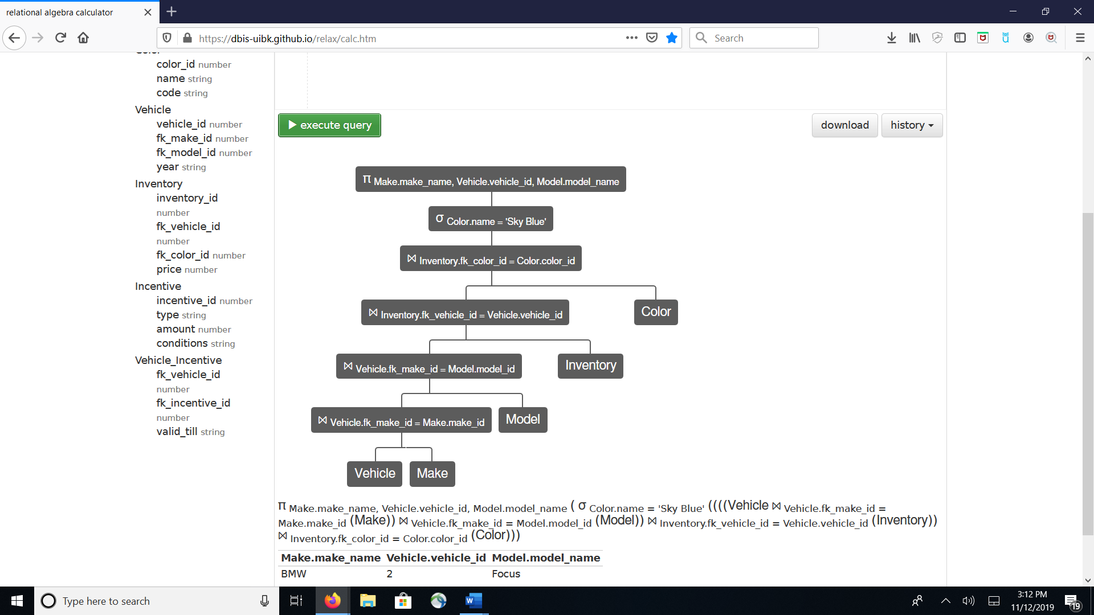

3. Select the make_name, model_name and incentive amount for all vehicles on the lot with an incentive type “dealer”.

π Make.make_name, Model.model_name, Incentive.amount ( σ Incentive.type = 'dealer' (((( Vehicle ⨝ Vehicle.fk_make_id = Make.make_id (Make)) ⨝ Vehicle.fk_model_id = Model.model_id (Model)) ⨝ Vehicle_Incentive.fk_vehicle_id = Vehicle.vehicle_id (Vehicle_Incentive))⨝ Incentive.incentive_id = Vehicle_Incentive.fk_incentive_id (Incentive)))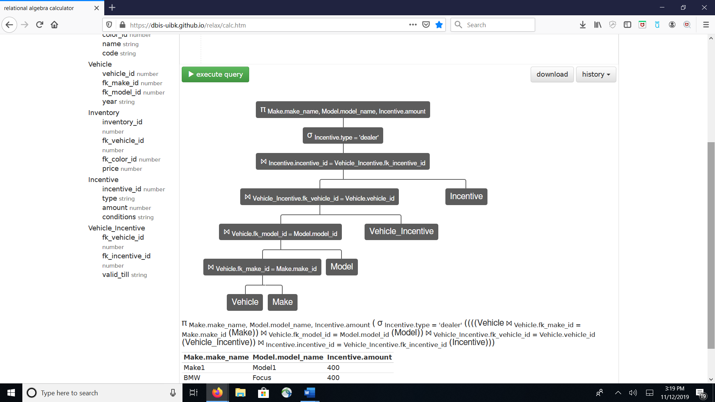

4. Convert the following query to relational algebra  
    SELECT Player.id, Team.name, City.name FROM Player  
    INNER JOIN Team ON Player.team_id = Team.id   
    INNER JOIN City ON Team.city_id = City.id  
    WHERE Player.score = 100;

π Player.id, Team.name, City.name (

σ Player.score = '100' ((Team ⨝ Team.id = Player.team_id (Player))

⨝ Team.city_id = City.id (City)))

5. For problem 3 above, convert your relational algebra query into a SQL query

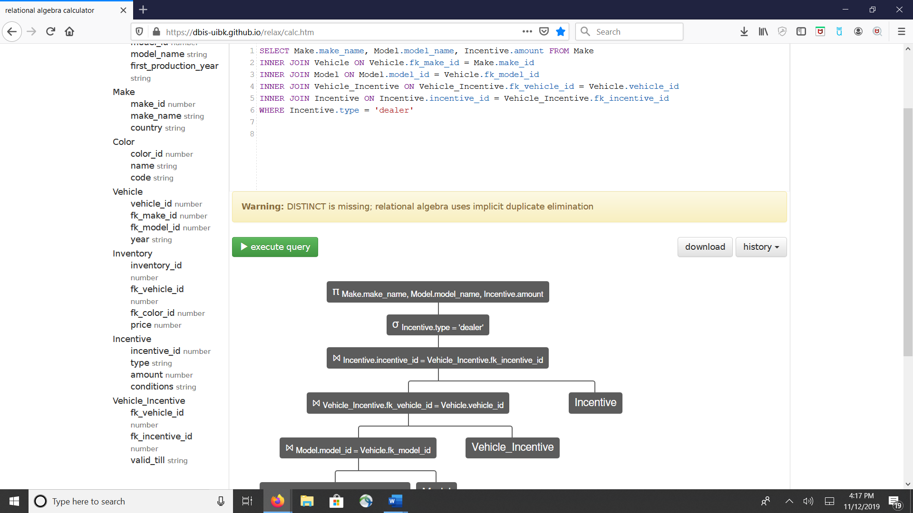

second page

