Documentation from the zoom call with ta Bana on 2/4/2021

filezilla shows my fie hasn’t been modified on the school server then shows when it was zipped

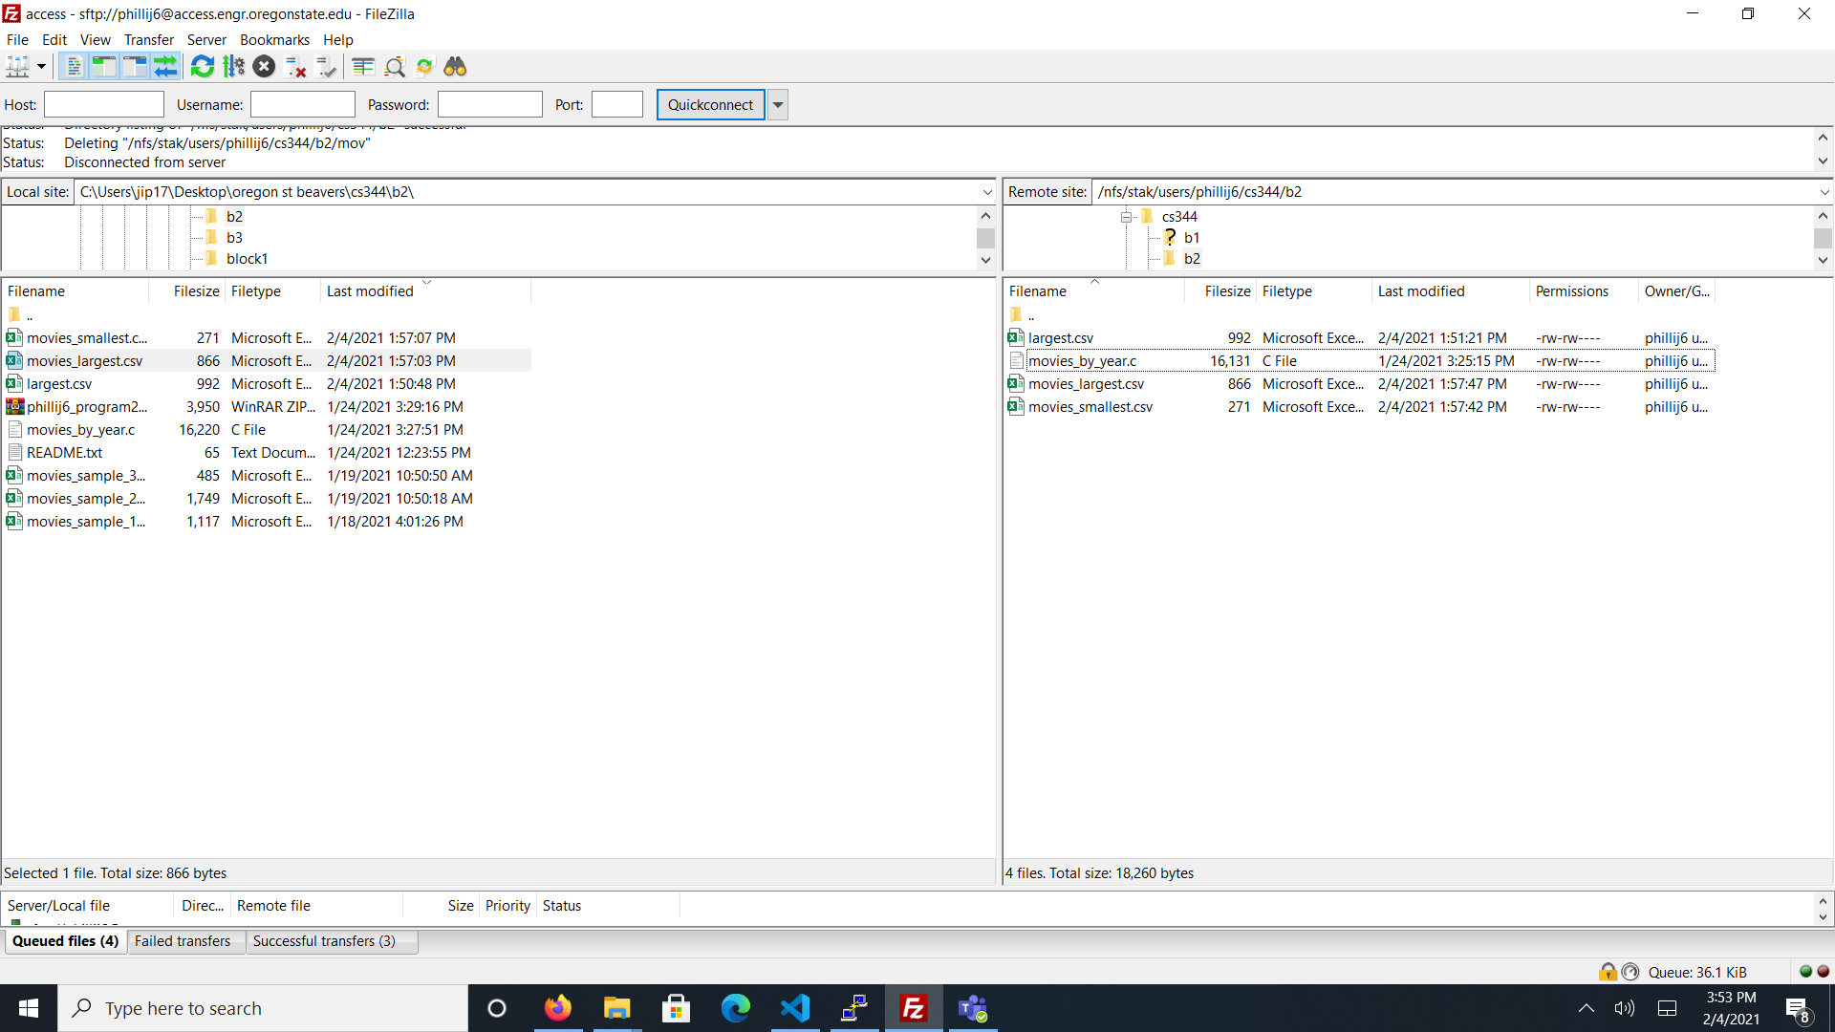

The log of all of the program being ran on my pc on the school os1 server.

