Justin Phillips

Assignment 3b

cs362 winter 2020

1/29/2020

Action Card class

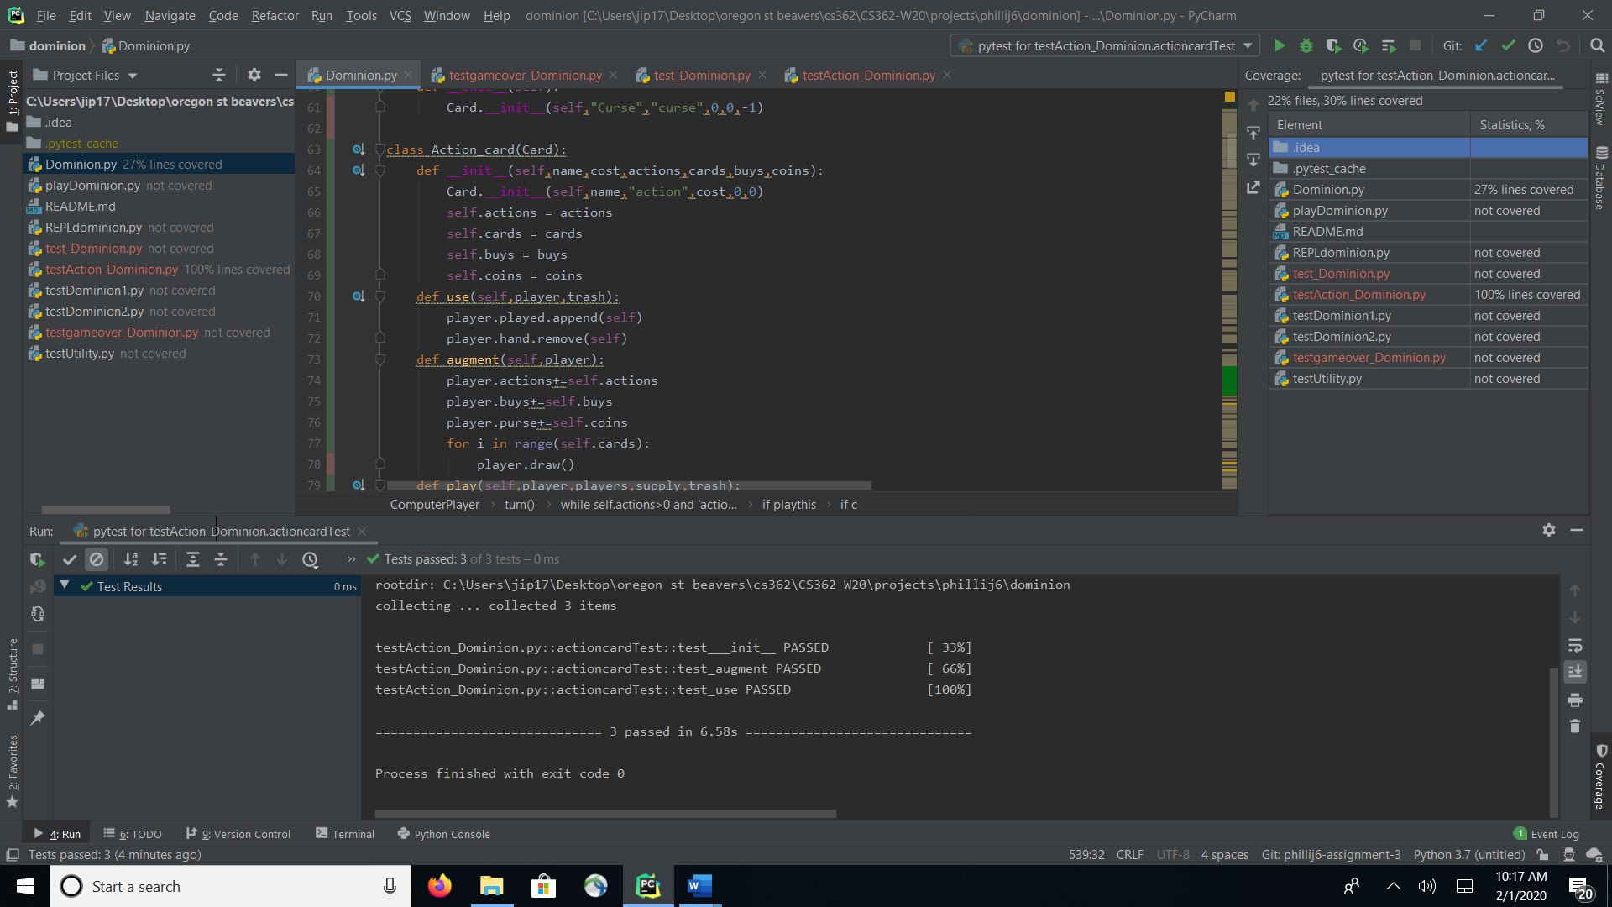

Based on the coverage test it looks like all the lines in the Action Card class are covered except the player.draw() that is called in the for loop in the augment test. To cover this I believe I could add another assert that will check if a card has been drawn, This will be done after I added code where the player calls draw from cards and is added to their cards.

Player Class

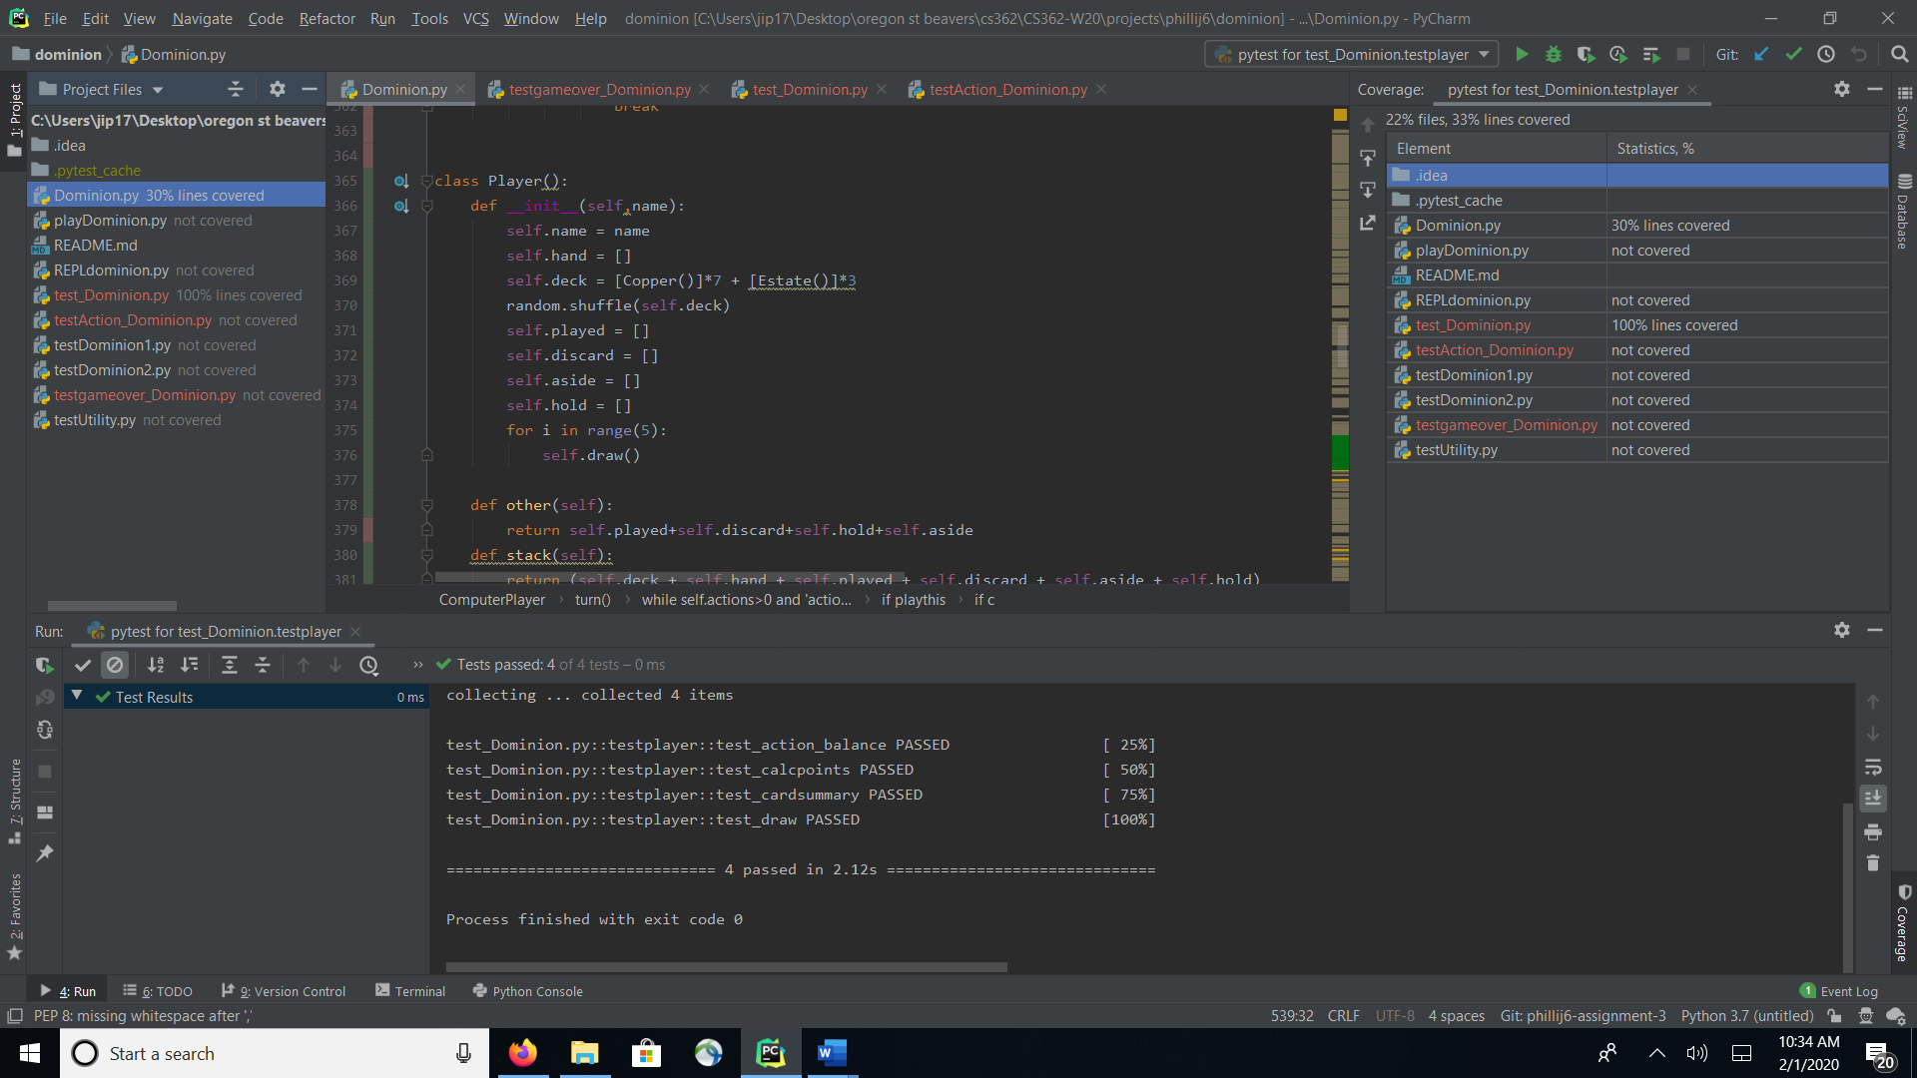

The draw function in the player class seems to be covered 100% .

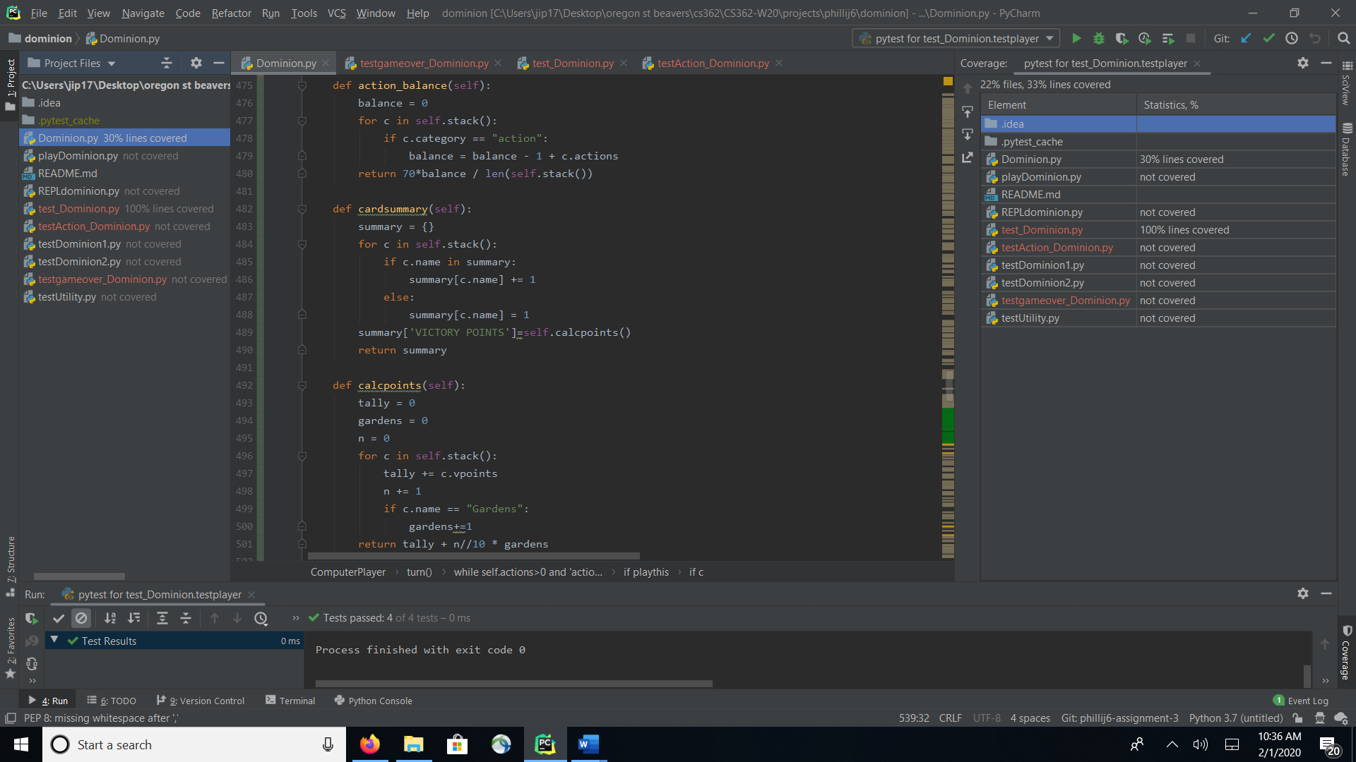

Also, the remainder of the tests action_balance, cardsummary, and calcpoints are all covered 100%

Game Over Test

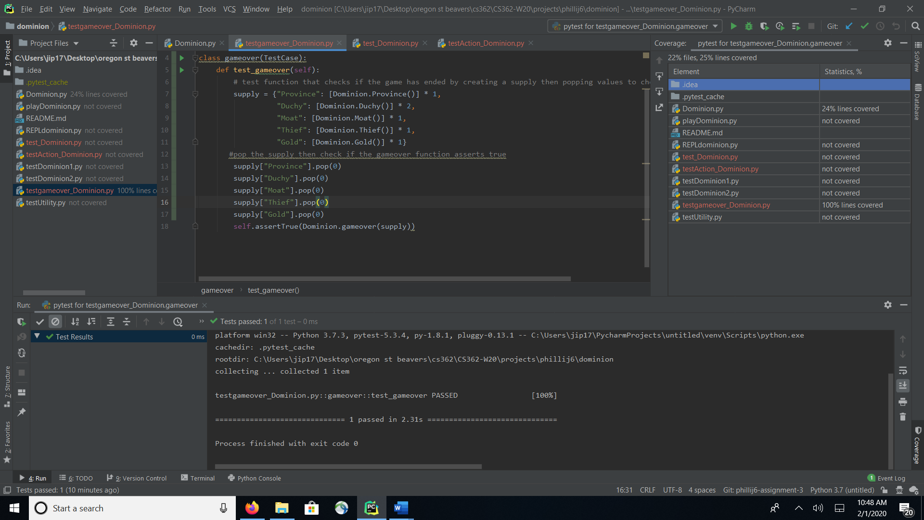

The last function is to see if the game is over, this is checked by the gameover function and is also 100% covered except I am not sure why assertTrue doesn’t have color next to it.