Justin Phillips

Assignment 5

cs362 winter 2020

2/24/2020

Pushed area function

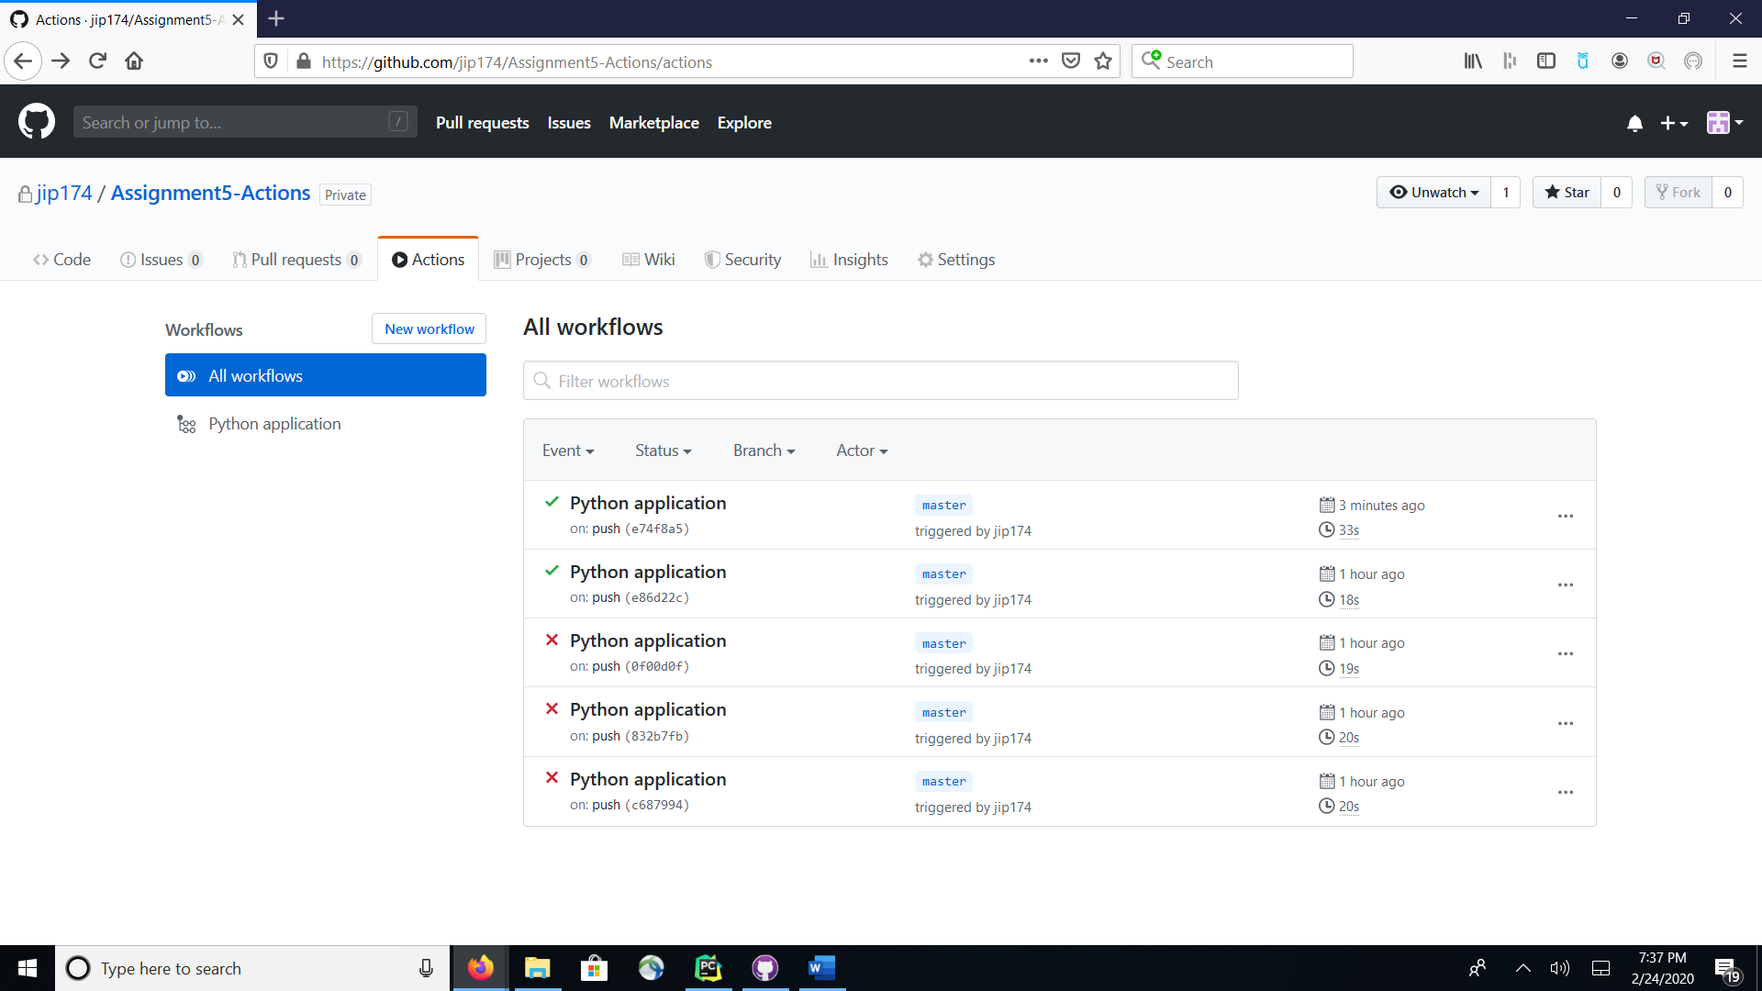

pushed first/last function

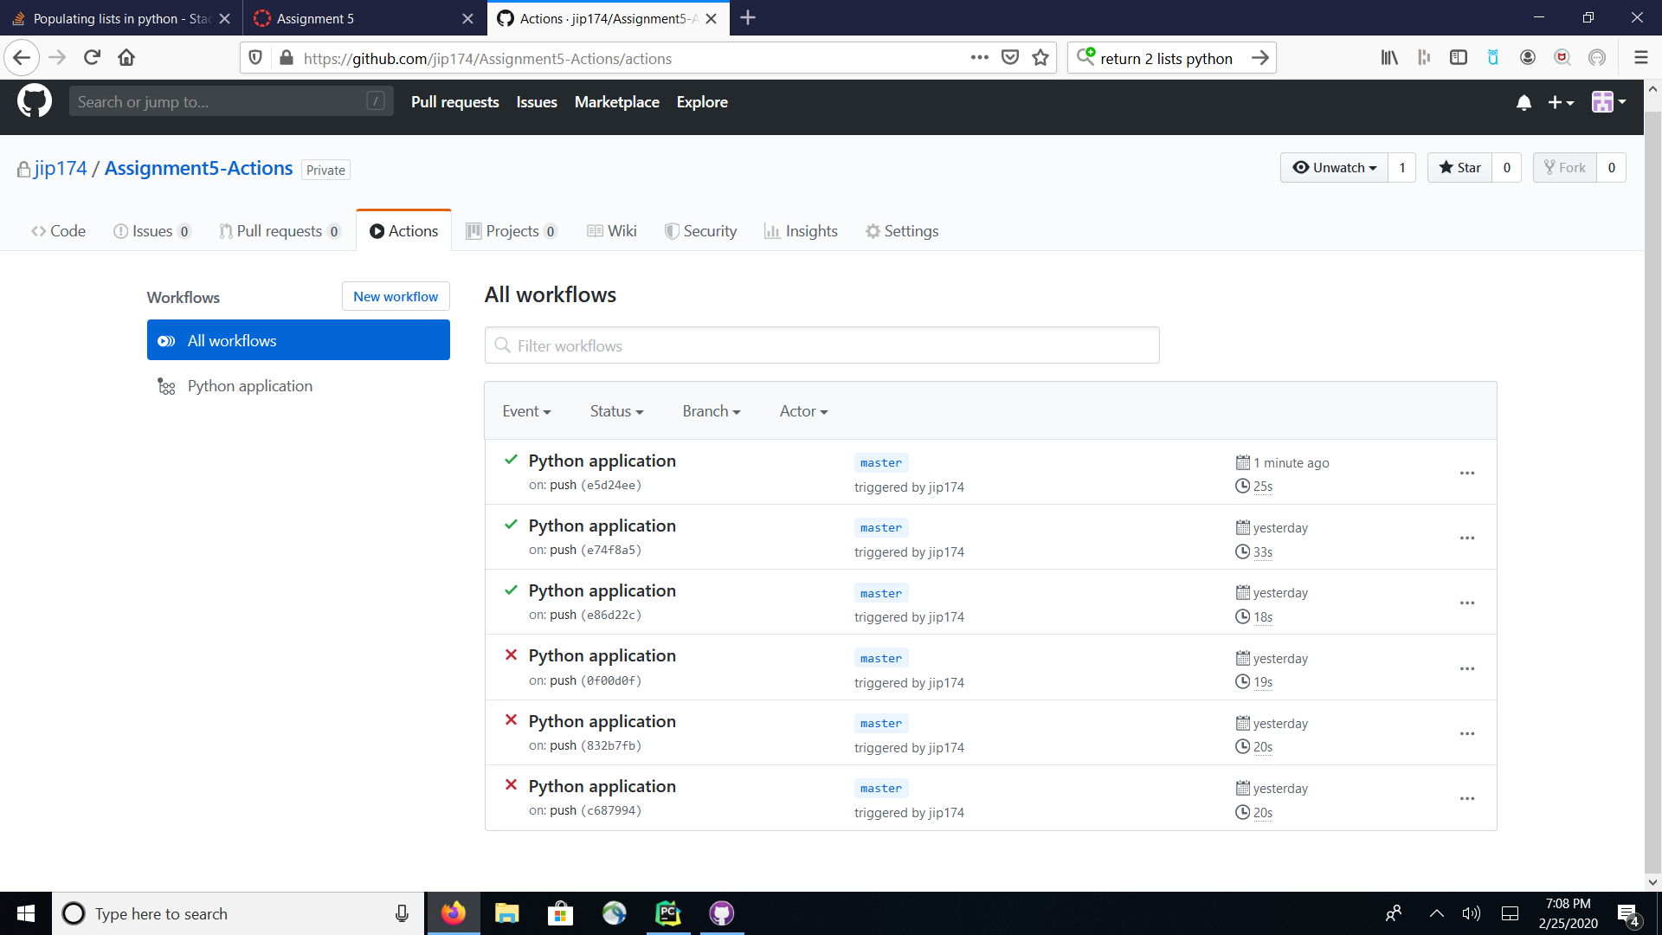

Date diff function/test

