Justin Phillips (phillij6)

cs372 summer

project1

6/29/2020

a. The way to run my program is start the file project1.py. I wrote it on VC and complile using the run with python on the terminal also I’m using python 3. A prompt will appear asking which part you want to run 1,2 or 3. 1 is the small get program, 2 is the large get and 3 is the simple HTTP. I got the HTTP program set up to run on 127.0.0.1:1234, there’s a prompt notifying you to open your browser to complete the request.

b. Screen shots of the codes running

1. The screen shot of small get

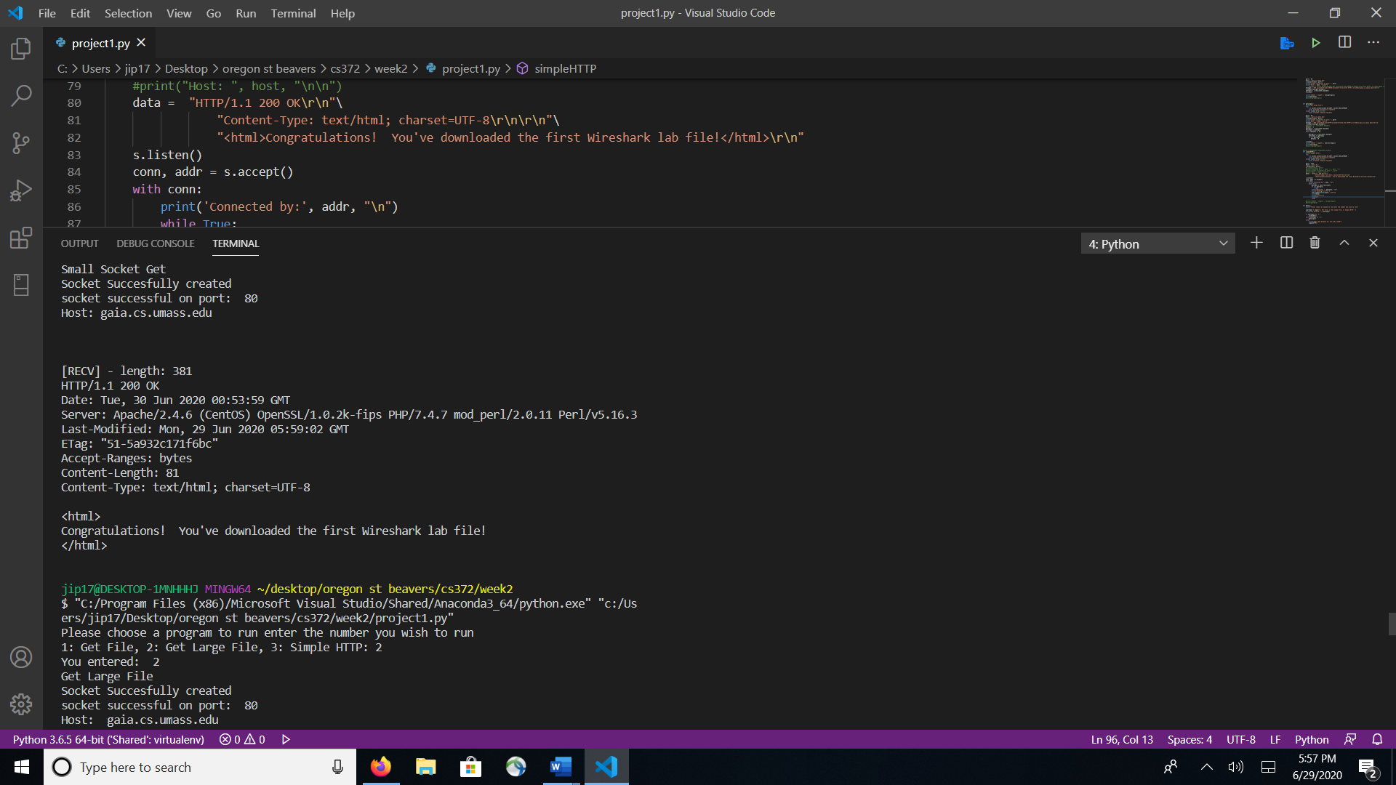

2. the large get screen shot

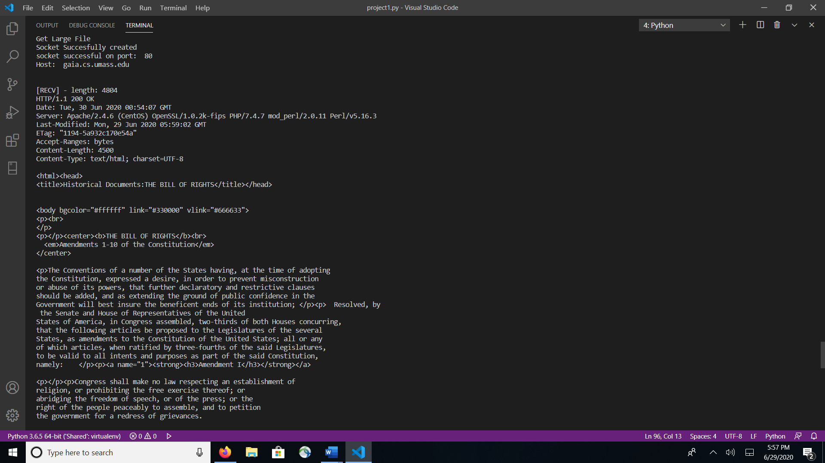

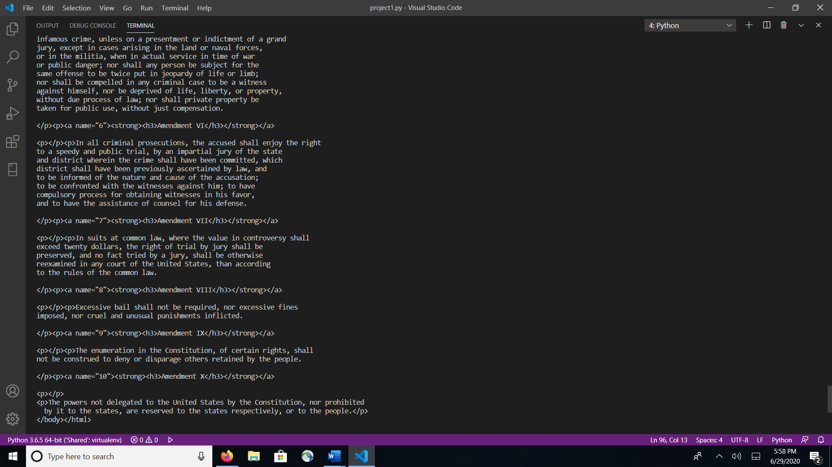

3. Screen shots of the simplest HTTP server

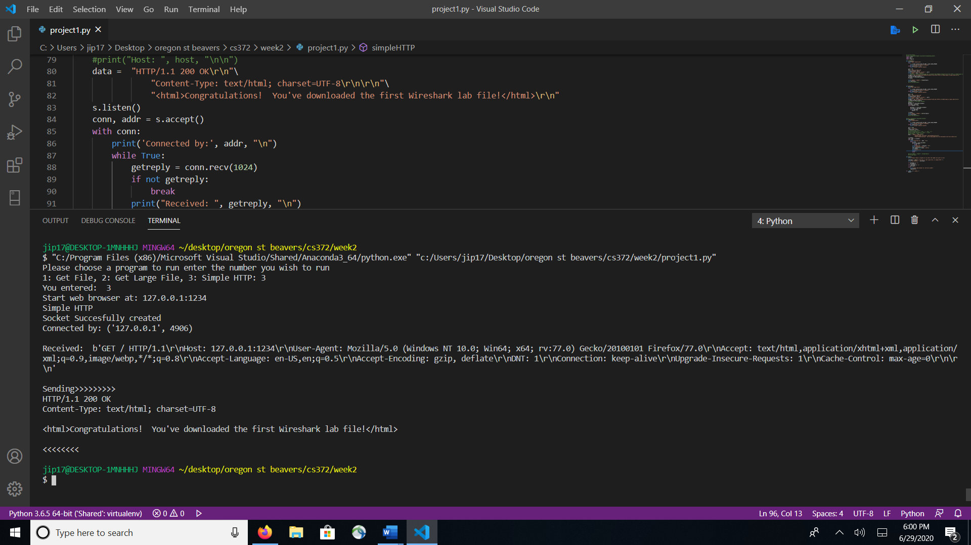

Screen shot of my browser(firefox)

