Justin Phillips

cs372 summer 2020

6/24/2020

1. List 3 different protocols that appear in the protocol column in the unfiltered packet-listing window in step 7 above.

Three different protocols that appear in the protocol column in the unfiltered packet-listing window are TCP, DNS and HTTP

2. How long did it take from when the HTTP GET message was sent until the HTTP OK reply was received? (By default, the value of the Time column in the packet-listing window is the amount of time, in seconds, since Wireshark tracing began. To display the Time field in time-of-day format, select the Wireshark View pull down menu, then select Time Display Format, then select Time-of-day.)

The get request was made at 12:29:48.489564 and the ok reply was at 12:29:48.603081 so it took .113517 seconds

screen shot of the original values and the highlighted response ti

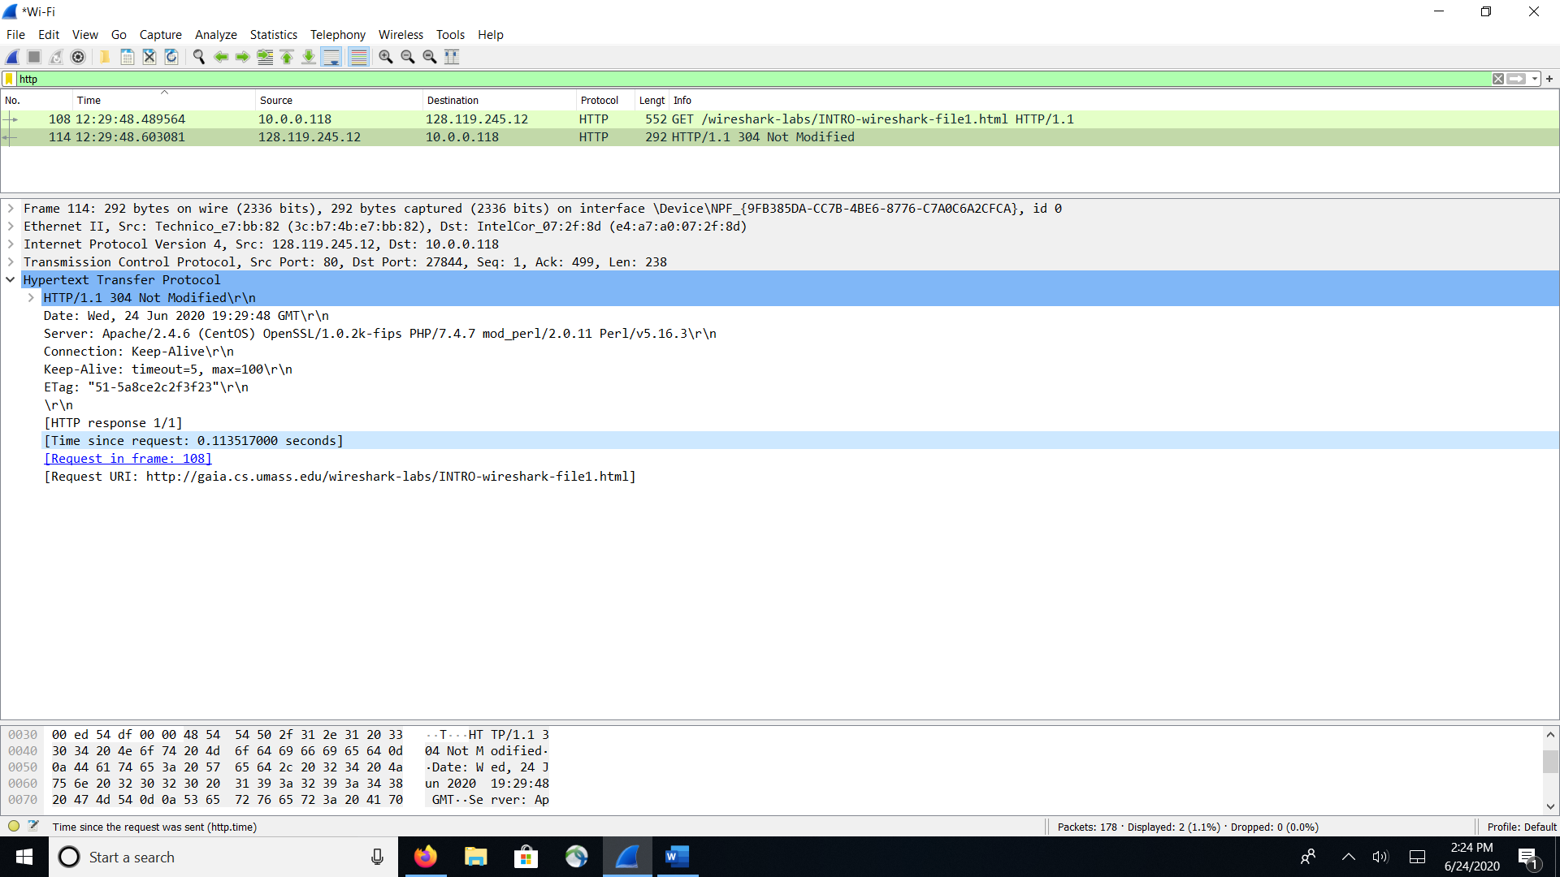

3. What is the Internet address of the gaia.cs.umass.edu (also known as www-net.cs.umass.edu)? What is the Internet address of your computer?

<http://gaia.cs.umass.edu/wireshark-labs/INTRO-wireshark-file1.html> : 128.119.245.12

address of my pc 10.0.0.118

4. Screenshot the two HTTP messages (GET and OK) referred to in question 2 above. Make sure to include all pertinent information in the screenshot (Time field, Internet addresses, etc). Paste these screenshots into your lab report.

Get

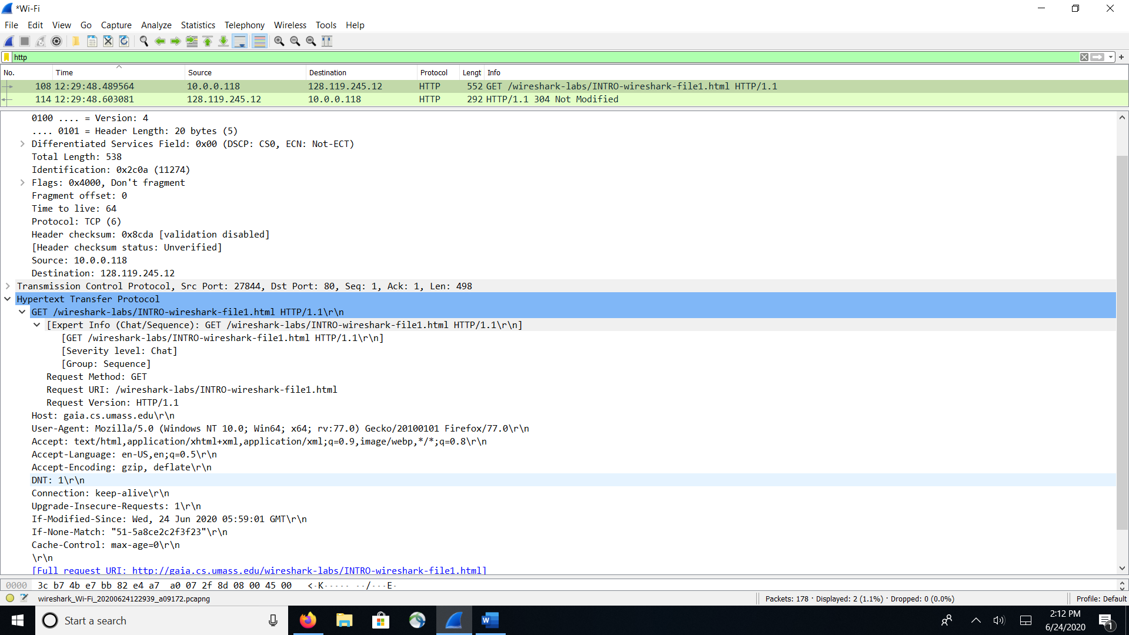



Return OK

